Proposed: YourName Energy Systems R&D Center, $X/yr
We propose the establishment of an Energy Systems R&D Center.
To get through climate change, we need big automated systems. However, many proposals for big research initiatives and big commercial ventures are rejected because they are too big. We want big, yet we do not want big. Yet we need big. In theory, one might break a system down into component parts and chip away at each, one at a time. An example is AT&T Bell Laboratories which developed much of the world's wired communication system between 1950 and 1980.
We believe the solution is a new R&D center, summarized below.

- A "YourName Energy Systems R&D Center" (YESRC) is established with a budget of $X/yr.
For business plan google search: "yna_YESRC".

- Mission is to develop large automated systems that significantly reduce climate change.

- YESRC develops and proposes plug-and-play interconnection standards that coordinate multiple companies who support large systems. This includes electronics, communications and mechanics.
- All technology developed by YESRC is made available to the public and given away for free to encourage collaboration, decarbonization and standardization.

YESRC is divided into several divisions, each of which is summarized below:

- Solar Skins: In theory, we should be able to wrap a building roof and wall surfaces with solar skins, at a cost less than traditional treatments. In the case of residential homes, this would entail attaching solar material directly to plywood, at a cost less than installing side wood clapboards and roof shingles. This would require complicated machines that fabricate custom pieces that wrap windows and install. For details, click here.

- Mechanization of Solar on Soil: Develop mechanized systems for coating large amounts of land with solar in a manner similar to how agricultural tractors maintain large swaths of land. Also, explore placing solar material directly onto soil and dramatically reducing material usage for each Watt of electricity produced. For details, click here.

- Smart Building: Place a processor into all building devices and network them together with reliable wired communication (i.e. data wire in power cable). Devices include: light switches, light sockets, motors that move thermal covers over windows, pumps that move water from thermal storage tanks to radiator valves, radiator valves, motorized dampers within ducts, motorized dampers at vent openings, fans within ducts, large appliances, thermostats, temperature sensors, occupancy sensors, and fire detectors, etc. In this initiative, we design devices and write software that reduces climate change via several techniques. For details, click here.

- Window Thermal Cover: Create automated window thermal covers which deploy when room is unoccupied. Thermal covers attach to smart building network. For details, click here.

- Next Generation HVAC: Develop standardized plug-and-play modules that provide more control over air in a building. This includes: motorized dampers in ducts, fans in ducts, valves on radiators, routing thermal storage water, routing 60°F ground source water, etc. Modules connect to smart building network. For details, click here.

- Automated Articulating Arm: Develop truck mounted articulating arm components that support construction and upgrades that reduce CO₂. For details, click here.

- Automated Market Place: Develop website-based automated market places that support construction and upgrade projects that reduce CO₂; making use of above data. For details, click here.

- Automated Data Access: In order to automate building construction and upgrade projects, software is written that collects, maintains and coordinates architectural drawings, laser scans of existing structures, photography, and ground penetrating radar data. For details, click here.

- Big Solar Architecture: Architects explore ways of providing large surfaces for solar, on and around a building. For details, click here.

- Consolidate Building Complexity into Factory-Made Modules: Researchers explore ways of consolidating additional building complexity into factory made modules that drop in via crane. For details, click here.

- Automated Ground Source Installation: Develop automated systems for installing ground source piping. For details, click here.
- Standard Electric Vehicle Battery: Develop swappable electric vehicle battery and support systems. For details, click here.
- 10ppm R&D Pledge: Encourage countries to dedicate 10ppm of their GDP to six R&D funds that reduce climate change. Maintain global website that coordinates researchers. For details, view YouTube video.

We Need Big Systems
The world does not have enough money to decarbonize via brute force; therefore, innovation is needed to get through this with minimal harm. However, we do not need just any innovation. We need to create big systems that do big things, and at reasonable cost.
Traditionally, research organizations and companies shy away from systems considered "too big" or "having too many moving parts". However, in theory, we should be able to break these down into component parts and chip away at each.
Surviving climate change is like a chess board. We might not know the moves needed to win the game; however, we can advance our position one move at a time. Developing one component in a big system is like one move. And free and open enables the world to maintain and advance from that position.
In summary, we need to not fear big automated systems, and press forward.

Apply Solar Skins Direct To Building Surfaces
For several decades engineers have theorized solar skins could wrap building roof and wall surfaces, edge-to-edge, and generate electricity on-site. Below is an illustration of what this might look like. This does not exist, yet is an exciting area of research referred to as “Building Integrated Photovoltaics” (BiPV). This document explores challenges faced by BiPV researchers.
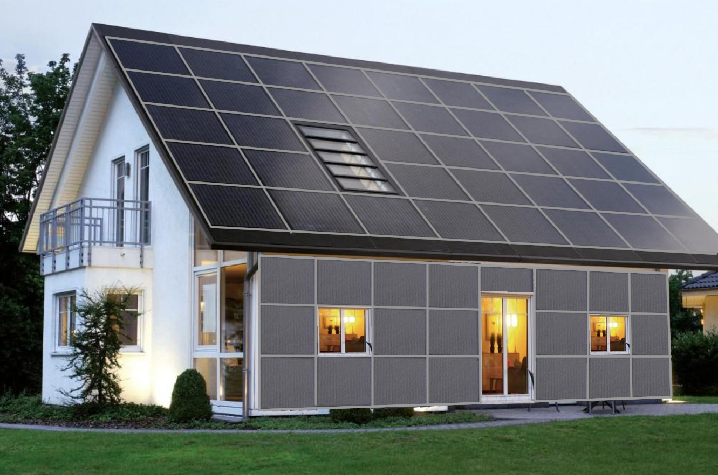

Wrapping with Solar
When building a house, 4 x 8ft sheets of internal drywall panels are typically shipped to a construction site and cut into custom shapes that wrap windows and doors. Architectural software produces a list of custom shapes for builders, who cut and install.
In theory, one could do the same with custom pieces of solar material that attach directly to external plywood. Custom solar would probably be made to order in a factory, shipped in a canister, and installed by a specialized machine.
In this scenario, the solar material is the water barrier. This means that the cost of roof shingles and horizontal side clapboards are being eliminated. If it is cheaper to wrap than not wrap, then everyone would wrap, worldwide. This is a big deal. In order to decarbonize the planet we need to devise green technology that is cheaper than not-green. Solar skins is therefore a potential opportunity of global importance.

So what is the Problem?
The good news is conversion materials (i.e. silicon, thin film) are cheap. And developing mechanical systems to wrap a building cost little. The bad news is developing machines to fabricate and install is expensive. Also multiple complicated machines causes investors to consider this "too big" or "too many moving parts", which it is.
We intend to do implement Phase I, which is to develop the mechanics of wrappings, develop embedded electronics, and explore machines that fabricate and install. If Phase I was positive, anyone could continue onto Phase II and fully develop machines that fabricate and install, at a cost of $50M to $300M. In other words, developing a solar skin system would cost little, yet developing machines to implement would cost much more.

Flexible Solar Products Already Exist
Flexible solar products currently exist, an example of which is the SunPower product, pictured below. This involves solar PV cells embedded in flexible ETFE plastic that is 2mm thick. These can be attached to a curved surface, or rolled up and placed into a large canister. In theory, current flexible silicon solar products could be made larger, in custom shapes, and installed on building surfaces.
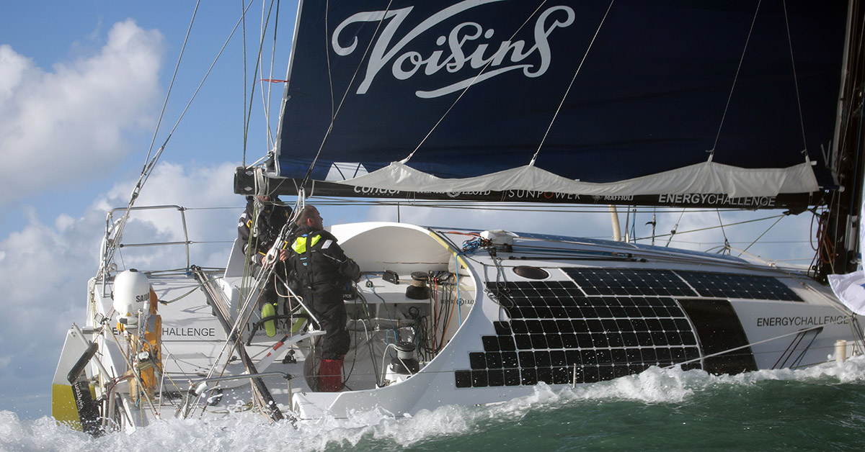

R&D Challenge #1: It's Too Big
Implementing solar skins directly to building surfaces would require machines that fabricate, install and maintain. Developing these machines might cost hundreds of millions of dollars. If one company developed one machine, then revenue would be zero in the absence of other machines (e.g. installation machine is not useful without material fabrication machine). This is commonly referred to as a "chicken and egg" problem. In theory, one company could develop multiple machines from scratch, yet almost all companies are reluctant to engage in an expensive, complex, and risky venture of this magnitude.
Our strategy is to develop initial technology that is used by others, and move the world closer to a final system.

R&D Challenge #2: Coordinating Multiple Companies with Standards
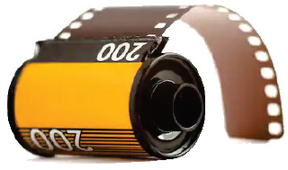
In theory, government and/or foundation money could design a system and propose interconnection standards that coordinate multiple companies. If there is a standard way to place rollable material into a canister, then a company that makes the fabrication machine could coordinate with a different company that makes the installation machine.
Twenty years ago, 35mm analog film was stored in a canister, pictured to the right (for younger readers). The dimensions of the film and canister were standardized and this enabled makers of cameras and makers of film processing machines to coordinate. One could apply the same principle to solar skins.

R&D Challenge #3: Securing Material to Building via Brackets that Control Water
We are looking at attaching solar material directly to plywood roof and wall surfaces, without an underlying water barrier. The solar material is the barrier. Custom solar skins would need to support disassembly and replacement, since a building might last five times longer than a set of skin. In other words, gluing solar direct to plywood is not feasible.
If you look carefully at most buildings, you will see overlapping components on both roof and wall surfaces. These exist to control rain water. Water is sneaky. If it can work its way into a building, it tends to do so, especially over time. Overlapping surfaces is an important technique for controlling water.
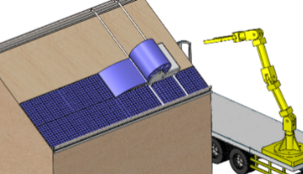
If one has a plywood roof that is 15m wide x 10m high, for example, they might place five overlapping strips of material directly onto plywood, where each strip is 15meter wide x 2meter high.
Below is an example of an overlapping horizontal joint. In the illustration at the beginning of this chapter, these are shown as horizontal light gray rails between horizontal 2m wide solar strips. The lower extruded aluminum rail (violet) attaches to plywood via screws, and the upper rail (light green) attaches to the lower via bolts. Flexible solar ~2mm thick (blue) attaches to rails via adhesive. A PCB (green) is embedded in the material, and in this design, supports electronic components 1cm tall (red). A lower layer of thin sheet metal (gray) presses against plywood, provides strength, and provides a fire barrier. Not shown is honeycomb plastic between the lower metal layer and upper solar layer. This fills empty space around PCB. Under the solar material is plywood (brown).
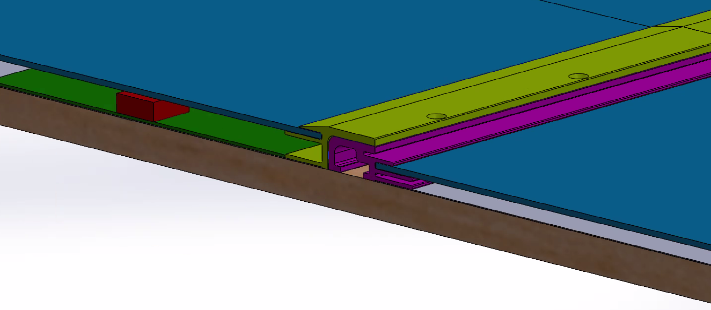
The following illustrations provide more detail:
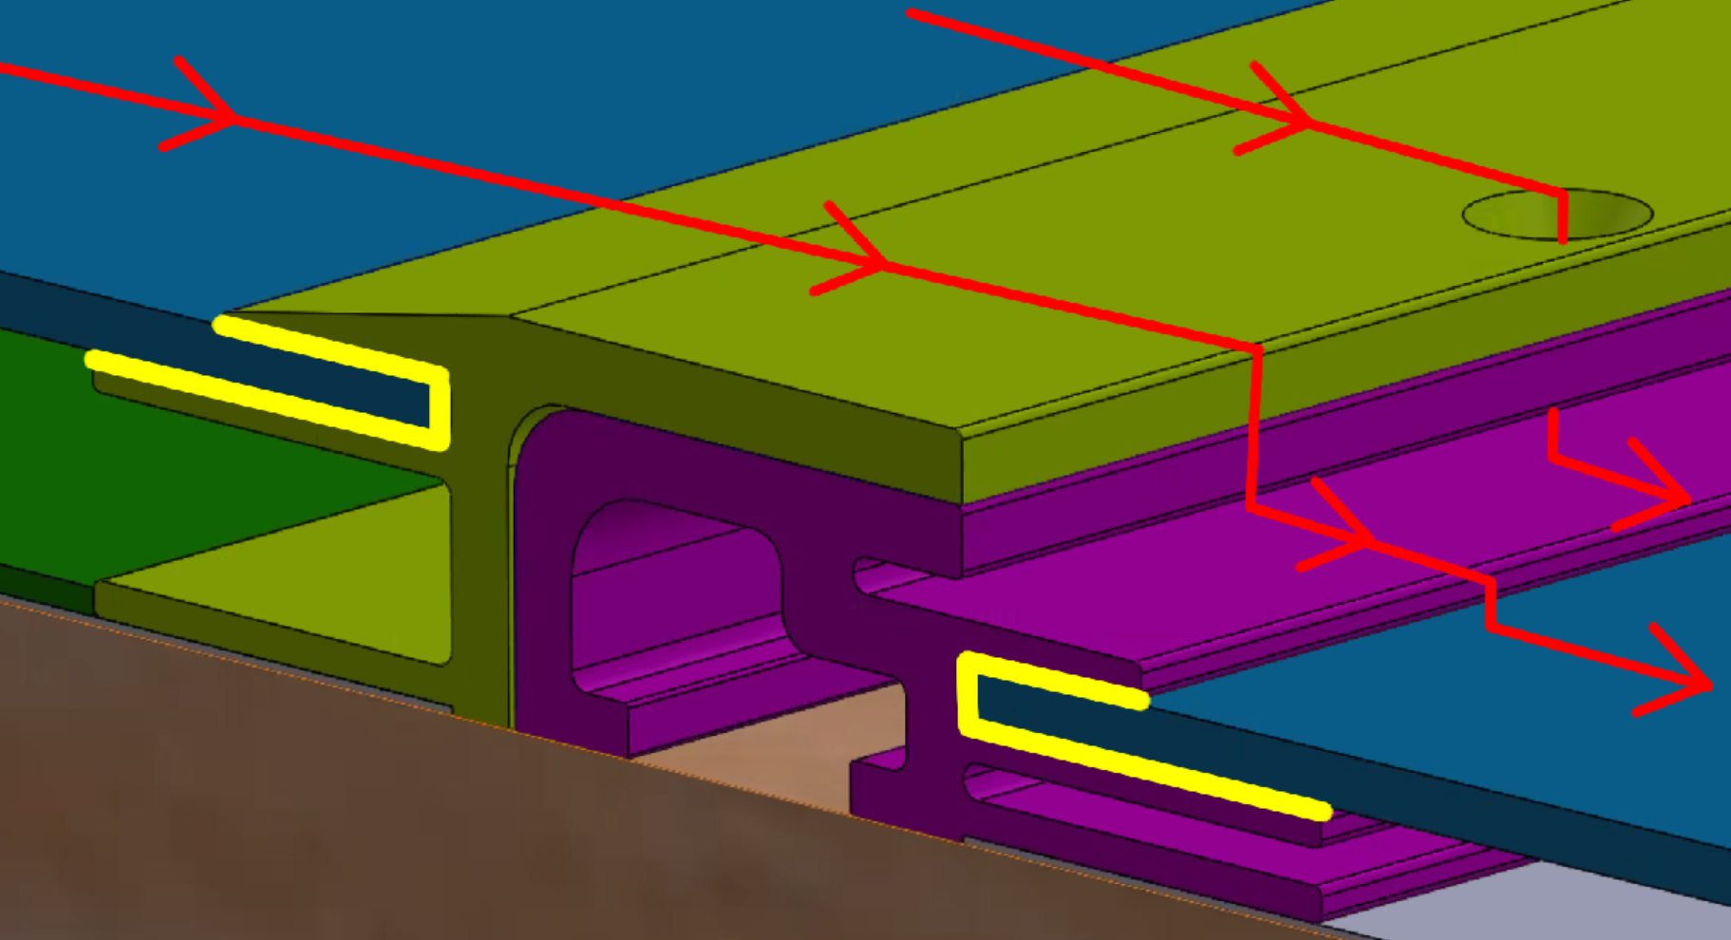 | 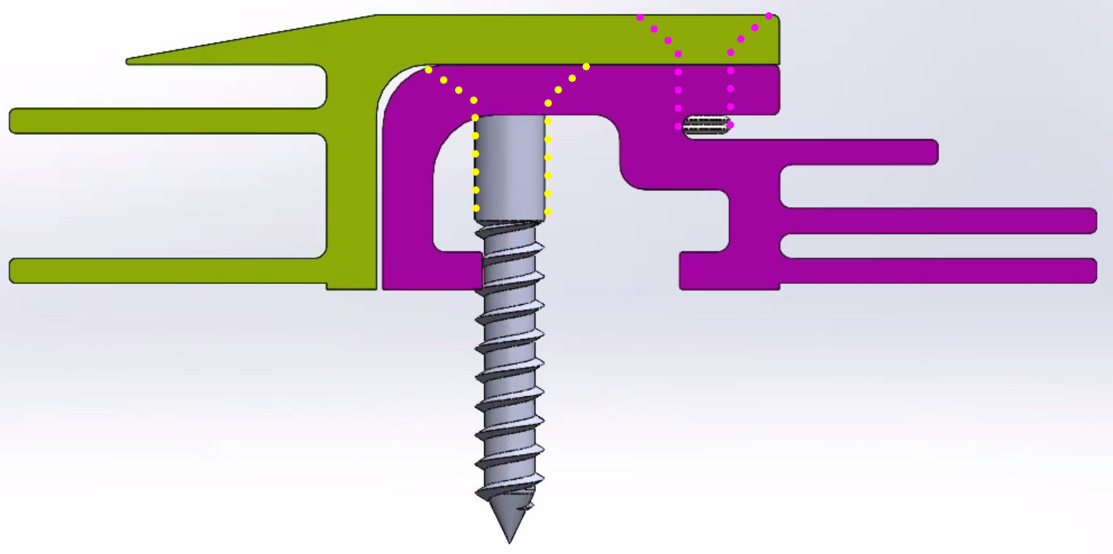
Rain water (red) flows across overlapping surfaces. Adhesive (yellow) bonds flexible solar material to metal rails. | Wood screws secure lower metal rail to plywood (dotted yellow) and bolt secures top rail to lower rail (dotted violet).
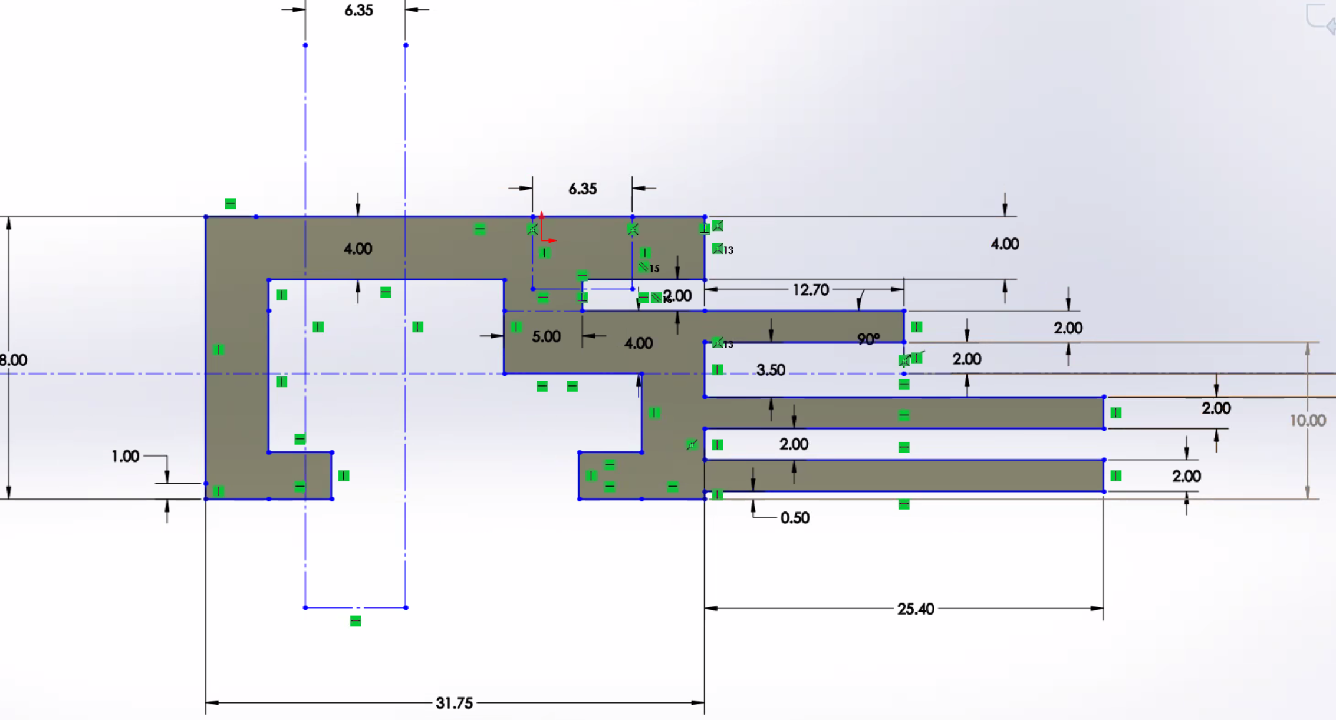 | 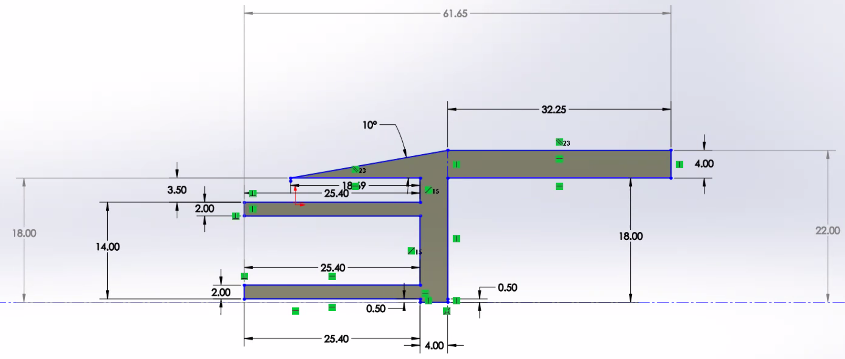
Lower metal bracket. | Upper metal bracket.

Designing Multiple Brackets
The above bracket applies to horizontal seams; however, to fully wrap a house, one would need about a dozen different types of brackets, illustrated below with green circles. For example, one would need a bracket at window vertical edge. Blue lines in below illustration shows how one might wrap features on roof and wall surfaces. A factory would fabricate custom shapes since one cannot cut solar in the field.
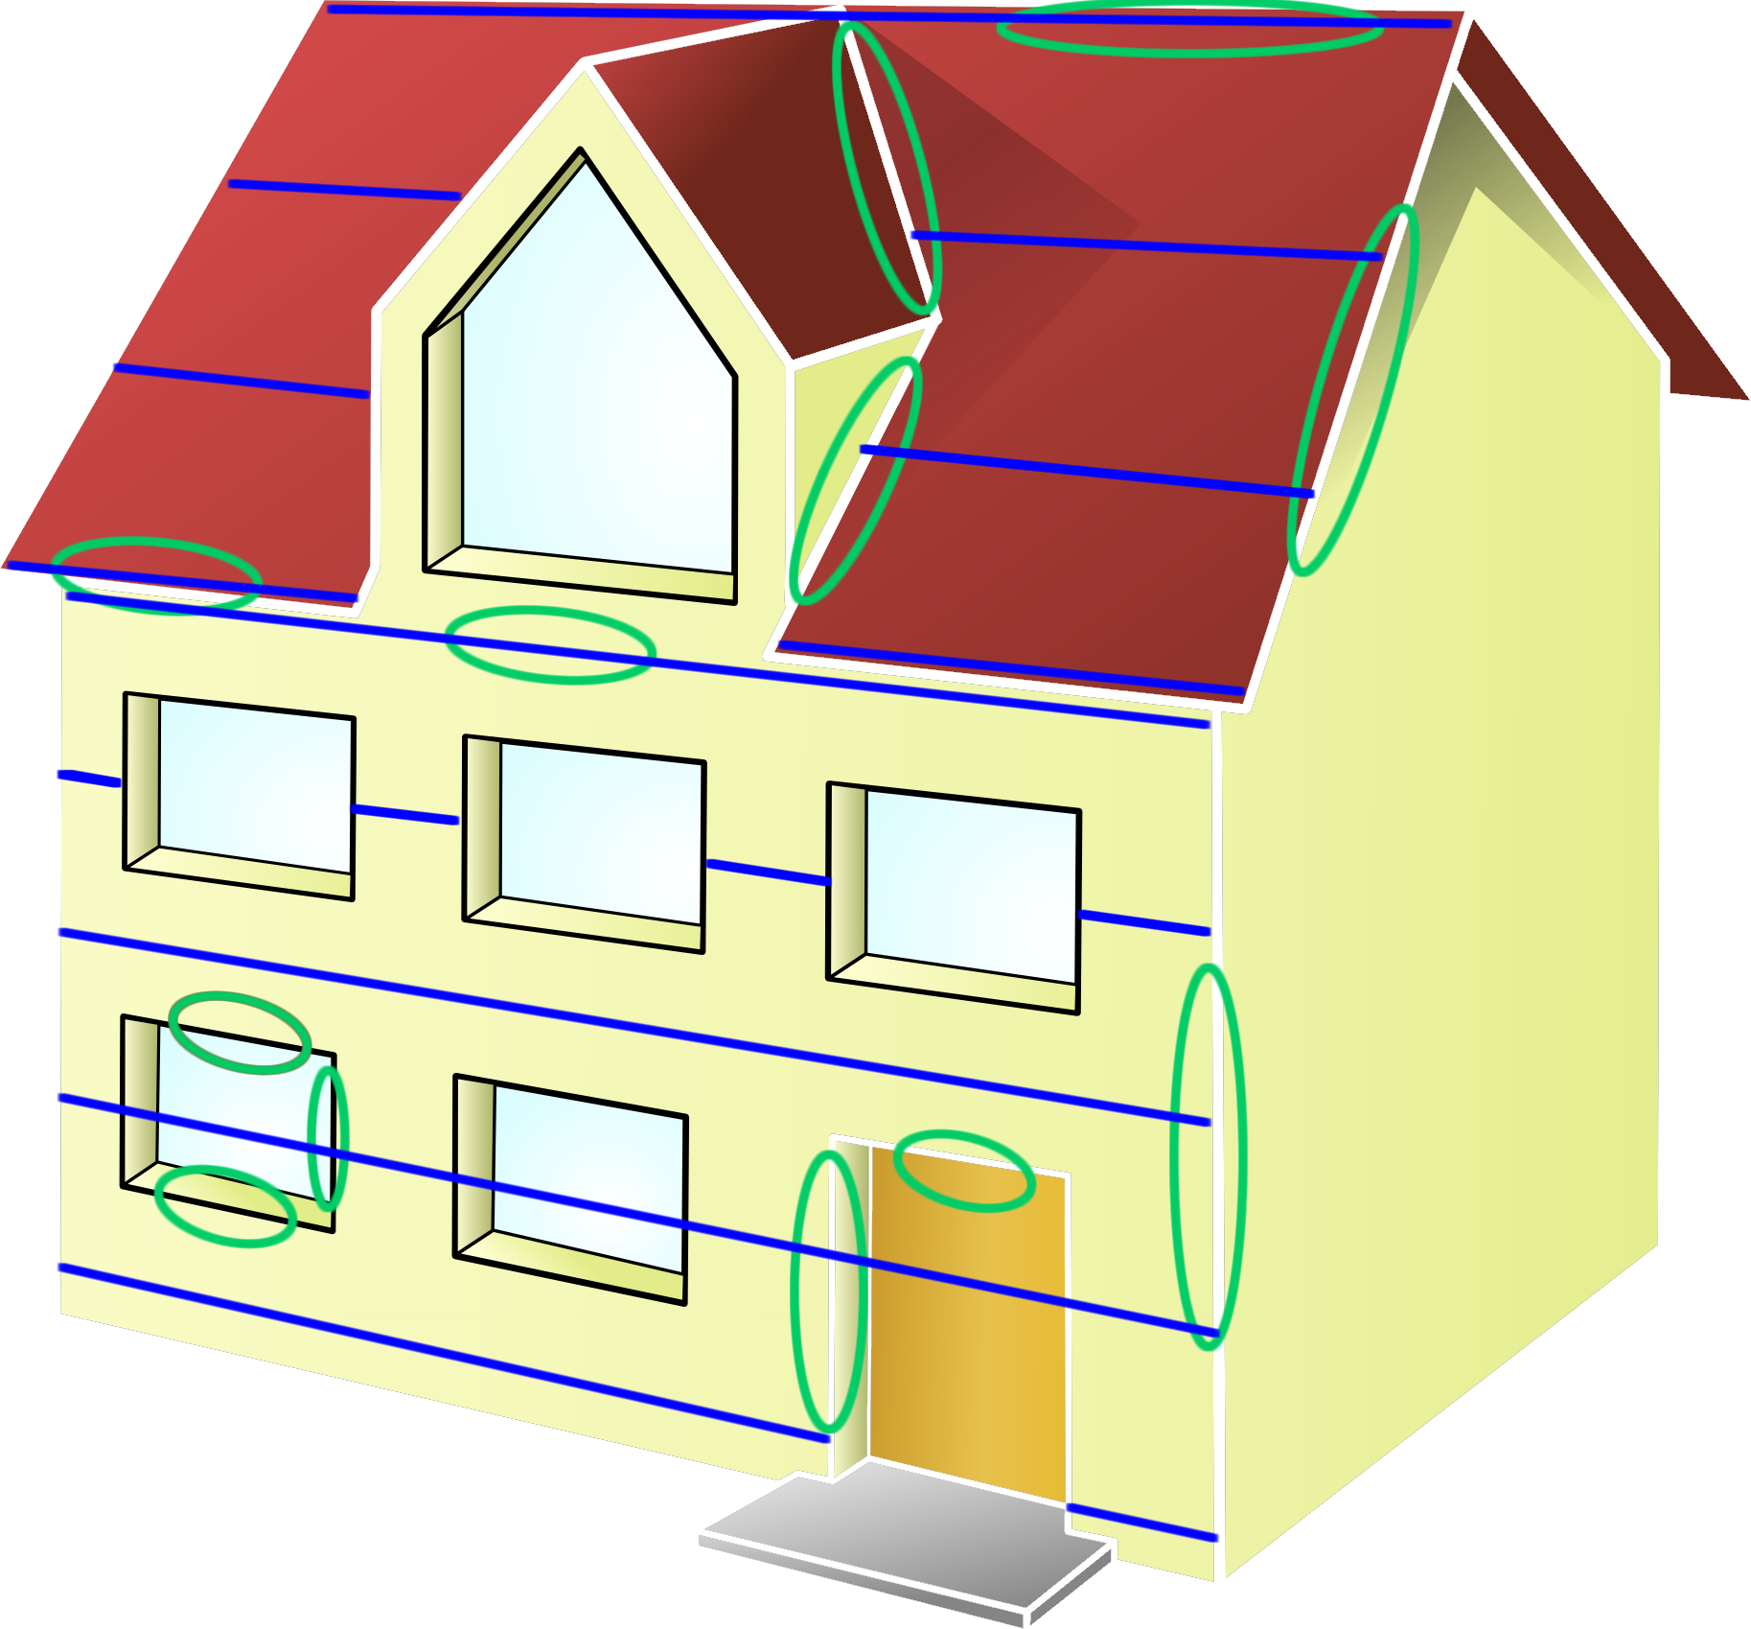

Small Flat, Large Flat, or Large Rollable?
Instead of large rollable, researchers can explore covering a roof with small flat non-rollable custom pieces that assemble like a puzzle and wrap features such as windows, doors and chimneys. In theory, a factory could stack custom pieces in the small 1 x 1.5m size range into a container, transport, and install via specialized machine. Alternatively, a worker could handle pieces due to their manageable size and weight. A flat non-rollable system might include 3.2mm thick tempered glass to resist hailstones.
One disadvantage of small flat vs. large rollable, is small flat needs to control water at vertical seams. A potential remedy is overlapping vertical ribs, similar to what one does with a metal ribbed roof on a commercial building. Yet many vertical seams, over many years, might be prone to reliability problems. And ribs tend to bend after being pressed on by things like tree branches.
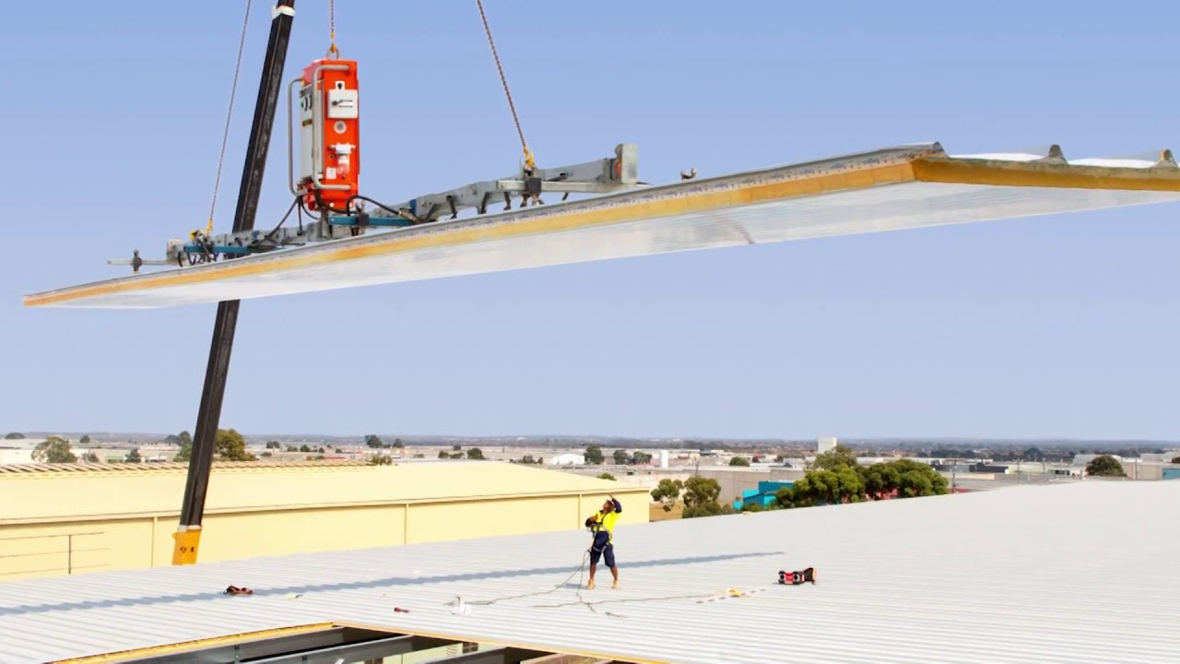
Another disadvantage of small flat is it entails an electrical connector at each piece, and this is less reliable than solder joints embedded in large rollable. Also, with many connectors, one tends to reduce the number of wires within each connector, which reduces the number of power conversion options. From a power conversion perspective, large rollable is very different from small flat, the details of which are beyond the scope of this discussion.
Alternatively, one might look at large custom flat that drop in via crane, similar to corrugated steel panels on commercial buildings, pictured here.
In summary, there are a variety of approaches, all of which deserve exploration by researchers.

Embedded Electronics Optional
In some cases, one might place power conversion electronics inside a building, such as under a roof in the attic. However, this is not always convenient. For example, a wall surface without access from inside the building might not support cabling to solar. Subsequently, one might have a ~1cm thick layer between solar cells and plywood, for electronics and cables, as illustrated above.

Seven Parameters that Characterize a Solar Skin System
There are many different types of solar skin systems, where each are characterized by seven parameters: type of building, new construction or existing, roof or wall or both, topology (large rollable, large flat, small flat), embedded electronics or not, 3mm flat glass or plastic cover, and silicon or thin film PV.

Solar Skin Mechanical System Involves Mounting Brackets and Material In-between
Mounting brackets would need to be standardized in order to coordinate machines from different companies that fabricate and install. This would be similar to 35mm analog film cartridges that coordinated cameras and film companies. There is no business model that supports the development of such brackets; therefore, an organization like ours would need to step up to move this forward. The good news is developing brackets, defining material between them, and building simple prototypes is cheap. The bad news is developing machines that fabricate and install is costly. Yet you need step #1 before step #2.
We intend to design multiple solar skins systems. For each, one needs to specify the above seven parameters (e.g. large rollable, large flat, or small flat) and be prepared to spend $1M to $10M. If free and open, others can easily build on one's work, including a standards body. This would not be enough money for machines, yet would move the world closer to a complete systems.

R&D Challenge #4: Developing Cost Effective and Long Lasting Electronics
In the below illustration we show one large piece of rollable solar with PCB's in green color. In this concept, each PCB maintains eight 300W power converters, where each 300W region of solar is shown in violet. These PCBs are connected together with multiple wire cable that joins via solder joints instead of connectors. Having this kind of access to solar cells, with more than 2-wires between PCB's, is different from the traditional 2-wires at each 1 x 1.5m panel. Figuring out how to combine power in a cost effective and reliable manner is a challenge for electrical engineers. It is our intent to develop and propose interconnection standards for electronics to help coordinate multiple companies.

R&D Challenge #6: Mitigating Fire and Safety Risks
Obviously, one does not want to burn the house down or electrocute the neighbor walking the dog.
To reduce fire risk, electronics can be designed to not produce excess heat upon component failure, and a thermal barrier can be placed at plywood.
If solar on wall is on ground floor or close to open window, one would need to limit voltage to avoid shock hazard. This would be necessary since cover surface could potentially fail and expose electrical contacts. Placing multiple power converters on one PCB, described above, could help limit voltages to an acceptable level.

R&D Challenge #5: Coordinating Architectural Data
Custom pieces that wrap building features requires the coordination of architectural software, servers that maintain architectural drawings, building owners, and factories that make custom solar pieces. Software that coordinates does not exist. To move this forward, we intend to implement a complete system in software, build prototypes (servers, user interface, database), and make source code available free and open to enable others to build on this work. Also, we intend to propose standard communication protocols that coordinate the various components.
The placement of windows and doors might only be accurate to +-1cm relative to drawings. Subsequently, one would need photography, video and/or laser scanning to improve accuracy.

R&D Challenge #6: Surviving Hailstones
A 2cm diameter ball of hail ice traveling at 100kph can damage silicon PV solar cells; however, thin film photovoltaic conversion material, such as CIGS, are more resilient. Silicon PV has higher conversion efficiency and less efficiency degradation over time, relative to CIGS, and is therefore more popular. However, BiPV researchers are not connected to any one conversion technology, since they are focused on the mechanics of wrapping and installing of any material.
Silicon solar cells on roof surfaces are typically protected by flat tempered glass 3.2mm thick. This glass cannot roll or bend. However, vertical walls do not take direct hailstone strikes, and are therefore safe with silicon solar cells embedded in flexible plastic such as ETFE. In other words, with today's conversion materials, one might look at covering vertical walls with ~2m diameter rollable silicon, and look at covering hailstone-proof roof surfaces with something like rollable CIGS or flat 3.2mm glass over silicon.
Also, researchers could try to develop a rollable silicon solution that resists hailstones, yet it is not clear this is possible. Sunpower Corporation is probably the leader in this field; however, their silicon still breaks when hit with a hailstone.

Design Problem
Assignment for researchers:
Develop multiple methods of covering building roof and wall surfaces (e.g. direct to plywood), edge-to-edge, where parts and labor costs are less than traditional treatments (e.g. shingles, side clapboards). Explore multiple solar skins systems, where each is characterized by above seven parameters. Assume $100M to $1B is available to develop complicated machines that fabricate, install and maintain. Assumptions: architectural software generates list of custom shapes that wrap building features, custom shapes are fabricated in factory, and installation is automated via specialized machine. Propose standards that define how components plug-and-play together, including mechanics, electronics, and communications. Do all development except full design of machines.

Summary
BiPV researchers face many challenges in devising a system that supports solar skins mounted directly onto building surfaces at a cost lower than non-solar coverings. The primary challenge is the high development cost of machines that fabricate and install. However, researchers can design much of the system before spending big money on machines. This includes developing brackets and material that wraps buildings; and proposing free and open mechanical interconnection standards that coordinate multiple companies. It is unlikely a company would fund free and open development; therefore, to move this forward, an organization like ours is needed.

See Also
For an example of free and open solar skins research, click here.

Mechanize Solar in Desert

The Solar/Hydrogen Pathway
There are different methods of reducing CO₂, each of which are referred to as a "pathway". Each has their advantages and disadvantages, especially with respect to different geographical regions. For example, Nevada might favor solar; whereas Toronto might favor hydroelectric dams.
One method of reducing CO₂ is to generate electricity at a solar farm and use a portion to create hydrogen gas (H₂). H₂ can later be burned like we burn natural gas (CH₄), to create heat and to power vehicles. The big difference is H₂ + O₂ = H₂O; and CH₄ + O₂ = CO₂. In other words, hydrogen is like natural gas, yet without the CO₂ greenhouse gas. Hydrogen can be placed into tanks, which resolves the issue of storage for when the sun is not shining. A variation is to create ammonia (NH₃), which is easier to store and transport than H₂ gas, yet still burns after being "cracked" into N and H₃.
Powering vehicles with hydrogen instead of electricity resolves the following issues: (a) no longer need to obtain significant amounts of EV related rare earth materials at reasonable cost, (b) charging many EV's at one time requires rebuilding the electrical grid between power plant and home, and (c) EV charging is sometimes inconvenient.
The disadvantage of the solar/hydrogen pathway is cost. Generating hydrogen via electricity is expensive. If we could reduce this cost via innovation, then this pathway would be more feasible.

Covering 25% of Nevada with Solar
The US currently consumes ~4K TWhr of electricity each year. Also, the US burns a similar amount of gasoline in vehicles, and burns a similar amount of natural gas for heat and processing. In other words, if we triple electricity generation from ~4K to ~12 TWhr/yr, and use this for transportation and heat, we could stop burning gasoline and natural gas. And, if electricity was generated without emitting CO₂, we could decarbonize the US. If we do the math on how much solar is need for ~12 TWhr/yr, it works out to coating ~25% of Nevada with solar PV material. This is enormous and expensive, and does not resolve the storage problem, yet is one possible decarbonization pathway.

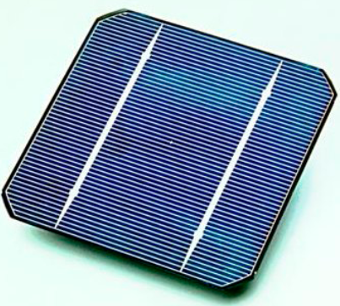
Solar Cells are Cheap
Let's begin by looking at the cost of an actual solar cell. This is a thin 5" x 5" x 0.01" device that converts light to electricity, and cost approximately $0.12 per watt. If one of these produces electricity for 20 years in a sunny region and you dispose of it after 20 years, the cost for the electricity attributed to the initial cost is $0.005 per KWhr ($0.005 = $0.12 / (0.707*5*365*20/1000)). The average US residence is currently paying approximately 20 times more for generated electricity. In other words, the 0.01 inch thick cell themselves cost less than 5% of the cost of electricity.
Metal, Glass and Cement
Solar farms place panels above ground and this involves a significant amount of metal and glass, and the occasional cement for foundations. These materials cost money. Yet perhaps more importantly, their fabrication requires heat, and heat requires energy. Steel is fabricated at 2600°F, aluminum at 1200°F, glass at 2600°F, and cement at 2500°F.
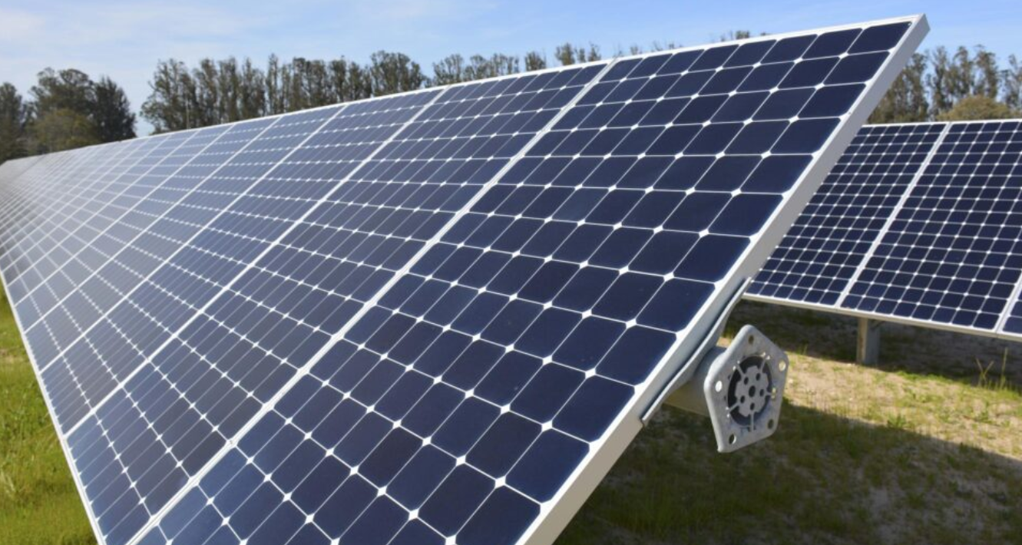
Wind and Snow Drives Material Requirements
Wind pressing on a surface exerts a force and that increases with the square of the velocity. For example, 50mph exerts 11 LBs-per-square foot (psf) and 100mph exerts 44psf. If a 100mph wind presses against a 6 x 6ft surface, for example, then 1800LBs presses against that surface (1800 = 50 x (6 x 6)). Panels are designed to handle snow loads as well. In many cases, weather is not so bad, yet handling the worst storm in 100 years requires a lot of material. In summary, material is heat is energy is CO₂.
Transformational Research
Every now and then a transformational innovation occurs that has a big impact on how we do things. An example is the LED light bulb that replaced the incandescent bulb and caused energy consumption from light to drop 7-fold. Before this occurred, no one could imagine this would happen, yet happen it did.
We will look at placing solar in deserts since this land is plentiful and is free of hailstones. No hailstones means we can work with plastic instead of glass. Products made out of plastic and silicon exist, an example of which is shown below. This Sunpower product is 2mm thick and is just as efficient as your ridged flat solar panel.
Rollable Solar
In theory, one could make large pieces of flexible solar in the ~2m x ~100m size range, roll them up (e.g. ~2.5m diameter), and place them into a canister for transport. This is similar to what we did with analog film -- pictured to the right for younger readers.

Solar Direct to Soil
The soil could be shaped with earth moving equipment as needed. For example, one could create rows that point toward sun. To hold the top solar layer in place, a flat underground anchoring layer, ~0.3m below ground, could attach to the above layer via many ~1.5mm diameter metal links. The below ground anchoring layer might be wire mesh embedded in plastic as well. Wire mesh is only ~0.25Kg per square meter (1.5mm diameter, 2.5cm squares, steel), it cost little (e.g. $0.50/m²), and is very strong. In other words, strength would probably not be an issue. Wind creates pressure which applies a force on the top solar layer. This system would transfer that load to the weight of the soil between the two layers. The good news is this might reduce cost and reduce material usage. The bad news is multiple R&D challenges, as discussed below.
One possible approach is detailed below.

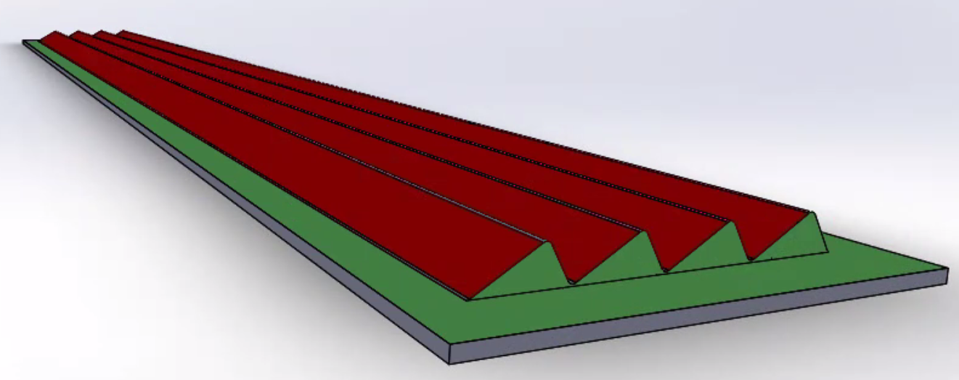 | 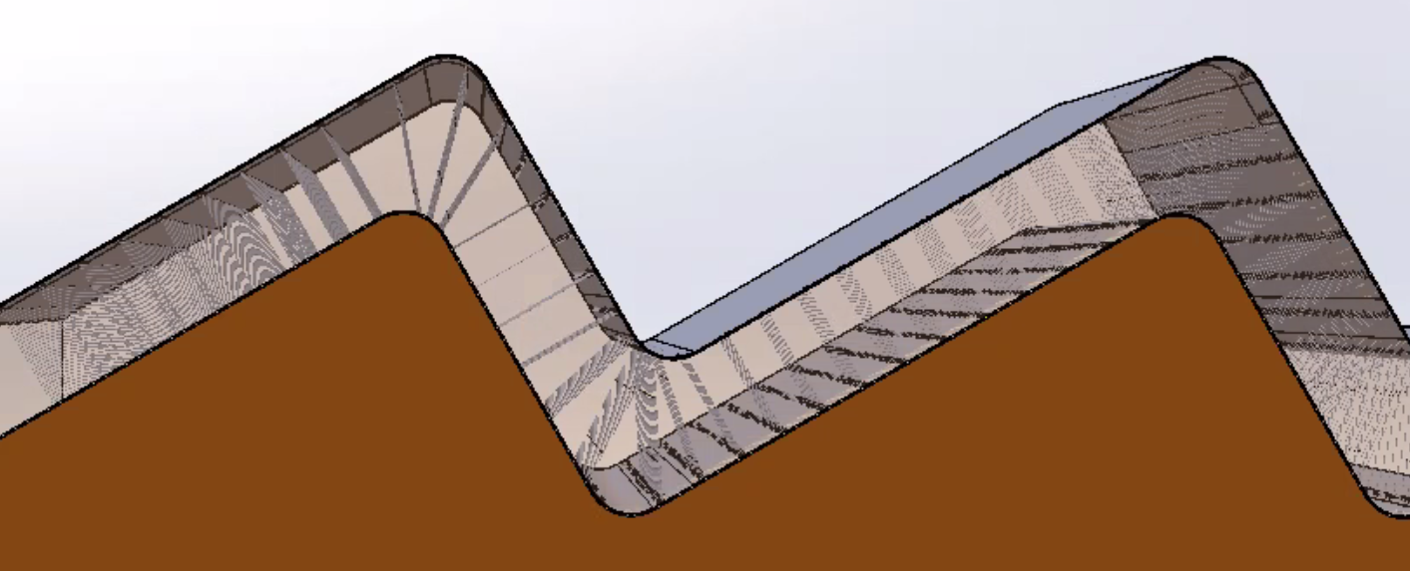
Multiple rows of flexible solar material are placed directly onto soil (e.g. 2m x 100m per row, shown in red). Entire bed is covered with solid material to control soil erosion from rain and wind. Skirt along outer perimeter (green) controls erosion near rows. | Metal links connect above-ground solar layer to below-ground anchoring layer. Silicon solar cells are embedded in plastic on top layer, similar to existing flexible solar products. Not shown is soil between two layers.
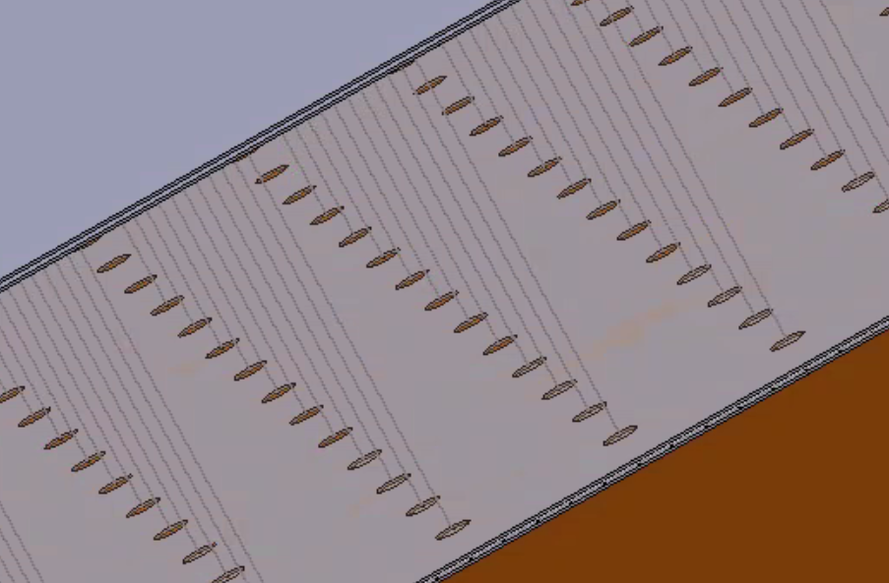 | 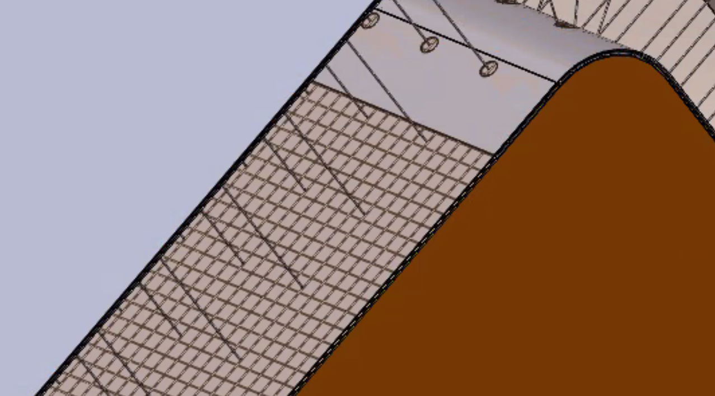
Vertical metal links connect above-ground solar layer to below ground anchoring layer. Load is transferred to the weight of the soil (not shown) between two layers. This keeps top layer in place when wind creates negative pressure. | Both above-ground solar layer and below-ground anchoring layer consists of flat plastic with embedded wire mesh (e.g. 1x1 inch metal squares). In above illustration, soil and top surface of anchoring layer are not shown allowing one to view metal mesh.
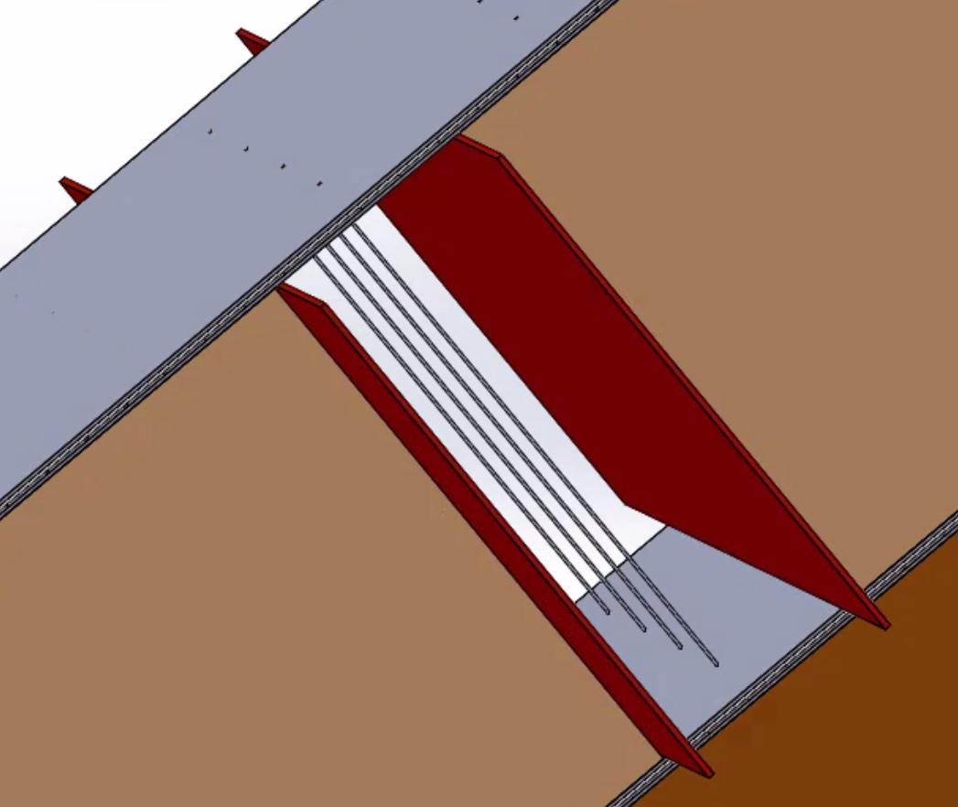 | 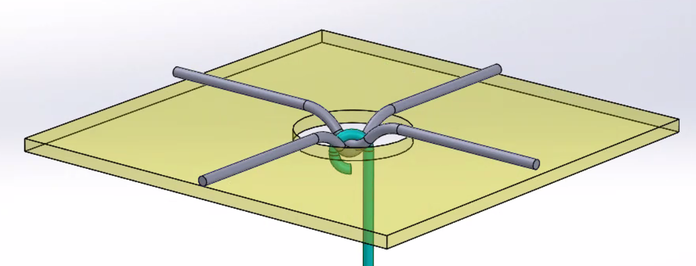
Installation machine uses retaining plates, shown in red, to control soil between top layer and below-ground anchor layer while a mechanism between plates (not shown) installs vertical metal links. The retaining plates move as the installation machine moves. Machine unrolls both layers, places soil in between, and connects them together via metal links. | Hooks in vertical metal links connect to wire mesh embedded in both top and bottom layers.

R&D Challenge #1: It's Too Big
The primary challenge with solar-direct-to-soil is one would need complex machines to fabricate, install, and maintain; and developing those is expensive. It is our intent to do Phase I research, which covers everything except costly machine design.

R&D Challenge #2: Erosion Due To Wind and Rain
Wind and rain could potentially move soil under and around the solar material. To mitigate, one could place flat material between solar rows and around the solar bed to control erosion. One might drain rain water into soil, in-place, in troughs between rows. However, it is not clear how much erosion one might experience after several decades of desert-like 10 inches rain-per-year.
Surviving many decades of wind and rain is a challenge for researchers. The good news is simulators can help predict how soil behaves given various designs and conditions.

R&D Challenge #3: Solar Efficiency Degradation
The amount of electricity collected by a silicon solar cell decreases with time, and is typically 0.5% per year. It is not clear how, if any, this is effected by storing cells in a curved state. Curved storage has not be studied.
All solar cells are not the same. There are different thickness, different doping, different metal patterns on top and bottom surfaces, and different ways to join multiple cells via metal clips. And storing in a curved state might affect each differently.
When solar is placed directly onto a roof with insulation under the solar, all heat must dissipate from the top surface. This causes the solar cells to run hotter than the case where the back surface is exposed to free air. Tesla solar roof is an example of this. The back surface of their tiles are not exposed to atmosphere. In the case of flexible solar direct to soil, soil conducts heat and 5m underground it is cool; therefore, solar direct to solar would probably run cooler than some of the warmer above-ground alternatives. Research is needed to better understand thermal effects of solar on soil, and with respect to the different types of solar cells.
When wind buffets a surface, it could potentially vibrate. Anchor links attached to the bottom surface of flexible solar on soil might vibrate and affect solar cells. Research is needed to ensure that solar cells do not degrade due to mechanical stress.

R&D Challenge #4: Reduce cost and Reduce Material Requirements
In order for this to be popular, it would need to be less costly and require less material, than the traditional solar farm.

Design Problem
Assignment for researchers:
Develop multiple methods for covering large amounts of desert land with photovoltaic solar where material usage is dramatically reduced relative to traditional solar farm (e.g. aluminum, glass, cement) and labor cost is reduced via mechanization. Assume $100M to $1B is available to develop complicated machines that fabricate, install and maintain. Propose standards that define how components plug-and-play together, including mechanics, electronics, and communications. Do all development except full design of machines.

Summary
Many challenges face researchers working on solar direct to soil. However, this could potentially provide enough energy to power our civilization, at reasonable cost, and with low material requirements. We still need to solve the problem of storage, which entails dealing with energy requirements after sunset. If the world developed a lower cost method of converting electricity to hydrogen gas, we could solve our storage problem.
The good news is researchers can explore different methods of placing solar on land without spending much money. The bad news is most concepts require multiple machines and these are costly to develop.
Investors tend to avoid projects that are "too big"; therefore, if this is going to move forward, an organization like ours needs to move this forward until not too big for investors.

See Also
For an example of free and open solar direct to soil research, click here.

Smart Building

A Microprocessor at Every Location
To make buildings smarter one could place a tiny $3 processor at every location and network them together.
Locations include: light switches, light sockets, motors that move thermal covers over windows, pumps that move water from thermal storage tanks to radiator valves, radiator valves, motorized dampers within ducts, motorized dampers at vent openings, fans within ducts, large appliances, thermostats, temperature sensors, occupancy sensors, and fire detectors.
These devices could then: control central air that flows to each room, move air from one room to any other room with central HVAC system off, heat or cool a tank of thermal storage water via solar for use when sun is not shining, move underground 60°F water into heat pumps, control motorized thermal covers at windows, and adjust illumination at each light bulb.
Much of this involves heating, cooling, and motorized window thermal covers embedded in the wall that slide out as needed.
From an engineering point of view, making a building smarter is easy since we already have the processors and software. And the cost of smart gadgets is often not an issue since building costs are driven by $75/hr. labor costs (fully loaded w/ overhead).

So what is the Problem?
There are several reasons why the above is not happening:
- We do not have an accepted standard communication system in buildings that connects together processors with ≥99.999% reliability and at low cost. "Five 9's" means the system fails on average ≤10minutes-per-year.
- We do not have an accepted standard operating system (OS) that is placed onto all devices in a building. We have an OS on Windows computers called "Windows", an OS on iPhones called "iOS" and an OS on smartphones called "Android". This enables them to coordinate and connect to a variety of software packages. Yet we do not have an accepted OS for building devices, making it difficult to integrate multiple smart devices in a building, plug-and-play.
In summary, plug-and-play standardization reduces cost via commoditization and reduced installation time.

Reliability
When one turns on a physical wall light switch, the communication between the switch and the ceiling bulb is operational ≥99.999% of the time. This is a subtle point that gets little attention, yet is important. Occupants and builders do not accept less reliability from common building infrastructure.
Wireless and power-line communication are significantly less reliable with failure rates on the order of 1% to 10%. This is due to dead zone, crowded spectrum, low signal to noise, antenna too small, blocked signal, etc.
Power-line communication involves placing a data signal on a power wire. Unfortunately, it incurs frequent errors due to dynamic voltage drops along the power cable and complex routing through the fuse box.
To achieve high reliability, one can add one or two additional data wires to a power cable. The cost of the additional copper, and the labor cost to pull a slightly larger cable is low.
The multi-device communication system built into low cost microcontroller IC's is called CANbus. Subsequently, if one wants to network together low cost processors reliably in buildings, they need a wire that supports CANbus (i.e. wire AND). CANbus is the networking system used by automobiles to interconnect sensors and actuators, and works well.
The data wire needs to be protected against damage in the event it is accidentally connected to the power wire, to protect devices from wiring errors.
There is a type of wiring topology called a "tree", which means one cable connects to multiple devices and has off-shoot branches, like a tree. One would need a data wire system that supports this, since power cables and building geometry are configured like branches in a tree. This is different from Ethernet which has a single wire between two devices. Also, this is different from daisy-chain which has multiple devices along one wire with no branches.

Light and Heavy Applications
One can divide consumers in a building into two categories: low power and high power. Low consumes <= 20Watts, whereas high consumes more. Low includes: LED bulbs, light switches, thermostats, temperature sensors, occupancy sensors, fire detectors, motors for window thermal covers, motors for curtains and blinds, motors for dampers in ducts/vents, and radiator valves. High power is for 110/220VAC power outlets, HVAC, large appliances, and fans.
Low is significantly lower than high. For example, a 10W LED bulb consumes 0.1Amps at 110VAC, and this is 1/200th of a 20Amp fuse. Most devices in a building are low.

48VDC for Light and 110/220VAC for Heavy
To save money, one could connect together low power devices with a lower power voltage and a less bulky power cable. For example, low might route 48VDC power on 18awg wire; while high places traditional 110/220VAC power on 14awg wire.
48VDC power involves lower cost electronics and lower cost data wire protection. Also, 48VDC entails building codes with fewer wiring restrictions.
If the majority of devices are powered with the less costly 48VDC, then one could potentially redirect saved money into networked smart devices at every location.

Common Software on All Devices
If one is frying an egg while a light bulb and occupancy detector are above their head, they might want the detector to tell the bulb to illuminate. One would like this to occur without relying on the cable that goes down the hall, the controller electronics at the end of the hall, the electronics in the basement, the cable modem, the internet, Alexa, Amazon, Xfinity, Google, etc.
This is what we call "local intelligence". We need for devices that are physically close to each other to do as much as possible, without requiring additional resources. This is needed to support fault tolerance, which means that if something is amiss, disruption throughout the building is minimized.
If one wants smart devices, low cost and high reliability there is only one way to do this -- place the same software onto all devices. And the only way to get the world to agree to that is to make it free and open, which means anyone can use and change at no cost. Also, there is one more requirement. Quality. The system will not be well received if it is buggy, unreliable, not well documented, or difficult to understand.
There are existing networking protocols that define how devices interact, yet they do not include software that facilitates a complete smart system.
For an example free and open smart device operating system search "BuildingBus" (with quotes). This OS allows any device to send a message to any other device, any device can read or write any port within any other device, any device can receive a library that contains information about other devices, any device can monitor sensors from any other device in pseudo real-time, and any device can send a control command to any other device.
Since each device knows what software is running on every other device, it can easily coordinate activities with fault tolerance and high reliability, plug-and-play. In summary, devices are smarter if they include a common operating system.

Design Problem
Assignment for researchers:
Develop physical layers that support CANbus, tree topology wiring, short circuit protection to power wires, and ≥99.999% reliability. One physical layer is for data wire(s) in low power cable (e.g. 48VDC), and the other is for data wire(s) in high AC power cable (e.g. 110/220VAC). Develop free and open operating system software that resides in all devices in system. Develop free and open devices typically found in a building (reference designs). Develop user interface, decision making, configuration, diagnostics, and trouble-shooting software. Propose standards that define how components plug-and-play together, including mechanics, electronics, and communications.

See Also
For an example of free and open smart building research, click here.

Window Thermal Cover
Every now and then a transformational innovation occurs that has a big impact on how we do things. An example is the LED light bulb that replaced the incandescent bulb and caused energy consumption to drop 7-fold. Before this occurred, no one could imagine this would happen, yet happen it did.
Approximately 25% to 30% of residential heating/cooling energy consumption is due to loss through physical wall windows; and we have yet to see a transformational event at the window. Researchers explore standardized systems that could potentially change this. Below is one example approach.

Window Thermal Cover
The average American home has an average wall insulation of R16 (amount of insulation). A typical window has an insulation of R3 (1/5th as much). In theory, one could thermally turn a window into a wall with a 5cm (2 inch) thick thermal cover (blue) embedded in the wall that automatically slides over the window when the room is not occupied; and thermally moves the R3 window to R16 wall, as illustrated below.
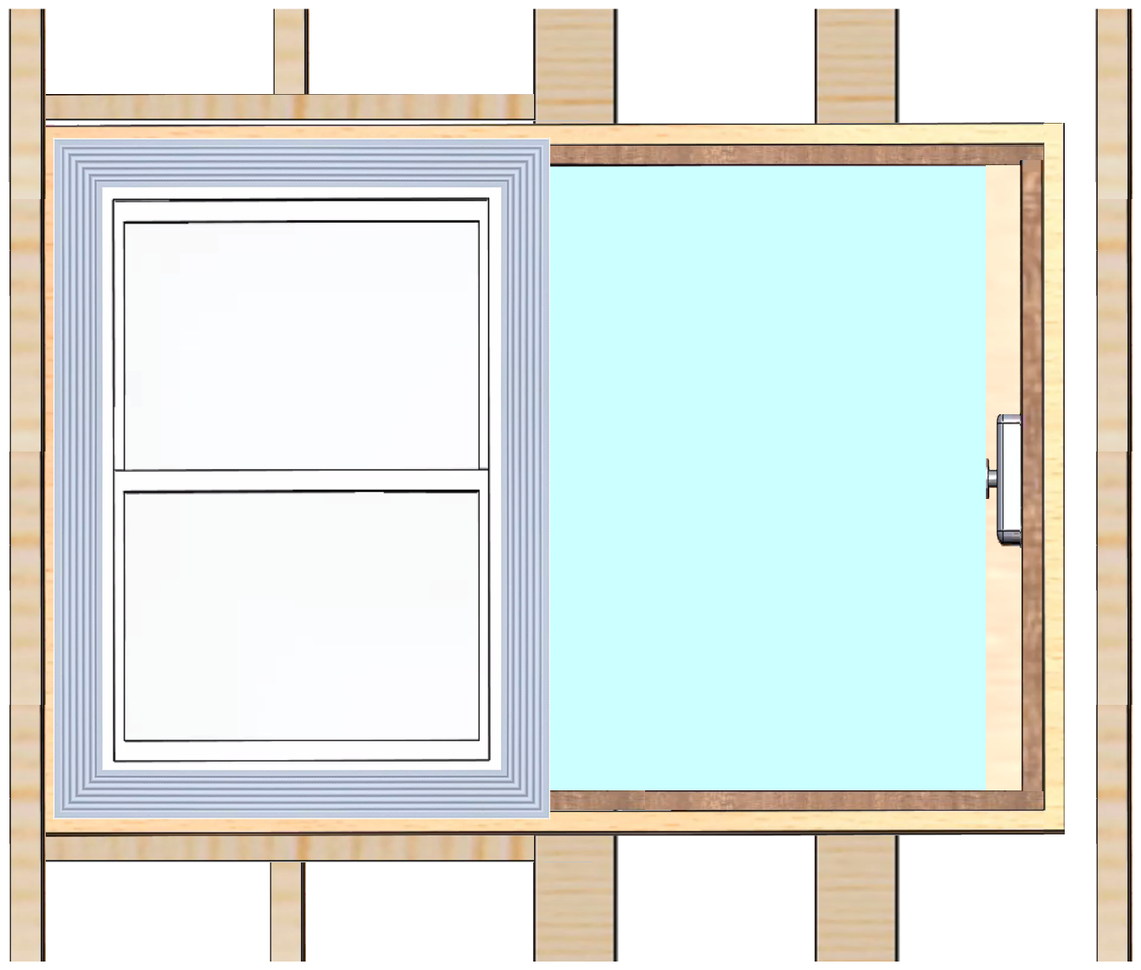
The below illustrations explain how this might work.
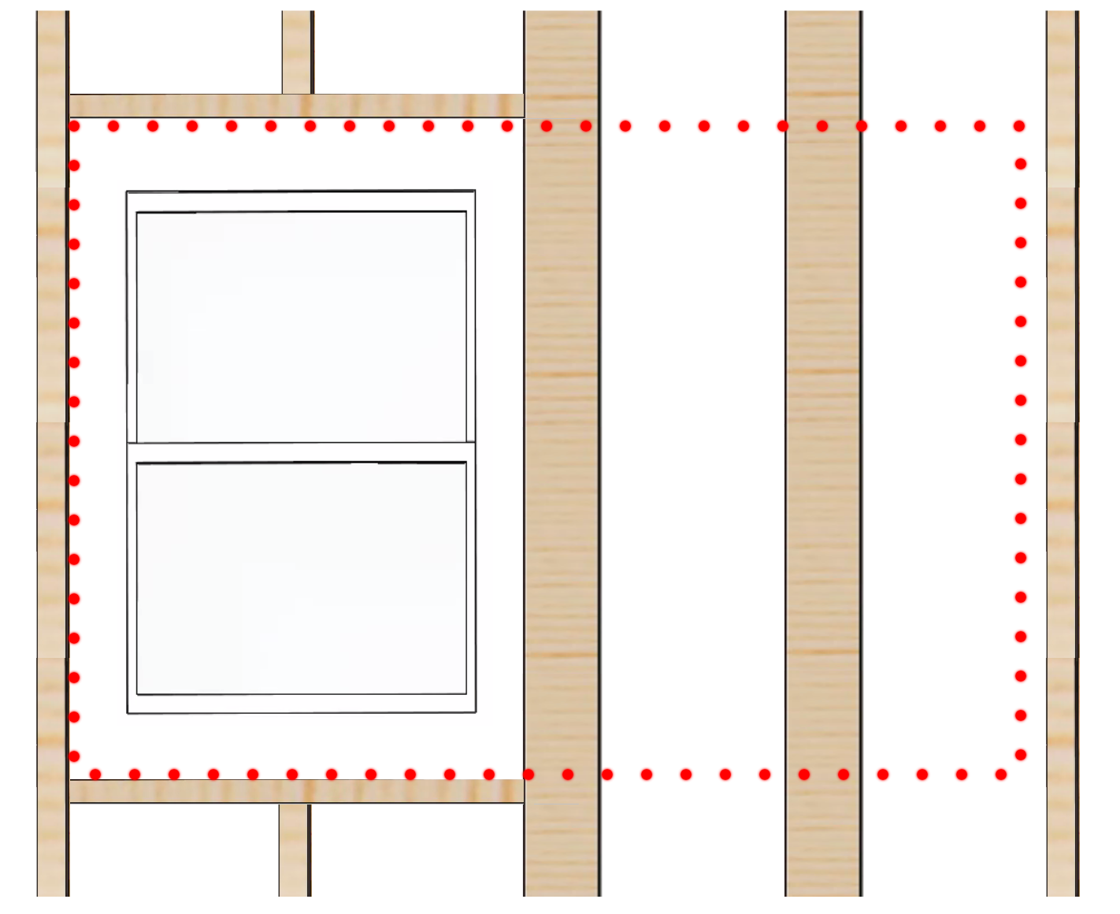 | 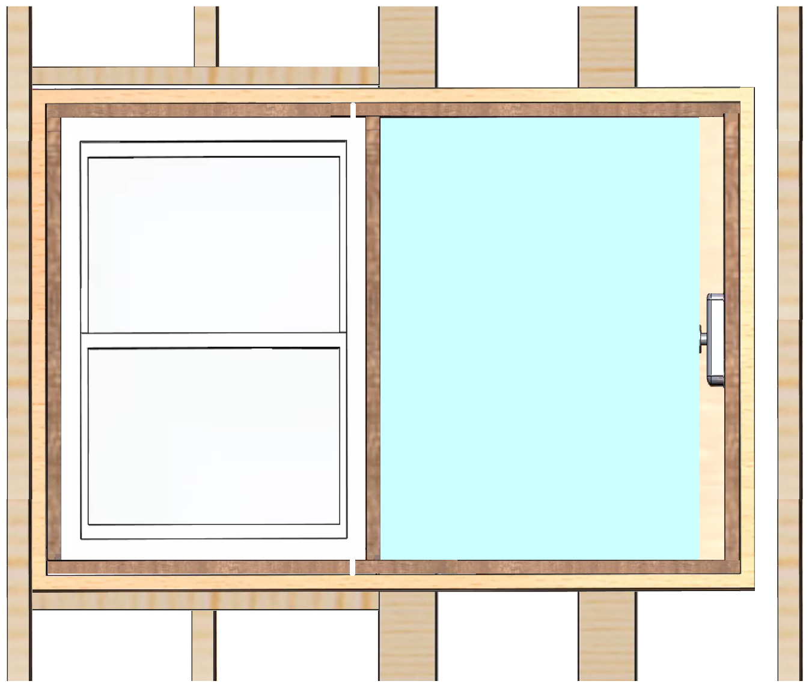
Shown above is wood framing (e.g. 2x6) and window without thermal cover. Framing bears load and is not effected by thermal cover, with the possible exception of rotating several breams by 90 degrees. Window must transfer load from hurricane force winds to framing. Alternatively, thermal cover assembly bears no load, and therefore does not increase framing costs. | Motor and worm-drive moves thermal cover (blue) into stow position behind drywall and out of view. Thermal cover assembly is pressed against drywall while insulation resides between thermal cover and exterior plywood sheathing. Moveable cover is light and therefore involves little force, ensuring safety. Internally, it contains Styrofoam like insulation several inches thick.
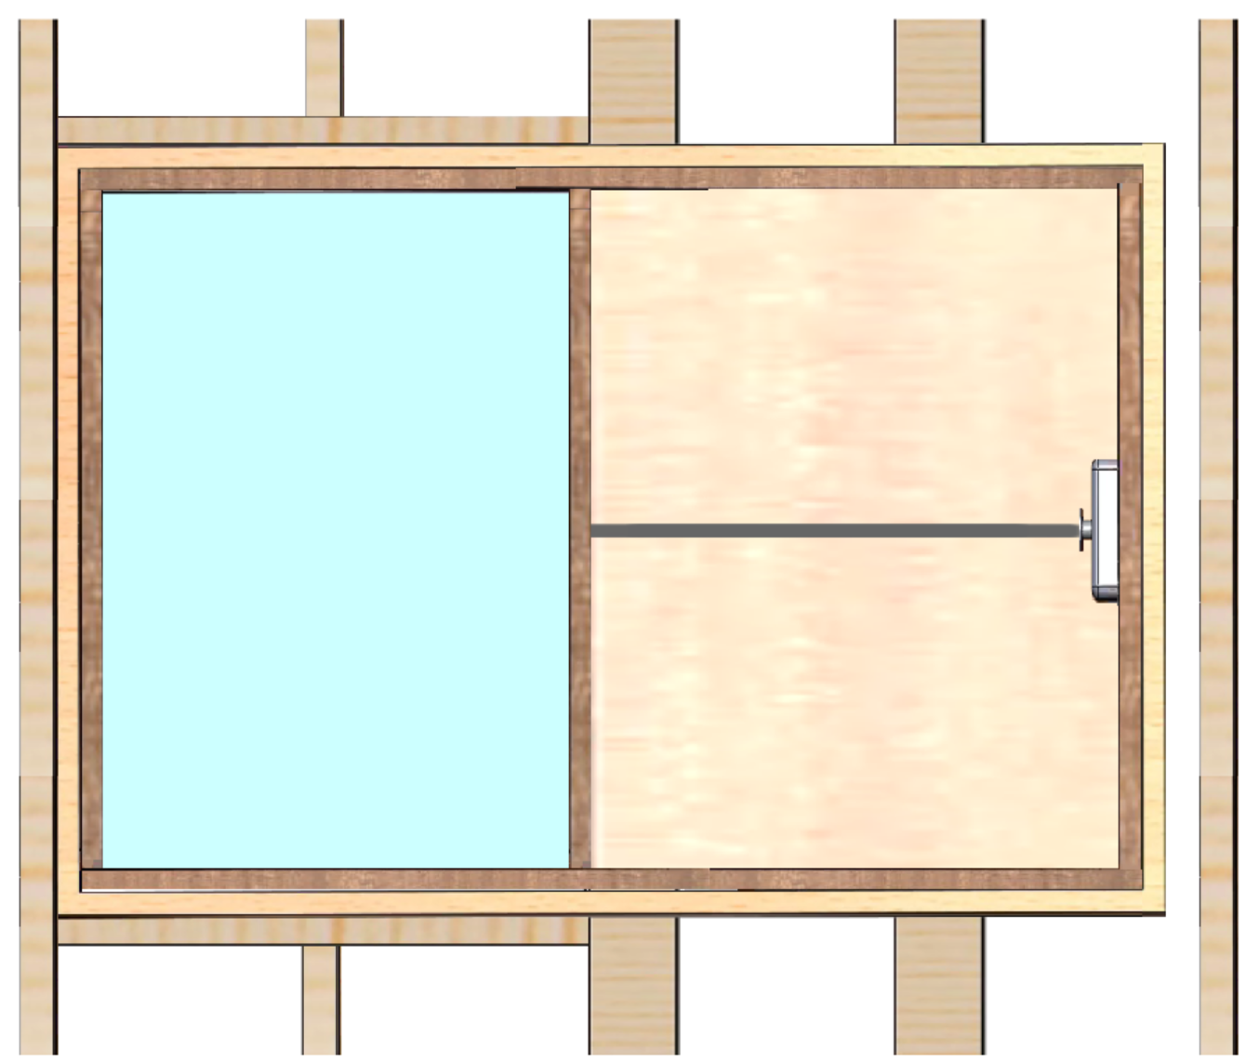 | 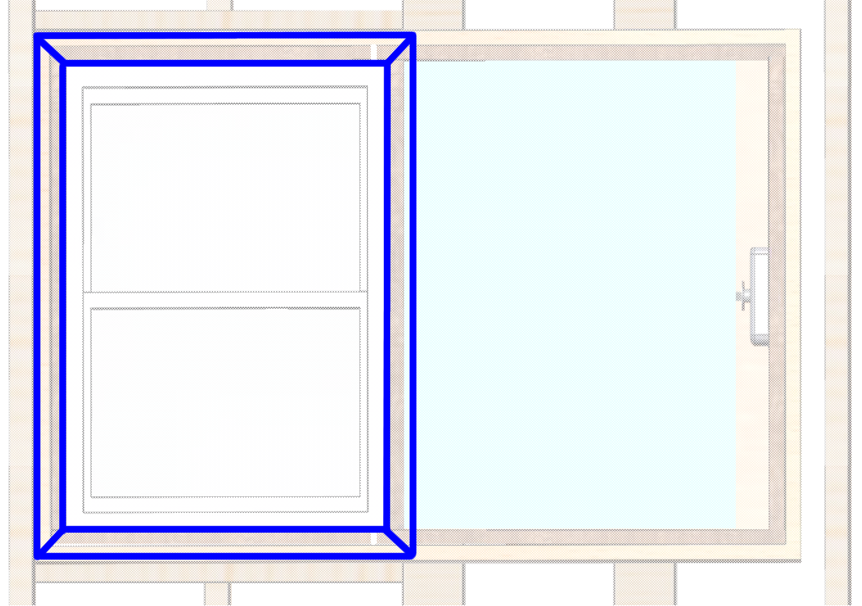
Thermal cover (blue) seals airflow at perimeter via gaskets after being moved in front of window via mechanism. Shown here is worm drive, yet one could use alternative systems such as pulley/cable or linear gear. | Molding (blue) is viewed by occupant and surrounds window opening in a traditional manner. Occupant sees drywall outside this molding.
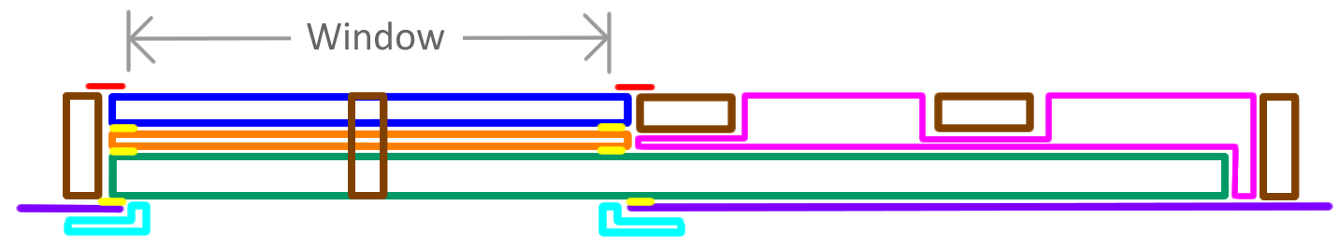 | 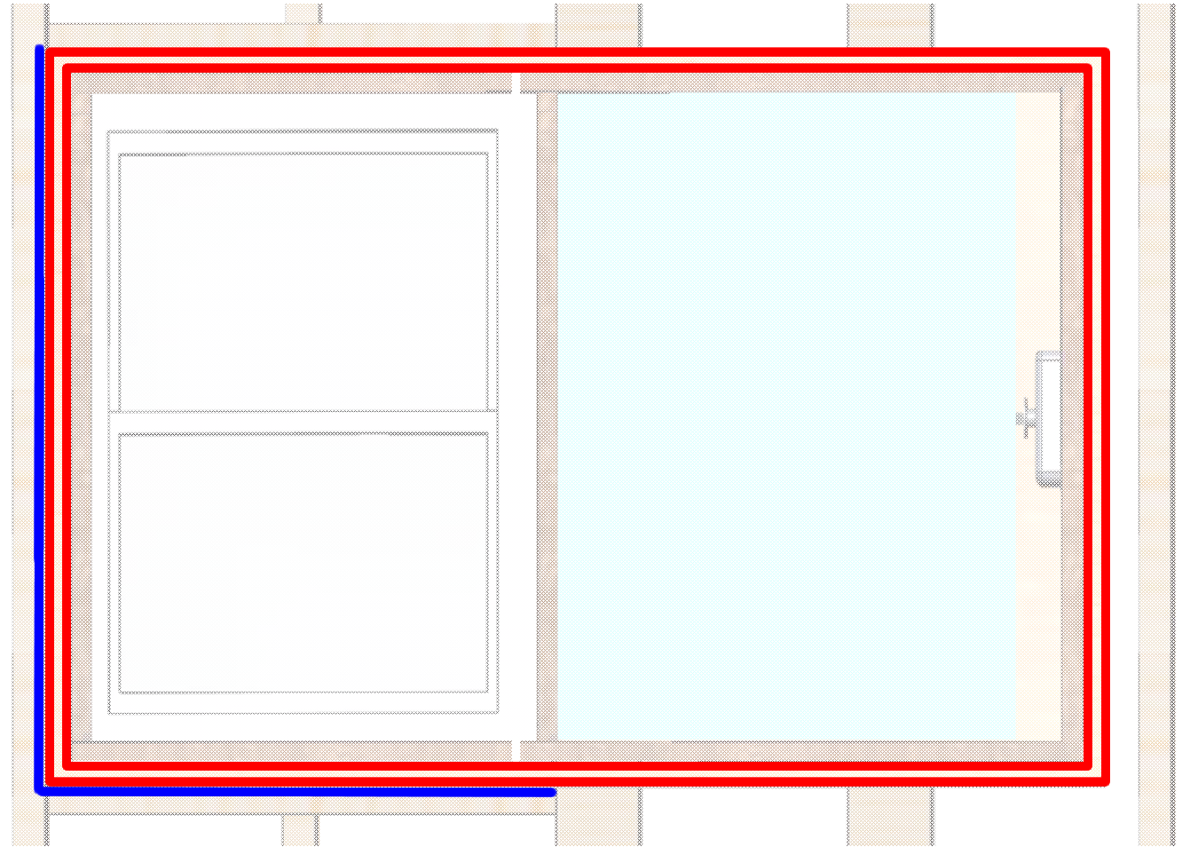
This top view shows window (blue) bonding to framing (brown) via metal plate (red). Thermal cover assembly (green) is pressed against drywall (purple) while insulation (violet) resides between assembly and external sheathing. Carpenter seals assembly via caulk (yellow) to stop airflow from inside wall. Carpenter also installs filler window casing (orange) between assembly and window, where casing thickness is determined by final wall thickness. Final wall thickness is determined by building requirements (e.g. amount of insulation). | Thermal cover assembly outer frame (red) permanently attaches to wall framing (e.g. 2x6) along two surfaces (blue) via fasteners (e.g. screws) and/or glue bond. Everything inside assembly is the "thermal cover product" and is responsibility of thermal cover manufacturer; whereas everything outside is the responsibility of architect and carpenter. Wall framing is accurate to ~1cm whereas windows and window covers are significantly more precise due to internal seals.
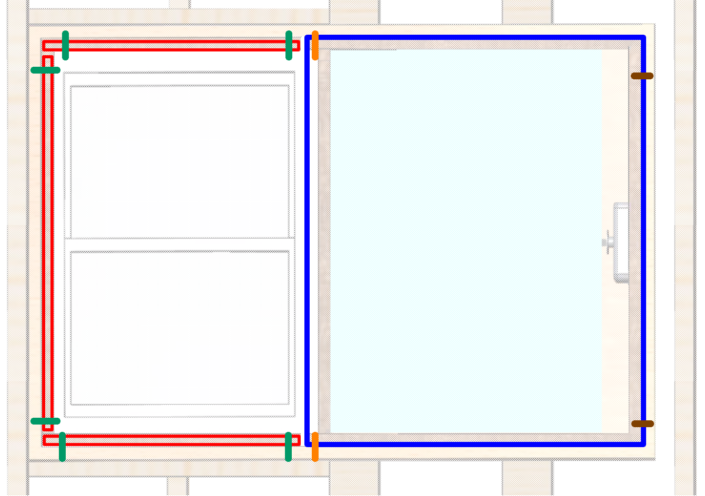 | 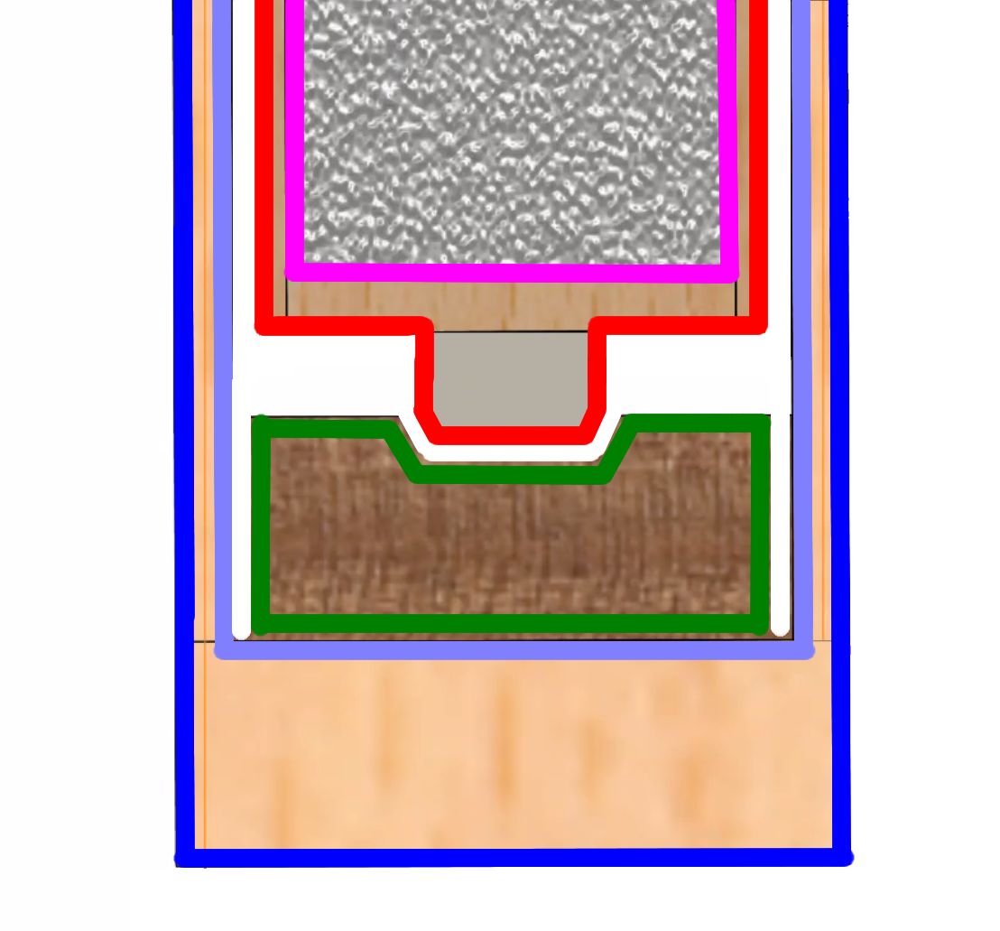
Replaceable plug-in module (blue) slides out after internal rails (red) are removed via bolts (green). Module (blue) is secured by bolts (orange) and pins (brown). Module contains components that will not last building lifetime. This includes moveable thermal cover, motor, worm-drive, electronics and gaskets. Standardization of module sizes ensures compatibility between different manufacturers; which increases access to replacement modules over building lifetime. | This is right side view of lower rail. Styrofoam-like insulation (violet) resides inside moveable cover (red). Thermal cover assembly (blue) and box inside assembly (purple) permanently attach to building. Plug-in module (green) houses cover and supports replacement. Carpenter seals permanent assembly (blue) to wall via caulk; and therefore prohibits airflow from inside wall to room.

Why Does This Not Exist?
Moveable embedded panels within walls are not new; however, we do not see them for several reasons:
- There is a standard way to electrically attach your vacuum cleaner to your living room wall (110VAC outlet), and a standard way to attach your computer to your router (Ethernet); however, there is no standard way to electrically attach a window thermal cover to a building. And multiple proprietary methods are costly for a variety of reasons.
- Mechanical components such as motors and sliding mechanisms typically fail every 10 to 30 years and need replacement; however, a building might last 100 years. And manufacturers are not likely to make a product for 100 years. Subsequently, replacement parts for a propriety system might become illusive over time. If a property is being sold and half the living room thermal covers are not working, and not being fixed, then buyers will consider it to be of less value. And developers, who fund and control the construction of a building, know this. Therefore, they will not embedded propriety gadgets in walls that periodically fail.
- If one wants massive adoption then one would want the savings from reduced energy loss to pay for the thermal cover in a reasonable period of time. Proprietary products tend to not meet this requirement due to high price, especially if sales volume is low.

R&D Challenge #1: Identify Best Method to Electrically Attach To Building
The "Smart Building" initiative discussed previously would provide a standard way to electrically attach a window thermal cover to a building; and solve Problem #1

R&D Challenge #2: Develop Plug-In Module That Supports Replacement
A standardized plug-in module would help solve Problem #2. The design illustrated previously has a removable plug-in module embedded in the wall that contains a moveable thermal cover, motor, mechanism, and electronics. A standards body could establish standard sizes for these plug-in modules. For example, one might have sizes 3ft x 32" x 3", 4ft x 32" x 3", and 5ft x 32" x 3". Architects would then have the option of pairing with common window sizes. The beauty of mechanical standardization is it addresses both Problem #2 and Problem #3. The disadvantage is it pushes architects to consider fewer window size options.

Example Proposed Standard
The above design supports standardization by specifying several parameters for each of several sizes: assembly frame thickness, assembly frame internal height/width (red), placement of bolts that secure internal removable rails (green), placement of bolts that secure plug-in module (orange), and placement of pins that secure module to right side (brown).
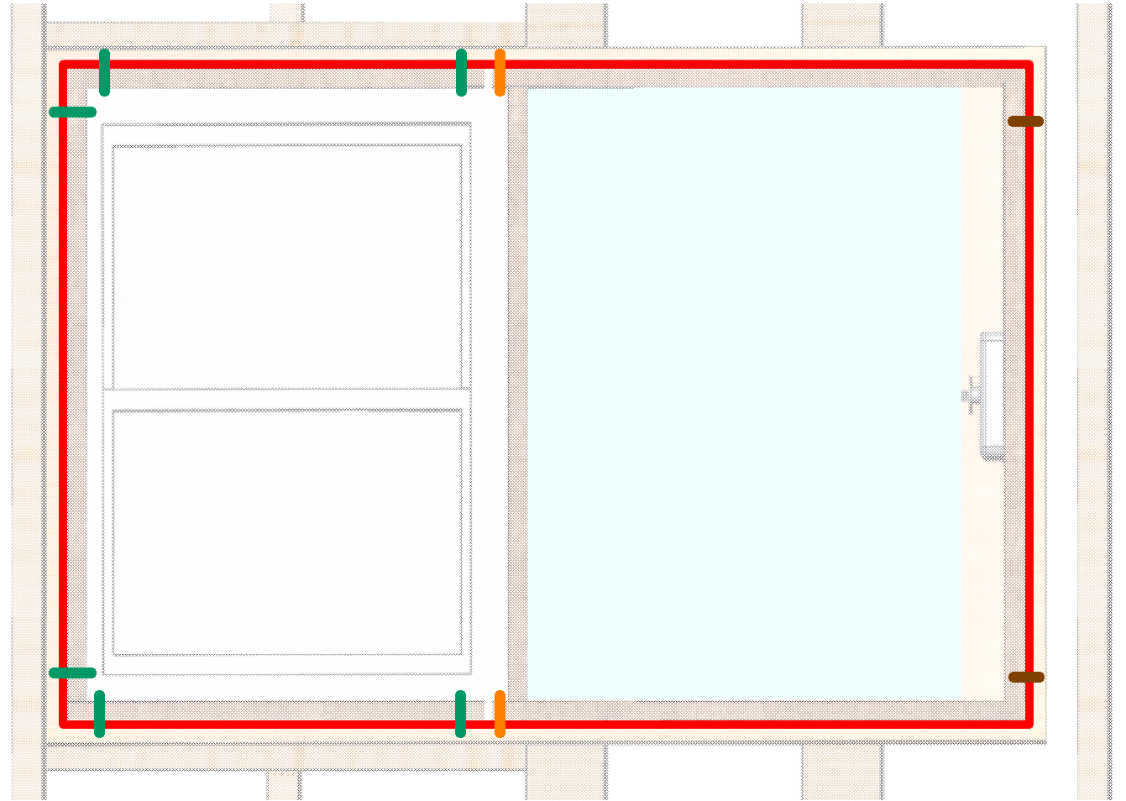
This means any product that meets these requirements will plug-and-play into an existing frame. Replacement gear consist of one plug-in module and three removable rails. Subsequently, manufacturers control: entire contents of module, gaskets, mechanics, motor, electronics, and different thermal designs.
Manufacturers might offer different levels of quality at different prices.
Over time, thermal properties might improve due to innovation. For example, one might utilize vacuum insulation to provide high thermal insulation at low thickness. Theoretically, internal electronics could power a small pump.

R&D Challenge #3: Reduce Cost
If we look at the amount of material within a window thermal cover, we see much less relative to the typical window, since the typical window needs to resist hurricane force winds, and must seal airflow under high wind pressure. Alternatively, an internal cover can be made of light materials that involve little force. Internally the thermal cover contains Styrofoam-like insulation, it seals on all four sides with gaskets similar to a window, and it includes shiny metal surfaces on both sides that reflects radiation.
Mechanical standardization drives down price via commoditization since it entails multiple companies with low R&D costs who compete on price.
In order to gain mass adoption, one would want parts and labor costs to be paid for with energy savings over a reasonable period of time. This is a bit complicated, since energy costs vary from region to region, and over time.

R&D Challenge #4: Block Visible Light, Infrared Radiation and Heat Radiation
If one places a frypan on a stove, heats it, holds it in air with one hand, and places the other hand below the pan five inches away, they will feel heat against the lower hand. This is not due to convection air currents, which is what you feel with your hand above the pan, since heat rises. The heat you feel below is called "heat radiation" or "black body radiation", and is an import component of energy loss through windows.
If you place your hand in the sun and feel warmth, then approximately half is from visible light radiation and the other half is from infrared radiation. These are similar, yet differ in frequency.
If you place your hand in front of a camp fire and feel warmth, you are mostly feeling infrared radiation.
The thermal cover's job is to block all three of these, since they are all energy. A shiny metal surface, such as aluminum foil, reflects visible, infrared and heat radiation. One would want shiny metal on both external and internal thermal cover surfaces to minimize energy loss.
Styrofoam-like insulation has ~R6 insulation per inch of thickness, and a typical window has ~R3 total. If you want your covered window to be the same as the average American wall at R16, you would need your thermal cover to be ~2 inches thick (2 x 6 + 3 = 15).
Alternatively, one might consider a rolled cover above a window and embedded in the wall. This could move down over the window like a rolled blind. However, it would only support thin material and sealing airflow at edges might be illusive in a gravity fed system.

R&D Challenge #5: Overcome Homeowner Resistance
It is probably impossible to satisfy a homeowner's sense of aesthetics with a thermal cover since they typically enjoy window views and outdoor light. The easy solution is to automatically retract when room is unoccupied. Subsequently, the homeowner is not forced to observe shiny metal panels in their living room.
Automation could cover windows during the winter provided the following conditions were met: room is unoccupied, outdoor temperature is colder than desired room temperature, and the sun is not shining on window. Or cover windows during the summer when the room is unoccupied and the outdoor temperature is warmer than set point.

Passive Heating
There is a technique called "passive heating" that entails sun shining through a window, heating the floor, and subsequently heating the building. However, this must contend with heat loss through glass when sun sets, and is therefore not popular. Window thermal covers could change this, and cause architects to rethink passive heating, especially in climates conducive to this technique.

Parameters That Characterize Thermal Cover System
Multiple parameters characterize each window thermal cover: embedded in new construction wall or external and supporting attachment to existing construction, building type, window type, cover is flat ridged panel or rollable, reflective or absorbing surface, thermal conduction R-factor, parts cost, and installation labor costs.

Design Problem
Assignment for researchers:
Develop multiple free and open window thermal cover systems, where each is characterized by above parameters. Propose mechanical plug-in standards that support replacement over building lifetime. Attach to building wiring and network via Smart Building initiative, described previously. Support plug-and-play to reduce installation and design costs. Calculate cost models, perform thermal analysis, and build simple prototypes. Propose standards that define how components plug-and-play together, including mechanics, electronics, and communications.

Summary
In theory, window thermal covers in new construction should be economically feasible; however, we do face multiple obstacles. This includes mechanical plug-in module standardization, electrical interface cable standardization, and software standardization. In summary, we need to plug-and-play to reduce cost. The good news is developing several standards cost little money.

See Also
For an example of free and open window thermal cover research, click here.

Standardized Articulating Arm
The world needs to update existing structures and build new structures; however, this is not being done fast enough due to cost. What can we develop to increase automation and therefore reduce cost? An example would be to develop technology that supports standardized attachments for an automated articulating arm, illustrated below.
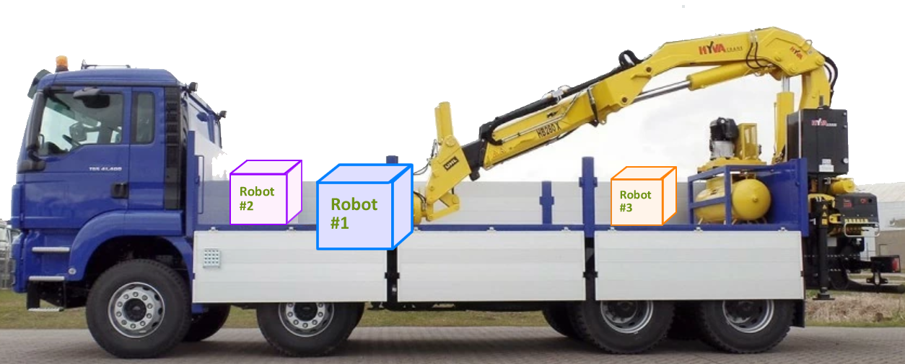
Pictured below is a tool exchanger for a milling machine, which utilizes one tool at a time. A similar approach at a construction site could be used to reduce the cost of construction and upgrade projects (e.g. add solar panels to roof and wall surfaces).
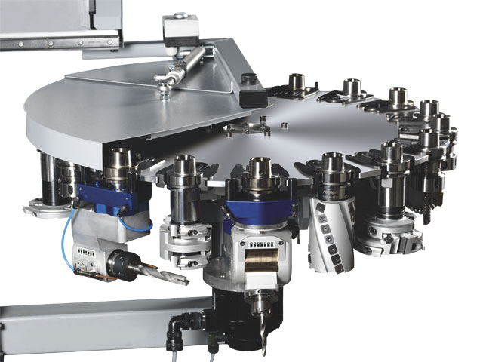
In theory, researchers could develop the following technologies until not too big for private companies to participate.
- Automated access to architectural drawings.
- Automated access to street and UAV photography.
- Laser scanning of site and structure to better understand position of features.
- Image processing of video to guide system.
- Mechanical stabilization to keep tool steady given wind and other destabilizing forces.
- Standardized socket between arm and tool that coordinates products from different companies.
- Standardized communication between different components.
- Design of multiple specialized tools (e.g. tool that automates solar panel installation).

Design Problem
Assignment for researchers:
Develop free and open technologies that support automated truck-mounted articulating arm systems. This includes coordinating machine with existing data, decision making (AI), laser/video/photography, mechanical stabilization, feedback/control, design of specialized attachments, and user interface. Propose standards that define how components plug-and-play together, including mechanics, electronics, and communications.

Automated Marketplace
If one looks at raw material cost for a solar carport, example pictured below, they will find it small relative to total. Total includes things like labor and customer acquisition. Raw materials include things like solar panels and steel. The commodity price of steel is ~$0.40 per LBs and the commodity price of solar panels for an enormous 24 x 24ft solar surface is ~$3K, for example ($0.22/Watt, 12KWatts, 200W/m², 40 panels, 64m²).
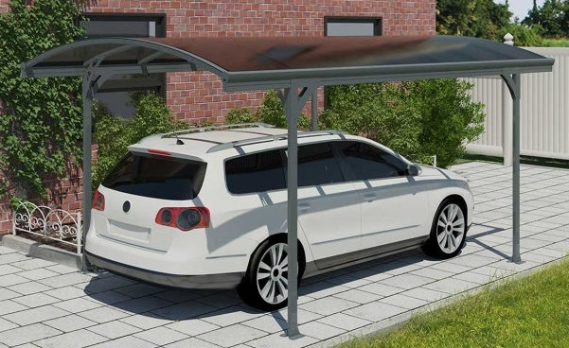
Customer acquisition involves home owner calling multiple suppliers, visiting with several, and selecting one. This means supplier sits in traffic while listening to Howard Stern, travels to client, discusses project, prepares quote, and then has client select a different supplier. This cost money and is added to the cost of a different project, since businesses ultimately pay for all expenses with money received.
The question is, "What can we do to reduce the cost of projects that reduce CO₂?" One solution is to automate the design, customer acquisition, contract management and permitting process. Doing this falls under the broad category of "automated marketplace". Examples are Uber, Airbnb, and Xometry.
In theory, one could have an automated marketplace for ground source installation, HVAC upgrade, solar installation, carport installation, etc. However, these do not exist, primarily due to missing technologies. For example, one might need automated access to: architectural drawings, underground infrastructure drawings, UAV photography, and laser scans of existing structures.
Computer science researchers can implement automated marketplaces in software without leaving their desk. They can build software prototypes and disseminate source code free and open, enabling others to build on their work. Researchers can develop subsystems until companies are comfortable putting in their own money.

Design Problem
Assignment for researchers:
Create automated marketplaces that install and maintain systems that reduce CO₂ emissions. Build prototypes and develop ancillary technology (e.g. user interface software that creates list of custom solar shapes given architectural drawings). Researchers assume $100M to $1B is available to deploy large and complicated automated systems; however, they are not responsible for deployment. Instead, they focus on writing free and open software, building prototypes, and making it easier for others to deploy. Researchers also propose standards that define how components plug-and-play together, to coordinate multiple companies.

Automated Access to Building Data
Many automated construction systems and marketplaces would benefit from automated access to architectural drawings.
The placement of windows and doors might only be accurate to +-1cm relative to drawings; therefore, to improve accuracy, one would also want to scan buildings via laser, video and/or photography. Software could then identify things like trees, telephone poles, power wires, driveway, windows, doors, etc. To wrap building surfaces with custom solar, one would need to know positions of things like windows, doors, and chimneys accurate to ~1mm.
In theory, one might scan all building surfaces with laser/video/photography via UAV, similar to how google photographs all buildings in Street View. To reduce privacy concerns, views of people and window glass could be redacted.
If all data resides on a centralized server and automated systems have access, then much could be done to reduce the cost of building construction and upgrade projects.

Design Problem
Assignment for researchers:
Create free and open UAV-based systems for scanning building surfaces. This includes controlling UAV, recording data, analyzing data, calculating position of building features, storing data in centralized server, and providing access to responsible parties. Researchers write software, build simple prototypes, and scan a small number of buildings. National deployment would be left to others.
Create free and open centralized system for storing architectural data. Provide access to responsible parties. Currently, each city controls this data via an office of deeds. The new centralized system would support concurrent operation with city system, or replacement. If concurrent, one would support new data entry only from legacy system, only from new system, or both. If legacy and new operated in parallel, one might read data from either.
Do something similar to the above yet with data that describes underground infrastructure. This would help with things like automated ground source installation and horizontal drilling for utilities.
Researchers propose communications and data standards as needed.

Big Solar Architecture
Below is an example big solar design by architect John Meyer. In this concept, roof is covered with solar, edge to edge, and is elongated two-to-one as noted by the red and violet lines. The garage incurs the same treatment. Subsequently, we have 2000 square feet of solar and 2000 square feet of floor space. This one-to-one ratio is unusual today, yet might become more common in the future.
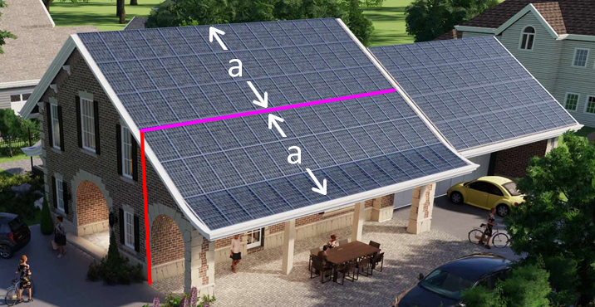
Zero energy buildings entails generating energy on-site. This means we are looking for a high ratio of solar PV to floor space. A ratio of one square foot of solar for each square foot of floor space, illustrated above, is three times more than your typical solar installation. Below are several concepts. Notice we are thinking "out of the box" and going beyond traditional design.
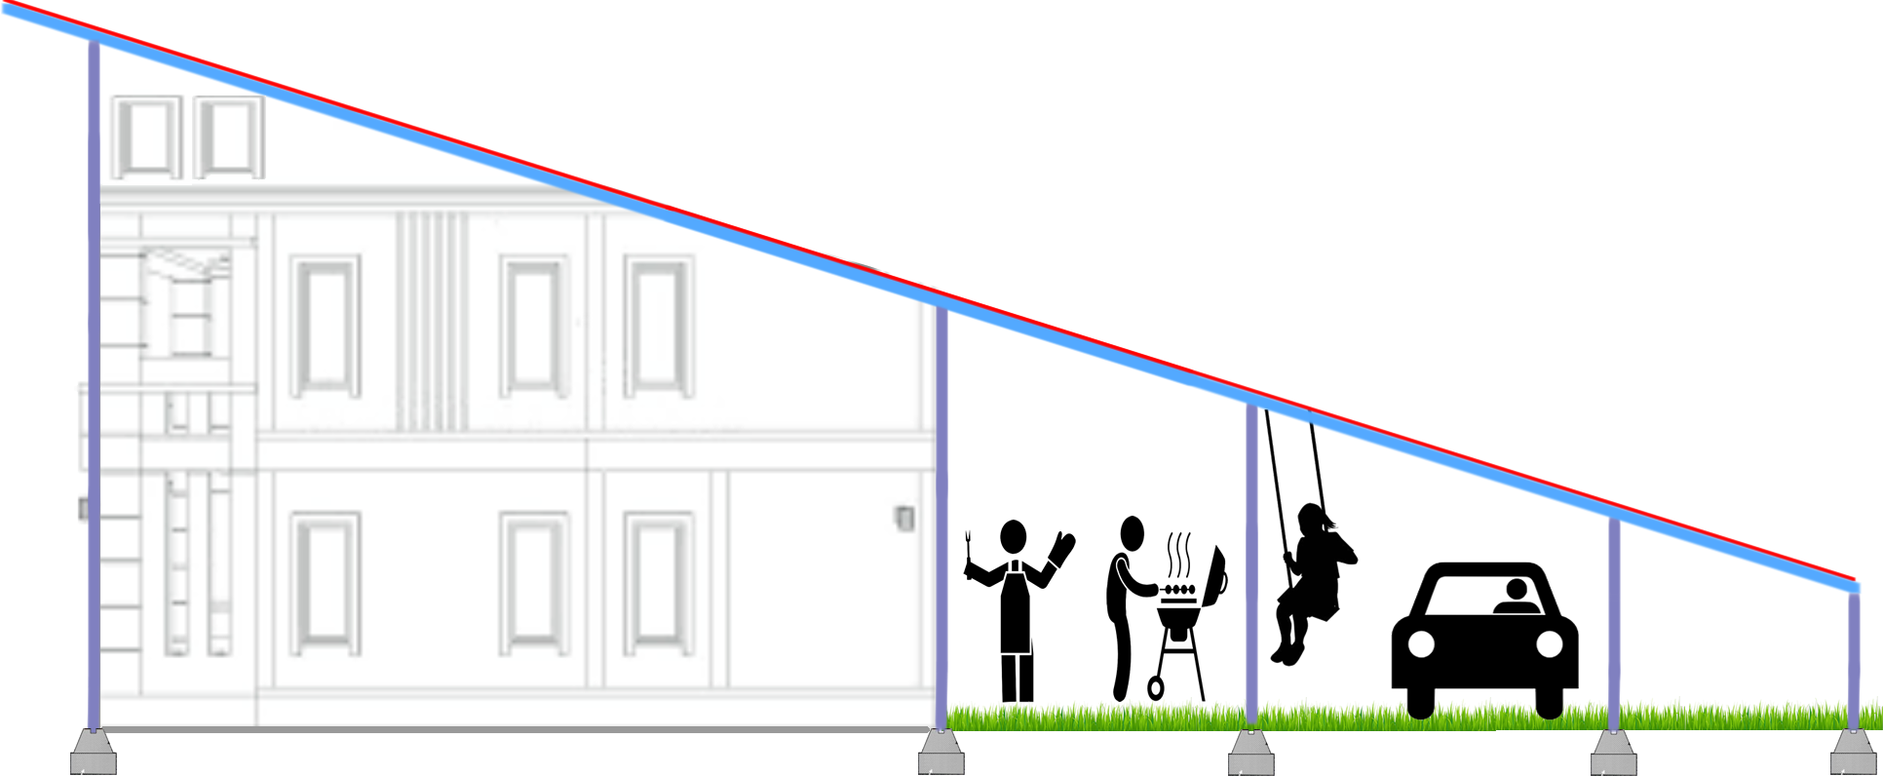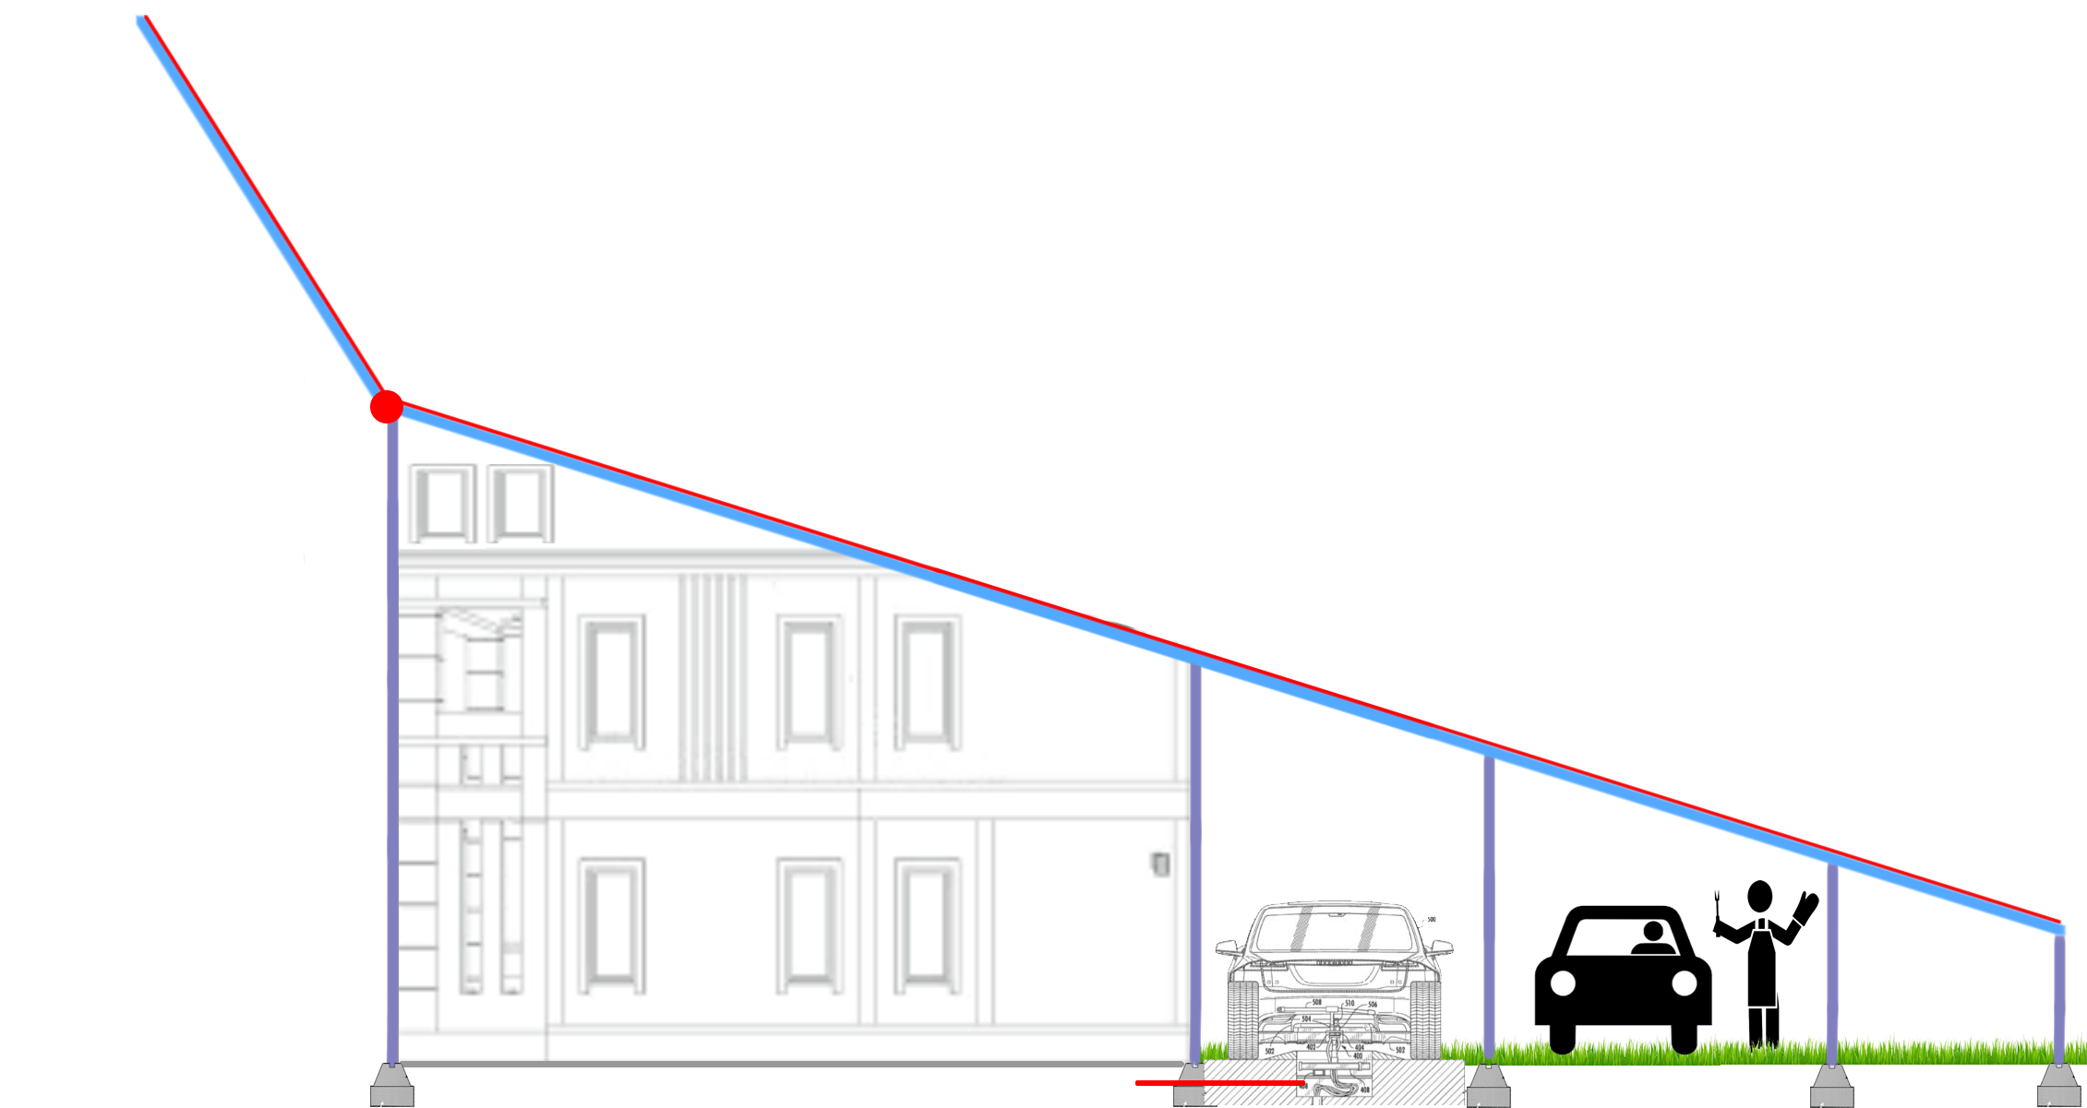
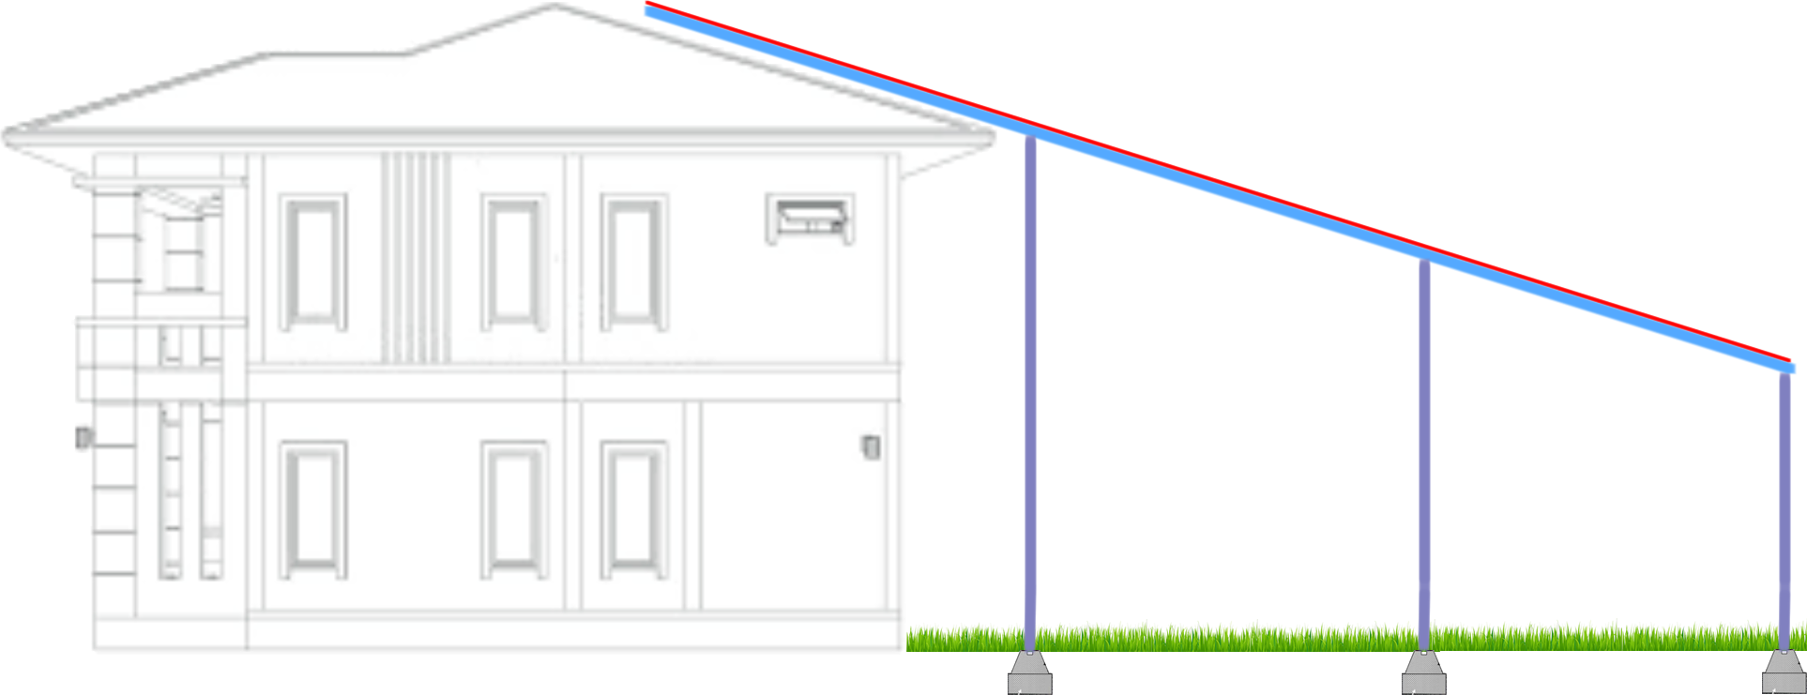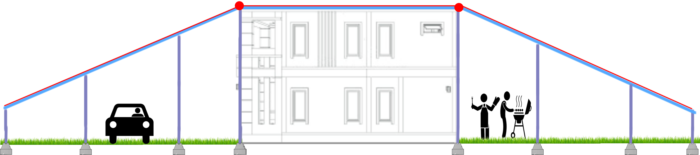
Existing construction can mount solar on roof and potentially make use of land, possibly behind the building, as illustrated above. Alternatively, new construction can more easily dedicate large surfaces to solar and integrate them into building design.
If a building claims to be "green" yet has many windows, it is probably not too green. Developers like glass because it is gorgeous, and gorgeous often gets priority over green. Gov't regulators could potentially apply pressure to reduce glass, yet this is not popular in many regions. Window thermal covers embedded in wall is one possible remedy, described in this document.
Wind traveling 100mph applies 50 Lbs. per square foot to a surface. If you have a 40 x 30 ft surface for example, this works out 60K Lbs. (50 x 40 x 30). Sustaining high wind loads, at reasonable cost, is an important consideration.
One option is to place solar on moveable panels that are stowed during high winds, pictured above upper-right. One would want these to be fault tolerant. For example, wind pressing on a moveable panel with failed power and failed motor might be pushed by wind into a stow position and locked down via springs.
Providing big surfaces for solar, at reasonable cost, and able to sustain weather over many years is a challenge for architects and engineers.

Parameters That Characterize a System
Multiple parameters characterize each solar PV support system: new construction vs existing construction, building type, attach directly to building surface or attach to structure near building, solar PV is fixed or tracks sun, and support structure is stationary or pivots.

Design Problem
Assignment for researchers:
Develop multiple low cost methods of providing large surface areas for build-based solar PV. Design systems where each is characterized by above parameters. Assume $100M to $1B is available to develop complicated machines that fabricate, install and maintain custom components. Assumptions: architectural software generates list of custom components that wrap building features, custom components are fabricated in factory, and installation is automated via specialized machines. Propose standards that define how components plug-and-play together, including mechanics, electronics, and communications. Do all development except full design of machines.

Consolidate Building Complexity into Factory-Made Modules
If we increase building complexity via automation (e.g. thermal storage water) then we can reduce CO₂ emissions. However, this will not be popular if expensive. Therefore, the challenge for researchers is to figure out how to increase complexity without increasing cost. This might sound impossible, yet may be feasible by consolidating complexity into factory-made modules that drop in via crane.
Installing individual components in the field, one at a time, is very costly; therefore factory made modules might be the only way to maintain reasonable control costs while increasing complexity.
Below is an example approach for a two story residential home with basement:
- All energy intensive hardware is physically consolidated into 3 small utility rooms that are stacked on top of each other (e.g. 8 x 10ft). One accesses each via a door. We call these "Energy Cores" (EC).
- A tank of water in basement stores heat and/or cold. For example, solar heats water during the day, and water heats house at night.
- A ground source supplies cold to the house via pipes that route to underground ~60°F soil. This significantly reduces both cooling and heating energy consumption via a Ground Source Heat Pump (GSHP).
- Energy intensive appliances back up against the EC wall. This includes oven, washer/dryer, dish washer, and refrigerator. Researchers consider standardized ports that integrate appliances with EC utility room. Interface includes things like electrical power, wired Ethernet, domestic hot/cold water, 60°F ground source water, thermal storage water, and heat pump airflow.
- Faucets, drains, air vents and HVAC radiators share wall with EC room.
- Stacked EC rooms contain: heat pump, water thermal storage tank, domestic hot water tank, ducts and pipes, electrical wiring, internet modem and Ethernet router. Air ducts and HVAC piping are kept short since they are consolidated into a small space; reducing energy loss.
- Fully loaded modular EC rooms, held together with metal or wood framing, drop in via crane.
Researchers design examples of how energy cores might be implemented and propose mechanical, electrical, communications, and piping standards that define how the various pieces fit together in a plug-and-play manner.

Design Problem
Assignment for researchers:
Design factory-made modular components that consolidate building complexity. Write software that automates component design and coordinates internal systems; and build simple prototypes. Develop and propose standards that define how components plug-and-play together, to coordinate multiple companies. This includes interface between large appliances and factory-made modules (e.g. washer and dryer, refrigerator, dish washer). Researchers assume $100M to $1B is available to develop machines that customize, fabricate, install and maintain. However, researchers are not responsible for these machines, and instead focus on systems development and plug-and-play standards development.

Next Generation HVAC
One can reduce HVAC energy consumption with more control. One can get control with $3 microcontroller IC's in physical devices networked together with reliable communication. Devices include:
- motorized dampers inside ducts
- motorized dampers at vent openings
- fans inside ducts
- motorized valves at radiators
- pumps that moves 60°F water from ground source into radiators and heat exchangers
- pumps that move water from thermal storage tank in basement into radiators and heat exchangers (water heated or cooled via solar when sun shining)
- sensors (occupancy, indoor/outdoor temperature, sun, wind pressure)
With the above technology, one can:
- more precisely control airflow from central HVAC fan
- move air from one room to another room while HVAC is off (e.g. move cool air from basement to warm office on 2nd floor without turning on central HVAC)
- route ground source 60°F water as needed
- route thermal storage water as needed
- integrate large appliances, thermal storage water, ground source 60°F water, and central HVAC
Devices with processors exist, yet we are not doing the above due to:
- a standard way to electrically plug the above devices into a building does not exist
- a common operating system for all devices that supports plug and play and reliable integration does not exist
- standard physical plug-in modules with fans and dampers does not exist
Standardization reduces cost via commoditization. Plug and play reduces cost via less design and installation labor.
One would want a system whose additional cost is paid for with reduce energy bills within a reasonable period of time. If researchers can do this, then mass adoption becomes feasible.

Standard Plug-In Fans and Motorized Dampers
If one places a proprietary damper or fan in a duct and it fails every 15 years while the building lasts 100 years, and the manufacturer stops production after 5 years, then the building will degrade in value due to difficult to obtain replacement parts. The only way to resolve this is to make use of standardized plug-in modules at vent openings.
For example, to replace a fan or motorized damper within a duct, one would remove the vent cover, reach into the duct, remove ~4 bolts, unplug the module, remove through vent opening, and replace with new standardized module, plug-and-play.

Motorized Damper Module
Below is an example of a motorized damper module. This attaches to a bracket via 4 bolts, and the bracket is spot welded to the duct wall. One positions this near a vent opening to support replacement. These would be available in standard sizes which match standard ducts sizes; and standardization would allow one to replace with units from different manufacturers. One could place this in-line to control duct airflow; or place in the channel between duct and vent to control air into one room.
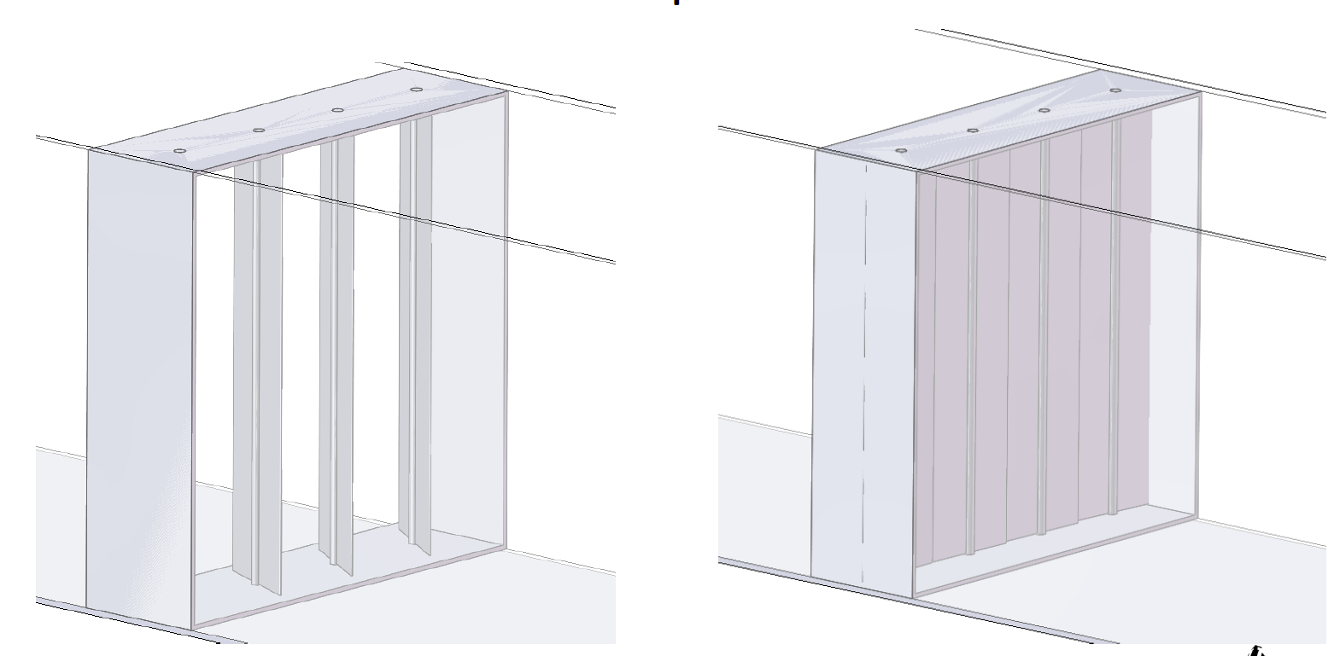

Pivot Fan in Duct Module
Shown here is an example of a pivot fan module which either resides in a storage position while the central HVAC fan controls air; or pivots to an in-line position. If deployed, it can either act as a booster fan while the central HVAC fan is on; or it can move air between rooms while the central HVAC fan is off. A powerful fan might shake; therefore one would need to secure to a hefty bracket that attaches to wood framing (e.g. 2x4) in the wall. Like the above motorized damper, this would be available in standard sizes and it would support replacement near a vent.
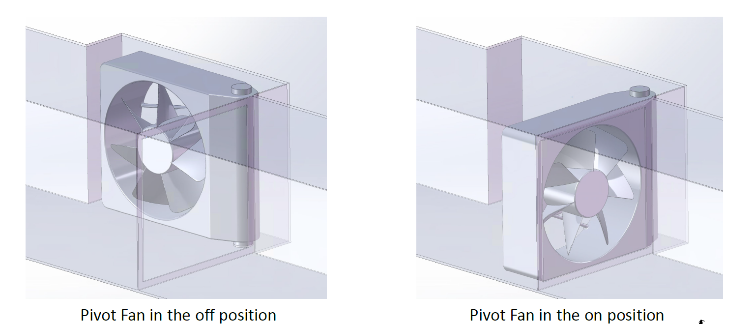

Example Fan Module
Below is an example of a replaceable fan module.
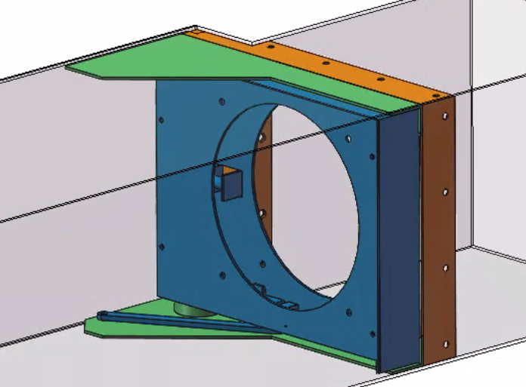 | 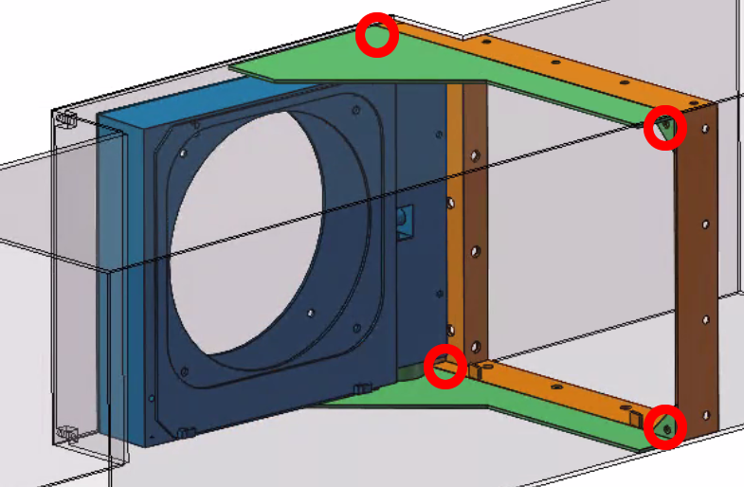
Bracket (orange) is spot welded to duct and attaches to module base (green) via 4 bolts. Circular fan (not shown) mounts within pivot assembly (blue). Replaceable module consists of base (green) and pivot assembly (blue). HVAC designer places this near vent, to allow access during replacement. | Module pivot assembly (blue) is shown here in storage bump-out position, possibly between wood wall framing (e.g. 2x4). During storage, only a small amount of central HVAC air is obstructed. Bolts (red) secure bracket to module base (green), supporting module replacement.
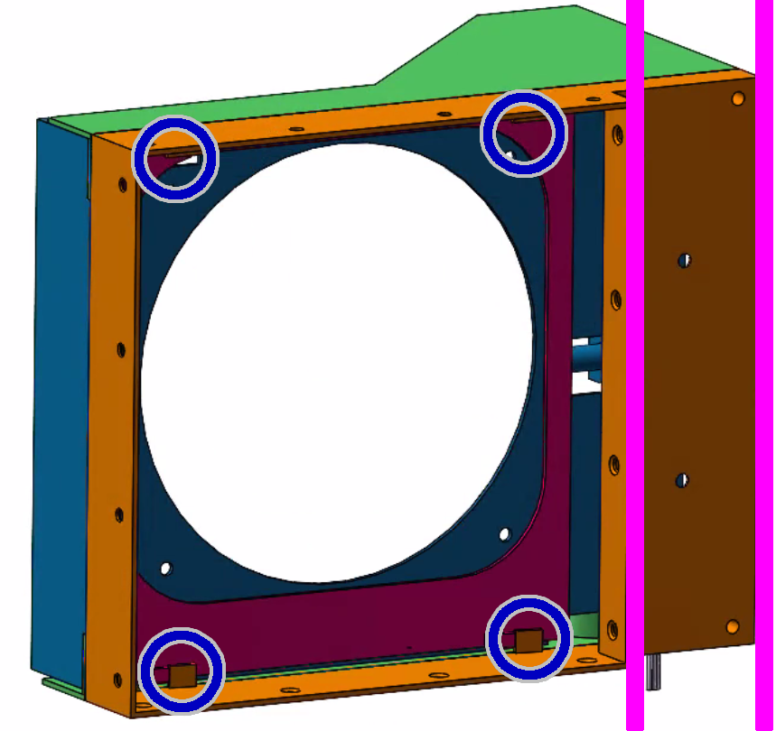 | 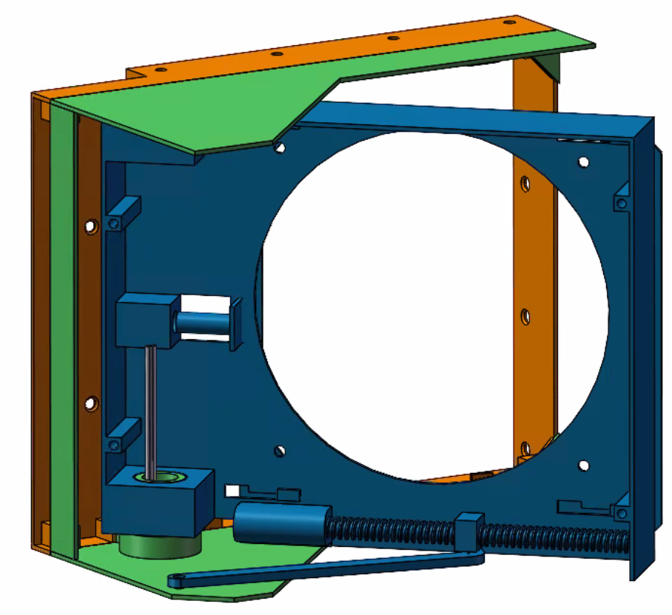
Bracket (orange) secures to wood framing (violet) outside of duct. Fan vibration is transferred from fan to pivot assembly, to bracket, to wood wall framing (e.g. 2x4). Pivot assembly (blue) secures to bracket via sliding locking plate (burgundy) to reduce vibration. | Mechanism rotates pivot assembly (blue) 90 degrees and slides locking plate (on reverse side, not shown). Designers are proposing these to be made in standard sizes, to support replacement by multiple companies over building lifetime.

Example Motorized Damper
Below is an example of a replaceable damper module.
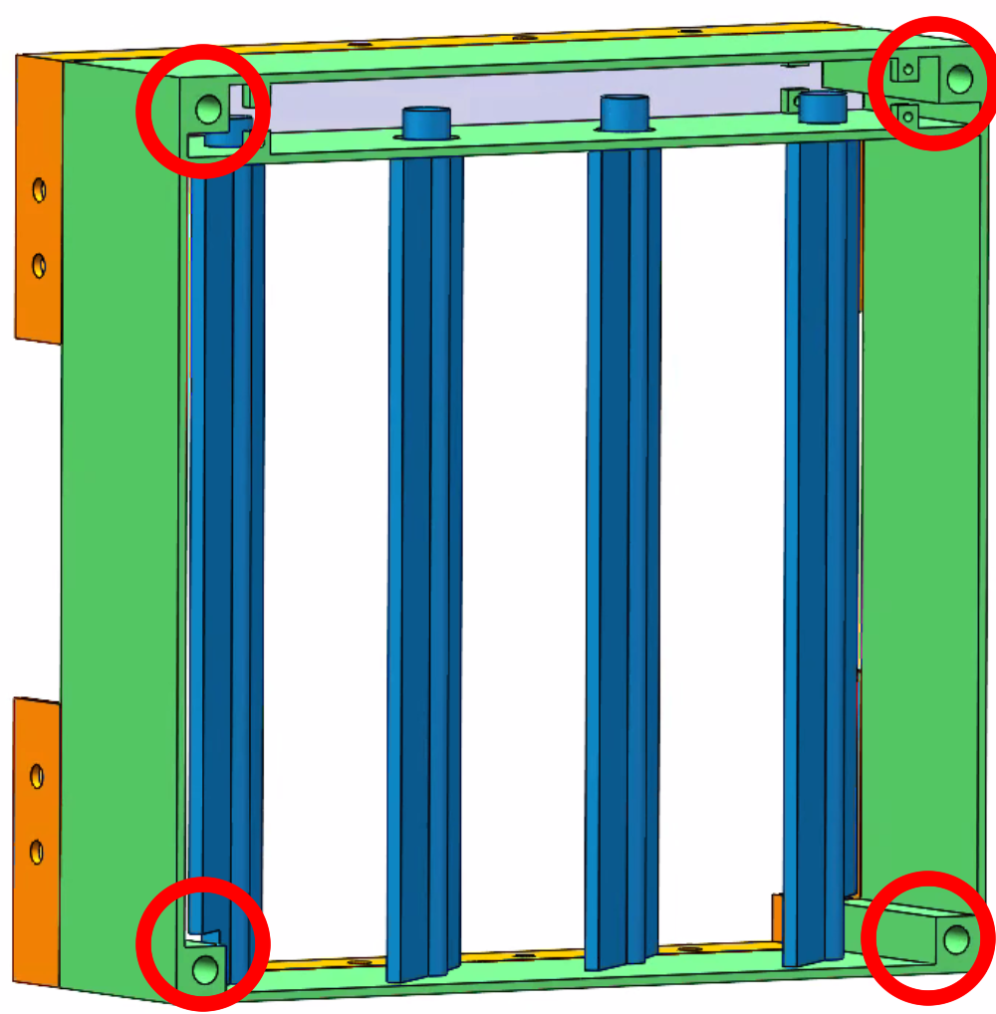 | 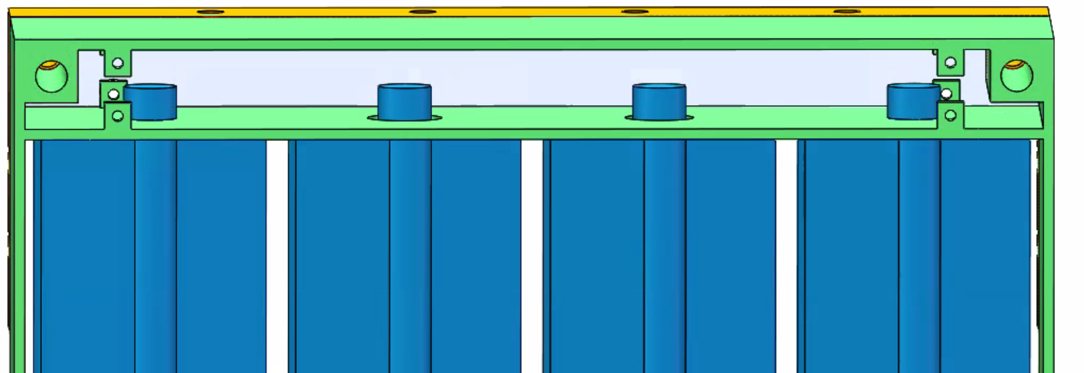
Bracket (orange) is spot welded to duct and attaches to replaceable plug-in module (green) via 4 bolts (red). | Motorized mechanism (not shown) controls damper opening.
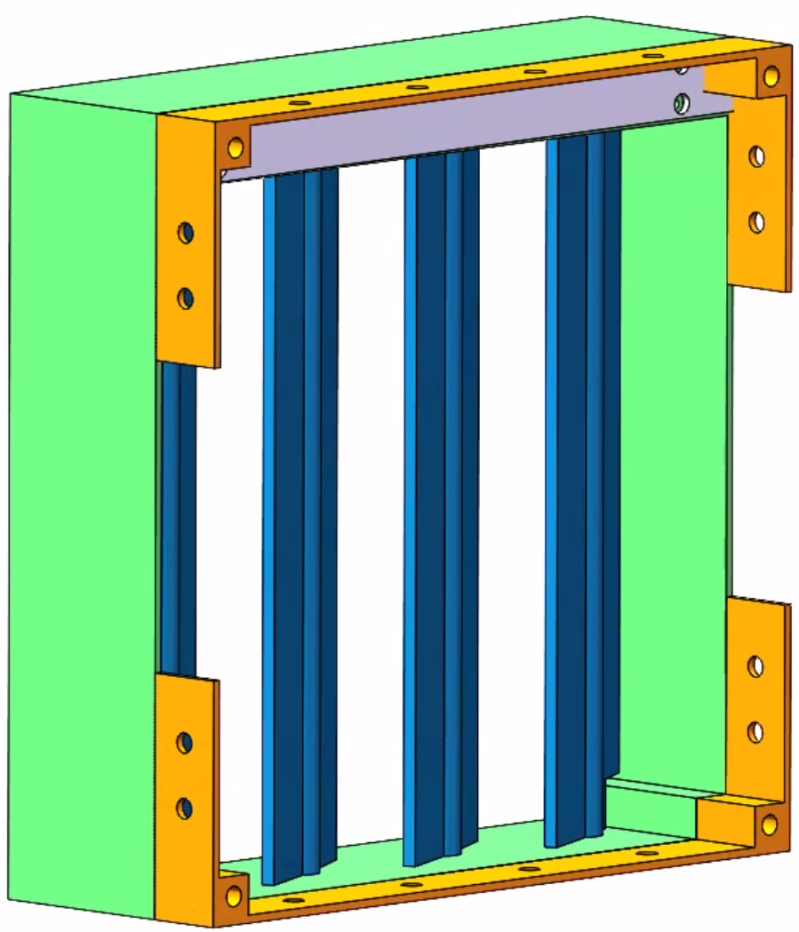 | 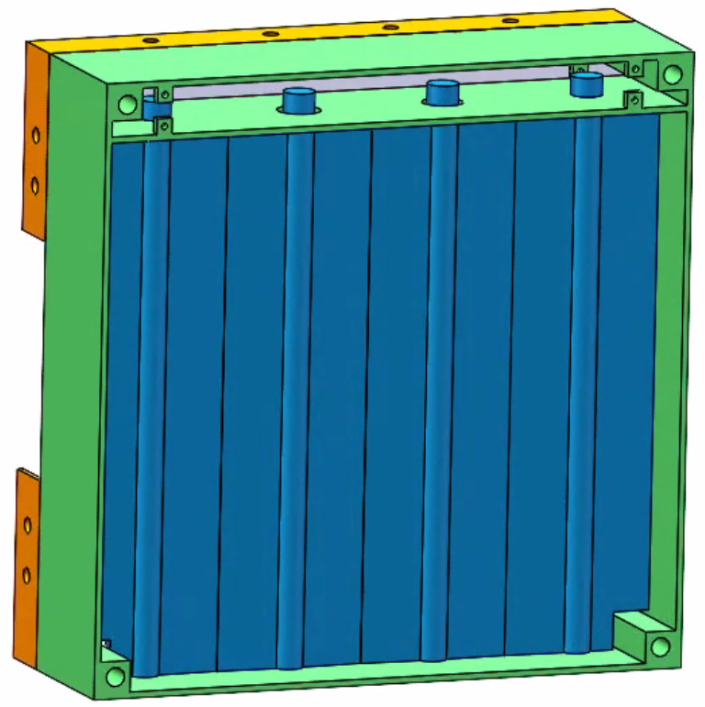
System minimizes obstruction of airflow when fully open. HVAC designer places this near vent, to allow access during replacement. | These are made in standard sizes, to support replacement by multiple manufacturers over building lifetime.

Proposed Standard
A standardized system would support replacement by multiple manufacturers, with the hope of ensuring maintenance over a building's lifetime. This requires manufactures to agree on the mechanical interface between bracket and plug-in module, for several module sizes (e.g. 2x10x10 in, 3x12x18 in). More specifically, the following parameters would need to be agreed upon at a standards body meeting: module height, module width, position of bolts, thread size, position of electrical connector, connector type, position of pivot, and thickness of module. Researchers can propose values for several common module sizes; with the hope that industry engineers will later rework to their satisfaction.

Design Problem
Assignment for researchers:
Develop free and open networkable HVAC components, including: fans in duct, dampers in duct, fluid valves and pumps (e.g. for heated water, ground source water, and thermal storage water), thermal storage system, ground source system, heat exchangers, and HVAC components. Propose mechanical plug-in standards that support replacement over building lifetime. All components attach to building wiring and network via Smart Building initiative, described previously. Support plug-and-play to reduce installation and design costs. Propose standards that define how components connect together, including mechanics, electronics, and communications. Write free and open software that runs on component processors; and coordinates them in a system. Write software that supports diagnostics, monitoring, trouble-shooting, and user interface. Test components in a system (e.g. dozens of components mounted in 19" rack, components interconnected in small test home).

Summary
With relatively little money, the world can develop standardized plug-and-play components that provide more control over air.

See Also
For an example of free and open next generation hvac research, click here.

Automated Ground Source Installation
If one circulates ~58°F ground water through a heating/air conditioning heat pump, instead of outside air, they can reduce space heating/cooling energy consumption approximately 2 to 1. The problem is it is expensive to install underground piping through which one circulates water. The aim of this initiative is to reduce the cost of installing this pipe. Researchers design systems that utilize an independent drilling mechanism that worms its way into the ground instead of the traditional method of drilling (e.g. rotate heavy pipe that traverses entire length of drill hole with ~10,000 Kg of downward pressure). Researcher are not responsible for building the actual machine, and instead work with computer simulators to design a system "on paper" that works reasonably well. All designs, simulation files, reports and calculations are free and open; allowing others to build on this work.

Design Problem
Assignment for researchers:
Develop free and open designs for systems that automate the installation of ground source piping. Design the system, simulate, build simple prototypes, and explore machine design. Propose standards that define how components plug-and-play together, including mechanics, electronics, and communications.

Standard Electric Vehicle Battery

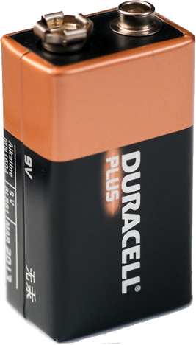
Develop Standard Electrical Vehicle Battery
Currently, the world has a mechanical and electrical standard that defines the 9V battery; and this enables one to power small appliances at low cost.
In theory, one could have a standardized car battery that looks similar to the Tesla battery, yet is used by all cars. The standard would define the mechanics (e.g. height, length, and width), electrical connections, and communication between battery and car. One could potentially swap out and replace with a fresh battery in under one minute.
What might the world do with such a standard?
- Create market for companies that manufacture standard EV batteries; which reduces cost through competition and commoditization.
- Driver visits gas swap station, swaps out battery, pays for electricity consumed and wear inflicted on battery, and goes -- instead of catching nap at charging station.
- Home includes chamber in driveway that houses standard batteries. One owns multiple batteries, solar charges during day, batteries power house at night, and one swaps with car as needed.
Researchers develop standard mechanical and electrical battery system, communication system between battery and charger, and communication system between car and battery swap station. Car companies are invited to participate with things like company-paid engineer on sabbatical who works side-by-side with MA funded engineers. All work is free and open, to support collaboration and adoption by multiple companies.

Develop Standards that Better Coordinate the Charging of Electric Vehicles
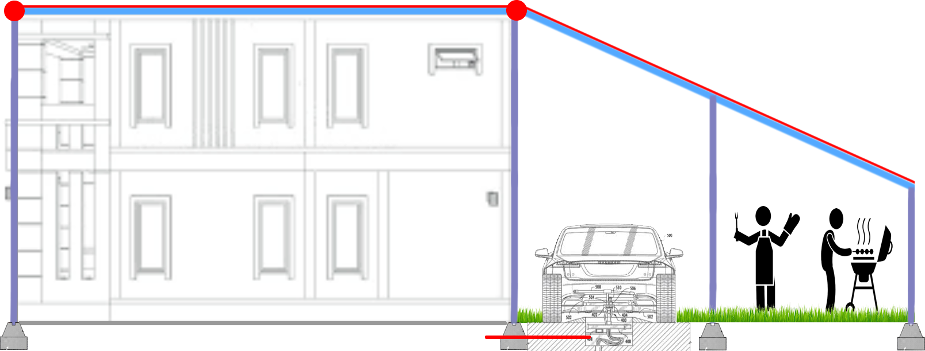
Many world leaders are advocating we decarbonize over the next 20 to 40 years. This means we will probably need to power vehicles with electricity and/or hydrogen gas, instead of gasoline. A big challenge with electric vehicles is they consume much electricity when charging. The electrical grid might support charging a few cars at night on one street. However, it will not support simultaneously charging a car at each house. Electrical wires on the street telephone pole, and those that route to the neighborhood, are not large enough. Subsequently, converting transportation from gas to electric involves a costly upgrade of the electrical grid.
In theory, it is possible to position charging stations throughout a community -- to places like office parking lots, street parking meters, and homeowner's property edge.
If swap chambers were everywhere and easy, then lower cost, lower energy density, and lower range batteries would be more feasible. This would reduce the dependency on rare earth materials; and would move the cost of electrical vehicles closer to that of gas vehicles.
Researchers propose standard electrical connectors, communication systems between car and charger, communication systems between grid and car display panel (tell me where I can charge and give me price), browser/smart phone user interface, and payment system interface.
Researchers might propose a new electrical connector that is potentially used by all manufacturers, with adaptors that affix to existing hardware.
Researchers might also propose standards that support radio communication between a common server and each car, and between that server and each charger. This would use very little radio spectrum since messages are short. Gov't or electric companies might be willing to pay for the server and radio spectrum, since it helps to distribute grid load.
Currently, there are several different systems and connectors that support charging and communication. Many are proprietary and are not recognized by multiple companies. For example, Tesla is not interested in talking to Ford, and vice versa. Researchers look at unifying suppliers and consumers with free and open software and standards.
An example project is a Website (server computer) that coordinates charging stations and cars. Owners of charging stations register, specify their location, and communicate their pricing model. Charging station constantly reports status (e.g. car is charging, solar electricity is available), price and source of electricity (e.g. solar, wind). Cars interact with website to identify reasonable charging options. System supports homeowners who charge cars at property edge. Researchers look at how to verify source of electricity and allow it to influence price (which might require standards that define how solar panels talk to charging hardware). Researchers do not implement the actual system, and instead create a prototype that demonstrates concepts and tests proposed standards. Deployment is a later step, which might involve a national gov't. All source code is given away for free, enabling others to build on the effort, and encouraging adoption by industry and gov't.

Design Problem
Assignment for researchers:
Develop free and open swappable electric car battery system. Design the system, simulate, and build simple prototypes. Propose standards that define how components plug-and-play together, including mechanics, electronics, and communications.

