The Climate Lab
Business Plan
By Glenn Weinreb

Mission: Do R&D to the extent required
to solve the entire climate problem.

Anyone can copy, modify and rename any or all material
at no charge via the CC BY 4.0 license. For original files, click here.

Aug 21, 2026 | v8i | Copyright © 2026 by Glenn Weinreb

Table of Contents
Table of Contents 2
1. Executive Summary 3
2. The Climate Solution is More R&D 8
3. Moonshot Decarbonization Strategy 11
4. Moonshot Organizational Structure 14
Section II: The Climate Problem 17
5. The Climate Problem’s Component Parts 18
6. Climate Science in Five Minutes 23
7. Preventing Runaway Climate Change 26
8. Stratospheric Aerosol Injection (SAI) 29
9. Decarbonization Economics 32
Section III: The Climate Solution 38
10. Improve Climate Models (A1) 39
11. Conduct Sunlight Reflectivity Experiments (A2) 41
12. Develop Large Automated Spray-Planes (A3) 42
13. Nuclear Power Climate Strategy 43
14. Automate Nuclear Power Construction (A4) 47
15. Co-locate Chemical Processing with Nuclear Power (A5) 54
16. Economic Fusion Moonshot (A6) 57
17. Develop Next Generation Solar Farm (A7) 65
18. Develop Swappable EV Battery Standard (A8.1) 70
19. Next Generation Building Automation and Control (A8.2) 73
20. Develop High-Temperature Tunnel Boring Machine (A9) 78
21. Develop Policy Making Tools (A10) 79
22. Related Material 86
23. Acknowledgements 88

Executive Summary
One strategy for addressing climate change is to set up a new laboratory and task it with solving the entire climate problem.
Yet what might they do? In theory, they could divide the problem into two primary parts and do R&D to the extent required to resolve each. One problem is carbon dioxide emissions (i.e., 40G_{t}CO₂/year), while the other is global warming (i.e., 0.3°C/decade).
To solve the carbon dioxide emissions problem, we need to figure out how to make green energy at a cost less than fossil fuel. Consumers would then switch to save money.
To solve the global warming problem, we need to figure out how to reflect sunlight back into outer space at a reasonable cost and without harm. We probably need to reflect approximately 1% of sunlight within ~15 years near the North and South poles. In theory, this could be done with airplanes that spray reflective gases into the upper atmosphere.

Financial Strategy
An R&D surge might be referred to as a “climate moonshot.”
A moonshot would probably be funded by people who want to use their money to save the planet from climate change, as opposed to investors who seek a financial return. Planet saving and investing differ in multiple ways. Candidates for moonshot sponsorship include high-net-worth individuals, foundations, and governments.
In theory, sponsors could require produced materials be placed on the internet for open review (“open-source”). This would save time and money for multiple reasons, including the reduction of inaccurate claims.
When doing R&D, small money is spent before medium money, and medium before large. For example, within a moonshot initiative, $1M might support proposal writing, $10M might support doing detailed design work, and $100M might support building prototypes.

What to Develop?
Ultimately, we need to think about how to spend billions of dollars, to save trillions. Also, for no money, one person or one group of people, can design a moonshot program by putting together a list of things to develop. In other words, they can focus on the following question:
What is a list of things that if developed solve the entire climate problem?
The document you are reading is an example list.

Lab Business Plan
This document is a business plan for The Climate Lab (TCL), a proposed new laboratory that intends to conduct R&D to the extent required to solve the climate problem. This document is open-source, which means anyone can copy (“bifurcate”) or modify for free via the CC BY 4.0 license. For original files, visit www.aplantosavetheplanet.org/lab.

Climate Moonshot
Our proposed moonshot divides the climate problem into 10 different research areas, with roughly $1B allocated to each over 5 years. Total cost is expected to be approximately $10B. The initial development phase cost $100M and supports proposal writing, design modeling, doing rough designs, and developing experiments. For a summary, see videos #19 , #20 and #21.
The 10 research areas are described as follows:

Moonshot Area I: Improve Climate Models
To bend the global warming curve, we need to reflect sunlight back into outer space. Before we do this, we need calculate to how much sunlight needs to be reflected, from where, and when. This requires climate models. However, existing models do not accurately predict observations (e.g. average global temperature, global warming rate, albedo rate of change, etc.). Therefore, a surge of funding is needed to improve them. More specifically, we need to improve our understanding of clouds, and of sunlight reflecting off air pollution (i.e. measure anthropogenic aerosol radiative forcing). For details, see videos #7 and #8; and for a billion-dollar sized proposal, click here.

Moonshot Area II: Conduct Sunlight Reflectivity Experiments (SAI)
In theory, airplanes can spray sulfur-based gases into the upper atmosphere, to reflect about 1% of sunlight back into outer space, to offset global warming. Sulfur is already present in coal and oil, and is therefore released upon combustion—and sunlight reflects off air laden with sulfur. Therefore, we could harvest sulfur from carbon-based fuel before combustion, transfer it to an airplane, and emit it at a high altitude, instead of at ground level. High-altitude sulfur stays aloft for one to two years, while ground-level sulfur typically stays aloft for hours to days. Consequently, changing the emission site reduces the planet's temperature, without increasing total sulfur emissions. In a sense, we can solve the global warming problem by moving air pollution. According to one study, this would cost approximately $18B/year. To better understand this, we need to develop airplanes that emit experimental quantities of material, and then monitor for days to weeks. For details, see videos #9 and #10; and for billion-dollar sized proposals, click here.

Moonshot Area III: Develop Large Automated Spray-Planes
To control global warming, we probably need large airplanes that can emit approximately 100 tons of material every several hours. To do this at a reasonable cost, we probably need a system that supports automated flying, automated refueling, and automated reloading. And we probably need 100 to 200 of these automated airplanes. But before we build hundreds of planes, we need to build one. In other words, we need to design and prototype an automated system that supports one large spray-plane.

Moonshot Area IV: Automate Nuclear Power Construction
The first three Moonshot Areas cost roughly $3B over 5 years, and sets us up to reflect sunlight within ~15 years (i.e. building airplanes and airports requires an additional ~10 years). Ultimately, future leaders would need to compare reflecting, with not reflecting.
Also, we have a carbon dioxide emissions problem. And to transition to a green economy, we need to reduce the cost of 24/7 green energy to below that of fossil fuel. Fortunately, this is easy. We just need to automate the construction of nuclear power plants. More specifically, we need to develop custom machines that build these sites. This would cost little compared to the cost of a nuclear power plant. For details, see videos #11 and #12; and for a billion-dollar sized proposal, click here.

Moonshot Area V: Co-locate Chemical Processing with Nuclear Power
To make chemicals without emitting carbon dioxide, at a cost less than the traditional approach, we need to co-locate chemical processing equipment with low-cost nuclear reactors. More specifically, we need to develop standards that define how this fits together.
Also, to reduce the cost of the processing equipment, we need to develop a transportation system that moves large platforms of chemical processing equipment from a shipyard or factory to a nuclear power site. For details, see video #13; and for a billion-dollar sized proposal, click here.

Moonshot Area VI: Economic Fusion Moonshot
There are primarily two types of nuclear power: fission and fusion. Fission is the traditional form that generates electricity with uranium fuel. However, it is not popular due to meltdown risk, nuclear waste, proliferation risk, and cost. Fusion, on the other hand, does not have these issues; however, it is still in development. In theory, we can accelerate development with a surge in funding for technologies used by fusion machines that by-design produce power that is competitive in an electricity market (i.e. focus on economic fusion). For details, see video #14; and for a billion-dollar sized proposal, click here.

Moonshot Area VII: Develop Next Generation Solar Farm
In theory, we can reduce the cost of solar power by developing a technique for placing solar material directly onto soil. For details, see video #17.

Moonshot Area VIII: Develop Green Energy Standards
In a green new world, we need more standards that define how things fit together mechanically, electrically, and with communications. This includes standards for devices in automated buildings, standards for swappable EV batteries, and standards for ships powered by liquid ammonia. For details, see videos #15 and #16.

Moonshot Area IX: Develop High-Temperature Tunnel Boring Machine
To extract underground geothermal energy at a low cost, we need vertical tunnel boring machines that operate at high temperatures (reference).

Moonshot Area X: Develop Policy Making Tools
In theory, we can build a website that creates climate plans based on requirements specified by the website user. This would allow policymakers and concerned citizens to get a better sense of how to fix climate at the lowest-cost. For details, see videos #4 and #5.

Are We Ready for a Climate Moonshot?
In theory, we can set up a new laboratory and task it with doing R&D to the extent required to solve the climate problem. Globally, this might cost billions of dollars per year. However, the cost to initiate and oversee might be closer to $100M/year. In other words, one funding source might be able to get this started for much less than $1B. Yet more importantly, a solution to the climate problem exists, and it is not blocked by politics or financial constraints.

The Climate Solution is More R&D
As you probably know, the burning of fossil fuel causes carbon dioxide gas to be emitted into the atmosphere, and this leads to global warming. Also, in theory, this can be mitigated by switching to energy that does not emit carbon dioxide such as wind, solar, hydro, or nuclear.
But at what rate is this currently being done? We can assess by looking at the percentage of total energy that is made without emitting carbon dioxide, and see how it changes with time.

The History of Decarbonization
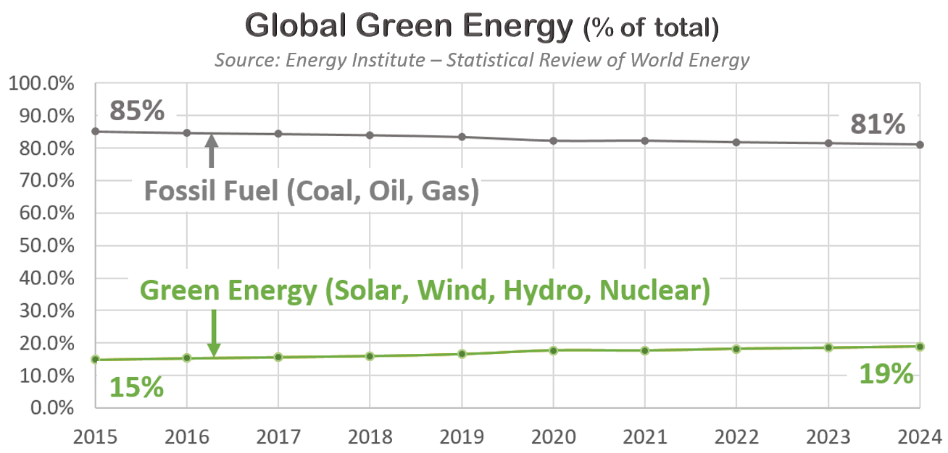
According to the data, the percentage of global energy that is so-called “green” has increased from 15% to 19% over the last decade. This is all energy, not just electricity—and this is the entire world, not just one nation.
At this pace, reaching full decarbonization would take about 200 years. Far too long to solve the carbon dioxide emissions problem.
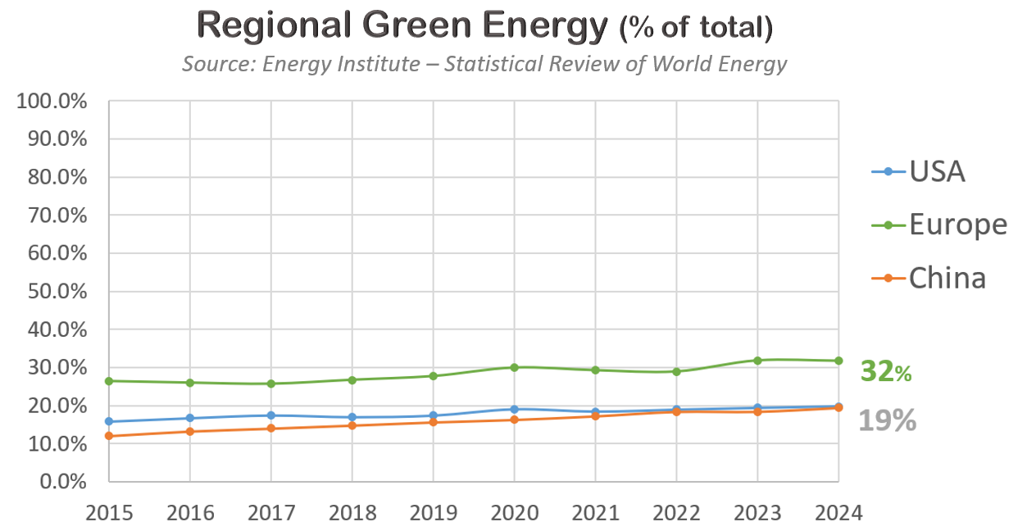
We can also look at the U.S., Europe, and China. The U.S. is on track to decarbonize over 200 years, Europe over 125 years, and China over 100 years.
Furthermore, U.S. decarbonization during the Trump 1.0 years was similar to that of the Biden years, even though Biden focused more on climate. This is because key energy policies were similar, and market forces changed little. For example, they both had a 30% subsidy on building solar farms, and they both had natural gas costing less than coal. In other words, both liberal and conservative energy policies have little impact on emissions and on warming.
But why decarbonize slowly? There are several reasons which we will now review.

Climate Economics
In some cases, the green option costs less than the carbon option and switching over is easy. While in other cases, the green option costs more and switching over is less popular, especially at large scales. In these cases, the additional cost of the green product is referred to as the “green premium.” Also, consumers tend to avoid this so-called premium. This is because they do not benefit from reducing their own emissions. They’re too small. Instead, harm comes from the collective emissions of our planet's eight billion people. For this reason, each person wants everyone else to reduce.
Furthermore, companies need to compete with other companies, and regions need to compete with other regions—and they do not want additional costs to make them less competitive.
Ultimately, decarbonization is limited by these economic constraints.

Climate Politics
Nations are dominated politically by large industries that employ millions of people. Examples are the fossil fuel industry, labor unions, auto makers, and factories. Employees and their friends vote, while employees and companies make political donations. To connect the dots, lobbyists suggest to lawmakers that donations are contingent on support for specific measures.
Climate, in comparison, employs few people and is therefore politically weak. In a sense, large industries are like political gorillas, while climate is the small monkey. Also, the strong sometimes take from the weak. For example, the U.S. Inflation Reduction Act required builders of solar farms to buy U.S.-made solar panels to qualify for subsidies. While this created factory jobs, it also raised the cost of solar farms — ironically leading to higher carbon dioxide emissions. In other words, labor hijacked the climate issue for their own purposes.
Ultimately, climate is politically weak, in part due to employing relatively few people.

The Global Warming Problem
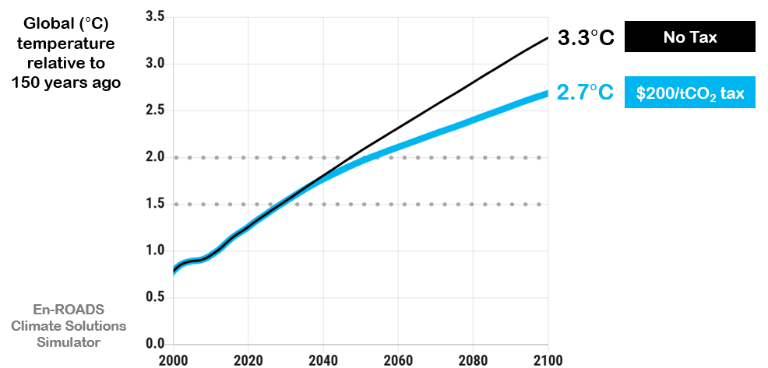
In summary, climate faces both political and economic constraints. But what would happen if this was not the case? For example, what would happen if a $200 per ton global tax was levied on carbon dioxide emissions? This would cost the world roughly $5T/year, and it is not politically feasible. Yet let’s ignore that for a moment, and assess the impact this would have on the planet.
According to the MIT climate solutions simulator, we get runaway climate change both with and without this $200/_{t}CO₂ tax. In other words, a massive global tax on carbon would not solve the problem. This might seem confusing since we’ve been bombarded with the following message:
Carbon dioxide emissions cause global warming
and eliminating these emissions will solve the problem.
However, this is only slightly correct. Instead, global warming is caused by excess carbon dioxide in atmosphere (i.e. due to 150 years of emissions), plus methane emissions, plus declining sea ice, plus thawing permafrost, etc.

The Policy Confusion Problem
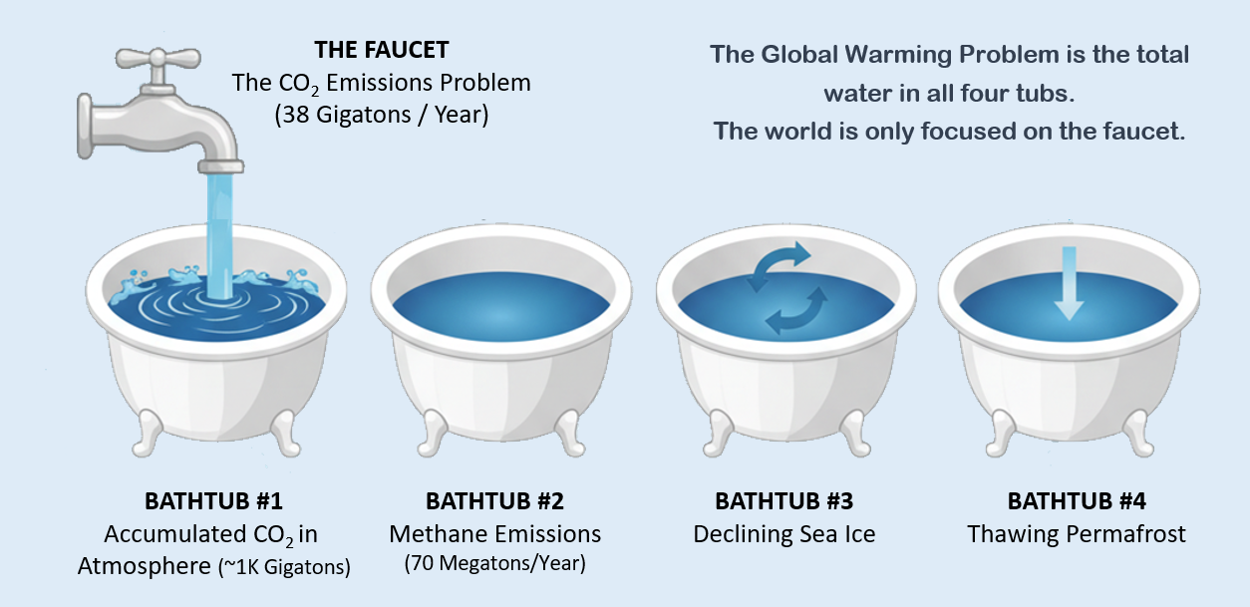
The climate problem is like a faucet with several bathtubs. The faucet represents annual carbon dioxide emissions, while the water in the tubs represents global warming.
More specifically, the water at the faucet is proportional to the amount of carbon dioxide that is emitted into the atmosphere each year. While the combined water in all the tubs is proportional to the increase in Earth’s temperature each year in units of degrees Celsius.
The water in the first tub is due to 150 years of past carbon dioxide emissions—not one year’s emissions. And the water in the other tubs is proportional to warming from methane emissions, warming from declining sea ice, etc. Ultimately, multiple sources of warming combine and increase the planet’s temperature.
Global policy, media, and activism are all obsessed with slightly turning down the faucet, while completely ignoring the fact that water already in the tubs is what’s causing catastrophic global warming. So, while the planet heads towards disaster, the people responsible for fixing it are trying to solve the wrong problem.

The Climate Solution
Let’s review the key points:
- Climate faces economic limitations.
      - Climate faces political limitations.
      - Policymakers are confused.
The situation might seem bad; however, there is a simple solution. It is to think of the climate problem as two problems, and do R&D, to the extent required, to resolve each.
One problem is carbon dioxide emissions (“faucet”) while the other problem is global warming (“bathtubs”). We can solve the first problem by doing R&D to drive down the cost of 24/7 green energy to below that of fossil fuel; and we can solve the second problem by doing R&D to determine how to reflect sunlight back into outer space, at a reasonable cost and without harm.
As noted previously, climate involves both political and economic constraints. However, these do not apply to R&D since it can be funded by a small number of high-net-worth individuals, foundations, and governments. Also, reflecting sunlight would move forward if future leaders believed reflecting is better than not reflecting. In other words, a path forward exists and it is not blocked by politics, economics, or confused policymakers.

Moonshot Decarbonization Strategy
Roughly one-third of carbon dioxide comes from electrical power generation, roughly one-third from industrial processes that make chemicals and materials, and roughly one-third from transportation.
Electrical power is the easiest to decarbonize, followed by chemicals, followed by transportation. Also, nations tend to decarbonize in lowest-cost order, which means we can expect electrical power to come first, followed by chemicals/materials and transportation.
Roughly half of electrical power can be decarbonized by building solar farms and wind farms. However, without sun and wind, we cannot produce green electricity that is competitive in an electricity market.
Global decarbonization has been slow, in part due to the economic and political constraints discussed in the previous chapter, and in part due to decreasing solar/wind costs (i.e. it pays to wait). In other words, it is in a nation's best financial interests to minimize costs, while putting on a show of concern and encouraging others to act.

Known Technologies with Favorable Cost Models
Energy economics is a field of study that examines our society's behavior with energy—or more specifically, energy markets. For details, consider reading The New Map by Yergin. According to basic principles of this field, the only way to solve the carbon dioxide emissions problem is to drive down the cost of 24/7 green energy so that it’s cheaper than carbon-based energy. Fortunately, more R&D can make this happen, and it would cost little relative to other costs typically associated with climate. However, this does not apply to any R&D. Instead, it applies to R&D that supports known technologies with favorable cost models.
Let’s look at some examples to get a better sense of how this works.

Cheap Green Electrical Power
It typically takes multiple decades to commercialize a nuclear fission reactor that is still in development. However, this is not necessary. Instead, a currently operating system can be copied. Also, construction can be automated to decrease cost.
The safest reactor in the world is HTR-PM. It does not melt-down when not cooled. Also, its reactor vessel and heat exchanger cost little. Instead, most of the cost comes from site construction. Fortunately, for little money, we can do rough designs of custom machines that automate site construction. In other words, for small money, we should be able to identify how to produce 24/7 green electrical power, at a cost less than carbon-based power.
Why has this not been done? Engineers typically build one nuclear reactor at a time, instead of building many low-cost reactors. And a laboratory tasked with solving the entire climate problem would focus on doing the R&D that supports many.

Cheap Green Chemicals & Materials
Now let's look at making chemicals and materials. We want to do this without emitting carbon dioxide, and we want to do it for less money than the carbon-based approach. This can probably be done by using heat directly from a cost-reduced nuclear reactor. More specifically, we can pump steam or molten metal through pipes, from a nuclear reactor, to a nearby industrial process.
To further reduce costs, a new transportation system could be developed that transports platforms of chemical processing equipment from a factory or shipyard to nuclear power site. For example, we could develop a double-rail system that moves large and heavy loads over land and water. Also, multiple railcars could move large platforms of industrial processing equipment and place them side-by-side, near a nuclear reactor. Typically, 66% of energy produced by nuclear power is lost to the environment as unused heat. However, this could be used by nearby industrial processes, to further reduce costs. Developing the standards that define how this fits together, plug-and-play, would cost little compared to costs typically associated with nuclear power. For details, see the nuclear power chapter later in this document.

Cheap Green Cars
Now let's look at cars. We want cars that do not emit carbon dioxide, cost less than gas cars, and are as convenient as gas cars. Unfortunately, we are not doing this with electric vehicles (EVs)—they are not convenient. So how might we do better?
Currently, proprietary batteries are built into EVs and charged periodically. Alternatively, EVs could use a standard plug-in battery, where all cars use the same form and swap with a fresh battery in several minutes. Car owners would pay for electricity consumed and for wear on the battery—and pay less when using lower-cost batteries.
Today, mechanical and electrical standards define batteries and allow us to power many products at a low cost. In theory, this could also be done with EVs. In other words, a standardized battery, similar to the Tesla EV battery, could be used by multiple manufacturers. Batteries sitting in swap stations could charge at any time, over multiple days.
This would reduce costs for multiple reasons: (a) batteries could charge at night when electricity is cheap, (b) batteries could charge when solar farms and wind farms are producing power, (c) batteries could charge slowly and avoid expensive fast-charging hardware, and (d) competition between battery manufacturers would drive down costs. In other words, we could get favorable costs and favorable convenience—which is what we need to go green with cars.
So why has this not been done?
This problem is lawmakers delegate to auto companies, and auto companies focus on their own financial interests, not fixing the planet. To move this forward, someone would need to support the development of standards that define how this fits together mechanically, electrically and with communications. More specifically, donation money (not investment) would probably need to build this up to the point of working prototypes, and give the designs away for free.

Building Automation & Control
To fully automate buildings, we would need to put a microprocessor into every device, and connect them together with reliable communication. Devices would include light switches, light sockets, HVAC equipment, appliances, fans in ducts, occupancy sensors, temperature sensors, etc.
This could save money, improve comfort, and cut energy use in many ways. For example, it could help control each room’s temperature, and move heat from one room to another. In theory, TCL could develop the standards that define how this fits together—plug-and-play.

Fusion Moonshot
Currently, scientists are exploring how to generate energy with a hot plasma, inside a donut-shaped chamber. This is referred to as “fusion,” and some scientists believe it will not be commercially available for another 20 years. However, a multi-billion-dollar R&D initiative, overseen by the world's top fusion scientists, could potentially speed this up.
In 1961 President Kennedy stated he wanted a man on the moon by the end of the decade. In response, a program was set up and funded. In theory, a government or foundation leader could do the same with nuclear fusion. For example, they could state they want to generate electricity with fusion, at a cost less than carbon-based electricity, and they want this done within a handful of years.
Engineers would then focus on a published design that achieves this objective. It turns out, such a thing exists, as noted in the fusion chapter later in this document.
In summary, much can be done with additional R&D in key areas—and for each area it cost little to assess technical and economic feasibility.

Moonshot Organizational Structure
Our planet's climate future is bleak, which suggest past climate-related R&D efforts have been insufficient. So, what might we do differently? Let's explore.

Big R&D
Universities typically focus on professors-sized projects, while companies typically focus on projects that provide a return on investment within a reasonable amount of time. But there's another type that is often overlooked. Bill Gates refers to it as “Big R&D.” These are large-scale projects that exceed the capabilities of a university or a company. Examples include The Manhattan Project during World War II, and the U.S. program that landed a man on the moon. Each started with a goal, broke the problem down into parts, and pushed forward. And each involved multiple teams, and multiple organizations.
In theory, the same could be done for climate. More specifically, a new laboratory could do R&D to the extent required to: (a) drive down the cost of 24/7 green energy to below that of fossil fuel, and (b) determine how to reflect sunlight at reasonable cost and without harm.
Big R&D is often avoided by Companies due to excessive risk. It is often avoided by Universities due to a reliance on professor-sized projects. And it is often avoided by Governments unless they are under extreme pressure. In theory, these barriers could be overcome with a unique organizational structure that coordinates multiple foundations, universities, and funding sources.
Yet how might this be organized, and how might it get started?

Spend Money Wisely
Big R&D might sound expensive; however, feasibility can often be verified with relatively little money. More specifically, one typically spends small money before medium money, medium money before big money—and only advances if technically and economically feasible. Small typically involves developing rough designs, building cost models, and writing proposals. This is sometimes referred to as “Phase One R&D.” Medium typically entails, detailed engineering, and prototype development. While Big typically involves setting up factories, and supporting large volumes.

Sources of Funding
There are two primary sources of R&D funding: Climate Money and Investment Money. Climate Money hopes to save the planet from climate change, whereas Investment Money hopes to make more money. Each has constraints. For example, Investment Money avoids projects that are too complex, too risky, or lack consumer demand. While Climate Money often requires results to be shared openly, to maximize climate benefit-per-dollar spent.
Open sharing brings real advantages: (a) it maximizes use of developed technology, (b) it encourages peer review, (c) it promotes development of interconnection standards, (d) it reduces exaggerated claims, and (e) it lessens dependency on researchers and institutions.
Typical sources of Climate Money include governments, foundations, and individual donors. While Investment Money typically comes from companies and investment funds. Companies and universities often prioritize their own financial interests, over climate interests. For example, they often avoid sharing information since it can interfere with securing patents, developing proprietary products, and attracting further investment.

Organizational Structure
The Lab consists of multiple Divisions, each of which consists of multiple R&D Funds.
Each R&D Fund is an account with money that supports a specific technical area. These are overseen by Fund Managers (FM) who issue Purchase Orders (PO) to scientists and engineers, to do R&D. Invoices are paid using money in their fund.
Each Division is led by a Division Manager (DM) who oversees R&D Funds within their Division.
Later chapters within this document describes Divisions and R&D Funds.

Financial Strategy
Funding Sources (“sponsors”) include governments, foundations, and high-net-worth individuals.
Funding Sources can direct donations to the entire laboratory, specific Divisions, specific R&D Funds, or specific regions. For example, the French government might require their money only support French scientists and engineers.

Management
R&D Funds and Managers are overseen by Managing Foundations (MF). These are well-known organizations with a history of managing R&D money responsibly. Candidates include The Gates Foundation (GF), Bloomberg Philanthropies (BP), and The Bezos Earth Foundation (BEF).
Managing Foundations receive donations from Funding Sources, oversee bank accounts, employ Fund Managers, and provide administration support.
The Lab is overseen by a tiny office within an organization. This office does not handle money, and it does not decide how money is spent. Instead, it maintains agreements between it and Managing Foundations. These agreements specify several requirements, such as:
- Managing Foundations recruit, employ, and oversee Division Managers and Fund Managers.
- Material developed by scientists and engineers is to be marked “open-source,” and is to be freely distributed by the internet. This maximizes utilization of developed technology, and minimizes inaccurate claims.
- All Funding Sources and all Managers can view all Purchase Orders. In other words, participants receive read-only access into the accounting system.
- Managing Foundations use their own money to pay for overhead. This includes support for Managers, reviewers, symposiums, and administrative personnel. For example, a Funding Source donates $10M and the Managing Foundation spends $1M of their own money to manage the $10M. Purchase Orders to scientists and engineers sum to $10M. This reduces the tendency of Managing Foundation employees to add excess overhead, and this makes the system more attractive to Funding Sources.

Authority
The Lab is controlled by the TCL Board of Directors (BOD). The largest sponsors receive one seat on the BOD, with voting share proportional to the size of their donations over the previous 12 months.
The BOD has the authority to hire/fire Managing Foundations, add/subtract Divisions, and hire/fire Division Managers.
Division Managers have the authority to add/subtract R&D Funds within their Division, and hire/fire Fund Managers.
Fund Managers have the authority to issue Purchase Orders to scientists/engineers.

The Last Great Hope
Unfortunately, our society does not have a plan to solve the climate problem. It does not evaluate the cost and impact of decarbonization initiatives. It does not have a mechanism that favors the lowest-cost approach. And no one feels responsible for solving the entire climate problem. Perhaps the last point is the most relevant. Can we make someone—or some organization—responsible for fixing this? And if so, what might that look like? We believe The Lab might be the answer, and if this is true, it might be the last great hope of avoiding disaster.

Section II: The Climate Problem

Section II
The Climate Problem

The Climate Problem’s Component Parts
This chapter looks at the many problems that are related to climate change.

Breaking it Down …
There are several techniques for solving a problem, one of which is to break a it down into component parts, and look for a solution that follows basic principles of politics, economics, engineering and science. In theory, we can apply this to climate. Yet what are the component parts? Below is a summary in no particular order.

The Excess Carbon Dioxide Problem
Today's atmosphere contains an additional 1130 billion of tons of carbon dioxide, relative to where it was 150 years ago. This causes the earth's average temperature to increase, due to the absorption of outgoing infrared radiation and short-term feedbacks (e.g., more heat leads to more water in air which causes more heat).

The Carbon Dioxide Emissions Problem
The 1130-billion-tons of excess increases by 38 billion tons each year due to carbon dioxide emissions. Put differently, the excess increases roughly 1/30th each year due to the burning of coal, oil and natural gas. The 38-billion-ton increase has little impact on the temperature of the planet, since global warming is primarily caused by the 1130-billion-ton excess and other factors.

The Climate Policy Confusion Problem
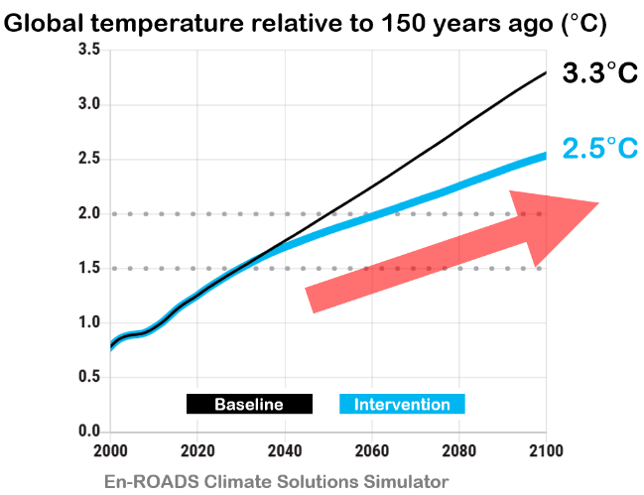
The MIT En-ROADS Climate Solution Software estimates future global temperatures in the event a global tax causes the price of fossil fuel to increase 4-fold. It estimates this would lower the projected end-of-century temperature from 3.3°C to 2.5°C, relative to where we were 150 years ago. Also, in both the baseline and intervention cases, the average global temperature keeps going up, as shown in the graph. This is sometimes referred to as “runaway climate change” or “the global warming problem.”
At first glance it might seem like the carbon dioxide emissions problem (i.e., 38 G_{t}CO₂/yr), and the global warming problem (i.e., 0.3°C/decade) are the same; however, they are different. Global warming is caused by many things, of which annual emissions only play a small role.
Harm comes from global warming, not emissions. Yet government policy focuses on emissions, not warming. In other words, policy makers are trying to solve the wrong problem, and will accomplish little.

The Geoengineering-is-Bad Problem
The public has been led to believe geoengineering (e.g., reflecting sunlight) is bad. However, it is needed to solve the global warming problem. Ultimately, scientists need to determine how to reflect sunlight at a reasonable cost and without harm.

The Journalism Problem
Journalists report on existing climate initiatives, yet do not explain what it takes to solve the entire climate problem. Also, they do not quantify the impact of existing climate initiatives on global carbon dioxide emissions and on global warming. There are several techniques for doing this, such as the MIT software; however, this is largely ignored. Incomplete reporting has led to a lack of clarity by the public—which has led to wasted time and money.

The Unrealized Warming Problem
After emitting carbon dioxide into atmosphere, some warming occurs within several months due to the absorption of infrared radiation and short-term feedbacks. However, significantly more warming occurs over many years due to long-term feedbacks (e.g. melting sea ice, thawing permafrost, etc.).
More specifically, about 15% of warming occurs within a few months, 28% within five years, 28% over the next 100 years, and 28% over the next 1000 years. This suggests warming would still occur if emissions stopped completely in one day. Scientists refer to this as “unrealized warming” or “warming in the pipeline.”

The Acceleration Problem
The average global temperature was about 1.2°C above pre-industrial levels in 2022, and then it jumped 0.3°C in two years, to hit 1.5°C in 2024. For reference, the global warming rate was 0.18°C-per-decade between 1970 and 2010. In other words, global warming seems to be accelerating. Unfortunately, accelerating changes are also observed with sea ice, ocean currents, and thawing permafrost.

The Climate Tipping Point Problem
Climate tipping points are critical thresholds in Earth's systems that once crossed trigger abrupt changes. Like a row of dominoes, the toppling of one tipping point can unleash a cascade of effects accelerating the pace of climate change beyond our control. Tipping points are triggered by higher global temperatures; therefore, more warming puts us at risk of tipping point activation.

The Sea Ice Problem
The first tipping point to activate will probably be North Pole sea ice. After it melts, the average global temperature is expected to jump about 0.6°C. This is due to sunlight being absorbed by sea water, instead of being reflected by ice. After this, more tipping points are expected to activate.

The Air Pollution Cooling Problem
Sunlight reflects off air pollution and back into outer space—and this offsets global warming with cooling. Also, this presents us with an additional problem. If we stopped burning fossil fuel completely tomorrow, this cooling effect would go away, and the global warming rate would surge from 0.30°C-per-decade to roughly 0.45°C-per-decade.

The Methane Problem
Methane emissions also cause global warming.

The Prisoner's Dilemma Problem
In some cases, the green option costs less than the carbon option, and switching over is easy. While in other cases, the green option costs more, and switching over is less popular, especially at large scales. In these cases, the additional cost of the green product is referred to as the “green premium.” Unfortunately, consumers tend to avoid this so-called premium. This is because they do not benefit from reducing their own emissions—they are too small. Instead, harm comes from the collective emissions of our planet's eight billion people. For this reason, each person wants everyone else to reduce. In other words, it is in one's best financial interests to minimize their own climate costs, while encouraging others to act. Economists refer to this as a “prisoner's dilemma problem.”

The Climate Solvers Disincentive Problem
In theory, our society could improve our handling of the climate problem with several measures. These include: (a) developing a plan that solves the entire climate problem while observing basic principles of economics, politics, engineering and science (this document is an example of this), (b) quantifying the impact of climate initiatives (i.e. on both carbon dioxide emissions and average global temperature), and (c) developing a mechanism that causes us to favor the lowest solution.
These things are not done, in part because many people responsible for fixing the problem would lose their jobs if we instead tackled climate at the lowest cost.

The Competition Problem
Companies compete with other companies, regions compete with regions, and nations compete with nations—and they lose market share if they don't keep costs down.
Companies are often encouraged to reduce their carbon dioxide emissions. But in practice, they face two choices. They can either decarbonize for real, at high cost. Or they can appear to decarbonize, at less cost. For publicly traded companies, spending more on climate action usually means lower profit, which can push stock prices down. However, CEOs are expected to do the opposite. They are expected to increase profit and increase stock price. So many responds with token climate efforts designed to look good while keeping costs low. One common approach is buying carbon offsets. In theory, these pay for projects that reduce emissions. But in many cases, they do not deliver as promised. For example, if a carbon offset blocks tree farmers from harvesting on one parcel of land, and trees are instead harvested elsewhere, there’s no benefit. Ultimately, many CEOs need to select either more decarbonization and less profit, or less decarbonization and more profit. Too often they choose the latter option, in part because their decarbonization claims are rarely verified.
Competition is both good and bad for climate. For example, it is good when green energy costs less than carbon-based energy (i.e. green suppliers take market share away from carbon-based suppliers); and it is bad when green energy costs more (i.e. companies avoid green premiums to reduce costs, to be more competitive).

The Solar/Wind Saturation Problem
When building up solar power, the amount of electricity from solar panels eventually exceeds the amount of electricity consumed by customers, when sunny. If one builds further, electricity is discarded due to supply from solar exceeding demand. This is referred to as “solar saturation,” and at this point, solar construction stops. Ultimately there is a limit to how much decarbonization can be achieved with solar power. The same applies to wind power.
So, what impact would global solar saturation have on global carbon dioxide emissions? Let's quantify. The sun burns bright about 6 hours out of every 24, which means we can get roughly 25% of our electricity from solar power (6/24). Also, roughly one-third of carbon dioxide emissions are from electrical power. Therefore, building up solar until saturation would decrease global carbon dioxide emissions by approximately 8% (¹/₁₂ = ¹/₄ ✖ ¹/₃).

The GDP Growth Problem
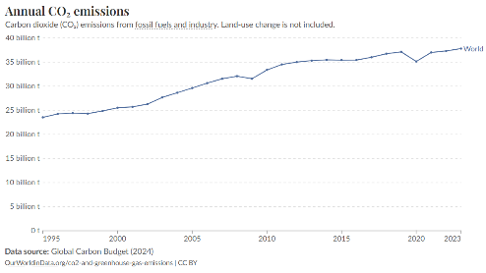
Global GDP growth is approximately 3%-per-year, which works out to an 80% increase over 20 years (80% = 1.03²⁰ - 1). Therefore, if solar was built up to saturation over 20 years, global carbon dioxide emissions would increase 72% if only influenced by solar construction and GDP growth (80% - 8%).
It is worth noting, global carbon dioxide emissions have increased over the last 30 years, in part due to GDP growth.

The Political Gorillas Problem
Nations are dominated politically by large industries that employ millions of people. Examples are the fossil fuel industry, labor unions, auto makers, and factories. Employees and their friends vote, while employees and companies make political donations. To connect the dots, lobbyists suggest to lawmakers that donations are contingent on support for specific measures.
Climate, in comparison, employs few people and is therefore politically weak. In a sense, large industries are like political gorillas, while climate is the small monkey. Also, the strong sometimes take from the weak. For example, the U.S. Inflation Reduction Act (IRA) required builders of solar farms to buy U.S. made solar panels to qualify for subsidies. While this created U.S. jobs, it also raised the cost of solar electricity—ironically leading to higher carbon dioxide emissions. In other words, labor “hijacked” the climate issue for their own purposes.
The European Emissions Trading Systems (ETS) raises $42B/year with a carbon tax; however political gorillas have insured that most of this money doesn’t reduce carbon dioxide, or does not do it cost-effectively.
Imagine a room with 10 gorillas, one monkey, and a bowl of delicious fruit. The monkey gets little, and there is no way to change this since the gorillas will adapt to measures that try to alter the outcome.

The Big R&D Problem
Universities typically focus on professor-sized projects, while companies typically focus on projects that provide a return on investment within a reasonable amount of time. But there's another type that is often overlooked. These are large-scale projects that exceed the capabilities of a university or a company. Examples include The Manhattan Project during World War II, and the U.S. program that landed a man on the moon. In theory, a large R&D initiative could drive down the cost of 24/7 green energy and determine how to reflect sunlight without harm. However, this might not be considered since large initiatives are avoided by companies due to excessive risk, avoided by universities due to a reliance on professor-sized projects, and avoided by governments unless under extreme pressure. Ultimately, a reasonably-priced solution might exist, but without financial support. Bill Gates refers to this as “The Big R&D Problem.”

A Path to Solve the Entire Climate Problem
Now that we have broken the climate problem down into multiple different sub-problems, what is a reasonable path forward?
There is only one solution. It is Big R&D to drive down the cost of 24/7 green energy to below that of fossil fuel, to solve the emissions problem; and Big R&D to determine how to reflect sunlight at reasonable cost and without harm, to solve the warming problem.
Big R&D does not require support from governments and companies, since a few funding sources can push it forward. In a sense, this is the opposite of what we are doing now, which is to expect all governments and all companies to incur additional costs when they don't benefit.
If Big R&D is the answer, why aren't we doing it?
Ultimately, we have a communications problem—it is difficult to communicate this approach when surrounded by a sea of confusion.

Climate Science in Five Minutes
The following is a brief summary of climate science.

The 1.5°C Problem
Several decades ago, climate scientists stated the world needs to avoid a 1.5°C global temperature increase, relative to 150 years ago, or “bad things” will happen. They implied we are to peak at 1.5°C, and then drop back down. Instead, we breached 1.5°C in 2023, and we are not cresting. Instead, we are warming rapidly.
Also, global CO₂ emissions would need to be close to zero at the point of cresting, to cause global temperatures to decrease. Instead, emissions are at their highest level, and are still increasing.

The Failure of Decarbonization
It takes several decades to decarbonize to zero emissions; therefore, the world would have had to start decarbonizing roughly 30 years ago, to get to zero CO₂ emissions today. In other words, over the last several decades, our society failed to decarbonize.

Sunlight Reflects Off Air Pollution
Sunlight reflects off man-made air pollution and back into outer space, offsetting global warming, with cooling.

The 0.3°C Jump
In 2022 the average global temperature, relative to 150 years ago, was 1.2°C; and over the next two years, it surged by 0.3°C, reaching 1.5°C.
For 40 years, between 1970 and 2010, global temperatures rose at a rate of about 0.18°C per decade. Therefore, a 0.3°C jump over a few years is unusual.
Top climate scientist James Hansen believes some of this was due to cloud changes, and some was due to a reduction in air pollution. As noted previously, air pollution cools the planet; therefore, less pollution leads to more warming.

Tipping Points
Tipping points are additional sources of global warming that add to global warming already done by CO₂. An example is North Pole sea ice. It is one to two meters thick, and when it melts, sunlight is absorbed by sea water, instead of being reflected by sea ice—and this causes the temperature of the planet to increase.
Another example tipping point is the West Antarctic Ice Sheet. If this were to collapse, sea levels would rise multiple meters, and this would disrupt coastal areas.
Published studies suggest tipping points are likely to activate after global warming exceeds 1.5°C.

Global Warming Components
Global warming is made up of multiple components that add together, as illustrated below. As one can see, some components increase global warming (red), whereas others decrease global warming (blue). These combine to produce total warming (green).
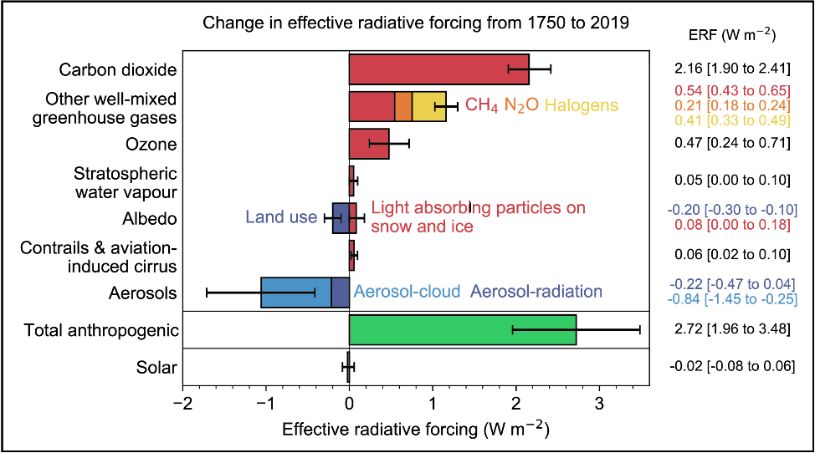
Figure 6.1: Sources of global warming (red) and cooling (blue) in units of watts per square meter of Earth's surface area. Total actual warming (green) is observed with instruments. Source: IPCC's 6th Climate Report, Figure 7.6.

Global Cooling
Global cooling—represented by the blue bars in the above graphic—is caused by sunlight reflecting off particles and droplets in the atmosphere. These substances, known as aerosols, often originate from human-made air pollution.

Direct Warming from CO₂ (Absorption of Outgoing Infrared Radiation)
Sunlight warms the planet's surface after passing through CO₂ in atmosphere. The planet then emits infrared (IR) heat radiation back into outer space. CO₂ absorbs this outgoing IR radiation more than the incoming visible light, trapping heat and raising the average temperature of the planet.

Indirect Warming from CO₂ (Climate Feedbacks)
After direct warming occurs, more warming occurs due to climate feedbacks. For example, initial warming melts sea ice, which leads to more sunlight being absorbed by ocean water, which leads to more warming. Other feedbacks include: (a) release of additional greenhouses gases (e.g., methane and CO₂) from thawing permafrost, and (b) increased water vapor in atmosphere (due to warmer air), which further traps heat.

Climate Feedback Response Time
Climate feedbacks don’t occur all at once—they unfold over time. After carbon dioxide enters the atmosphere, roughly one-third of the resulting warming occurs within the first five years, another third over the next 100 years, and the final third over the following 1,000 years.
This delayed response means the full effect of today’s emissions will not be felt for generations. It also implies that a significant amount of future warming is already “locked in” due to past emissions.

CO₂ in Atmosphere
Hundreds of years ago, atmospheric CO₂ levels were about 280 parts per million (ppm). Today, they are around 425 ppm, and they are projected to reach 560 ppm by the year 2075—double the pre-industrial level.

Earth Climate Sensitivity (ECS)
The amount of eventual warming (e.g., after 1000 years) that occurs after a doubling of CO₂ in atmosphere (and holding it steady at this level) is referred to as the Earth Climate Sensitivity (ECS). Some scientists believe this is 3°C, whereas others think it is closer to 5°C. If ECS is high, then more tipping points will activate, and sooner.

Global Cooling Uncertainty
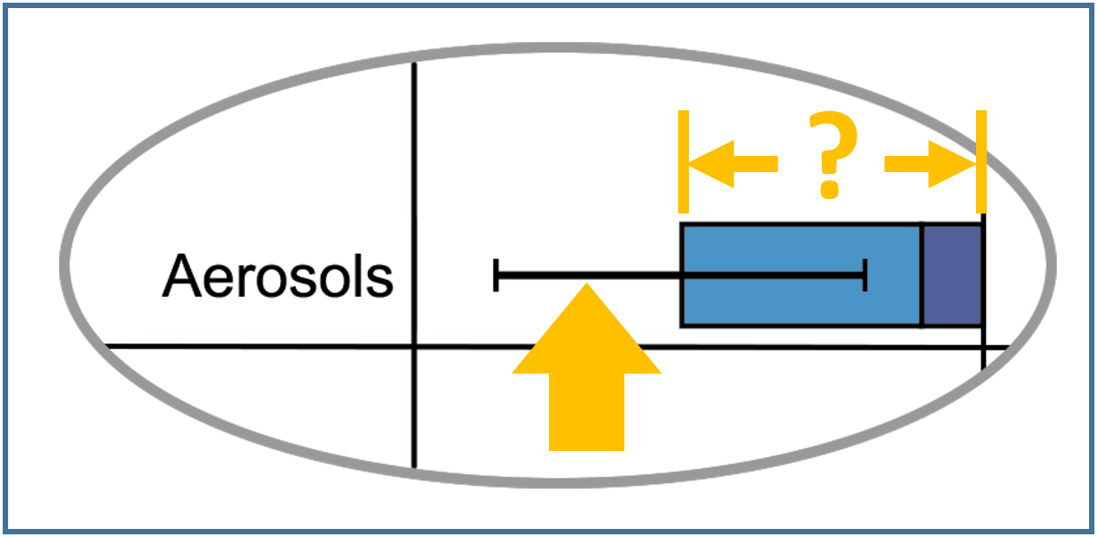
What is fascinating about global cooling in the above graphic is the error bars. These tell us climate scientists do not know if this is a little, or a lot. If actual cooling is large, then climate models estimate ECS is high, and significant changes will occur to our planet over the next few decades. Otherwise, if actual cooling is small, climate models suggest ECS is low, and we have more time.

Uncertainty Magnitude
Notice the size of the global cooling error bars relative to the amount of warming from 150 years' worth of carbon dioxide (i.e., red bar in Figure 6.1). It is about 80% of that level. In other words, the degree to which scientists do not understand global warming, based on cooling error bars, is enormous. This makes it difficult for national leaders to craft an appropriate response, since the severity of the problem is unknown, by climate scientists' own admission.

Sense of Urgency
Some scientists believe the recent 0.3°C jump indicates global cooling is large and ECS is high. If this is true, it will probably be accepted by the wider scientific community within several years. If this occurs, the sense of urgency among national leaders will probably increase. However, many so-called decarbonization initiatives are not effective, or not cost-effective. Therefore, expanding them is not likely to have a significant impact.
Ultimately, interest in reflecting sunlight is likely to increase as it becomes clearer that: (a) decarbonization has failed, (b) the climate problem is worse than previously considered, and (c) global temperatures are accelerating upward.

Preventing Runaway Climate Change
We can solve the carbon dioxide problem by replacing fossil fuel with green energy. However, this alone will probably not solve the climate tipping points problem. We seem to be approaching these critical thresholds too quickly. Therefore, we probably need to reflect approximately 1% of sunlight back into outer space, to cool the planet. For a video version of this chapter, see TCL Video #9.
The key question for scientists is “How might we reflect approximately 1% of sunlight back into outer space at a reasonable cost and without causing harm?” We're already reflecting sunlight, since it reflects off of man-made air pollution. More specifically, it reflects off of sulfur. It's possible this is a key element in solving the climate problem.

Sulfur 101
Sulfur is an element on the periodic table, and it is present in large amounts within coal and oil. Therefore, it is typically emitted into the atmosphere when these fuels are burned. Sulfur is harmful to people, plants, and oceans. Consequently, governments often require that some sulfur be filtered out, before or after combustion. However, even with some filtration, approximately 70 million tons of sulfur dioxide gas are emitted globally into the atmosphere each year.

Sulfur Cools the Planet
After sulfur is emitted into the atmosphere, it typically combines with water and oxygen to form H₂SO₄. This “nucleates,” which means it converts to tiny physical particles. Water sticks to these particles, and causes them to grow into physical water droplets. These droplets are so small and sparsely distributed that they are often imperceptible to the naked eye—and droplets containing sulfur typically reflect more sunlight than those without. Therefore, more sulfur causes more sunlight to reflect back into outer space, instead of being absorbed by the planet. In effect, sulfur cools the planet.
A notable example is the 1991 volcanic eruption of Mount Pinatubo which released sulfur dioxide gas into the atmosphere. This caused the average global temperature to decrease approximately 0.4°C for several months.

High Altitude Sulfur is Cooler
As noted previously, sulfur is present in coal and oil, and is released during combustion. In theory, we can filter more of it out before combustion, transport the harvested sulfur to an airplane, and emit it at a high altitude, instead of at ground level.
High-altitude sulfur stays aloft for one to two years, while ground-level sulfur typically stays aloft for only several days. Therefore, changing the emission site reduces the planet's temperature, without increasing total sulfur emissions. The latter point is important, since sulfur is harmful, as noted previously.
Sulfur-based materials are not the only substances with reflective properties. For instance, calcium carbonate (CaCO₃), commonly known as chalk, exhibits similar capabilities. Further research is needed to understand the benefits and drawbacks of each candidate material.

How Much Does this Cost?
To justify the expense, we would need to compare the cost of cooling the planet, with the cost of not cooling the planet. One study suggests large-scale planet cooling would cost approximately $18B/year. For comparison, the total value of New York City property is $1,400B—and this is just one coastal city that would be lost to sea level rise. If the U.S. paid half, planet cooling would cost each American $27-per-year (50% × $18B ÷ 330 million people).
Increasing the reflectivity of the atmosphere is a new field and there are many things we don't know. We don't know what to inject, when, where, and how. And we don't have an accurate assessment of costs, and adverse side effects. To resolve unknowns, we need R&D. This includes developing better instrumentation for measuring atmospheric reflectivity, developing equipment that injects small amounts of material for field experiments, and developing equipment that injects large amounts of material for full-scale operations.

Three Geoengineering Projects
Geoengineering involves injecting material into the atmosphere either intentionally, or as a side effect of another activity. An example is the 40 billion tons of carbon dioxide, and the 70 million tons of sulfur dioxide that are emitted into the atmosphere each year due to burning fossil fuel. Also, to prevent runaway climate change, roughly 7 million tons of sulfur dioxide are considered for injection each year into the upper atmosphere.
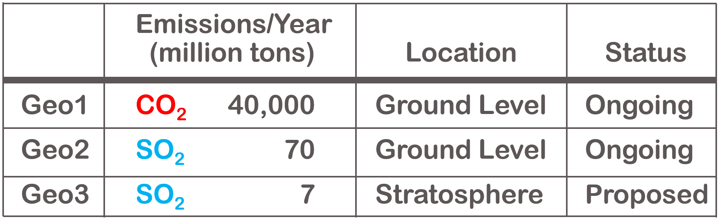
Let's compare these three geoengineering activities. To make this easier to follow, we will refer to them as “Geo1”, “Geo2”, and “Geo3”. Geo1 and Geo2 are ongoing operations, while Geo3 is under consideration. Also, Geo1 and Geo2 inject material at low altitudes, while Geo3 targets high altitudes with airplanes. Geo1 warms the planet, while Geo2 and Geo3 cools the planet. Geo3 involves 6,000 times less material than Geo1, by weight. However, Geo3 has a large cooling effect, per gram of material, in part due to its long hover time, as noted previously.
Each geoengineering activity can be characterized with multiple parameters (“climate variables”) and these can be quantified by scientists. They do this with scientific models, laboratory experiments, and field experiments. Lab experiments typically involve measuring properties of gasses within chambers, inside a laboratory.
An example parameter is increased acidity. We know how much acidity is caused by each gram of material, and we know how many grams of material are emitted each year. From this, we see Geo2 contributes 10 times more acidity than Geo3, and Geo1 contributes roughly 100 times more than Geo2—and yes, acidity is bad.
We can also look at size by weight. For instance, Geo1 is enormous. To get a sense of this, we can look at what happens when an A380 airplane flies from New York to Tokyo. This one flight injects roughly one million pounds, or 500 metric tons, of carbon dioxide into the atmosphere. This is about the same weight as 500 small cars—and this is just from one flight, from one airplane. For reference, there are roughly 28,000 commercial airplanes worldwide, and airplanes are responsible for just 3% of total carbon dioxide emissions. In other words, Geo1 is massive, and in comparison, Geo3 is tiny.
However, for the most part, the public does not like Geo3, even though it could potentially be helpful. This is likely to change, as the risk of runaway climate change becomes more evident. Most climate activists prefer decarbonization. However, as noted previously, the climate problem has progressed beyond point where decarbonization by itself is sufficient.

Preventing Runaway Climate Change
The first tipping point to activate would probably be North Pole sea ice. After this melts, sunlight would be absorbed by water, instead of being reflected by sea ice. To get a sense of what this would do, one can hold their hand up to the sun, and feel the warmth. This is the amount of additional heat we would get times the surface area of North Pole sea ice. This is not a small chunk of ice. It has a surface area of 5 million square kilometers, which is half the size of the United States. Loosing this reflector would increase the average global temperature by 0.6°C, and this would trigger other tipping points. Therefore, we would like to prevent the first tipping point from activating. This entails calculating the percentage of sunlight that needs to be reflected, and the year that full-scale operations would need to commence. Also, this entails putting together a reflectivity plan that estimates what would need to be done each year between now and deployment. The plan would have three primary phases: R&D, construction, and full-scale operations. R&D would involve field experiments; construction would involve building a fleet of airplanes and supporting airport infrastructure; and full-scale operations would involve flying airplanes.

Public Support is not Needed (yet)
Public support for reflecting sunlight is currently low, in part due to a lack of understanding of what would happen if sunlight was not reflected. However, this is not necessarily a problem. This is because initial R&D can be funded by forward-leaning foundations and governments; and therefore, does not need broad public support. However, support would eventually be needed for activities such as construction and full-scale operations.

Stratospheric Aerosol Injection (SAI)
To solve the global warming problem, we probably need to reflect approximately 1% of sunlight back into outer space, to cool the planet. There are several ways to do this, one of which is called “stratospheric aerosol injection” (SAI). This involves spraying reflective gases, or liquids, into the upper atmosphere, using airplanes. For a video version of this chapter, see TCL Video #10.

Sunlight Reflectivity Strategy

The two primary layers within the atmosphere are the troposphere and the stratosphere. To simplify, we will refer to these as the “lower atmosphere” and the “upper atmosphere.”
Stratospheric aerosol injection involves inserting material with reflective properties into the upper atmosphere. The altitude needed to access this layer depends on position. For example, at the equator, the upper atmosphere starts at a 20km (65K feet) altitude, whereas near the North and South Poles, it starts at a 12km (40K feet) altitude.
Existing aircraft can reach the upper atmosphere over the Polar Regions, making it possible to cool them using existing airplanes. However, cooling the entire planet would require injecting material at the equator, at altitudes of 20km (65K feet). Unfortunately, we don't have large airplanes that fly to that height. Therefore, to cool the entire planet with SAI, we would need to develop new aircraft, which takes time and money.
For this reason, SAI would probably involve two phases:
SAI Phase I Cool the Polar Regions with existing airplanes, to prevent tipping points associated with those regions.
SAI Phase II Cool the entire planet, at a later date, with newly developed aircraft.
Each phase would probably be built up gradually. For example, one could operate at one 1/10,000th of full-scale operations for a while, look for harm, and expand if none was detected.

Sulfur Cools the Planet
Sulfur injected into the upper atmosphere follows a different path than sulfur injected into the lower atmosphere.

Sulfur in the Upper Atmosphere (aerosol-radiation effect in stratosphere)
Sulfur in the upper atmosphere is rare; however, it is made possible with and SAI and volcanic eruptions. When SO₂ gas enters the upper atmosphere, it chemically reacts with water and oxygen to form liquid H₂SO₄. This combines with water to produce microscopic droplets that are typically 50% H₂SO₄ and 50% water. These droplets last for one to two years, while reflecting sunlight back into outer space.

Sulfur in the Lower Atmosphere (aerosol-cloud effect in troposphere)
Significant quantities of sulfur are already present in the lower atmosphere, primarily due to fossil fuel combustion. However, this sulfur typically remains airborne for only hours to days because of rainfall and gravity. In humid conditions, tiny sulfuric droplets form into cloud droplets consisting of more than 99% water. Clouds with sulfur reflect more sunlight than clouds without, and therefore offset global warming, with cooling.

Moving Air Pollution to Save the Planet
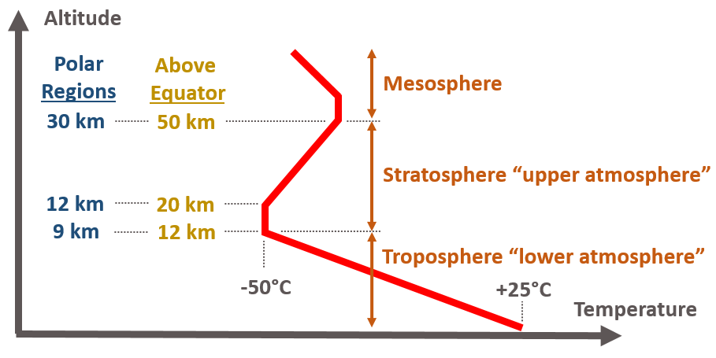
Air temperature varies with altitude in unobvious ways, as shown in this graph. As one can see, altitude is represented by the vertical axis, and air temperature by the horizontal axis.
The atmosphere is relatively warm at ground level, and gets colder as one goes up. However, this reverses after one enters the upper atmosphere, since ozone in this region absorbs solar radiation, and causes temperatures to become warmer as one goes higher. In other words, there is a layer of relatively cold air at the bottom of the upper atmosphere, and a layer of warmer air above it.
Also, warm air rises, which means material injected at the bottom of the upper atmosphere will go up, and not quickly fall to Earth due to gravity. Therefore, one gram of sulfur injected into the upper atmosphere will cool the planet significantly more than one gram injected at ground level. This is why moving one gram sulfur, from the lower atmosphere to the upper atmosphere, cools the planet, and does not increase total sulfur emissions. Put differently, SAI involves moving sulfur, not adding it.

Three Physical Areas of Operation
Increasing the reflectivity of the atmosphere involves three physical areas of operation. These are polar research, cooling the Polar Regions, and cooling the entire planet.
Polar research involves a spray plane that injects material into the upper atmosphere, and then monitoring that material for days to weeks. Monitoring entails flying below the material, above the material, and through the material. For details, see SAI field experiments.
Cooling the Polar Regions involves approximately one-hundred Boeing 777 airplanes that inject material close to the North and South Poles, to block tipping points associated with those regions. For details, see On Thin Ice: Solar Geoengineering to Manage Tipping Element Risks in the Cryosphere by 2040.
And cooling the entire planet involves approximately one-hundred large, custom-made, high-altitude aircraft that inject material near the equator, to block all climate tipping points. For details, see The cost of stratospheric aerosol injection through 2100 and Pandora's Toolbox.

Sunlight Reflectivity Risks
Reflecting sunlight at the scale needed and the timeframe needed is not easy to do. It involves risks. Two that stand out are site security risk and undercapitalization risk.
Site security risk involves protecting reflectivity operations from physical attack. This is important since any “grumpy” national leader could potentially enter the coordinates of reflectivity infrastructure into a missile guidance system, and press a button. There are multiple reasons why they might do this, one of which is they perceive it as harmful. This is a complex topic, since the magnitude of harm could vary in both time and place—and we would want to weigh it against the harm of doing nothing. Ultimately, this could get complicated and lead to fighting.
Also, there is undercapitalization risk. This is when financial support for initial research is insufficient, followed by a panicked national leader that pushes forward at large scales, before scientists had measured side-effects at small scales.
There are many potential problems, and these are just a few.

Decarbonization Economics
This chapter explores the economics associated with decarbonization. For a video version of this chapter, see TCL Video #18.
In some cases, the green option costs less than the carbon option, and switching over is easy. While in other cases, the green option costs more, and switching over is less popular, especially at large scales.
Incurring decarbonization costs is unpopular primarily due to competitive forces. Companies compete with other companies, regions compete with regions, and nations compete with nations—and they lose market share if they don't keep costs down. Furthermore, the cost of green infrastructure is decreasing, which means it pays to wait.
Lawmakers sometimes ask, “Why spend $200 to reduce carbon dioxide emissions by one ton, when we can do it for $20?” For this reason, some favor decarbonizing in lowest-cost order. In other words, easiest first, followed by the more difficult.
Roughly one-third of carbon dioxide comes from electrical power generation, roughly one-third from industrial processes that make chemicals & materials, and roughly one-third from transportation. Electrical power is the easiest to decarbonize, followed by chemicals, followed by transportation.
Electrical power is currently being decarbonized by building solar farms and wind farms. However, industrial processes and transportation have seen little decarbonization, relative to total. Again, nations tend to tackle climate in lowest-cost order.

Electrical Power Fundamentals
On most home electric bills, electricity use is measured in units of kilowatt-hours (kWh). When one vacuums for an hour, they typically consume one kilowatt-hour of electricity. The average U.S. home consumes 10,000 kilowatt-hours each year, at 14 cents per kilowatt-hour, for a total cost of $1,400-per-year. This is retail cost and it covers electricity generation and distribution. Generation refers to making electricity at the power plant, while distribution refers to the network of power wires between generation plants and consumers. U.S. homeowners typically pay 7 cents per kilowatt-hour for generation, and 7 cents for distribution.

Residential Decarbonization Costs
Green electricity, which is produced without emitting carbon dioxide, sometimes cost 2 cents more per kilowatt-hour than electricity from fossil fuels (and sometimes less). This is without subsidies and without taxes. Currently, roughly 40% of U.S. electricity is green, which means we still need to decarbonize the remaining 60%. If we spread this transition evenly over 12 years, that’s about 5% per year. According to the math, 5% of 10,000 at an additional 2 cents is $10 per year. Therefore, the additional cost per U.S. household could be $10 in the first year, $20 in the second year, $30 in the third year, and so on. As one can see, costs start out surprisingly low and then increase.

Solar/Wind Saturation
When building up solar power, the amount of electricity from solar panels eventually exceeds the amount of electricity consumed by customers, when sunny. If one builds further, electricity is discarded due to supply from solar exceeding demand. This is referred to as “solar saturation,” and at this point, solar construction stops. Ultimately there is a limit to how much decarbonization can be achieved with solar power. The same applies to wind power.

Residential Solar Is Expensive
Electricity from solar panels installed on a house typically costs about three times more than electricity from solar farms. This is due to overhead costs incurred at each house. Residential installation involves marketing costs, mechanical and electrical design, city permits, installation, and final inspection. Alternatively, at a solar farm, one does not incur these costs every 15 solar panels. In other words, it cost much less to decarbonize by building solar farms, than to place solar panels on buildings.

China's Solar Surge
A coal shortage in China recently increased the cost of their coal-based electricity to the point where it's roughly twice the cost of their solar farm electricity. To reduce coal demand, reduce coal price, and save money, the Chinese built 277 GW of solar power in 2024. This is approximately 10-times more than that built in the U.S. over the same time period. Also, this is approximately 46-times more than China's nuclear construction (277 GW_{e} ÷ 6 GW_{e}). At their current solar construction rates, they will reach saturation within several years, and stop building farms.
The Chinese are demonstrating that large amounts of solar are technically and economically feasible, and their large production volumes are driving down solar costs due to economies of scale. For reference, solar panels made in the U.S. cost approximately $170/kW more than solar panels made in China—which equates to $4/MWh more for electricity.
China's solar construction spree is not due to climate change. Instead, it is due to their high cost of fossil fuel, and a lack of local sources of oil and natural gas. Europe is similarly challenged, and is therefore interested in alternatives, such as renewables. In comparison, the U.S. has local low-cost sources of fossil fuel, and is therefore less inclined to go green.

Solar Farms and Wind Farms
Some regions are more sunny, while others are more windy. As one might imagine, it cost less to generate electricity with a solar farm in a sunny region, and it cost less to generate electricity with a wind farm in a windy region. Yet by how much? The following tables show the wholesale cost of electricity from wind farms and solar farms built in the year 2025 and the year 2033, as estimated by the U.S. National Renewable Energy Laboratory (NREL). The units shown here are megawatt hours (MWh), which are 1000-larger than kilowatt-hours (kWh).

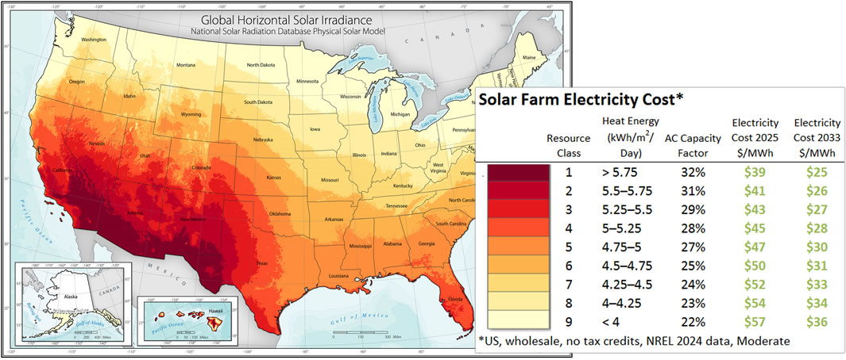
Figure 9.1: This map shows the cost to generate electricity with a solar farm.
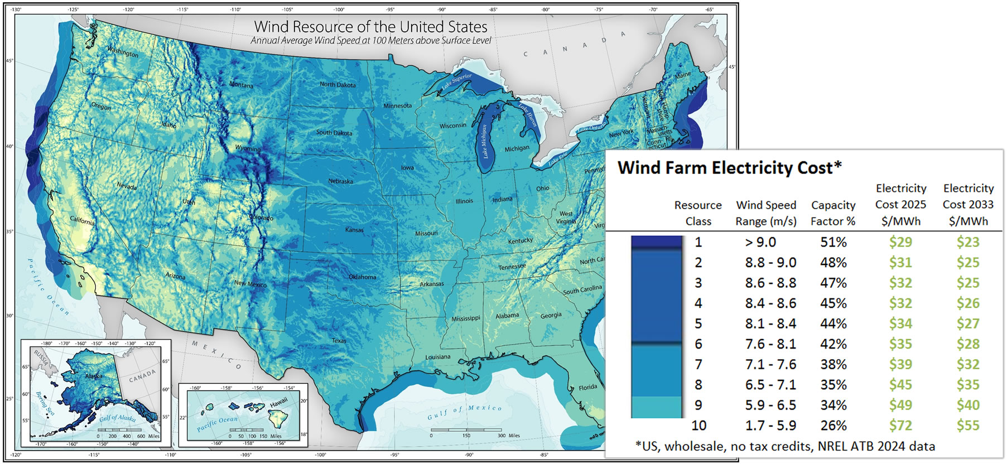
Figure 9.2: This map shows the cost to generate electricity with a wind farm.
Wind energy tells a similar story. It’s often windy at higher altitudes, so windmills are technically feasible in many areas. But because of audio noise and other concerns, they can’t be placed too close to people. That’s why wind farms are typically set up in remote areas. For example, windmills for U.S. east coast cities are likely to reside 200 miles inland.

Fossil Fuel Costs
Now let’s compare this with fossil fuels. The table below shows the wholesale cost of fossil fuel, plus the variable cost of generating electricity with it. When we replace fossil‑fuel based electricity with solar or wind, this is the money we save. In other words, the cost to decarbonize is the cost of the green electricity minus a red value shown below.
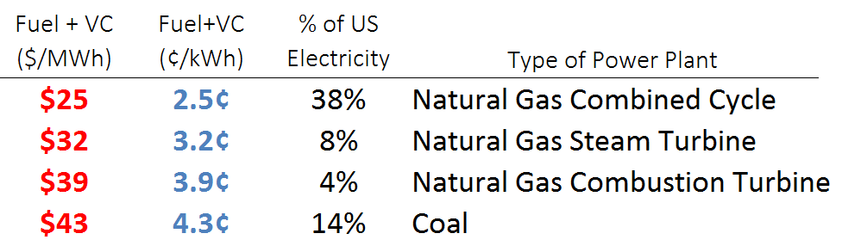
Figure 9.3: Wholesale fuel cost plus variable cost at carbon based power plants. Source: NREL 2024 ATB

30-Year Projections
The United States government estimates green energy costs over the next 30 years, as shown below. In summary, solar and wind are expected to be somewhat competitive with fossil fuel. However, the more reliable forms of green energy—such as those available 24/7—are projected to remain more expensive for decades to come.
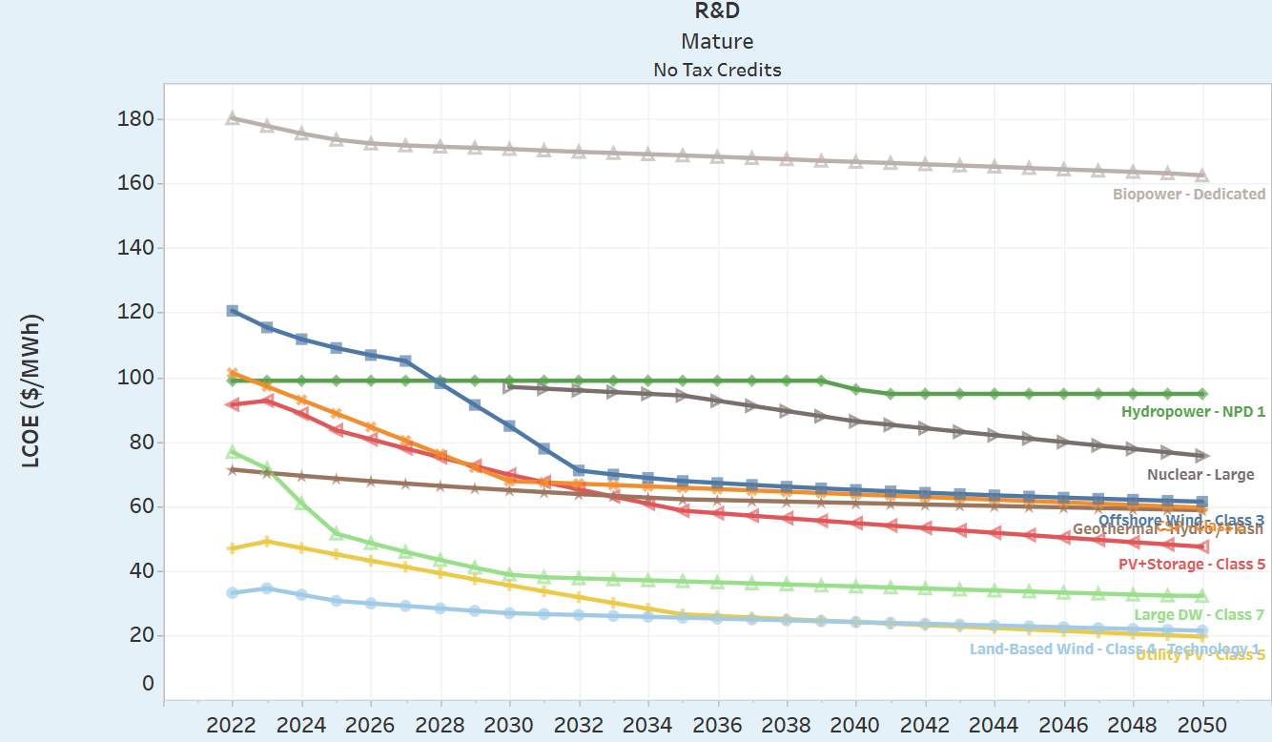
Figure 9.4: Projected cost of green electricity. Source: NREL 2025

Lowest-Cost Order
If the U.S. reduced carbon dioxide emissions 1/30th per year over 30 years, in lowest-cost order, to get to zero emissions 30 years from now; then additional costs would be close to zero for the first 5 to 7 years, and then go up. In other words, decarbonization would be easy at first, and then less easy. In theory, additional R&D could make the later years easy too.

U.S. Government CO₂ Projections
Now, let’s look at carbon dioxide emissions across the entire U.S. energy system—not just electricity. The graph below shows a U.S. government projection of carbon dioxide emissions from the U.S. over the next 30 years.
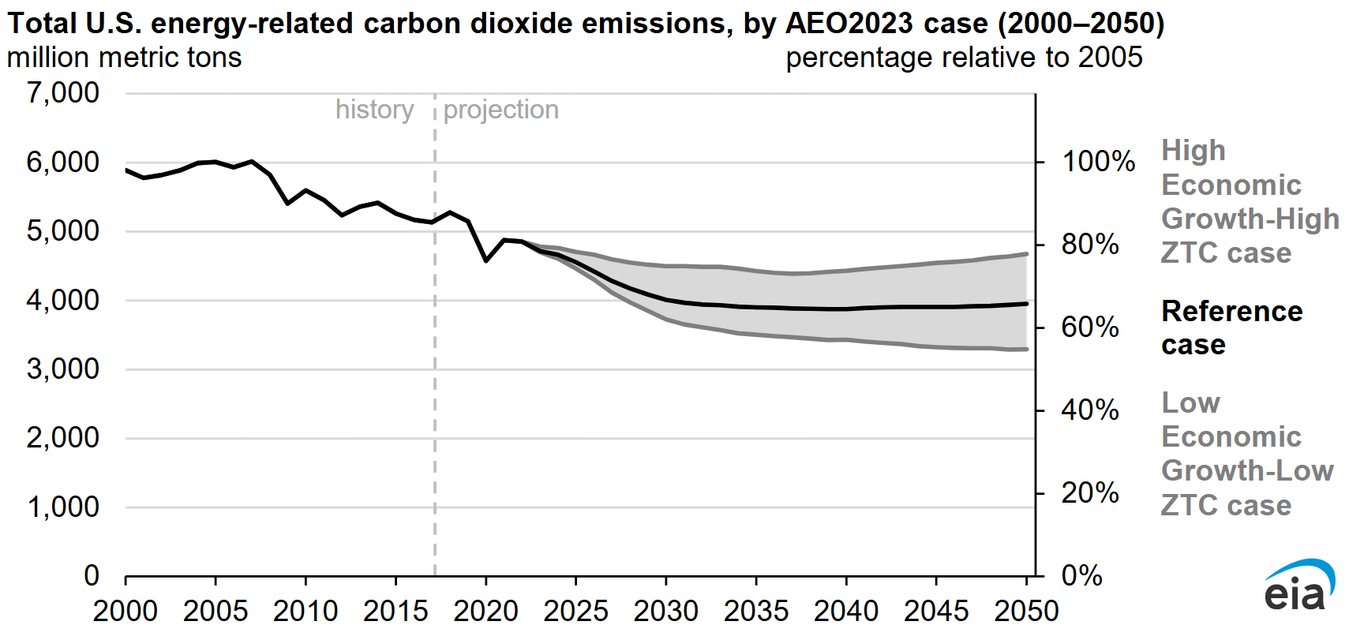
Figure 9.5: Projected CO₂ emissions from U.S. due to fossil fuel. Source: EIA
Over the last 20 years, U.S. annual carbon dioxide emissions fell by about 1.2 billion tons. But surprisingly, most of this decline had little to do with renewable energy, government policy, or climate change. Instead, about 80% of the drop came from natural gas costing less than coal. Due to the internal chemistry of molecules, natural gas produces half as much carbon dioxide per unit energy; therefore, switching over reduces carbon dioxide emissions.
That was the past. Going forward, U.S. government economists expect additional U.S. decarbonization over the next decade, primarily driven by low-cost solar power, low-cost wind power, and low-cost natural gas. But these have limits. Solar and wind can’t be built beyond saturation, and there’s a finite number of coal plants left to replace. Once these limits are reached, decarbonization would slow—and according to the above projection, it basically stops. More specifically, Figure 9.5 shows constant carbon dioxide emissions from the U.S. after 2035.
What to do?
Additional R&D, beyond that expected by the U.S. government, could potentially lead to more decarbonization.

Decarbonization Politics
Over the last decade the United States reduced carbon dioxide emissions by building wind farms, solar farms, hydro-electric dams, and nuclear power plants. But how was this influenced by politics?
Between 2016 and 2019, conservatives were in control of the U.S. government and carbon dioxide from U.S. electrical power decreased 11%. Several years later, liberals were in control and decarbonization was similar. But liberals spent additional hundreds of billions of dollars on climate. So why was the outcome similar?
To answer this question, we need to look at what drives decarbonization. In the United States, electrical power decarbonization is primarily driven by three things: (a) state decarbonization requirements, (b) federal subsidies on building solar farms and wind farms, and (c) natural gas costs less than coal. These things changed little over the last eight years, and this is why decarbonization was somewhat consistent.
The public has a different view in part because mainstream news organizations often ignore the behavior of energy markets. To complicate matters, the impact of government policy on global warming is rarely quantified—by anybody.

Increase U.S. Solar Construction 5-Fold?
Let's forget the past and focus on the future. Let's say someone is nervous about climate and they want to increase the annual construction of solar farms in the U.S. by a factor of five. And let's assume this is done with a federal law that requires power companies to buy more solar power and pass additional costs (or savings) onto customers. Solar saturation would be achieved 5-times sooner, yet what impact would this have on global warming? Unfortunately, the impact would be negligible. Furthermore, nations that spend heavily on climate typically have little impact on warming.

Climate Plan
All of this begs the question, “What is our plan?” A reasonable approach is to conduct R&D to the extent required to: (a) drive down the cost of 24/7 green energy to below that of fossil fuel, to solve the emissions problem, and (b) determine how to reflect sunlight at reasonable cost and without harm, to solve the warming problem.

A Beautiful Decarbonization
In theory, decarbonization can occur in lowest cost order, and R&D can keep green energy costs below fossil fuel costs as one goes through time. TCL refers to this as a “Beautiful Decarbonization”.

Commissioning a Study
In theory a government or foundation can commission a study to produce a plan that performs a beautiful decarbonization. More specifically, scientists and engineers can be tasked with: (a) producing a list of things that if developed solve the entire climate problem, and (b) produce an R&D plan that maintains low decarbonization costs over a multi-decade global decarbonization.

Section III: The Climate Solution

Section III
The Climate Solution

Improve Climate Models (A1)
To prevent runaway climate change, we need to reflect sunlight back into outer space. Before we do this, we need calculate to how much sunlight needs to be reflected, from where, and when. This requires climate models. However, existing models do not accurately predict observations. Therefore, a surge of funding is needed to improve them.

Sources of Uncertainty
Over the last 25 years, our planet has become darker, and is therefore absorbing more sunlight. More specifically, Earth receives 1.7W/m² more energy where “W/m²” refers to Watts (energy over time) per square meter of Earth surface area. This is measured by satellites, so we know it is real.
Dr. James Hansen believes 1.05 of the 1.7W/m² is due to cloud changes, and 0.5 is due to air pollution changes. However, estimates from climate models are one-fourth these levels. In other words, scientists do not understand clouds, and they do not understand how much sunlight reflects off air pollution.

We Need to Measure How much Sunlight Reflects off Air Pollution
Global warming is made up of multiple components that add together, as illustrated here (IPCC Ar6 Wg1 Fig7.6).
As one can see, some components increase global warming (red), whereas others decrease global warming (blue). These combine to produce total warming (green).
The blue “Aerosol” cooling bar is caused by sunlight reflecting off particles and droplets in the atmosphere. These substances, known as aerosols, often originate from human-made air pollution.
Notice the size of the Aerosol error bar relative to the amount of warming from 150 years' worth of carbon dioxide (i.e., top red bar). It is about 80% of that level. In other words, the degree to which scientists do not understand global warming, based on cooling error bars, is large.
This makes it difficult to calculate when sunlight needs to be reflected, to avoid runaway climate change. In other words, the Aerosol parameter needs to be measured, instead of being estimated (with a large degree of uncertainty). More specifically, climate scientists need to design experiments that measure how much sunlight reflects off anthropogenic aerosols (i.e. air pollution). For a summary of this issue, see TCL Video #8; and for comments from artificial intelligence, click here.

We Need a Surge of Funding for Cloud Research
A surge of funding is needed to improve our understanding of clouds. For details, see videos #7 and #8; and for a billion-dollar sized proposal, click here.

R&D Funds
- R&D Fund: Measure Aerosol Reflectivity
Support the development of experiments and proposals that measure how much sunlight reflects off aerosols, to reduce the size of the blue error bar in IPCC Ar6 Figure 7.6 (Example Aerosol Experiments).
- R&D Fund: Cloud Research
Support experiments that improve our understanding of clouds.

Conduct Sunlight Reflectivity Experiments (A2)
A multi-billion-dollar research initiative is needed to determine how to reflect sunlight at a reasonable cost and without harm. The most cost-effective approach is Stratospheric Aerosol Injection (SAI), as noted in previous chapters.

Sunlight Reflectivity Laboratory
To better understand SAI, we need to inject experimental quantities of material into the upper atmosphere, and then monitor that material for days to weeks. Monitoring can be done by flying above, below and through the material. Different materials need to be tested, at different locations, with different monitoring instruments. Also, before experiments are conducted, airplanes need to be developed that inject and monitor. For details, see videos #9 and #10; and for billion-dollar sized proposals, click here.

R&D Funds
- R&D Fund: SAI Experiment Development
Support the development of experiments and proposals that physically injects material into the stratosphere, and monitors that material over days to weeks (Reference: SAI Field Experiments).
- R&D Fund: SAI Spray Hardware R&D
Support the development of spray equipment on airplanes (e.g., tanks, pumps, and nozzles).
- R&D Fund: SAI Instrumentation R&D
Support the development of instruments that monitor injected material (e.g., LIDAR, UV/IR spectroscopy, radio wave measurements, direct sampling, and remote measurements).
- R&D Fund: SAI Experimental Spray Plane R&D
Support the development of spray planes that conduct SAI experiments (e.g., modify an airplane to spray 10 tons of SO₂ gas at a 14km (43k ft) altitude near the North Pole).
- R&D Fund: SAI Monitor Plane R&D
Support the development of monitoring aircraft that analyze injected material by flying through it, above it, and below it. This includes flying through material and analyzing direct samples, flying above material and comparing sunlight reflected off material with sunlight that does not pass through material, and flying below material and comparing sunlight that passes through material with sunlight that does not.

Develop Large Automated Spray-Planes (A3)
To control global warming, we probably need large SAI airplanes that can emit approximately 100 tons of material every several hours. To do this at a reasonable cost, we probably need a system that supports automated flying, automated refueling, and automated reloading. And we probably need 100 to 200 of these automated airplanes. But before we build hundreds of planes, we need to build one. In other words, we need to design and prototype an automated system that supports one large spray-plane. In theory, a Boeing 777 airplane can be modified to perform this task. For details, see Wake Smith’s 2024 Cryosphere Paper; and for a billion-dollar sized proposal, click here.

R&D Funds
- R&D Fund: Polar SAI Airplane R&D
Support the development of airplanes that conduct full-scale SAI operations near the North and South Poles (e.g., Modify a Boeing 777).
- R&D Fund: Equatorial SAI Airplane R&D
Support the development of new high-altitude aircraft (e.g., SAIL-01) specifically built to disperse material near the equator, at a ~20 km (60k ft) altitude, to cool the entire planet.
- R&D Fund: SAI Airport Development
Support the development of automated airports that conduct full-scale SAI operations (ref).
- R&D Fund: Automated SAI Refueling R&D
Support the development of automated equipment that refuels and reloads SAI airplanes between flights.

Nuclear Power Climate Strategy
The costs of nuclear fission power could theoretically be reduced through measures such as building standardized reactors (“design one, build many”), automating site construction, relying heavily on factory-made subassemblies (“modularity”), and developing a new transportation system that moves large subassemblies from factories to power plant sites.
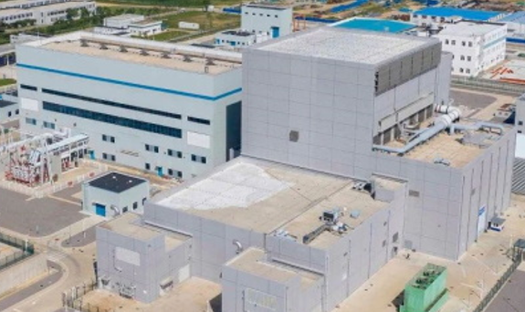
The traditional form of nuclear fission power is not popular in many nations due to meltdown risk. In theory, this can be resolved with advanced reactors that do not melt down, when not cooled. For instance, the nuclear fuel in China’s HTR-PM reactor, pictured here, includes an additive that reduces output power when cooling is lost, preventing the fuel from melting. This additional safety increases costs ~20%. However, additional cost-reduction could make this more tolerable.
Nuclear waste can also be reduced by spending more money. For example, allocating approximately 10% of the wholesale electricity cost for advanced waste processing could significantly decrease both the volume and the longevity of nuclear waste.
For a video that summarizes this chapter, see TCL Video #11.

Nuclear Power Markets
China and South Korea have constructed many nuclear reactors over recent decades, gaining expertise that allows them to build at relatively low costs. Conversely, the United States and Europe have been less active, resulting in less proficiency and higher costs. However, this lack of experience is not permanent. If nuclear power was used to solve the carbon dioxide problem, more construction would result in more proficiency and lower costs. Also, if construction was automated, this would naturally occur first in regions that are comfortable with nuclear power, and eventually spread to nations who are less comfortable.

Basic Concepts of Nuclear Power
Large nuclear power facilities typically host between three and six reactors, with each reactor commonly producing approximately one billion watts of electricity (1 GW_{e}). Given that an average U.S. household consumes about 1,000 watts, a single reactor can supply electricity to roughly one million homes. Additionally, the process of generating electricity from nuclear reactors typically requires about 2.5 watts of heat (2.5 W_{t}) to produce 1 watt of electricity (1 W_{e}).

Decarbonization Problem Size
We know how much energy is consumed worldwide each year, and we know how much is produced by a large 1 GW_{e} nuclear reactor. To get a sense of decarbonization problem size, we can divide these two numbers to calculate how many 1 GW_{e} reactors would be needed to replace global energy. The math works out to about 9,000 GW_{e} of nuclear power. This refers to all energy, not just electricity.

The Nuclear Solution
If, for example, nuclear power was used to decarbonize 50% of global energy over the next 30 years, approximately 150 GW_{e} of nuclear power would be constructed worldwide each year (50% × 9,000 GW_{e} ÷ 30 years). This would entail building 41 GW_{e} per year in China, 23 GW_{e} per year in the U.S., and 19 GW_{e} per year in Europe.
Over a 30-year span, China alone would add approximately 1,250 GW_{e} of nuclear capacity. If distributed across roughly 240 sites, each site would support approximately 5 GW_{e} (1,250 ÷ 240).
Current nuclear construction rates are about 7 GW_{e} per year in China, 0.15 GW_{e} per year in the U.S., and 0.17 GW_{e} per year in Europe. Therefore, to replace 50% of global energy over 30 years, annual construction rates would need to increase approximately 6-fold in China, 150-fold in the U.S., and 100-fold in Europe.
Calculations used in this chapter can be accessed here. For simplicity, they assume zero economic growth.

Nuclear Economics
The cost of new nuclear reactors in China is currently around $2 per watt ($2/W). In contrast, reactors in the U.S. and Europe are significantly more expensive, primarily due to less construction experience, rather than higher labor costs (as labor represents only a small fraction of total costs). Thus, reactor costs in the U.S. and Europe would likely approach Chinese levels if construction volumes were similarly high, adjusted for labor cost differences.
If global nuclear construction were scaled up to 150 GW_{e} per year, then cost-reduction due to automated construction could potentially offset the additional cost of higher quality (e.g., less meltdown risk, less waste). In other words, the $2/W cost could potentially continue, with 150 GW_{e} of annual construction costing $300B per year ($2/W × 150 GW_{e}). While this is a rough estimate, it provides a general sense of costs in a world more reliant on fission power.
We can compare a $300B per year nuclear cost with the annual cost of half of fossil fuel. Present global fossil fuel spending is around $4,000B per year. This includes $2,500B for oil (based on ~35 billion barrels annually at ~$70 per barrel), $1,000B for coal, and $500B for natural gas. While nuclear reactors are not a direct replacement, we see that $300B per year for new nuclear reactors, is less than $2,000B per year for half of fossil fuel.

Site Construction
The nuclear reactor vessel itself accounts for only a small fraction of total nuclear site costs. For example, the HTR-PM reactor vessel cost only 2% of total site cost in China. This works out to 5 pennies per Watt of capacity ($2.30 x 2%).
The majority of expenses arise from excavation, concrete pouring, and rebar installation. These costs could potentially be reduced through: (a) developing equipment that automates site construction, (b) building factories that make large subassemblies, and (c) creating equipment that transports subassemblies from factory to site.
For details, see Decarbonization R&D Videos.

Design One, Build Many
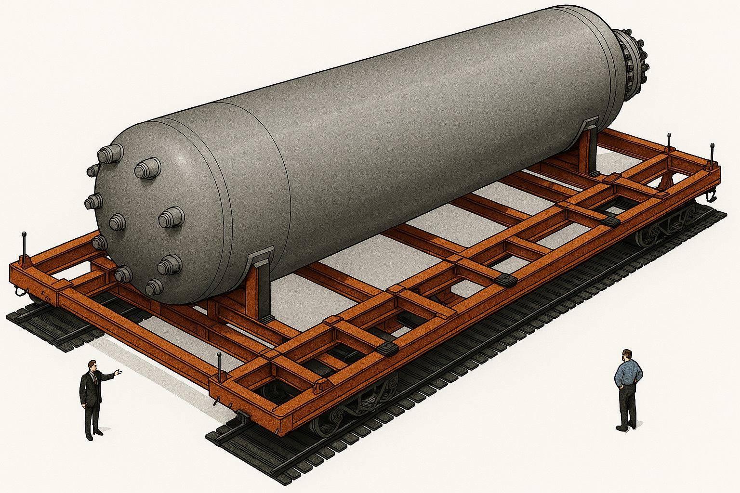
Engaging in a lengthy nuclear reactor design and certification process is unnecessary. Instead, one can copy an existing design. China's HTR-PM is a reasonable candidate since it is probably the safest commercially operating nuclear fission reactor in the world. In particular, it does not melt down if not cooled; its fuel and coolant do not react with air or water; and its helium gas coolant is not radioactive. In the event coolant is lost, the core radiates heat outward to the metal containment vessel, which then radiates heat to the concrete containment chamber, which conducts heat to bedrock. The HTR-PM reactor took 20 years to develop and repeating this process is not necessary.

New Transportation System
In theory, a new transportation system could be developed to move large and heavy loads over land and water, to better connect factories to nuclear power sites. For example, a 12m wide by 24m long railcar on double-rails could potentially transport: (a) large nuclear reactor components, (b) bins of concrete, (c) concrete forms, (d) rebar subassemblies, and (e) large automated construction equipment.
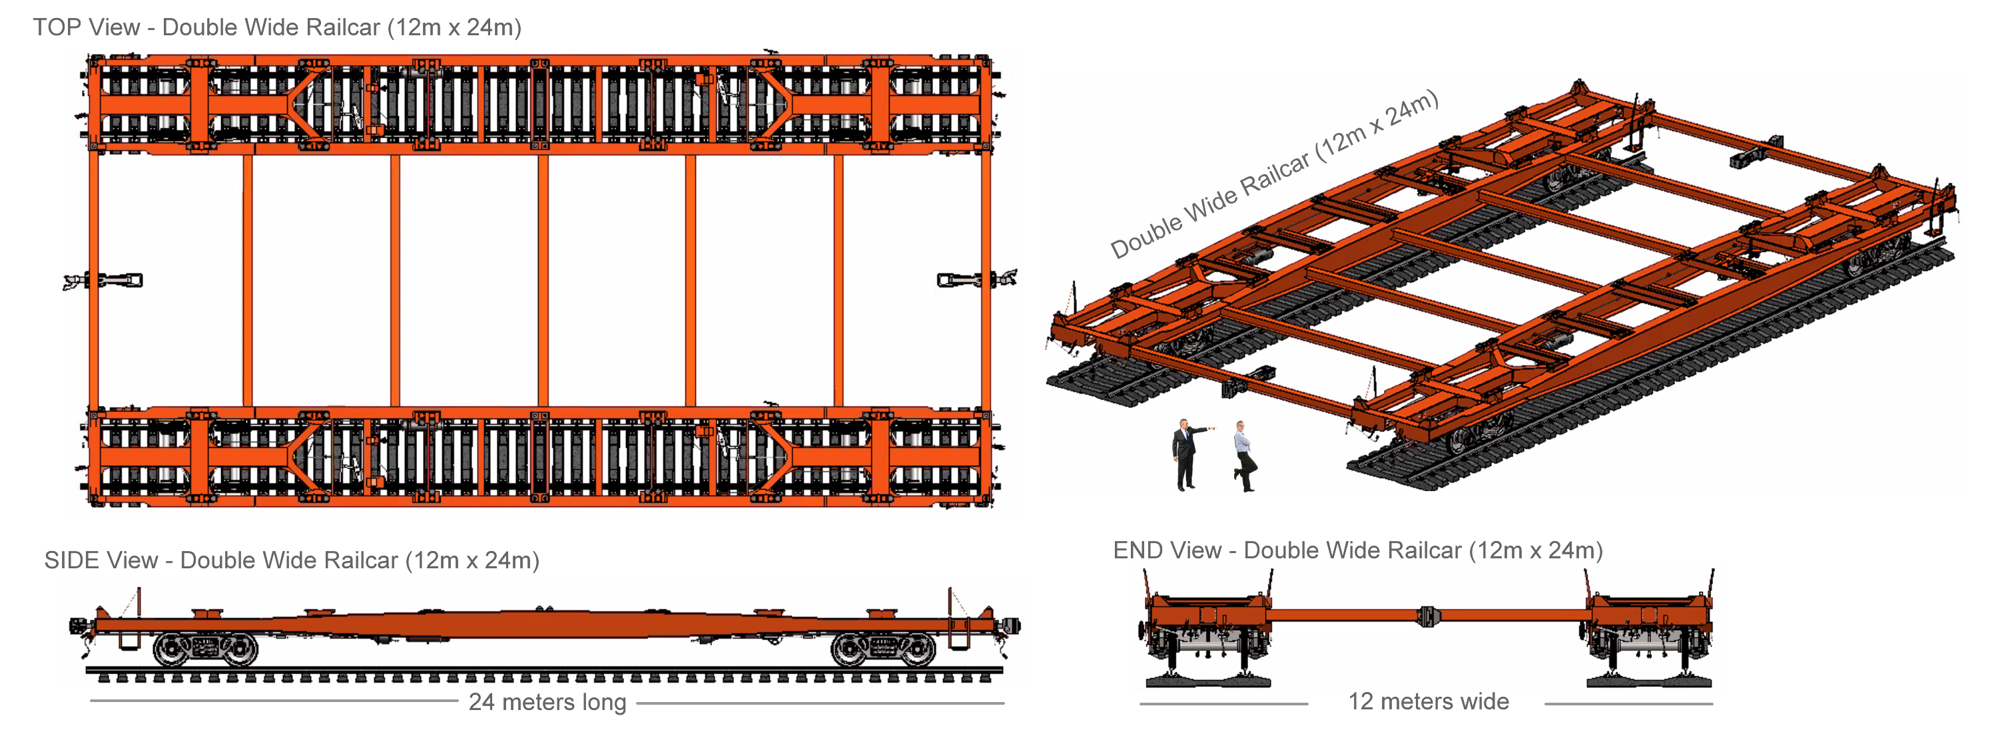
Figure 13.1: Double-width railcar. Concept illustration by G. Weinreb.
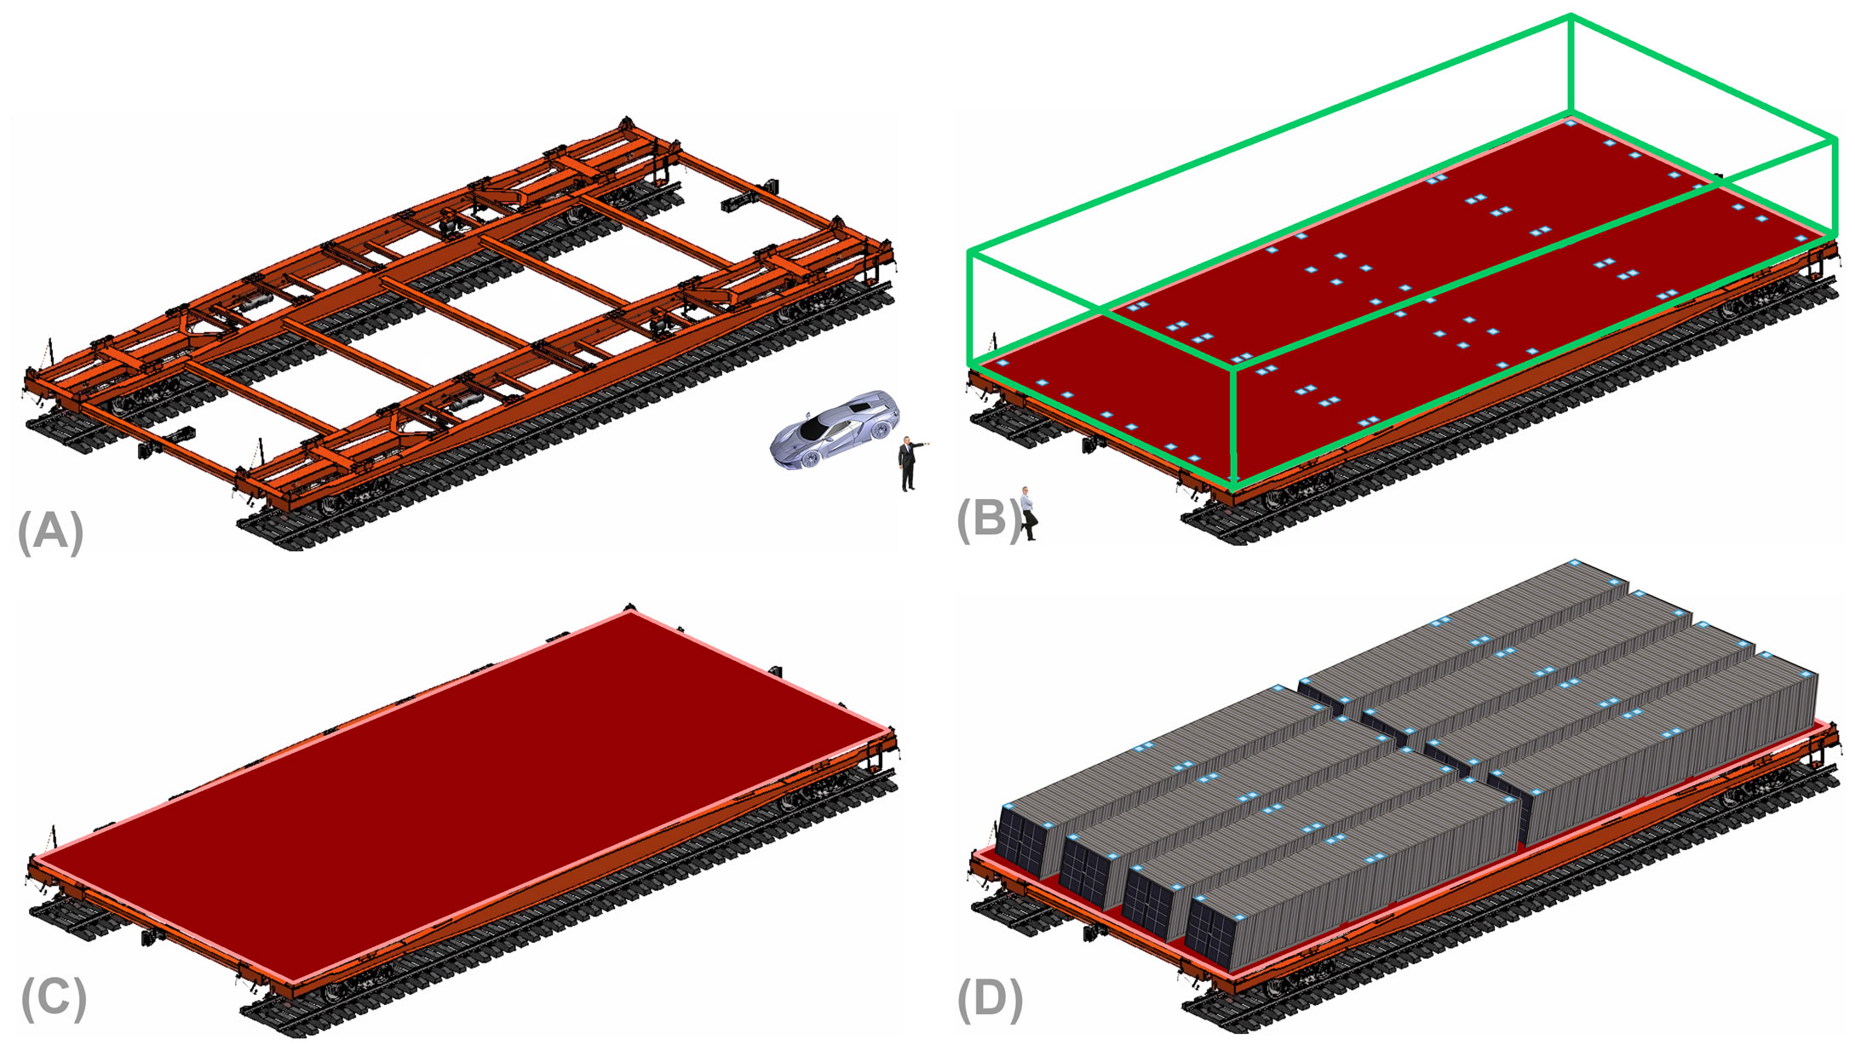
Figure 13.2: A large railcar could be adapted to support: (A) base frame, (B) large container, (C) flat working surface, and (D) multiple shipping containers.

Automate Nuclear Power Construction (A4)
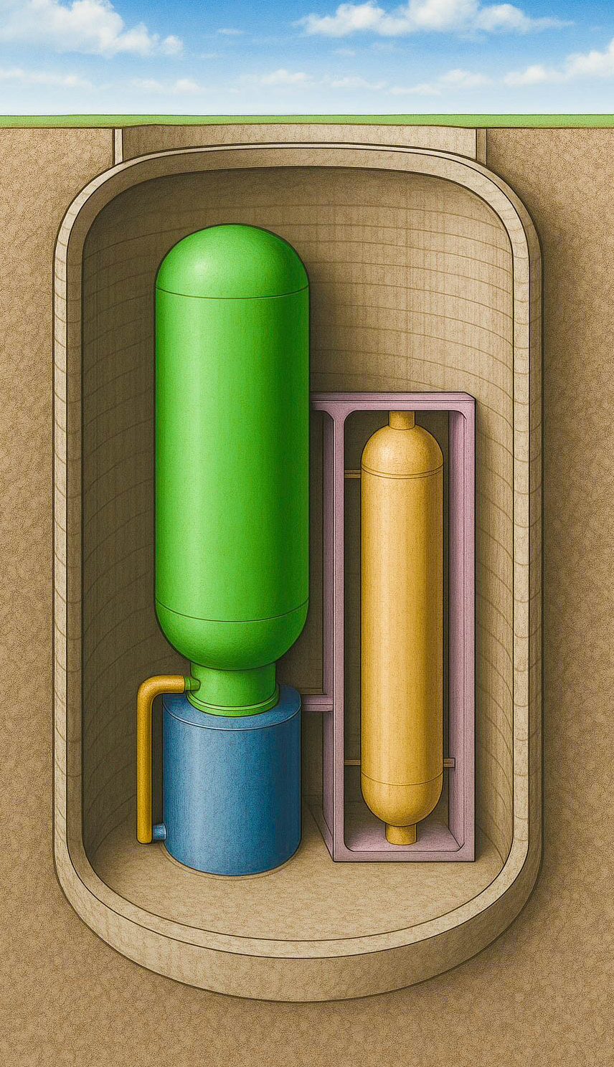
Nuclear fission reactors typically require significant amounts of concrete and rebar, in part because they need to withstand attacks from missiles and airplanes. In principle, these costs could be reduced by placing the reactor vessel underground, inside a concrete-lined chamber, surrounded by bedrock. Achieving this affordably would probably require the development of specialized machines that automate: excavation, installation of concrete lining, and assembly of reactor components. For details, see videos #11 and #12; and for a billion-dollar sized proposal, click here.

Rethinking Nuclear Fission
It typically cost more to build underground. However, this might not hold true for gas-cooled nuclear fission reactors that are built with machines that automate construction.
Traditional reactors are cooled with pressurized water; however, several advanced designs instead use helium gas.
Gas carries less heat per unit volume compared to water, and therefore gas-cooled reactors are physically larger than their water-cooled counterparts. Consequently, their nuclear fuel is more spread out, which helps them not melt when not cooled. More specifically, in the event coolant is lost in a gas-cooled reactor, decay heat is moved via radiation to concrete chamber walls, to bedrock, without melting. Alternately, water-cooled reactors are dependent on external systems that must be protected against airplane attack, significantly driving up costs. For details, see this video.

Automated Excavation and Concrete Installation
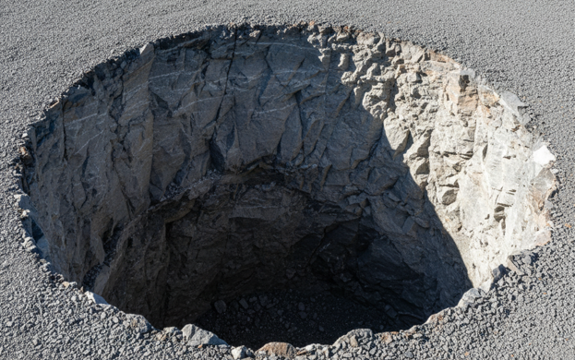

A cost-effective underground approach would involve developing specialized machinery that excavates in bedrock and installs a concrete lining. Rebar and formwork assemblies could be prefabricated within a factory, transported to the site, lowered into the excavated cavity, and then filled with wet concrete.

Concrete Example
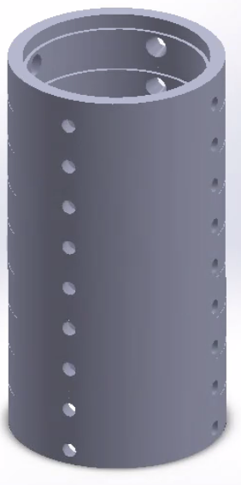
Let's examine some numbers to get a better sense of this. An example of a commercially operating gas-cooled reactor is the HTR-PM, with a 24m tall by 7m diameter reactor vessel, and a 22m tall by 4.5m diameter heat exchanger (drawing). In theory, these could be arranged side-by-side or stacked vertically, and the containment structure shape could either be cylindrical or rectangular.
Assuming a vertical arrangement, let's position the reactor vessel and heat exchanger within a 50m-deep cylindrical chamber, 12m in diameter. According to the math, a 1m thick concrete lining would weighing approximately 2,700 metric tons.
Standard railcars typically support around 125 tons, and their capacity can be increased with more axels. Thus, double-width railcars should be able to support several hundred tons, or more weight with more axels.
A bin measuring 20m × 10m × 1m weighs 200 tons when filled with water, 288 tons when filled with dry cement powder, and 320 tons when filled with dry aggregate gravel. Therefore, roughly 14 double-width railcars of material would be needed to make the concrete lining described above.

Concrete Strategy
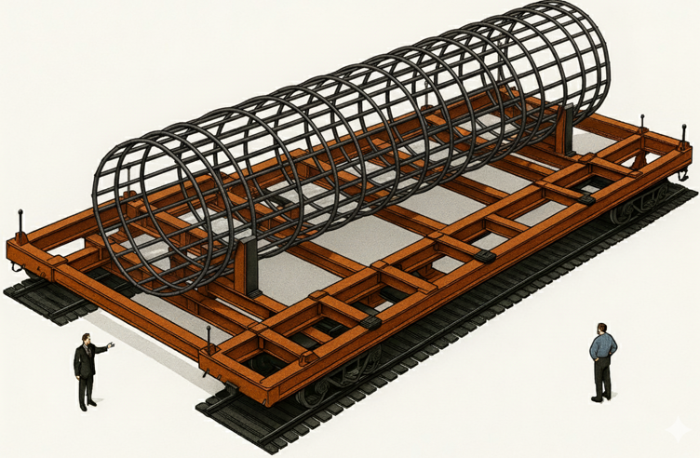
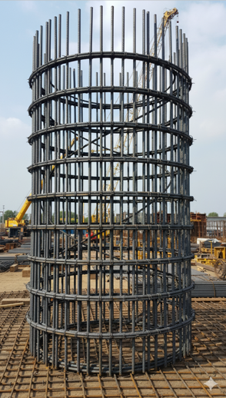
There are two primary methods for concrete construction: precast segments and on-site casting. The first approach involves molding large concrete segments with protruding rebar at an off-site factory, transporting to the construction site, and then joining with wet concrete. The second approach entails manufacturing rebar cages and formwork in a factory, transporting to the site, and pouring wet concrete to form a solid structure. In theory, custom machines could be developed that support both methods.

Excavation
There are two primary methods for excavating bedrock: blasting and mechanical excavation. Blasting uses explosives to fracture rock, while mechanical excavation uses machinery to cut and remove material in a controlled manner. Costs can vary significantly, reaching up to approximately $250 per cubic meter of rock. However, based on calculations, bedrock excavation would cost less than 2% of total site costs.

Excavation Support
Custom machines are needed to break bedrock, remove debris, install a concrete lining, and install nuclear components. This would probably require a gantry-like crane system that lowers custom machines into an excavation, an example of which is shown below. In this illustration, the cylinder-shaped excavation is depicted in blue, and a custom machine being lowered into the excavation is shown in orange.
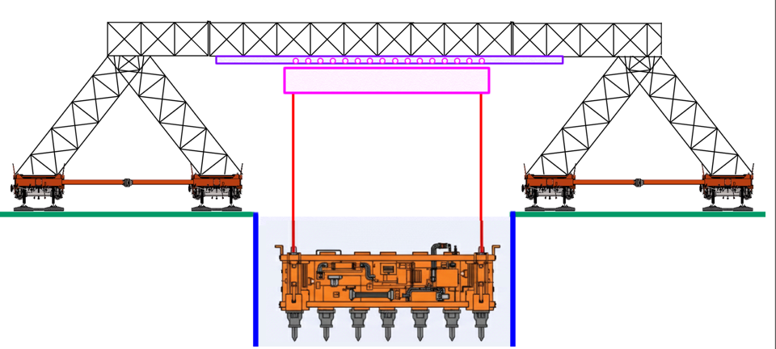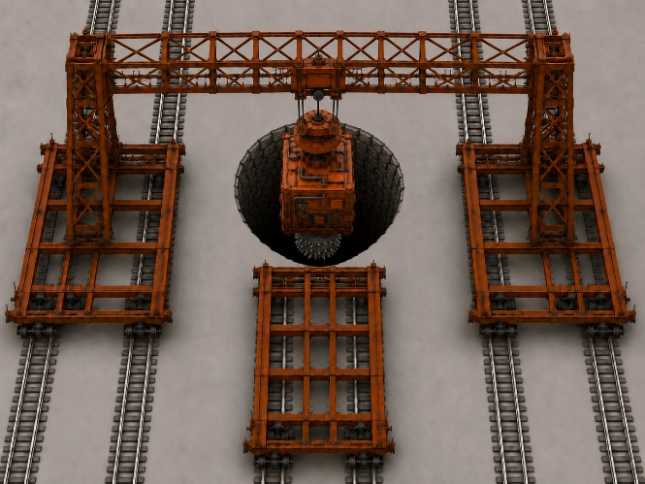
Figure 14.1: Gantry-like crane supports excavation.
Custom machines would perform several key functions: (a) excavation support, including breaking and removing bedrock; (b) concrete lining installation, such as placing rebar cages and pouring wet concrete; and (c) installation of subassemblies. These machines would operate within the excavation under the control of the gantry crane system, enabling precise placement and sequencing of tasks.

Gantry-Like Crane
In theory, a truss mounted on two synchronized railcars could span the excavation and implement a crane system. A trolley could move along the truss to enable Y-axis movement, railcars could provide motion along the X-axis, and motorized hoists could provide Z-axis vertical positioning.
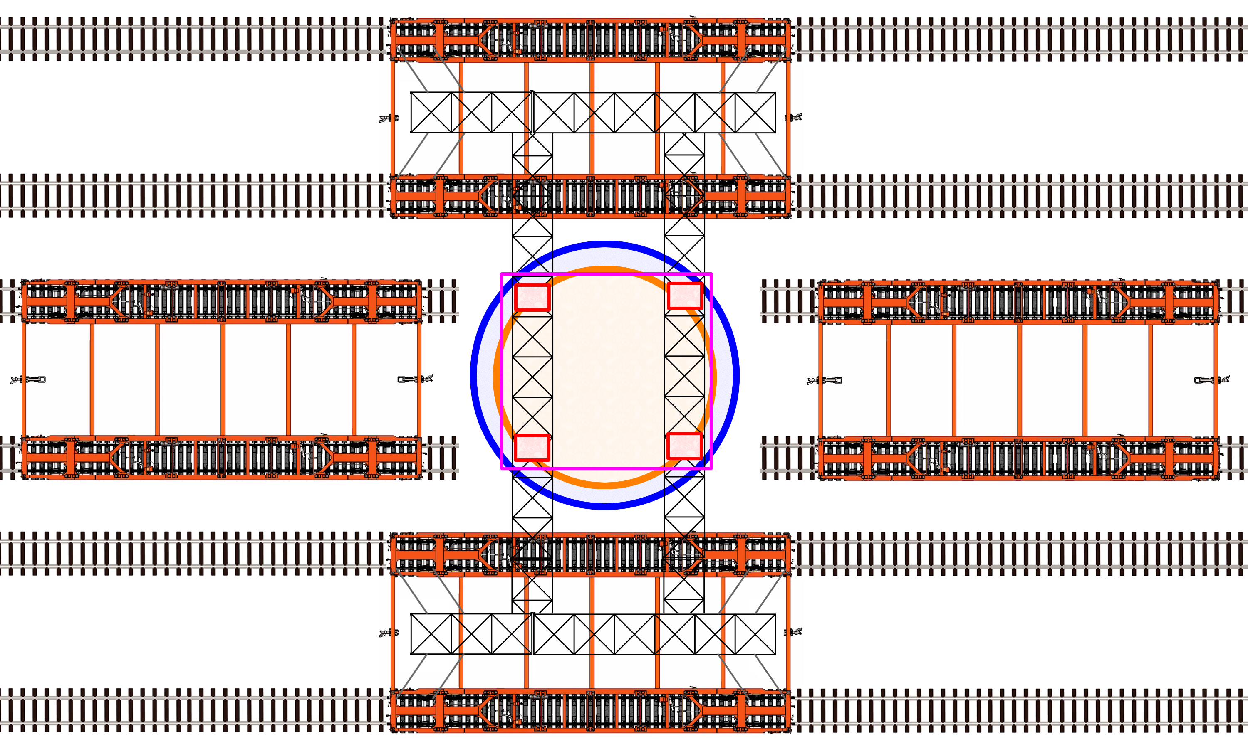
Figure 14.2: Top view of excavation.
In the above concept, additional railcars support material handling and machine exchange. For example, a rock removal machine could be retrieved from one support car, lowered into the excavation, and used to transport material via conveyor to a bin on another support railcar.

Nuclear Containment
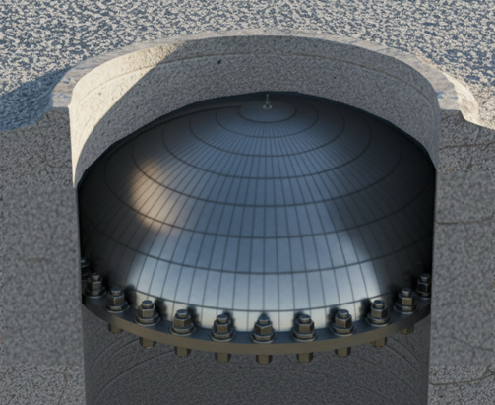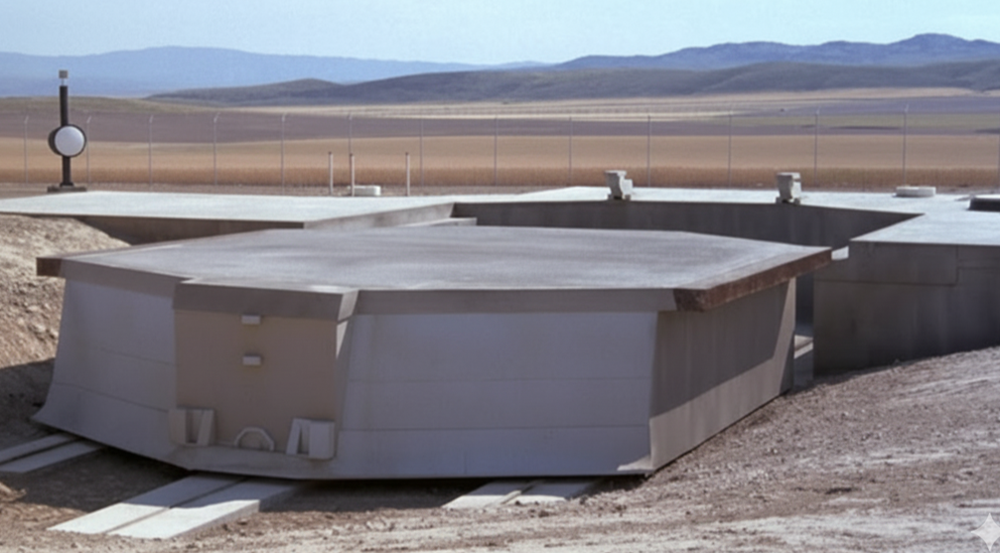
The primary functions of the containment structure are to withstand airplane attacks and to contain radiation under pressure in the event of system failure. To hold pressure, a dome-shaped seal could be bolted to the top; and to protect against attack, a retractable concrete block could be placed above it.

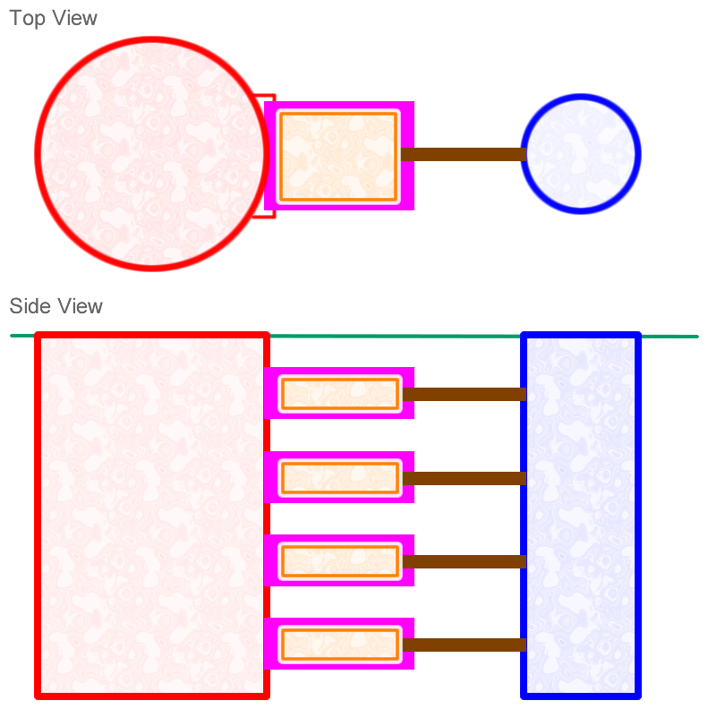
Support Equipment
Nuclear reactors require various support systems, including pumps, electrical power generators, monitoring instruments, control systems, and nuclear fuel storage. In theory, these could be housed in a separate “equipment excavation,” while reactor vessels and heat exchangers are kept in “power excavations.”
Support systems could be preassembled within factory-made metal enclosures that are transported to the site, lowered into the equipment excavation, and slid into pre-positioned concrete boxes.
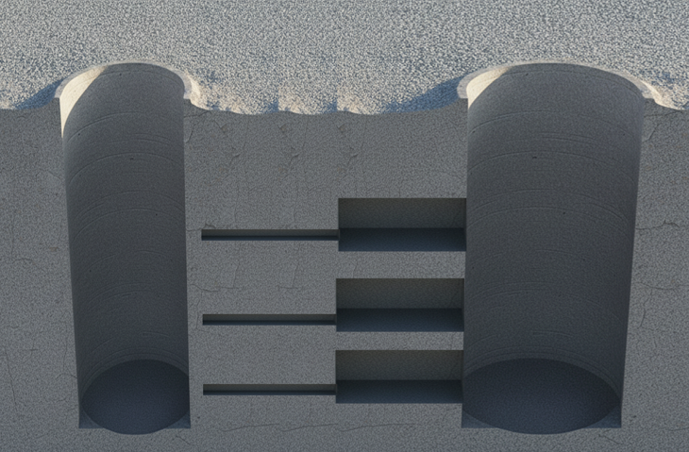
This is illustrated here with power excavations shown in blue, equipment excavations shown in red, concrete boxes shown in violet, metal equipment boxes shown in orange, and connecting tunnels shown in brown.
In theory, a custom machine could excavate rectangular chambers in the side of the equipment excavation. A second machine could install factory-made concrete boxes to prevent bedrock collapse. A third machine could pump wet concrete between bedrock and concrete boxes to affix in place. And a forth machine could install metal equipment boxes.

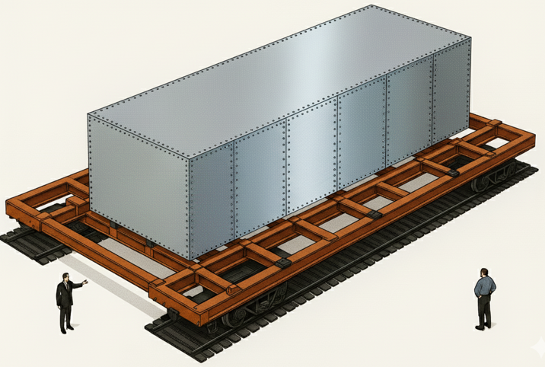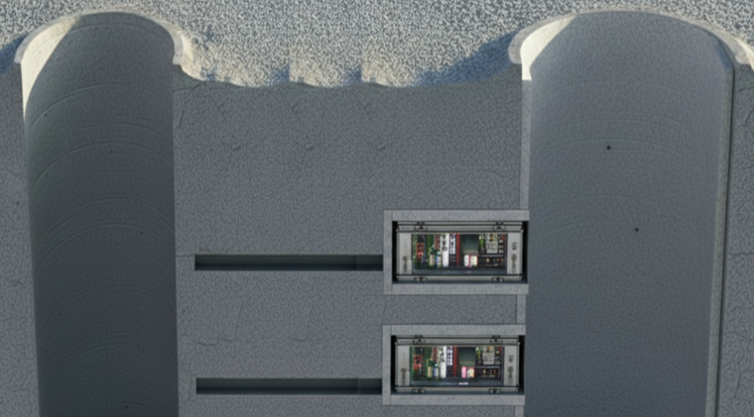

Site Design
To reduce costs, multiple power excavations could be positioned around a single central equipment excavation, as shown below.
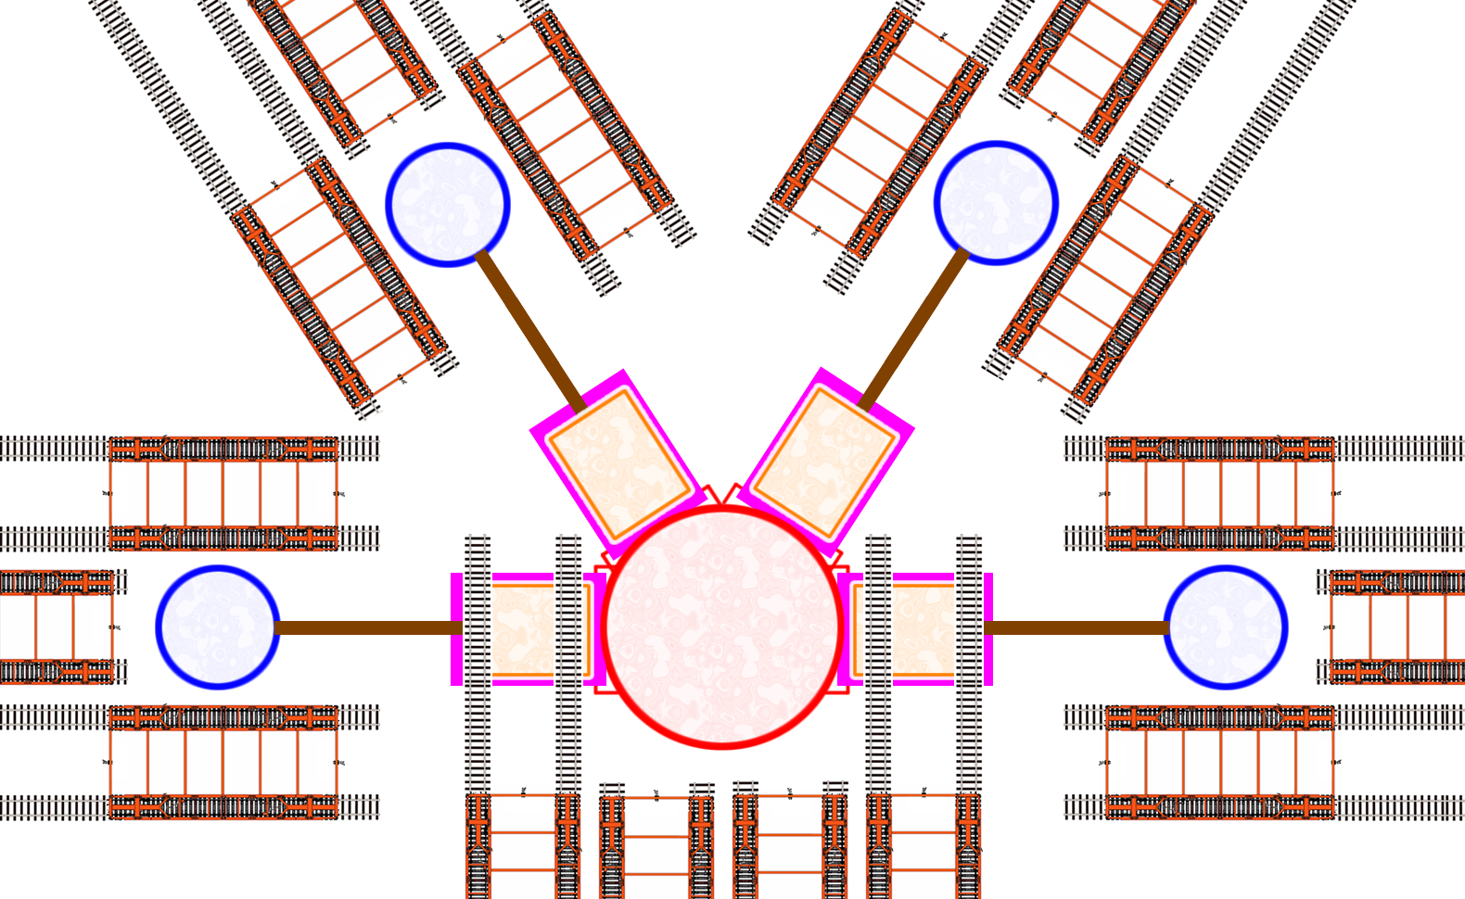
Figure 14.3: Top view of nuclear power system. Concept illustration by G. Weinreb.
A preliminary estimate finds this approach would consume 9-times less concrete-per-unit-electricity than Vogtle 4, and 26-times less concrete-per-unit-electricity than Hinkley C. In other words, less concrete is needed when mission-critical infrastructure is kept close to gas-cooled reactors.


Excavation Alignment
Excavation might begin by drilling multiple ~1m diameter pilot holes outside the excavation, as shown here. Rails could be installed in these holes to guide custom machines that break rock and remove rock. Wheels on the machines could slide within the rails to ensure alignment. In this illustration, the excavated cylinder is shown in blue, pilot holes are shown in gold, rails are shown in red, wheels are shown in black, and the custom machine is shown in orange.

Precision Excavation
Traditional excavation methods are often imprecise, while a surface accurate to ±1 cm might be preferred. Therefore, crude excavation methods might be used to remove bulk material, followed by more precise methods. For example, a custom machine with a rotating cutting head could be used to refine the excavated surface to a higher precision, as shown in Figure 14.4. In this illustration, a custom machine is shown in orange, a rotating assembly in green, a bearing in yellow, and cutting heads in red.
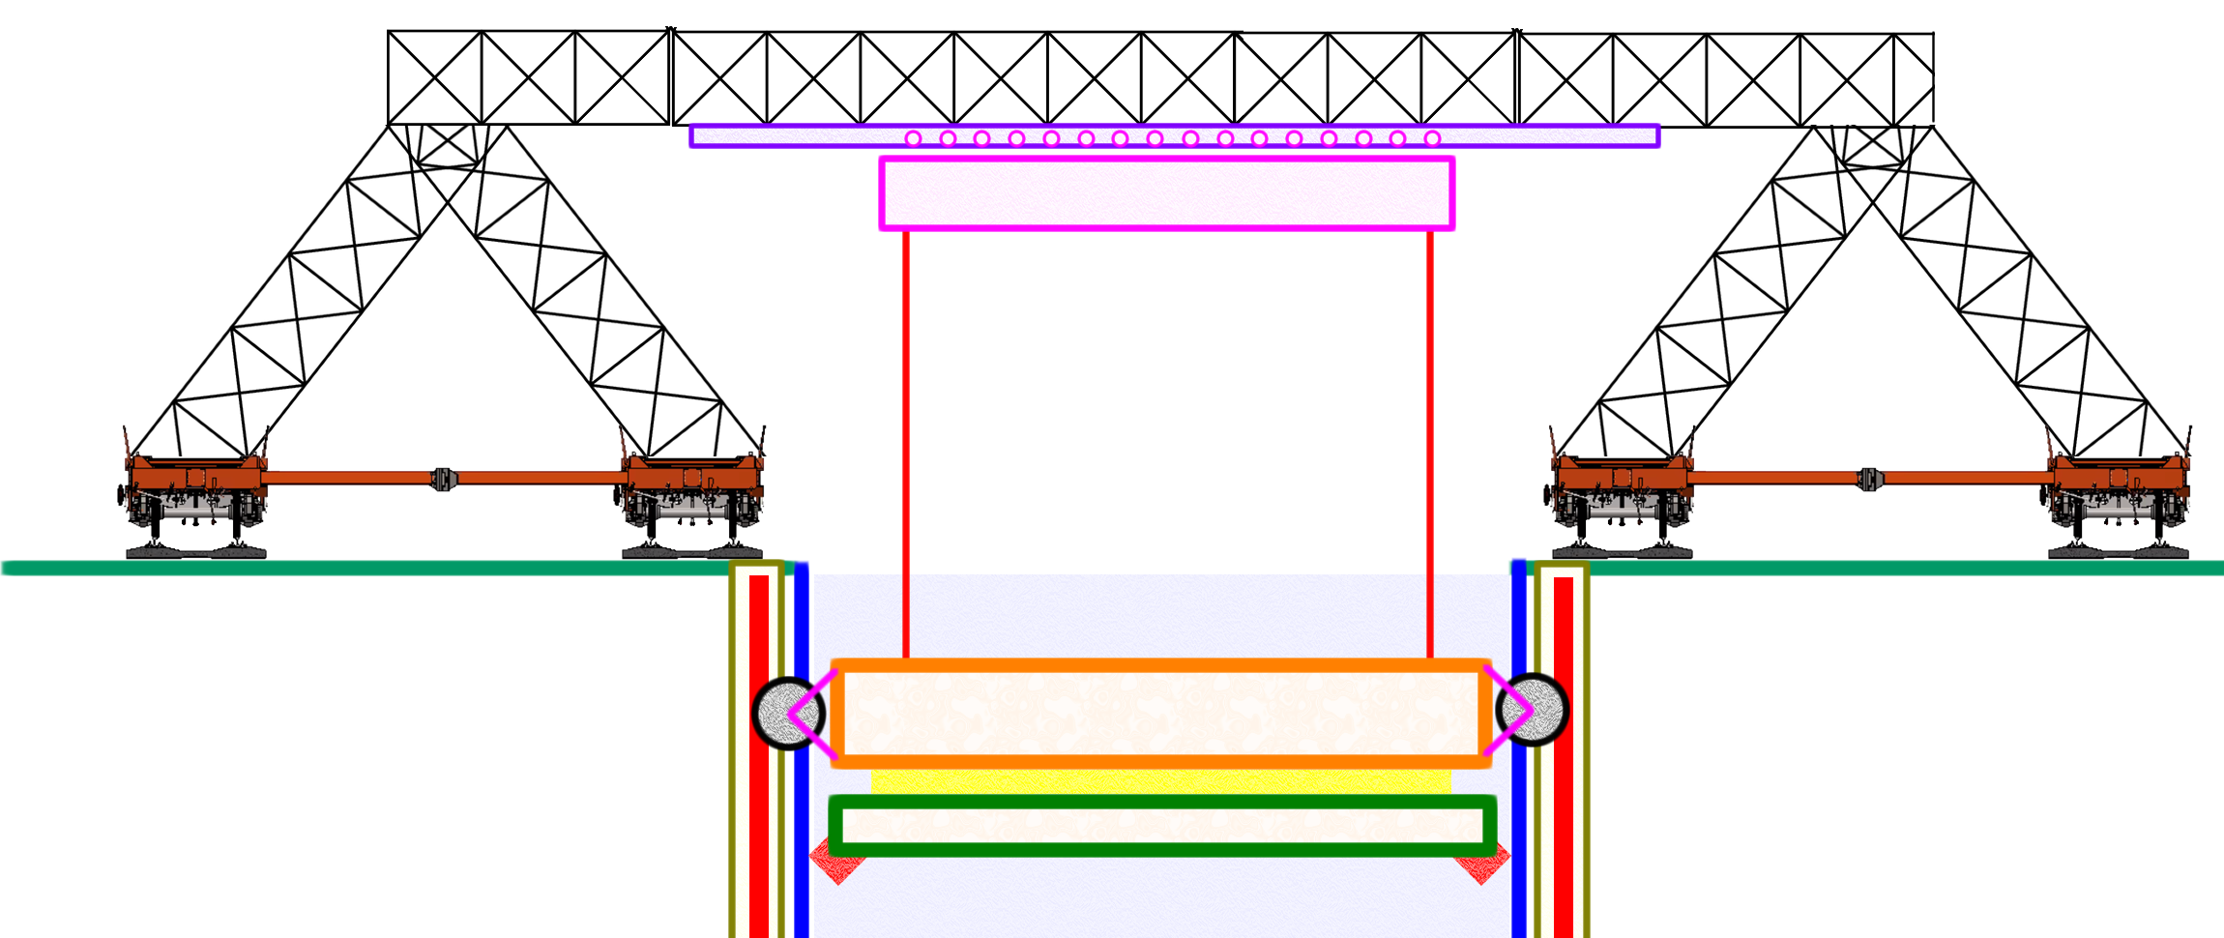
Figure 14.4: Side view of precision excavation machine.

Power Generation
Heat from nuclear reactors creates steam, which presses on fan turbine blades, which produces electricity. The electrical turbine could be located either above ground, or below ground within the equipment excavation. In theory, custom machines could support both methods.

Robot Support
In theory, AI-based robots could oversee nuclear site construction, factory construction, and factory production.

R&D Funds: Automate Nuclear Power Construction (ANPC)
- R&D Fund: Underground Nuclear Power Site Design
Support the design of nuclear power plants that embed gas-cooled fission reactors in bedrock, and automate site construction.
- R&D Fund: Nuclear Power Automated Construction R&D
Support the development of custom machines that automate the construction of nuclear fission power plants.

Co-locate Chemical Processing with Nuclear Power (A5)
Large platforms of chemical processing equipment could theoretically be co-located with nuclear power plants, and powered by heat transported through pipes carrying steam or molten salt. For instance, platforms measuring 12m wide by 96m long could be transported via double-rail and positioned side-by-side near the reactor (Figure 15.1). Site-wide efficiency could be maximized by capturing unused heat and redirecting it to generate electricity, produce chemicals, or increase the temperature of thermal storage. In theory, platforms of chemical processing equipment could support the production of common chemicals, including hydrogen gas, liquid ammonia, methanol, ethylene, sulfuric acid, chlorine, caustic soda, and cement. For details, see video #13; and for a billion-dollar sized proposal, click here.
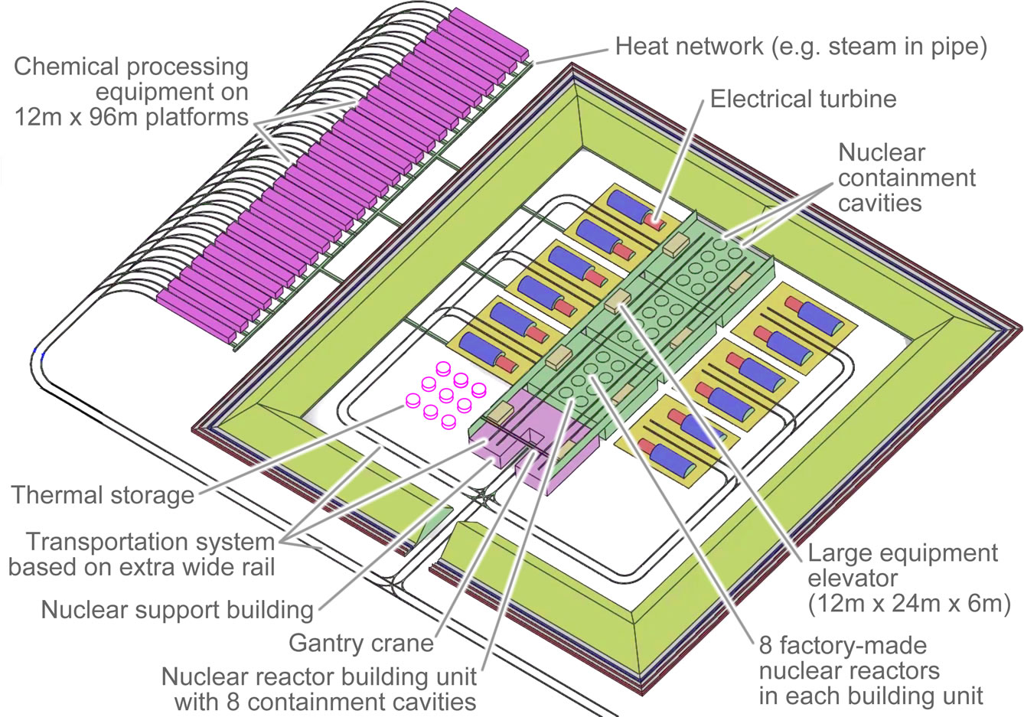
Figure 15.1: Nuclear reactors co-located with multiple platforms of chemical processing equipment. Concept illustration by G. Weinreb.

Chemical Processing Yard
In theory, chemical processing platforms could be positioned side-by-side, as shown below. In this illustration, platforms are shown in green, pipes carrying heat from the nuclear reactors are shown in blue, underground tunnels that support pipes in between platforms are shown in light violet, and underground tunnels that support moving material into and out of the chemical processing platforms are shown in light purple.
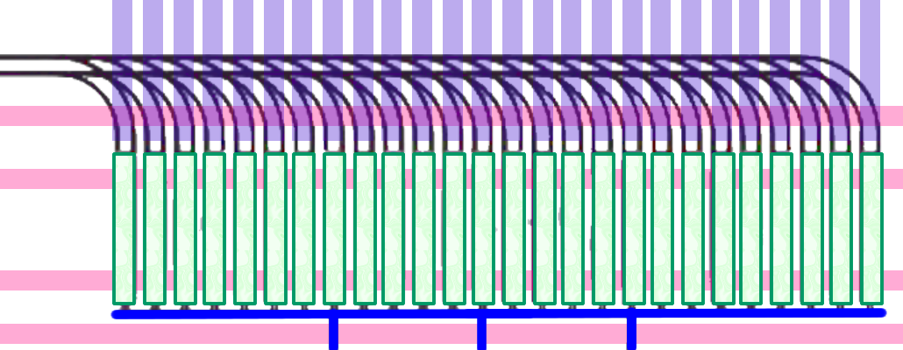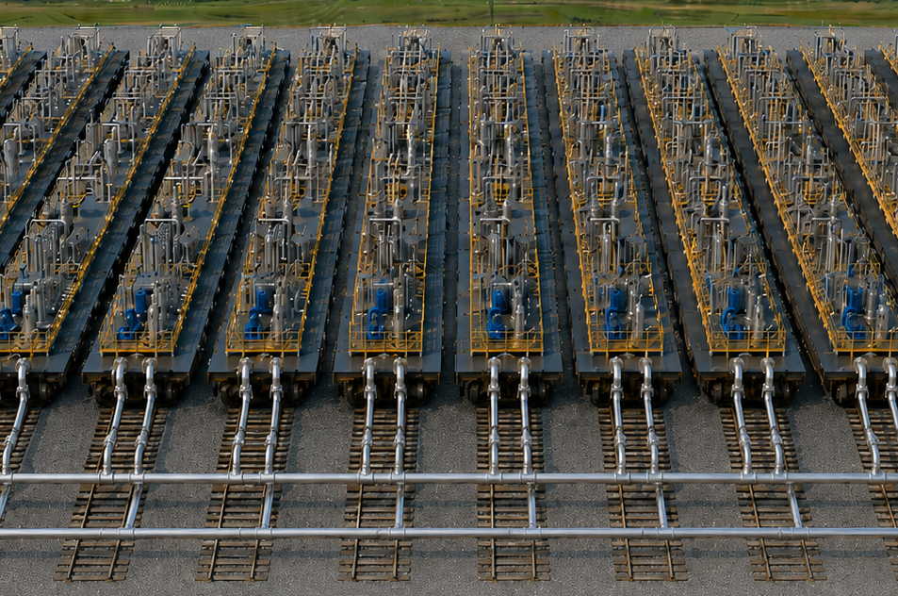
Figure 15.2: Chemical processing yard consists of processing platforms side-by-side.
There are two primary approaches to underground tunnel construction. One method involves manufacturing precast concrete modules at an off-site factory, transporting them to the site, and joining them with more concrete. Alternatively, rebar cages and forms could be assembled off-site, transported to the site, and then filled with wet concrete. Specialized equipment and factories could be developed that support both methods.

Platform Transporter
In theory, equipment could be developed that moves 12m × 96m platforms across land via double-rail, and across water via specially built ships. To prevent bending when traveling over hills or around curves, these platforms could be mounted on a ridged truss supported by jacks between the truss and railcars, as illustrated below.
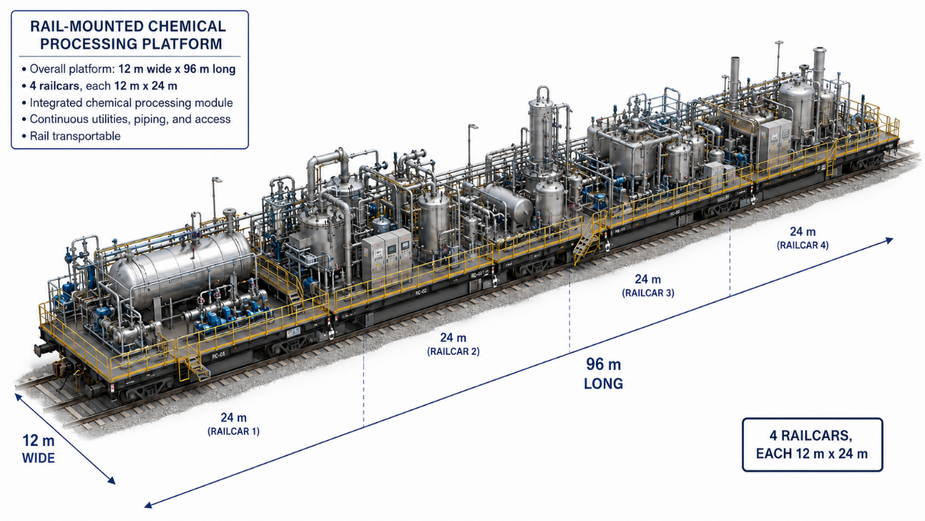
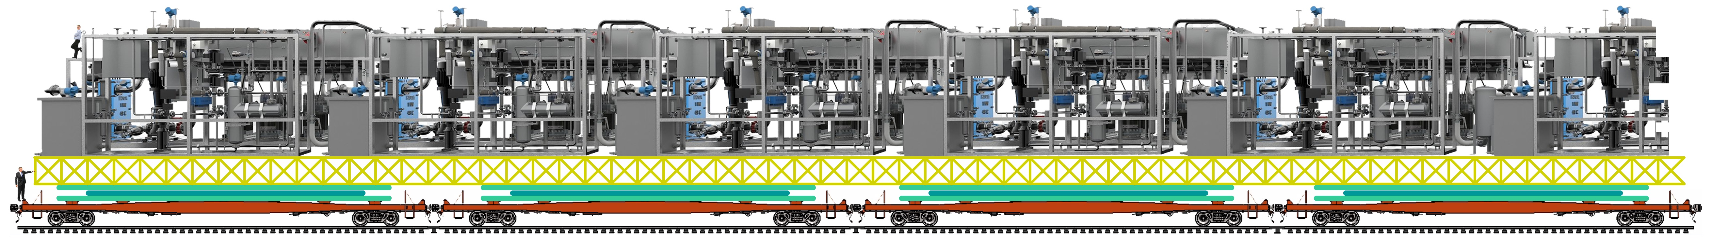
Figure 15.3: Concept illustration of chemical processing platform transported on a rigid truss, mounted on four double-width railcars.

Thermal Storage
When electricity demand is low, nuclear reactors can increase the temperature of a hot liquid in a thermal storage tank; and when electricity demand is high, the stored energy can be used to make electricity. In other words, to minimize costs, thermal storage can bridge the gap between fluctuating demand and constant supply. Also, thermal storage can minimize waste heat by consuming it when available at a temperature higher than the storage temperature. In theory, R&D could reduce thermal storage costs by supporting the development of equipment that automates the construction of thermal storage tanks.

R&D Funds: Co-locate Chemical Processing with Nuclear Power (CPNP)
- R&D Fund: Chemical Processing Platform Design
Support the development of large chemical processing platforms (e.g., 12m × 96m) that produce common chemicals.
- R&D Fund: Chemical Processing Platform Factory Design
Support the development of an automated factory that builds large chemical processing platforms.
- R&D Fund: Chemical Processing Site Design
Support the development of chemical processing yards which support multiple platforms.
- R&D Fund: Chemical Processing Platform Standards Development
Support the development of plug-and-play standards that define how heat sources (e.g., fission reactors) connect to adjacent platforms of chemical processing equipment.
- R&D Fund: Chemical Processing Platform Transportation R&D
Support the creation of a transportation system that moves large platforms of chemical processing equipment from factories to power generation sites.
- R&D Fund: Double-Rail Transportation R&D
Support the development of equipment that supports double-rail transportation (e.g., railcars, special purpose-built ships, equipment that moves cargo from ship to shore, and interconnection standards).
- R&D Fund: Double-Rail Concrete Processing R&D
Support the development of concrete processing equipment that resides on double-railcars (e.g., machines that mix water, gravel and dry cement; along with bins/tanks that contain these ingredients).
- R&D Fund: Automated Thermal Storage Construction R&D
Support the development of custom machines that build thermal storage tanks (e.g., large factory-made subassemblies are joined on-site by custom machines).

Economic Fusion Moonshot (A6)
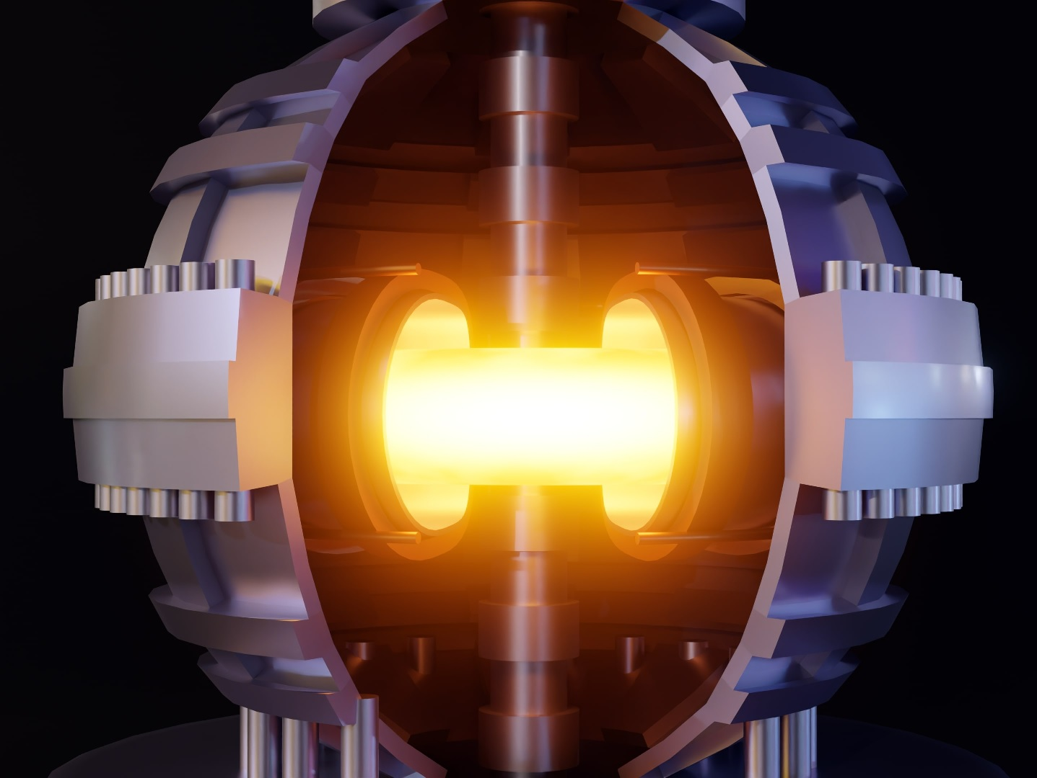
There are two primary types of nuclear power: fission and fusion.
Fission is the traditional form that generates electricity with uranium fuel. However, this is not popular due to meltdown risk, nuclear waste, nuclear bomb proliferation risk, and cost.
Fusion, on the other hand, does not have these issues; however, it is still in development. Typical fusion systems maintain a hot plasma within a donut-shaped reactor, as illustrated here.

Commercial Fusion
Some scientists believe fusion power will not become commercially viable for another 20 years. However, a multi-billion-dollar R&D initiative, overseen by the world's top scientists, could potentially accelerate development.
TCL defines “commercial fusion” as generating electricity with fusion at a cost below that of fossil fuel-based electricity. Scientists refer to this as “economic fusion”, and it requires the fusion machine to operate reliably for extended periods, without failure, while keeping costs low.
If green energy were cheaper than fossil fuels, nations would have a powerful incentive to decarbonize, to save money, to remain competitive, to keep voters employed. In other words, cheaper green energy could potentially solve the carbon dioxide emissions problem.
Current fusion machines take years to construct and operate for seconds to minutes per experiment. Many scientists hope this will lead to economic fusion within a few decades. Alternatively, a surge of funding in key areas could potentially change this trajectory. For details, see video #14; and for a billion-dollar sized proposal, click here.

Fusion Moonshot
Harm from climate change is likely to cost trillions of dollars; therefore, it is reasonable for governments and foundations to allocate billions of dollars to achieve economic fusion within several years. While this might seem unrealistic, consider the remarkable number of “gadgets” the U.S. designed and manufactured between 1939 and 1945.
In 1961, President Kennedy declared his goal to land a man on the moon by the end of the decade. In response, a program was established and funded. In theory, a similar approach could be applied to economic fusion.
But how might our society tackle fusion R&D differently? Let's explore.

Tokamak vs. Stellarator
The tokamak and the stellarator are two fusion designs that could potentially produce large amounts of electricity in the near future. The tokamak features a donut-like shape, while the stellarator is more bumpy.
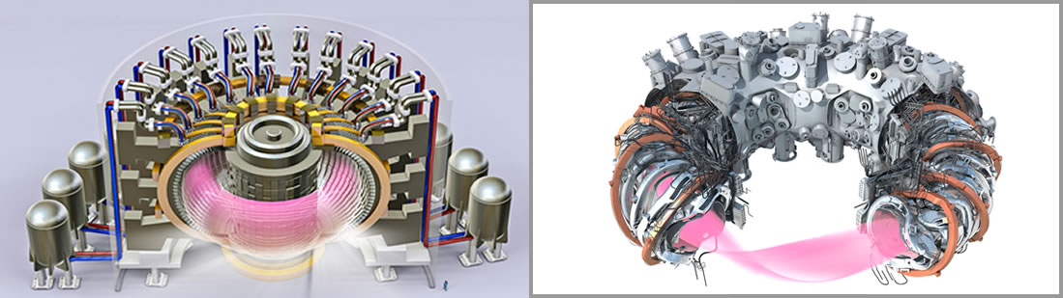
Figure 16.1: Tokamak (left) and stellarator (right).
These two approaches to fusion might seem to differ by bumpiness. However, upon careful inspection, one might notice additional gadgetry in the middle of the tokamak. This is used to maintain an extraordinarily high current—approximately 10 million amperes—within the plasma.
Sustaining such currents is no small feat. For context, a typical household vacuum cleaner draws about 10 amps, making tokamak currents equivalent to a million vacuum cleaners operating simultaneously. If a "disruption" occurs and this current inadvertently contacts the containment vessel wall, severe damage can result. Tokamaks must contend with this risk; however, plasma in stellarators do not have these currents, and are therefore easier to maintain.

Damage is Bad
Damage within high-energy fusion devices is especially problematic because internal components typically become radioactive during operation. Radioactivity results from neutron activation and from the absorption of radioactive tritium gas into surfaces, which later outgas. As a result, human contact with these components must be avoided for many years after the reactor begins operation.
If ITER, a major tokamak project, experiences damage after starting high-energy operations (expected around 2034), repairs might be impossible due to radioactivity hazards. In other words, due to worker safety, the site might need to be abandoned—despite its roughly 50-year construction period.

Cost Advantages of Stellarators
Cost models estimate the cost to generate electricity with a tokamak and with a stellarator, and according to Princeton Plasma Physics Laboratory (PPPL) Director Steven Cowley, “stellarator cost models beat tokamak every time—but it is at a very low technology level.”
In other words, stellarators are less expensive. Their cost advantages stem from several factors: (a) they do not require the central gadgetry found in tokamaks, (b) they avoid the need to periodically replace central magnets damaged by neutrons, (c) they are not prone to disruptions that damage internal surfaces, and (d) they do not require external microwave power to sustain the plasma.

Making Electricity
The heat from a fusion reactor core needs to be moved outward, to create steam, to press on fan turbine blades, to produce electricity. The easiest way to do this is to pump fluids, such as molten lead or molten salt, toward the hot plasma, and then outward.
To produce electricity cost-effectively, the energy output from the plasma must exceed the energy input (plasma gain > 1), and the electrical power generated by the site must surpass the electrical power consumed (engineering gain > 1). This requires powerful magnets and adequate plasma confinement, both of which are reasonably well understood by scientists.

First Wall
There are two primary methods for handling the plasma-facing “first wall.” One involves flowing liquid directly in front of a metal plate, and the other involves flowing liquid behind a metal plate.
Liquid Metal Wall
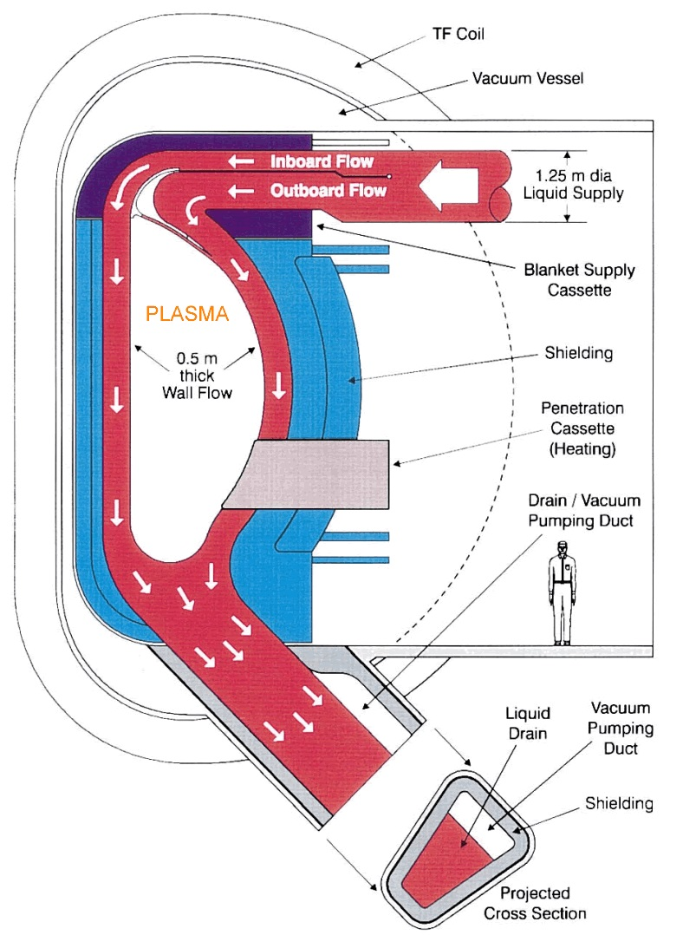
In theory, a roughly 0.5m thick layer of flowing molten lithium metal could cover the internal surface of the plasma containment chamber. This would be held in place by electric currents in the liquid metal itself.

Figure 16.2: Plasma radiates against liquid wall (red), held in place against metal plate (blue) by electrical currents and by magnet fields. This image first appeared in a 2001 paper by Dr. Mohamed Abdou.

Pushing Liquid Outward
As one might recall from physics class, a force is exerted on a current-carrying conductor in the presence of a magnetic field. In other words, one can embed posts within a fluid, move current between the posts, and maintain an evenly distributed wall of liquid by pushing it toward the plate, even if the plate is above the fluid.
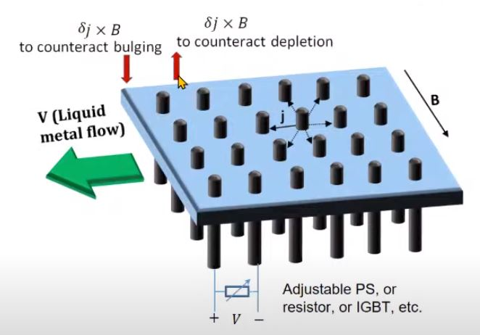
Figure 16.3: Flowing liquid is pushed toward plate by surrounding magnetic field and by electrical currents between posts. Courtesy Renaissance Fusion.
Internal Cooling System
The alternative cooling method is to expose a thin (~2mm) metal plate to neutron radiation, and cool it by flowing molten liquid along its back surface. However, the neutrons cause the metal plate to become brittle, requiring replacement every one to five years. Frequent replacement necessitates disassembly, which is both challenging and expensive. Therefore, it is more cost-effective to protect the metal plate with a flowing liquid metal wall, and only assemble the machine once during its lifetime.
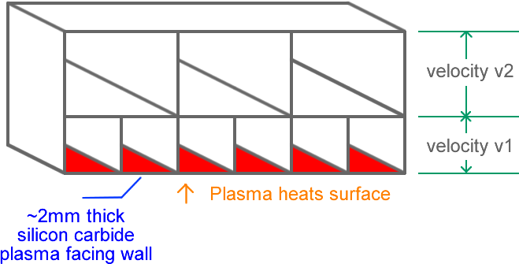
Figure 16.4: Liquid flows in channels behind metal plate (red) and removes heat.
Concept illustration by G. Weinreb.
Liquid Metal Wall vs. Internal Cooling System
There is a limit to how much power one can radiate against a metal plate. In theory, more power can be radiated against a wall of flowing liquid metal. Additionally, increasing the power per square meter of internal wall surface area reduces the reactor's physical size for a fixed amount of total power. This is good, since smaller physical size costs less to build.
In summary, a flowing liquid metal wall offers substantial advantages: improved heat removal, avoid component embrittlement, avoid neutron activation, smaller reactor size, and no disassembly—all resulting in lower costs. Nevertheless, liquid metal wall technology is relatively new, and more experiments are needed to validate feasibility and identify optimal materials, both liquid and solid. This area of research should be prioritized, as it could significantly influence reactor designs.
For details, see liquid metal wall video, tutorial, design and theory.

Magnet Making Machines
Fusion devices contain large, expensive magnets whose cost could be reduced by developing specialized machines capable of: (a) producing superconducting REBCO-like tape more quickly and at a lower cost, (b) print wide 2cm to 2m conductors onto a rotating tube, (c) print narrow 0.1cm to 2cm conductors directly onto a rotating tube, and (d) print conductors directly onto a magnet baseplate.

3D Magnet Printing
Stellarators require irregularly shaped magnets to confine plasma, and these magnets are expensive to fabricate using traditional methods. In theory, these magnets could be made by placing alternating layers of superconductor and “insulator” onto a rotating tube via an additive process such as ion deposition. For example, one might place five irregular shaped magnets onto each of 12 tubes, and place a large magnet at the end of each tube—as illustrated lower-right. This could potentially reduce stellarator cost. Therefore, it is reasonable to dramatically increase funding for the development of 3D magnet printing machines. For details, see this video.
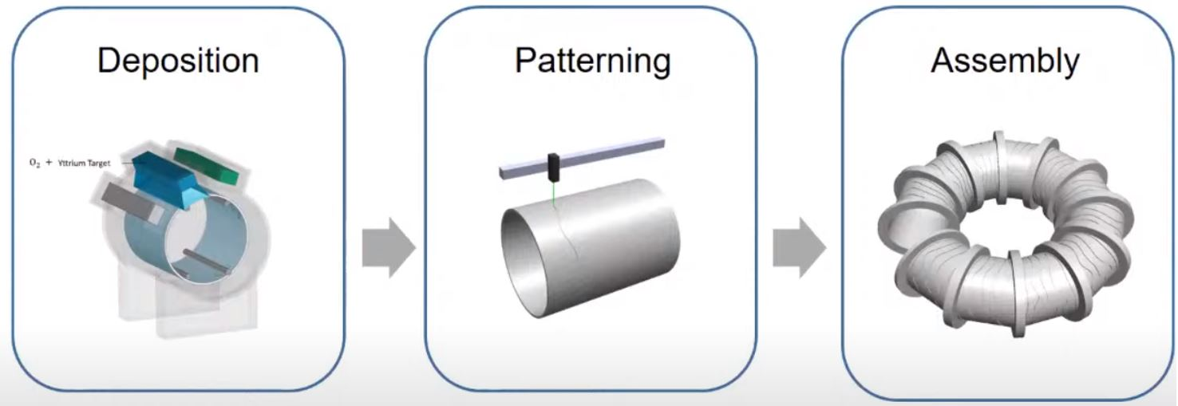
Figure 16.5: 3D magnet printing. Courtesy Renaissance Fusion.

Paper Only Designs
In theory, researchers can design a commercial fusion machine entirely on paper, and publish their work. This has been done. For example, the Volpe/Frost P1 design is expected to generate 1GW_{e} of electrical power at a cost of $50/MWh, with an estimated site cost of $5 billion. Also, if one doubles the site cost to $10 billion, and doubles the reactor diameter, the electricity cost decreases 2-fold, to $25/MWh. This is less than fossil fuel-based electricity. These figures represent first-of-a-kind (FOAK) costs, which are expected to decrease by 20% to 40% as additional units are built. Magnet costs account for ≤18% of the total, with the remaining expenses distributed across the facility. For a closer look at a fusion facility, check out this tour of the SPARC site.
For more details on the Volpe/Frost design, refer to their 2024 paper, design summary, energy diagram, cost breakdown, YouTube video, and cost model. This design incorporates new innovations, such as liquid metal wall and 3D magnet printing. However, as noted earlier, these technologies have yet to be validated in a working fusion machine.
The work by MIT and Commonwealth Fusion Systems (CFS) is also noteworthy. However their papers refer to a more expensive approach that does not include liquid metal walls. As a result, their machine requires disassembly every one to five years, which is expensive. For a summary of parameters that describe a fusion machine, click here.

Parallel, not Serial
The fusion research community is operating under the assumption continuously-operating fusion machines will not appear soon. As a result, relatively little funding has been directed toward developing the equipment required for continuous operation. For instance, specialized systems are needed to separate exhaust gases (such as helium, tritium, and deuterium) and extract tritium from a stream of liquid lithium. To accelerate commercial fusion R&D, all subsystems must be developed concurrently, supported by equipment that tests these systems at maximum power for months.

High-Power Long-Duration Experiments
Plasma in a commercial fusion machine would emit high levels of neutron radiation continuously over years, and this would have a significant effect on both liquids and solids within the first one to two meters of the chamber wall. While these effects have been estimated, they have not yet been measured. To validate these estimates, a high-power neutron source is needed to expose candidate materials to radiation for weeks to months (e.g., > 1 MW/m²). Building such a facility is a significant challenge. Currently, the closest example is the billion-dollar IFMIF test facility, which is currently under construction. However, it is not expected to be operational until the 2030s—too late for those seeking relief from climate change.
What is urgently needed is an experimental fusion reactor that tests candidate materials and subsystems for long durations. This machine would not need to be large, efficient, or cost-effective. Instead, it would need to be built quickly to guide other designs and influence funding decisions. Ideally, this system would de-risk key technologies such as shielding solid components with liquid metal walls, separating helium from deuterium/tritium, extracting tritium from liquid lithium, implementing neutron multiplication, avoiding neutron activation, managing high neutron wall loading, and removing large amounts of heat over extended periods. Also, multiple experimental reactors might be needed to explore different approaches.
The most promising facility for testing is the Chinese Comprehensive Research Facility for Fusion Technology (CRAFT). However, achieving commercial fusion within a few years would require significantly more funding for a facility like this.
Let’s recap. Current experimental fusion reactors operate for seconds to minutes. To accelerate the path to commercial fusion, multiple experimental reactors would be needed that support continuous operation. These would each cost approximately $2 billion. After achieving high-power, long-duration fusion, engineers could focus on designing a fusion machine that generates low-cost electricity.

Computer Aided Design
In theory, manufacturing engineers could develop software capable of generating detailed fusion designs based on a set of key parameters. With sufficient funding and resources, such software could produce comprehensive drawings for every component on site, including drawings for casting molds, assembly instructions, and cost models. This capability would streamline the process of designing and constructing both experimental and commercial fusion reactors, significantly reducing development time.
The United States has approximately 300,000 mechanical engineers, while China has over a million. Similar numbers of electrical engineers are available in both countries. In theory, more engineers could be mobilized to support commercial fusion R&D.

Government Support
The U.S. government currently allocates approximately $800 million annually to basic fusion research, supporting programs such as PPPL, ITER, and DIII. In theory, a new initiative could be launched to achieve economic fusion through a top-down approach, led by the world’s leading scientists. Such an initiative would integrate plasma physics, manufacturing engineering, and cost analysis to achieve an objective such as achieve economic fusion within several years. Priority would be given to de-risking key technologies, such as liquid metal walls and 3D-printed magnets.

Open Fusion
Companies and research laboratories often avoid sharing developed materials, fearing that open review could negatively impact their funding. However, achieving commercial fusion within a few years may require a shift toward greater transparency. Sharing experimental data and materials online for open review could accelerate progress by identifying and addressing problems more quickly. In theory, climate money could pay test laboratories, such as China's CRAFT, to share (“collaboration”). It could also fund scientists and engineers to conduct R&D and publish open-source materials online, maximizing the climate benefit per dollar spent.

Fusion Companies are not Aiming to Fix the Climate Problem
TCL hopes to generate electricity from fusion at a cost lower than fossil fuels—a breakthrough that could significantly impact the climate crisis. However, most fusion companies have a different focus. Their primary goal is to develop a single fusion machine, potentially in the 2030s, capable of producing electricity at a cost much higher than that of fossil fuel-based electricity. This single machine would be paid for by investors, rather than by the typical electricity customer.
In other words, it is easier to build a fusion machine that generates electricity at $150/MWh, funded by investors, than to build one that generates electricity at $30/MWh, funded by consumers. While fusion companies are concentrating on the former, climate-focused funding is looking at the latter, at an accelerated timeline, and at a higher funding level.

The Lab's Role
TCL dramatically increases funding for key technologies needed to achieve economic fusion within a few years.

R&D Funds: Economic Fusion (EF)
- R&D Fund: Liquid Metal Wall R&D
Support liquid metal wall research and development (e.g., design experiments, write proposals, fund proposals).
- R&D Fund: Wide Tube Magnet Printing R&D
Support the development of machines that print wide 2cm to 2m REBCO-like tape directly onto a rotating tube.
- R&D Fund: Narrow Tube Magnet Printing R&D
Support the development of machines that print narrow 0.1cm to 2cm REBCO-like tape directly onto a rotating tube.
- R&D Fund: Baseplate Magnet Printing R&D
Support the development of machines that print REBCO-like tape directly onto a magnet baseplate.
- R&D Fund: Exhaust Gas Processing R&D
Support the development of equipment that separates exhaust gases (e.g., deuterium, tritium, helium).
- R&D Fund: Liquid Lithium Processing R&D
Support the development of equipment that extracts tritium gas from a stream of liquid lithium.
- R&D Fund: Experimental Tokamak with Liquid Metal Wall Design
Support the design of an experimental D-T tokamak with liquid metal wall that runs continuously at maximum power for months. Cost, size, and efficiency are not a priority.
- R&D Fund: Experimental Stellarator Design
Support the design of an experimental stellarator with liquid metal wall and 3D-printed tube magnets. Cost, size, and efficiency are not a priority.
- R&D Fund: Economic Stellarator Design
Support the design of a commercial stellarator that produces electricity at a cost less than U.S. natural gas-based electricity.

Develop Next Generation Solar Farm (A7)
Agricultural farms were maintained by hand for thousands of years until they were mechanized with farm equipment. Today, we maintain solar farms mostly by hand, but in theory, they could be mechanized too. The world is looking at spending trillions of dollars on solar farms. Therefore, it is reasonable to spend billions of dollars to automate, to reduce cost. Obviously, one would first spend small money and verify feasibility, before spending big money. It is unlikely that a company would do the initial design since they would consider this too big. However, governments and foundations might be inclined to develop a next-generation solar farm that uses machines to install, maintain, clean, and mass-produce solar material. For details, see video #17.

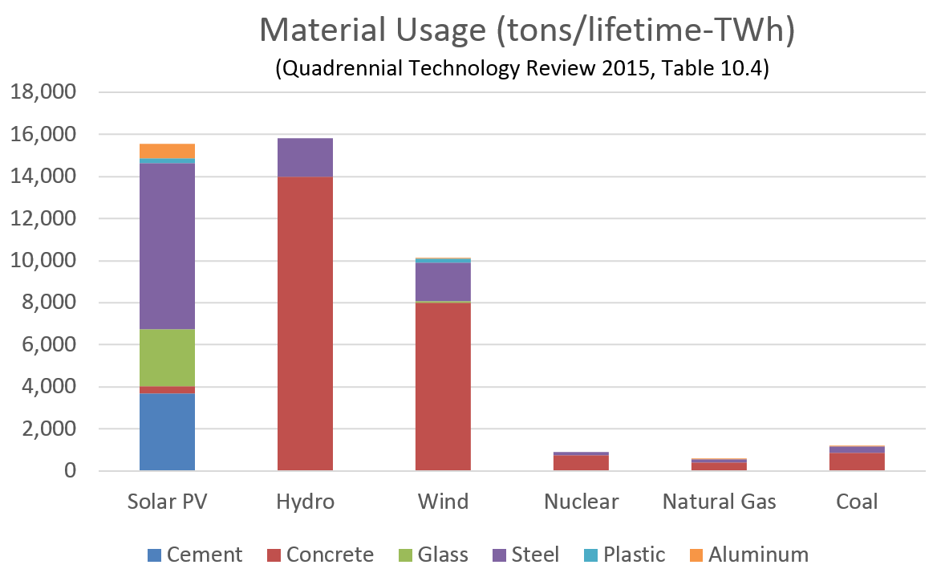
The Materials Problem
This graph shows how much material is used by the traditional methods of generating electricity. Materials primarily include steel, concrete, and glass. PV solar farms use as much material as hydroelectric dams in terms of weight per unit of lifetime electricity generated. This is a lot, and we would like to reduce, to reduce the cost of solar, and to reduce CO₂ emitted when making materials.
Silicon solar cells are typically covered with 3.2mm (0.125") thick tempered glass to protect against hailstones and wind. Wind applies tremendous force. For example, 100mph wind presses 220kg per-square-meter against a surface. In other words, protecting silicon for 30 years requires significant amounts of material.

Solar Direct to Soil
Solar farms typically mount silicon solar cells 1.5m (4.5ft) above ground. Alternatively, one might unroll flexible thin-film ~2mm (0.1") thick solar material directly onto soil in a manner similar to unrolling a 2m × 100m (6 × 300ft) carpet onto a surface. Prior to installation, the land would be shaped with earth-moving equipment under computer control.
Initially, this might seem like a bad idea. However, there are good reasons for going to ground, such as significantly less material usage. Engineers could explore various techniques for overcoming challenges such as soil erosion, upward pressure due to wind, and keeping solar material clean.
Traditional PV solar farms use aluminum and glass to resist wind loads. Alternatively, direct-to-soil would use soil for rigidity and use thin-film conversion material instead of silicon solar cells. Thin-film is typically rollable, resistant to hailstones, and does not need 3.2mm (0.12") thick protective flat tempered glass. It also has less conversion efficiency and more efficiency degradation per year, which means one needs more land for the same energy output. However, if one has an infinite supply of land, they might focus on cost-per-watt as opposed to cost-per-square meter of land.
The above-ground layer might be similar to flat flexible plastic with an embedded steel wire mesh. To hold in place, installation machinery might install a parallel layer of material underground, perhaps 50cm (20") below the top above-ground layer. The above-ground layer might connect to the underground anchoring layer via metal links. The following pictures illustrate this concept.
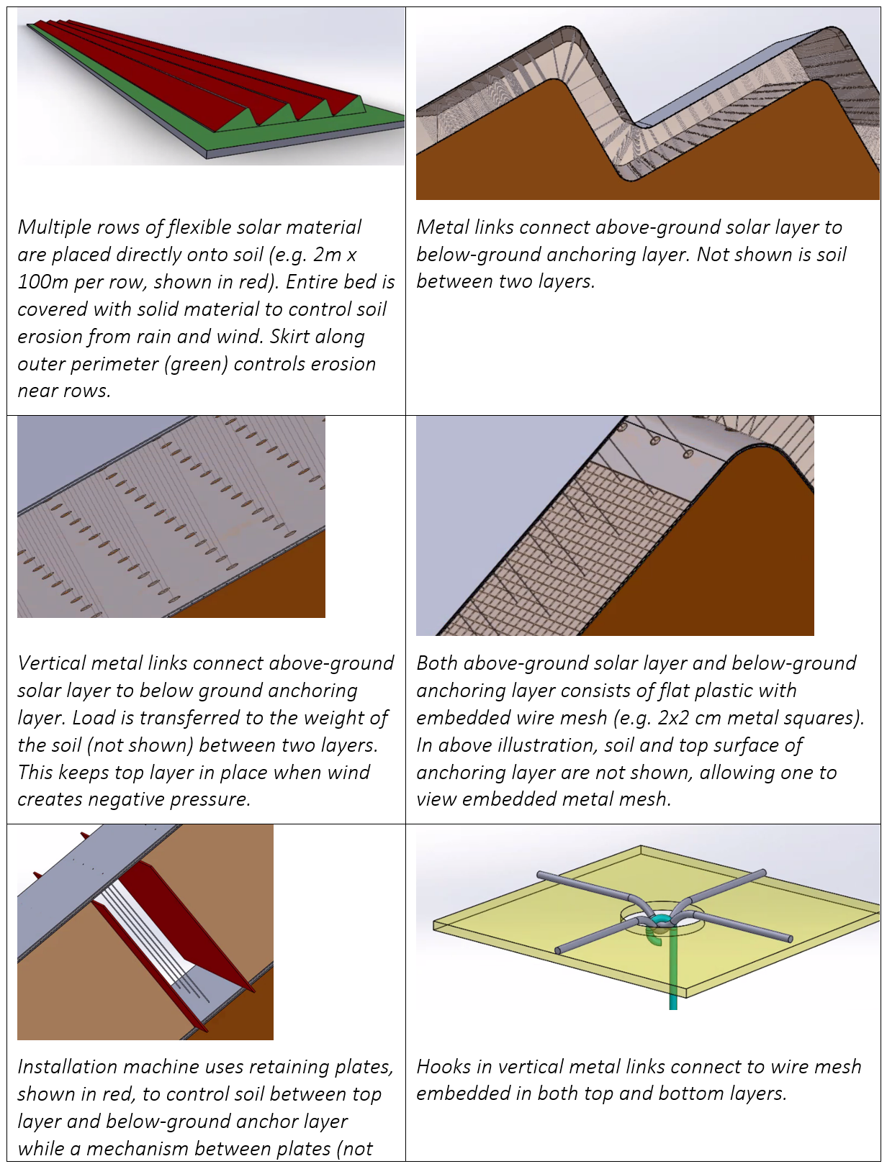
Figure 17.1. Thin-film solar direct to soil (concept illustration by Weinreb).

Region Differences
Some regions would be more feasible than others. For example, deserts with 3cm (1") rain per month, and dense soil, might be most suitable. Engineers would need multiple-decade simulations and wind tunnel testing to ensure that soil movement due to wind and rain is acceptable.

Thin-Film Plastic vs Silicon Solar Cells
Traditional solar farms use sheets of glass, and metal frames, to protect delicate silicon-based solar cells. Also, over the last 20 years, their costs have been driven down via mass production.
Alternatively, thin-film solar material mounted on rolls of plastic is currently expensive, due to less economies of scale. However, if mass produced via roll-to-roll processing, costs would be more competitive.

Custom Machines
Placing thin-film solar material directly onto soil would require the development of custom machines that shape the land, install the material, clean the material, and fabricate the material in a factory. Some of these machines might look similar to existing equipment, shown here.
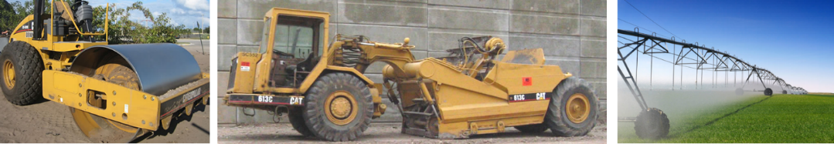
Figure 17.2. Earth-moving vehicles and agricultural sprinkler system.

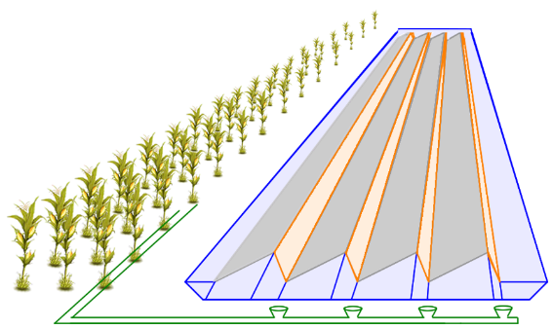
Erosion Control
Flowing water causes particles of soil to move. This is referred to as “erosion”, and we would not want this to occur under the solar material.
For this reason, rain water would need be controlled. For example, it might flow along troughs, into a drainage pipe, and then to a collection area, as shown here.

AI Cost Analysis
- ChatGPT https://chatgpt.com/g/g-p-679d2bb5b304819198acec1a2830d008-energy-and-climate/c/6931f3dc-8ed0-832c-9c50-53835ff64d30
- Grok https://grok.com/c/d522d70f-aa5f-4aa7-88fa-c179aaf40ebc?rid=48fc40a3-68be-4585-998d-ced2dfc02e22
- Gemini https://gemini.google.com/app/e2dc8f7566a3bf45

AI Concept Analysis
- ChatGPT https://chatgpt.com/g/g-p-679d2bb5b304819198acec1a2830d008/c/69371c87-33ec-8331-82ce-ef7a16cfc249
- Grok https://grok.com/c/cf4d9afc-107c-4f38-99b6-42c49e84ef89?rid=c39d13ae-d390-4460-a93e-45f1c4f3455d
- Gemini https://gemini.google.com/app/7636cef38cbf7ac5

R&D Funds: Solar Direct to Soil (SDS)
- R&D Fund: SDS Weather Modeling Research
Support the development of models that estimate the following parameters for every location on Earth: temperature, humidity, wind, precipitation, solar radiation, airborne particulate matter (such as dust), and surface debris accumulation (such as thin layers of solidified mud).
- R&D Fund: SDS Material Manufacturing R&D
Support the development of roll-to-roll processing machines that fabricate SDS material.
- R&D Fund: SDS Material Installation R&D
Support the development of machines that install SDS material.
- R&D Fund: SDS Material Cleaning R&D
Support the development of machines that clean SDS material.
- R&D Fund: SDS Material Removal R&D
Support the development of machines that remove SDS material.
- R&D Fund: SDS Standards Development
Support the development of interconnection standards that define how SDS components connect mechanically, electrically and with data communications.
- R&D Fund: SDS Site Preparation R&D
Support the development of site preparation techniques (e.g., automated earth moving machines).
- R&D Fund: SDS Water Handling Research
Support research in rain water handling (e.g., dispose in-place, flow to tank, flow to pond, etc.).
- R&D Fund: SDS Material Anchoring Research
Support the development of material anchoring techniques (e.g., underground anchoring layer holds above-ground material in place).

Further Reading
- Mechanizing PV Solar on Land
- Turning Deserts into Factories
- How to Solve the Climate Change Problem with Solar Farms

Develop Swappable EV Battery Standard (A8.1)
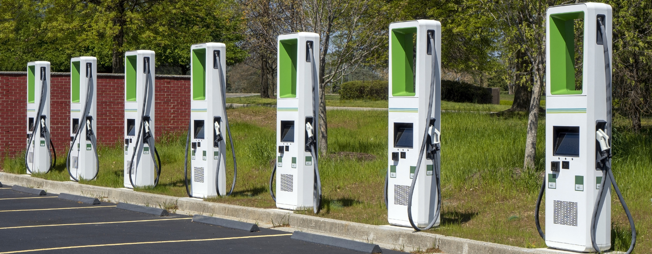
In the past, what did you see while glancing at fast charging stations? Did you see cars charging? In many cases, charging stations are underutilized.
The equipment cost-per-charge is determined by the equipment cost divided by the number of charges. Therefore, the cost-per-charge is high when the number of charges is low. This causes fast charging to typically cost three times more than slow charging at home. This, along with charging inconvenience, causes EV owners to rarely fast charge.

The Power Problem
The greatest challenge with fast charging cannot be seen. It is electrical power. The typical 50kWh EV battery consumes 100kW of power when charging in 30 minutes (100kW × 0.5h). This is the same amount of power drawn by 80 U.S. homes on average. In other words, supporting large amounts of power is expensive, especially if the hardware is underutilized.
Charging stations are often located at shopping malls and hotels since they have access to large amounts of power. However, one still needs expensive electronics to convert grid AC power to battery DC power. And to reduce cost, this gear is often undersized. This leads to longer charging times, especially when multiple cars are charging at the same time. And this leads to more range anxiety since drivers often do not know how long it will take to charge since it depends on who else is charging.

Swappable Standardized Battery
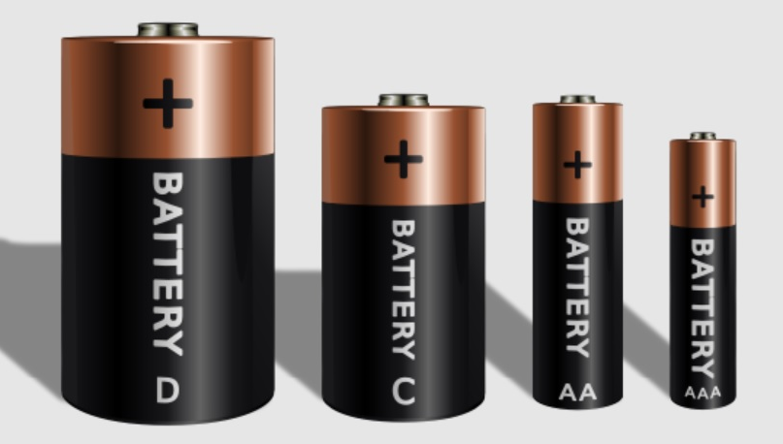
There is one way to resolve all of the problems alluded to above. It is a standardized plug-in swappable EV battery. Currently, the world has mechanical and electrical standards that define batteries, and these enable us to power many products at a low cost.
In theory, one could have a standardized car battery that looks similar to the Tesla EV battery, yet is used by multiple manufacturers. The standard would define the mechanics (e.g., height, length, and width), electrical connections, and communication between battery, car and swap station. For a video that explores this concept, click here; and for a video that looks at how to get started, see TCL Video #15.
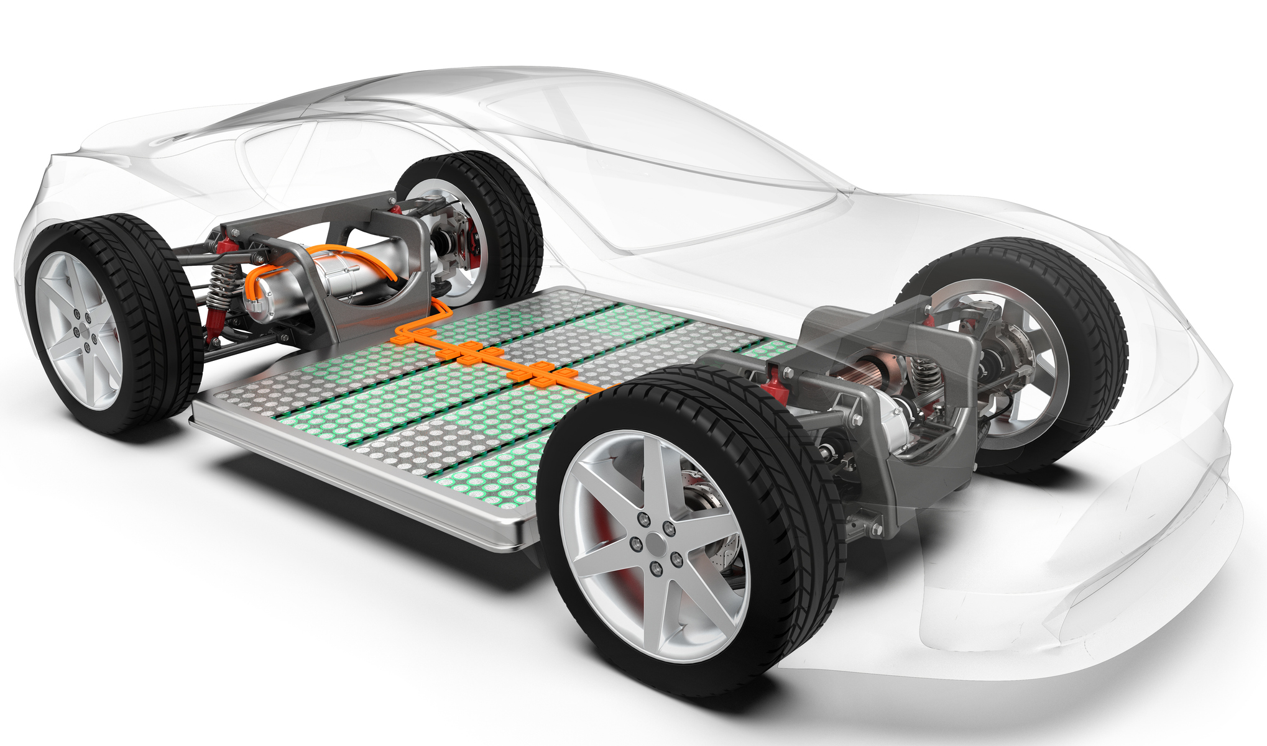
Currently, proprietary batteries are built into EVs and are charged periodically. Alternatively, one could have a standard plug-in battery, wherein all cars use the same form, and swap with a fresh battery in several minutes. Car owners would pay for electricity consumed and wear on the battery; and would pay less when using lower-cost batteries.
Batteries that can only slow-charge cost 2 to 3 times less per mile than batteries that can fast-charge. This is due to supporting more charge cycles, due to internal chemistry. Therefore, those who drive less than 150 miles (250 km) per day and never fast-charge could swap in a small slow-charge-only battery, and save money. Alternatively, for long trips, one could swap in an expensive high-range fast-charge battery; or swap more often.
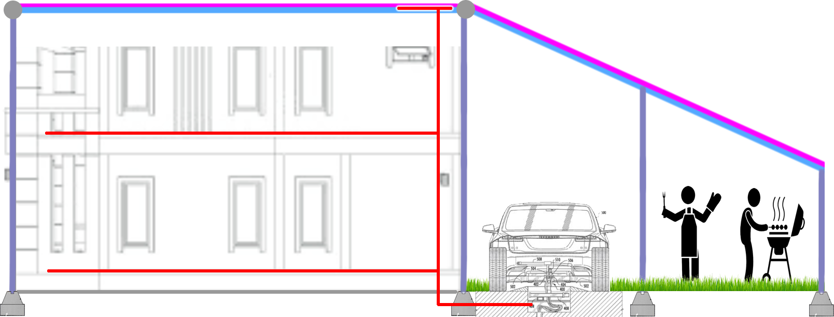
Also, homes could install swap chambers in their driveway with multiple batteries, as illustrated here. These could be charged by solar during the day, power the house at night, and swap with cars as needed.

Swap Costs Less
Batteries sitting in swap stations could charge anytime over multiple days. This would reduce costs for multiple reasons: (a) they could charge at night when electricity is cheap, (b) they could charge when solar farms and wind farms are producing power, (c) they could charge slowly and avoid expensive fast-charging hardware, (d) they could be placed near large power cables at shopping malls and buy electricity at the commercial rate which is 30% less than residential, and (e) manufacturers of cars, batteries and swap hardware could compete and drive down costs.

Chicken and Egg
Swappable EV batteries present a classic “chicken and egg” problem: automakers are hesitant to participate without an established network of swap stations, and investors are reluctant to fund swap stations without a significant number of compatible vehicles.
Nio is an example of a swappable EV manufacturer that has resolved this conundrum. On an annual basis they: (a) garner over $8 billion in revenue, (b) manufacture hundreds of thousands of swappable EVs, and (c) install thousands of battery swap stations. Their success is due largely to Chinese government policies that encourage electric vehicles, and a willingness of affluent EV owners to pay more for convenience.

Standards Development
If multiple EV manufacturers shared batteries and swap stations, then standards would be needed that define: (a) how batteries mechanically and electrically attach to cars and swap stations, (b) how batteries communicate with cars, and (c) how cars communicate with swap stations.
Automakers would not be inclined to invest in a swappable battery controlled by a competitor. Therefore, standards development would probably require the involvement of a neutral entity, such as a foundation or a government body.
Governments are already investing in EV charging infrastructure; therefore, they might be inclined to allocate a small portion to support standards development. More specifically, they might support the design, prototype and testing of: (a) swappable batteries, (b) swap mechanisms, (c) swap stations, (d) battery handling machines, and (e) battery transportation infrastructure. To encourage widespread adoption, developed technology could be disseminated free and open.

Economic Strategy
Regions that import significant amounts of oil, such as China and Europe, would probably lead the way since EVs reduce dependence on foreign oil. In contrast, the U.S. produces oil, and is therefore less interested in EVs. However, as adoption increased in regions fond of EVs, economies of scale would drive down costs, eventually making swap more attractive to regions less supportive of EVs.
To press forward, a government or foundation would probably need to fund the development of a free and open swappable EV battery standard.
For details, see video #15.

R&D Funds: Swappable EV Battery (SEVB)
- R&D Fund: SEVB Mechanical Standards Development
Support the development of standards that define how the various SEVB components fit together mechanically.
- R&D Fund: SEVB Electrical Standards Development
Support the development of standards that define how the various SEVB components connect electrically.
- R&D Fund: SEVB Communications Standards Development
Support the development of standards that define how the various SEVB components communicate.
- R&D Fund: SEVB Swap Station R&D
Support the design, prototype and testing of swap stations.

Next Generation Building Automation and Control (A8.2)

To fully automate buildings, one would need to place a microprocessor chip in every device, and connect all devices with reliable communication. Devices include things like light switches, light sockets, HVAC equipment, appliances, motorized dampers in ducts, fans in ducts, motorized valves in radiators, thermal storage tanks, motors that move thermal covers over windows, occupancy sensors, temperature sensors, and fire detectors.
This could save money, increase comfort, and reduce energy consumption via multiple techniques. For example, this could help control the temperature of each room, and help move heat from one room to another. For details, see video #16.

Open-Source Operating System
To facilitate global acceptance and ensure bug-free operation, the same free and open operating system software would probably be needed on all devices. An example is BuildingBus, developed by Weinreb in 2021. He has developed approximately 30 automation and control systems over the last 45 years.

Reliable Communication
When one flips a physical wall light switch, the communication between the switch and the ceiling bulb is operational ≥ 99.999% of the time (commonly referred to as 'five nines'). This gets little attention, yet is important. Occupants typically do not tolerate less reliability from building infrastructure. It’s worth noting that wireless and power-line communication are significantly less reliable, with failure rates on the order of ≥ 1%. To ensure high reliability, a communications data wire would probably be needed in power cables within walls. Fortunately, it would cost little to add this to new buildings.

Light and Heavy Devices
To reduce costs, devices could be divided into two categories: 'Light' and 'Heavy'. 'Light' might consume less than 20W and include bulbs, switches, sensors, and small motors; while 'Heavy' supports 110/220VAC outlets, HVAC equipment, and appliances. From a cabling perspective, 'Light' might be supported by 48VDC power and one communications wire; while 'Heavy' is supported by 110/220VAC power and two data wires.

Figure 19.1: In theory, buildings could be supported by two power/data networks, one for large loads, and one for small.
Most devices in a building are 'Light' and could use lower voltages and lower power to save money via multiple techniques. These include smaller cables, less conduit, fewer safety requirements, and less expensive microcontroller power supplies.
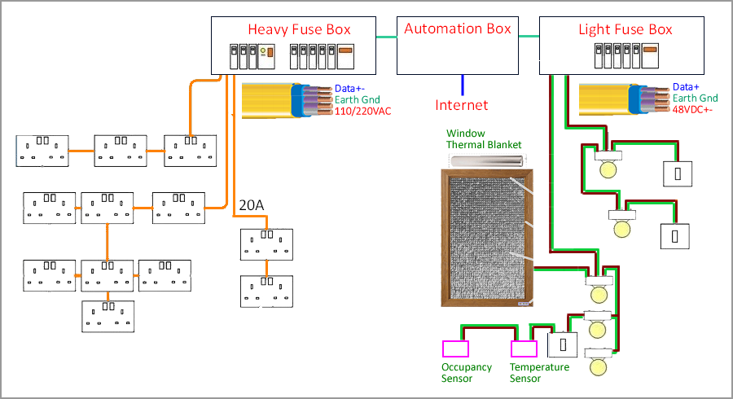
Figure 19.2: In theory, a data wire could be added to power cables in newly constructed buildings to enable reliable device communication.

Plug-and-Play Standards
To support plug-and-play operation, standards are needed that define how devices connect electrically, mechanically, and with data communications. Before these are proposed, components would need to be designed, prototyped, tested, debugged, and improved. This might cost 10's to 100's of millions of dollars given the size of the system.
So who might fund this initiative, and how might it be structured to meet the satisfaction of the various participants? Nations resist being controlled by external entities, and therefore might require new standards be based on free and open technology. Companies cannot afford to give their money to their competitors, and governments rarely provide leadership. Therefore, a foundation looking to save the planet from climate change might be required. The Gates Foundation is uniquely suited since Bill has experience developing networks, devices, operating systems and standards (e.g., UPnP).

System Requirements
TCL supports the development of a next generation building automation and control system that meets the following of requirements:
- The system supports device-to-device communication for purposes of automation and control within residential and commercial buildings. Devices include HVAC equipment, water heaters, appliances, control panels, motorized dampers and fans in ducts, motorized valves in radiators, thermal storage tanks, solar panel electronics, motors that move thermal covers over windows, occupancy sensors, temperature sensors, and fire detectors.
- The system supports: (a) managing the above list of devices, (b) regulating the temperature in each room, (c) transferring heat from one room to another, and (d) transferring heat between thermal storage, ground sources, appliances, and rooms.
- Any device can communicate with any other device within a house-sized structure. Typical data rates are 30K bits/second with ≥ 99.999% reliability (i.e., percent of data packets that are delivered without error). System does not support audio, video, or computer data; which is typically transmitted via wireless or powerline communication at higher data rates and with less reliability.
- Electrical power and communications standards are developed that support next generation 'Light' and 'Heavy' power/data cables embedded in walls. 'Light' includes two 48VDC power wires, one data wire, and one earth ground wire; while 'Heavy' includes two 110/220VAC power wires, two data wires, and one earth ground wire. The earth ground wire normally does not carry current, and instead supports RFI shielding and safety against power shorting to case. Devices must not incur damage if a power wire shorts to a data wire.
- Mechanical, electrical and software standards are developed that define replaceable standardized plug-in hardware modules. Open-source designs are published to reduce costs via commoditization, and to reduce risk of replacement parts not being available. Original module manufacturers are not likely to maintain production over a building's lifetime; and building owners understand a building will lose value if cannot be maintained; therefore, standardized commoditized replaceable modules are needed to facilitate system acceptance.
- To easily add sockets to power/data cables, a standardized clamshell clamp socket is developed along with a motorized hand-tool that mills plastic to expose conductors and turn bolts (ref 4.13).
- To support module replacement without additional user interaction, an eeprom memory IC is embedded in each socket, and programmed with physical location and module settings.
- Module sockets expose an additional diagnostic connector to help maintain the system over the building's lifetime. A custom cable with in-line electronics connects this diagnostics connector to a smartphone USB connector, allowing software to identify sources of failure (e.g., no power, data wire shorted or open), and suggest remedy (e.g., replace module, probe a different socket).
- Data protocol is CANbus since it is the only one-wire communications system embedded in low-cost microcontrollers. Devices mostly sleep in low-power mode, and are woken up when the CANbus data line asserts, and the device's ID is recognized.
- Physical layer signaling standards are developed for both 'Light' and 'Heavy' networks (ref 4.1). For example, 'Light' devices might signal by shorting a current limited data line to ground, and 'Heavy' devices might signal with opto-couplers to support large voltage drops between devices. Physical wiring topology is a tree and therefore does not support transmission line termination. Therefore, rise/fall times need to be long to avoid ringing (e.g., 3µSec).
- All devices are required to use the same free and open operating system software. Developers begin with the free BuildingBus OS, and improve as needed. This was written by Weinreb, who has developed approximately 30 automation and control systems over the last 45 years. For details, see the BuildingBus Software Development Guide, and Hardware Development Guide.
- Each power cable terminates at a fuse within a utility box; and each data wire terminates at an adjacent automation box. The latter is connected to the internet.
- Each power/data cable maintains a set of devices that signal along the same data wire, and each of these devices support an optional sub-network of devices, each with their own data wire. Also, each sub-network device supports an optional sub-sub-network, for further isolation. Ultimately, a 3 number physical address identifies each device (i.e., 0…15 network number, 0…31 sub-network number, 0…15 sub-sub-network number) and the BuildingBus software supports routing data packets from any device to any other device within this three-layer hierarchy. In other words, within a house-sized structure, any device can talk to any other device, with isolation and reliability.
- A low-cost, low-power communication system with ≥ 99.999% reliability is developed that enables 110/220VAC outlets to communicate with plugged-in appliances through their power cords (ref 4.13.6). Communication is supported after user powers appliance off via a low quiescent power supply. Note that 3V/1mA power costs less than 5 pennies per year.
- A system is developed that supports standardized communication between buildings and the electrical power company. This supports building heat decarbonization, the broadcast of electricity price, the broadcast of CO₂ emissions per unit of electricity, etc.
- A standardized system is developed that supports next generation LED lightbulbs in smart light sockets.
- Software is developed that helps electrical engineers specify devices when buildings are designed, helps electricians install modules, helps identify failures, and helps occupants live in comfort.

R&D Funds: Next Generation Building Automation & Control (NGBAC)
- R&D Fund: NGBAC Operating System Development
Support the development of an open source operating system that runs on all devices.
- R&D Fund: NGBAC User Interface Software Development
Support the development of user interface software for: (a) engineers who define the system in each building, (b) technicians who install and configure devices, (c) building owner, and (d) building occupants.
- R&D Fund: Standardized Plug-in Hardware Module Development
Support the development of standardized plug-in hardware modules, module sockets, socket-to-cable interface (ref 4.13), diagnostic tools, and installation tools.

- R&D Fund: Light Power Cable Standards Development
Support the development of standards that govern 'Light' power cables with data wire support.
- R&D Fund: Heavy Power Cable Standards Development
Support the development of standards that govern 'Heavy' power cables with data wire support.
- R&D Fund: NGBAC Master Controller Hardware and Software Development
Support development of master controllers (e.g., chassis next to fuse box that connects BuildingBus System to internet).
- R&D Fund: NGBAC Router Hardware and Software Development
Support development of routers that reside between subnetworks.
- R&D Fund: NGBAC Power Company Interface Standards Development
Support development of standards that connect NGBAC systems to power companies.
- R&D Fund: Appliance Interface Standards Development
Support development of standards that connect 110/220VAC plug-in appliances to the NGBAC system (e.g., NFC between power cord plug and outlet, ref 4.13.6).
- R&D Fund: Smart LED Bulb Standards Development
Support development of standards that govern next generation LED light bulbs and sockets (ref).
- R&D Fund: Window Thermal Cover Standards Development
Support the development of mechanical and electrical standards that govern replaceable motorized window thermal covers (e.g., embedded in a wall next to a window, and slide out to physically cover the window when the room is not occupied, ref).
- R&D Fund: Replaceable Fan Standards Development
Support the development of standards that govern replaceable fans embedded in HVAC ducts (ref).
- R&D Fund: Replaceable Dampers Standards Development
Support the development of standards that govern replaceable dampers embedded in HVAC ducts (ref).

Further Reading
- Using processors and software to make buildings smarter
- BuildingBus Development Guide
- Manhattan 2 Open-Source Smart Building Development
- Manhattan 2 Open-Source Window Thermal Cover Development
- Manhattan 2 Open-Source Fan/Damper Development

Develop High-Temperature Tunnel Boring Machine (A9)
To extract underground geothermal energy at a low cost, we need vertical tunnel boring machines that operate at high temperatures. For comments from artificial intelligence, click here.

Develop Policy Making Tools (A10)
To survive climate change, the public needs to understand the problem and the solution. This is To survive climate change, the public needs to understand the problem and the solution. This is difficult to describe in a document. Therefore, we propose a website be built that breaks the problem down into four parts:
Part 1 Score Climate Remedies: Quantify impact of decarbonization remedies
Part 2 Generate Decarbonization Plan: Create plan that reduces CO₂ emissions
Part 3 Assess Climate Situation: Summarize climate problem with several graphs
Part 4 Generate Reflectivity Plan: Generate plan that increases atmosphere's reflectivity
We call this website “Climate Solution,” and we built a non-functional prototype that demonstrates the concept, pictured below. For details, see Climate Plan Videos.

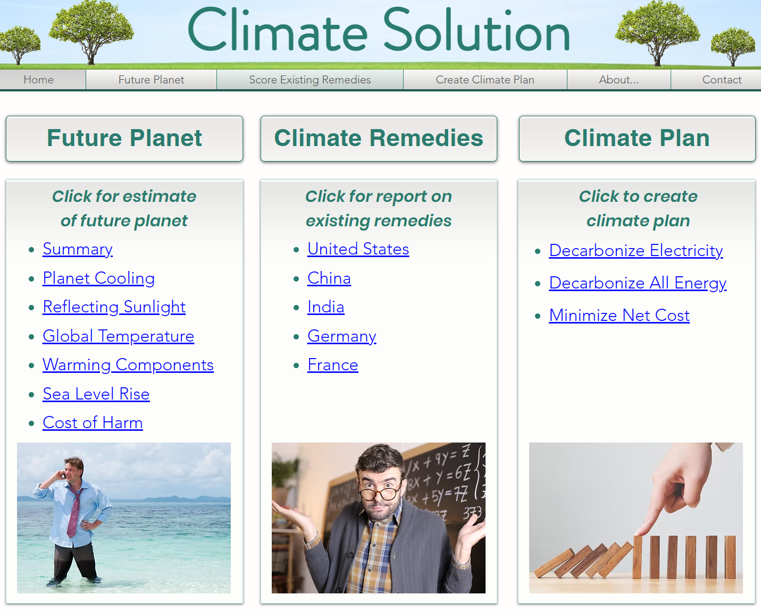

Website Part 1 - Score Climate Remedies
From an economics perspective, decarbonization involves initiatives that reduce CO₂ emissions. Each initiative has a cost to society, and an amount of CO₂ that is reduced. One can divide these two numbers to calculate the cost to reduce emission by one metric ton of CO₂.
For example, when homeowners install solar panels, it typically cost over $100 to reduce CO₂ emissions by one ton of CO₂. Conversely, when building solar farms or wind farms, it typically cost less than $20 per ton.
The first part of the website evaluates decarbonization initiatives, and presents the results in a Summary Remedy Table (SRT). Within this table, initiatives are listed in rows, while columns show cost to society ($), CO₂ reduced (mtCO₂), and cost per metric ton of CO₂ reduced ($/mtCO₂).
The table is sorted by cost per ton, placing the most cost-effective programs at the top. In theory, policymakers could expand effective programs, while reducing others.
The website supports multiple nations, since everyone needs to decarbonize—not just one nation.

Website Part 2 - Generate Decarbonization Plan
It is unlikely lawmakers would support significant changes to their economy without a detailed decarbonization plan. While such plans currently do not exist, they could be generated using software and existing economic energy models (such as NEMS).
The proposed website creates a climate plan after the user specifies a strategy. For example, a user might request a plan to “Decarbonize nation Z, over X years, in lowest-cost order, without taxes or subsidies, driven by gov't requirements, and with additional costs passed directly onto consumers.”
A decarbonization plan consists of a set of tables, one table per year, where individual initiatives are shown in rows, and key parameters (e.g., cost, tons of CO₂ reduced, and cost per ton) are shown in columns. Also, summary parameters are displayed at the bottom of each table (e.g., total societal cost per year, total CO₂ reduced per year, and average cost per ton).

How Much Does It Cost to Fix This?
A climate plan answers the critical question, “How much would it cost to solve the entire climate problem?” This question is of profound importance, yet rarely discussed. An example answer is shown below.
 | Year 1 | Year 2 | Year 3 | … | Year 10 | … | Year 20 | … | Year 30
Decarbonization R&D | $8 | $8 | $8 | … | $8 | … | $8 | … | $8
Operations | $10 | $20 | $32 | … | $142 | … | $445 | … | $727
Reflecting Sunlight R&D | $5 | $5 | $5 | … | $5 | … | $5 | … | $5
Operations |  |  |  | … | $27 | … | $27 | … | $27
TOTAL | $22 | $33 | $45 | … | $182 | … | $485 | … | $767

In this table, costs values are in units of dollars per American per year, although Europeans would see similar numbers. These costs would manifest as an increase in the price of goods and services, in addition to government and foundation expenditures for climate change.
The first two rows refer to a Decarbonization Plan, while the last two rows refer to a Sunlight Reflectivity Plan. The user clicks on rows to “drill-down,” and see a breakdown with more information.
This example table assumes a steady decarbonization rate over a 30-year period, with initial “green premium” costs starting at $20 per ton of CO₂ reduced, and gradually rising over 30 years to $80 per ton. In theory, these costs can be reduced with more R&D.
The left portion of the table represents Years 1, 2, and 3 (the “early years”), whereas the right portion covers Years 10, 20, and 30 (the “later years”). The early years are relatively easy, since green premium costs are proportional to the amount of CO₂ reduced, and initially this would be small.
For a video that further explains this table, click here.

Website Part 3 - Assess Climate Situation
The “Future Planet” section of the website summarizes the climate problem with several graphs. These estimate changes over the next century, including global temperature increase, sea-level rise, reduction in food production, amount of planet cooling needed to prevent cascading tipping points, costs associated with planet cooling, and economic losses due to climate change. A concept illustration of these graphs is shown below.
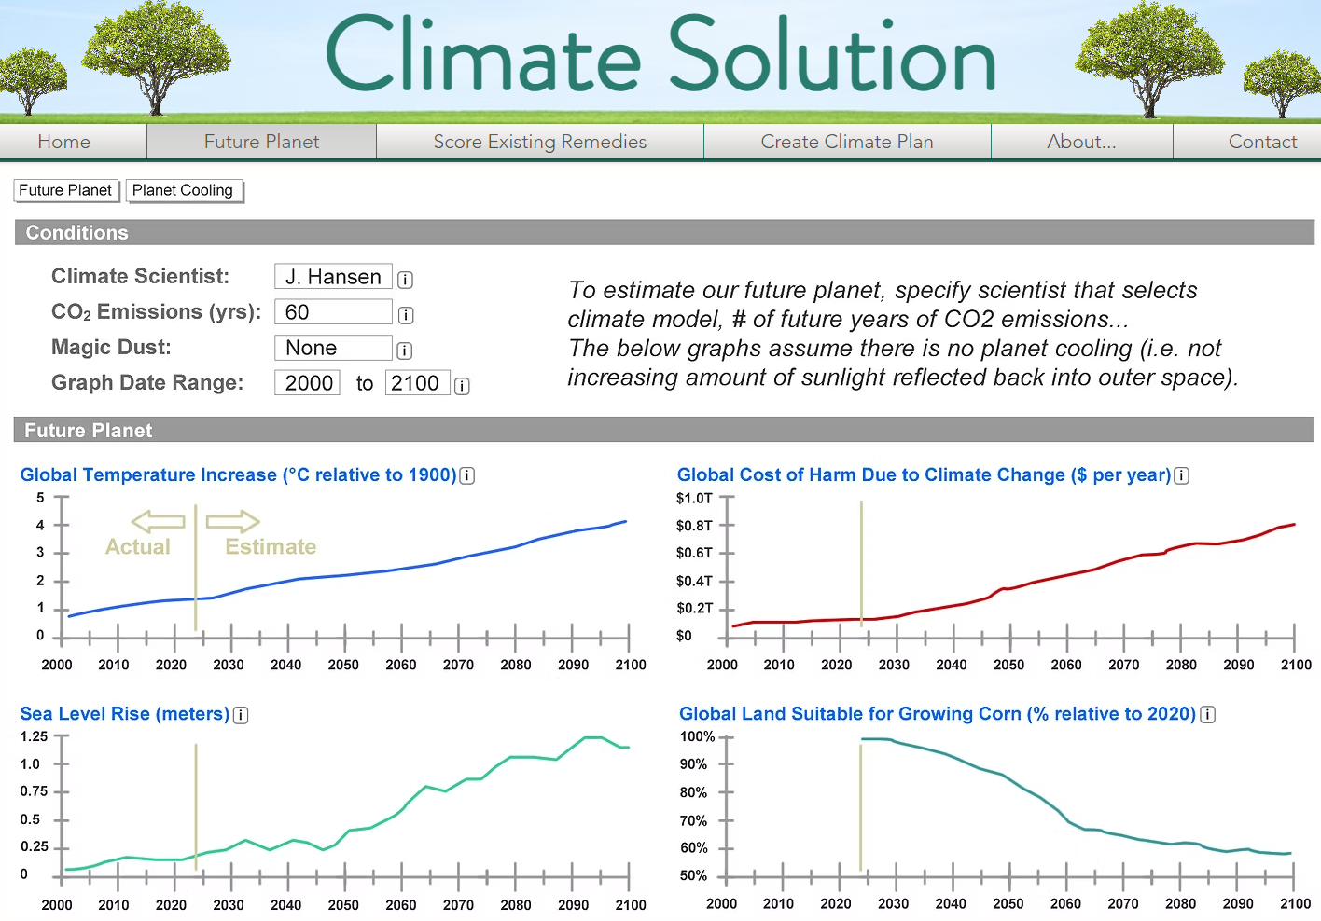
This data would be generated by climate models. However, selecting a model and its driving parameters is complicated. Therefore, climate models would be selected, and set up by leading scientists; and the website user would choose a scientist, instead of a model. For example, one user might trust the leader of the IPCC, while another prefers the leader of NOAA.
The website user would also specify how many more years they expect our society to emit CO₂ (e.g., 30, 40, 60, or 120 years). Many economists expect emissions to continue for over 100 years, whereas climate activists prefer less than 40.
After the user selects a scientist and decarbonization timeframe, graphs would summarize the climate problem, and indicate what it takes to avoid tipping points. In other words, for a given level of decarbonization and planet cooling, the user can see expected outcome.

Website Part 4 - Generate Reflectivity Plan
In theory, reflecting more sunlight back into outer space could cool the planet and prevent climate tipping points. However, it might take several decades and tens of billions of dollars to build up this capability. This presents us with a risk—by the time this capability is established, it might be too late. To help manage this risk, the website generates a sunlight reflectivity R&D plan based on objectives specified by the user (e.g., avoid a specific tipping point).

Spending Billions of Dollars to Save Trillions
Currently, the world spends $4T each year on fossil fuel. This includes $2.5T for oil, $1T for coal, and $0.5T for natural gas. If the world decarbonized, then $4T instead would be spent annually to produce green energy. This includes things like paying down the mortgage on solar farms and wind farms.
Let's focus on this $4T value. In a green new world, this is roughly how much money would be spent to produce green energy each year. Also, this cost could be reduced with targeted R&D. For example, if $20B was spent annually over 5 years on additional R&D ($100B total), and this caused 30 years of green energy costs to decrease by 20%, then each R&D dollar would save 240 green energy production dollars ($4T x 20% x 30yrs / $100B). In other words, we should think about how to spend billions of dollars on R&D, to save trillions of dollars.

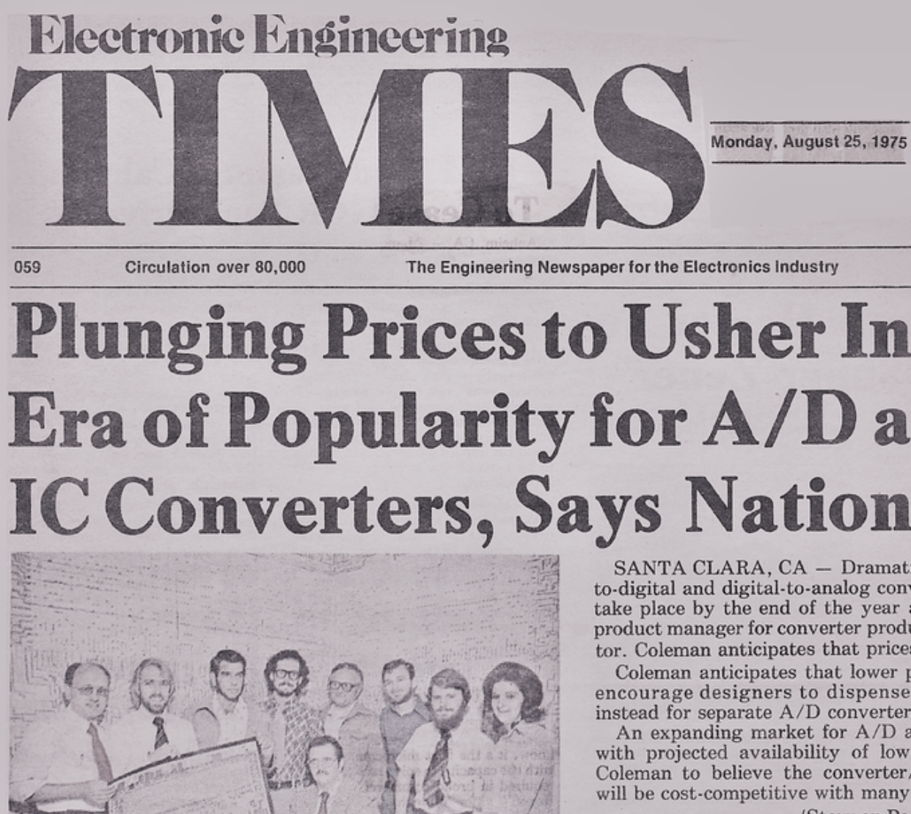
AspenCore Climate Solutions Research Center
But what R&D? Or more specifically, what can we develop that is currently not being developed, that has the potential for significant impact? Answering this question is the job of the AspenCore Climate Solutions Research Center.
AspenCore is the largest publishing company in the electronics industry. They publish Electronics Design News, Power Electronics, and EE Times. EE Times has been active for over 50 years. For example, in 1972 they snail-mailed a weekly physical newspaper to 60,000 electrical engineers.
Fast forward to modern times and we have AspenCore CEO Cyrus Krohn​​​​ noticing many readers are interested in electrical power, energy, and climate change. He responded by setting up a Climate Solutions Research Center to identify how to solve the entire problem, at the lowest cost to society, via engineering. Over 50 climate solution articles and over 50 climate solution videos have been published, and highlights have been copied into a Climate Lab Business Plan. AspenCore does not pay people to do R&D, and does receive money to do R&D. Instead, they publish free suggestions. Climate solution research is not easy. For example, 25 professors were interviewed for the fission and fusion chapters of the lab business plan.

R&D Packages
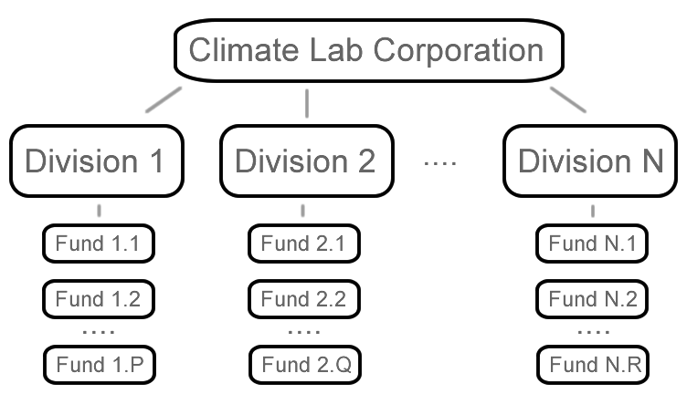
Additional R&D for climate change can be broken down into separate R&D areas, or “Packages,” where each is supported by multiple R&D Funds.
An R&D Fund is an account with money, and a Fund Manager is a human with the authority to issue purchase orders given that money.
In theory, an R&D Package within a plan could be implemented with a “Division” within a laboratory.
The Climate Lab Business Plan devotes one chapter to each of eight suggested R&D Packages. These include: (a) develop a climate solution website, (b) achieve economic fusion within a few years, (c) automate the construction of nuclear power sites, (d) develop underground nuclear power plants, (e) develop an automated system that places solar material directly onto soil, (f) develop a swappable car battery standard, (g) develop next generation building automation & control standards, and (h) determine how to reflect approximately 1% of sunlight back into outer space at a reasonable cost without harm.
The Climate Lab Business Plan has two purposes: (a) it helps set up a virtual R&D laboratory that is tasked with solving the entire climate problem, and (b) it helps describe R&D Packages within a Comprehensive Climate Plan for society.

Phased Activity
Initial R&D does not need to be expensive. One often spends small money before medium money, and medium money before big money—and only advances if technically and economically feasible. Small typically involves rough designs, cost models, and proposal writing. Medium typically entails detailed designs and prototypes. And big typically involves more software, more refinements, and small-scale operations.
One might refer to small, medium, and large as Phase I, II and III activities. A national climate plan would specify the following for each phase within each fund: (a) estimated cost, (b) estimated duration, and (c) brief description. This information would help populate the budget table for each R&D Package.

Giving Technology Away for Free
Companies typically focus on increasing the value of their stock, while foundations and governments typically focus on solving the climate problem. In theory, foundations and governments could support R&D that drives down the cost of green energy to below that of fossil fuel. And to facilitate global decarbonization, they could then give this technology away for free.
There is two types of R&D. One is Product R&D and the other is Production R&D. The former involves product development, while the later involves developing a factory that mass produces a product. In some cases, the factory is 100-times more complicated than the product. If a company devotes 15% of its revenue to Product R&D, and 15% to Production R&D, for example, then costs decrease 30% if someone else pays for their R&D.

Open-Source Requirement
The climate problem is large, and it follows that the solution would be large too. For example, if $20B was spent each year on additional climate R&D, and $500K/year was devoted to each technical person, then 40,000 technical people would be needed ($20B ÷ $500K). This goes beyond what one university could handle. Therefore, money would need to flow too many organizations.
An open-source requirement is probably needed to coordinate many people at many organizations. In other words, people who receive money through a climate lab system would probably be required to place developed materials marked “open-source” on the internet. Subsequently, they could be used by others for free. The alternative would likely introduce inefficiencies that discourage funding sources from participating. In other words, to get money to flow, open-source probably needs to be required.
Also, open-source is needed to distribute developed technology to companies, to reduce green energy costs worldwide, to reduce global CO₂ emissions.

Working with Costs
A Comprehensive Climate Plan would involve several types of costs. These include decarbonization operations costs (“green premium”), decarbonization R&D costs, reflecting sunlight operations costs, reflecting sunlight R&D costs, and climate harm costs. These costs are often interdependent. For example, if decarbonization operations costs decrease, then climate harm costs will probably increase. Or if decarbonization R&D costs increase, then decarbonization operations costs will probably decrease.
A website could estimate these costs, and help a user find a path that meets their satisfaction. Also, a website could calculate the cost of each option, and identify the lowest-cost approach.
Developing this website requires climate scientists that work with climate models, energy economists that work with economic models, and computer programmers that write software.

Who Pays for What?
It is not necessary for a Comprehensive Climate Plan to specify: (a) where R&D money comes from, (b) where R&D money goes, (c) organizations that maintain R&D Funds, (d) Fund Managers who have the authority to issue purchase orders, and (e) researchers who receive money for work. This information is important; however, funding sources would first need to specified requirements. For example, a national government might support several R&D Funds at a specific level, and require money be spent locally.

R&D Funds: Climate Solution Website Development (CSW)
Below is a list of suggested R&D Funds that support the development of software that creates a Comprehensive Climate Plan. Doing this to the satisfaction of multiple national governments would probably exceed the capabilities of one research group; therefore, we advocate multiple R&D Funds be established to support this kind of work.
- R&D Fund: Website Development - Score Climate Remedies
Support the creation of websites that evaluate existing decarbonization initiatives. For each initiative, the following parameters are estimated: cost to society, amount of CO₂ reduced, and cost per metric ton of CO₂ reduced (ref).
- R&D Fund: Website Development - Generate Decarbonization Plan
Support the creation of websites that generate a decarbonization plan based on user-defined criteria. For example, a website user might request a plan that reduces U.S. carbon dioxide emissions by 1/30th each year over 30 years, in lowest-cost order, driven by gov't requirements, without taxes or subsidies, and with additional costs passed onto consumers.
- R&D Fund: Website Development - Assess Climate Situation
Support the creation of websites that summarize the climate problem with several graphs, after the user specifies a climate model (via a well-known scientist) and number of years they expect our society to emit carbon dioxide.
- R&D Fund: Website Development - Generate Reflectivity Plan
Support the creation of websites that calculate how much sunlight needs to be reflected back into outer space to achieve a user-defined objective (e.g., prevent the collapse of the West Antarctic Ice Sheet), and generate a corresponding R&D plan.

Related Material

Moonshot Videos
What are the big ideas for solving the entire climate problem? (Videos #18 to #21, #0 to #3)
https://www.aplantosavetheplanet.org/biv

Decarbonization R&D Videos (Videos #2, #11 to #16)
https://www.aplantosavetheplanet.org/drd

Reflecting Sunlight Videos (Videos #6 to #10)
https://www.aplantosavetheplanet.org/rsv

Climate Plan Videos (Videos #4 and #5)
https://www.aplantosavetheplanet.org/cpv

Climate Lab Video Series (Videos #1…#21)
https://www.aplantosavetheplanet.org/video

Billion-Dollar Sized R&D Proposals
Climate Moonshot Portfolio
https://www.aplantosavetheplanet.org/cmp

Stratospheric Aerosol Injection (SAI) R&D Proposals
https://www.aplantosavetheplanet.org/cmp#sai

Marine Cloud Brightening (MCB) R&D Proposals
https://www.aplantosavetheplanet.org/cmp#mcb

Nuclear Fission R&D Proposals
https://www.aplantosavetheplanet.org/cmp#fission

Nuclear Fusion R&D Proposals
https://www.aplantosavetheplanet.org/cmp#fusion

Global Climate Model R&D Proposals
https://www.aplantosavetheplanet.org/cmp#gcm

Links to PDF files for Artificial Intelligence
Climate Moonshot files for AI
https://www.aplantosavetheplanet.org/pdf-ai

Videos Scripts (Videos #1…#21)
https://ma2life.org/g/video/Video_Scripts_TCL.pdf

Business Plan
Climate Lab Business Plan (90-page PDF)
https://www.aplantosavetheplanet.org/bp pdf file
https://www.aplantosavetheplanet.org/lab original files

United Nations Climate Lab Concept Paper (3-page PDF)
https://www.aplantosavetheplanet.org/unclcp

Stratospheric Aerosol Injection (SAI)
Sunlight Reflectivity Plan (7-page PDF)
https://www.ma2life.org/g/film/Reflectivity_Plan.pdf

Sunlight Reflectivity Field Experiments (PDF)
https://www.aplantosavetheplanet.org/sai

Scientific Research
IPCC Decarbonization Cost Calculations
https://www.aplantosavetheplanet.org/dc

Experiments that Measure How Much Sunlight Reflects off Aerosols (PDF)
https://www.aplantosavetheplanet.org/ae

$250M Cloud Research Surge (PDF)
https://ma2life.org/g/eet/eetcs_plan/decarb_plan/cloud_science_surge_ChatGPT.pdf

$2B Atmospheric Research (400-pages)
https://drive.google.com/drive/folders/1e5jvAmJUfBLCpkQVKwR0dS_Ur2UtFLkG?usp=sharing
https://ma2life.org/g/eet/eetcs_plan/decarb_plan/Atmospheric_Experiments.pdf

Moonshot Conference
Climate Moonshot Conference
https://www.aplantosavetheplanet.org/dc

Moonshot Movie
The Climate Kids (docudrama)
https://www.ma2life.org/g/film/The_Climate_Kids.pdf

Policy Making Tool Development
Climate Plan Generation Website (PDF)
https://www.aplantosavetheplanet.org/website

Author Glenn Weinreb
Articles by Glenn Weinreb
http://www.manhattan2.org/#articles

Free Book by Glenn Weinreb: A Plan to Save the Planet
http://www.APlanToSaveThePlanet.org/pdf

Acknowledgements

Open-Source
To the author's knowledge, the concepts discussed in this document are public knowledge and no patents are pending.
The document you are reading is open-source, which means anyone can copy (i.e. bifurcate), modify, and rename for free via the CC BY 4.0 license.
For original files, visit www.APlanToSaveThePlanet.org/lab

Acknowledgments
With the permission of publisher AspenCore, this document reprints material previously published in EE Times (www.EETimes.com), Power Electronics (www.PowerElectronicsNews.com), and Electronics Design News (www.EDN.com).

