An Engineered Approach
to Climate Change

━━━━━━━  CLIMATE  MOONSHOT  PORTFOLIO  Billions to  save trillions | ━━━━━━━━━━━━━━━━━━━━━━━━━━━━━━━━━━━━━━━━━━━━━━━━━━━  NEW RESEARCH CENTERS • LARGE-SCALE R&D • CLIMATE SOLUTION WEBSITE  DECARBONIZATION • CARBON DIOXIDE REMOVAL • SOLAR RADIATION MANAGEMENT  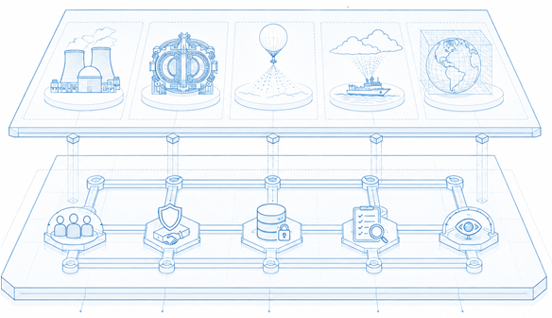  By Glenn Weinreb
━━━━━━━  OPEN  SOURCE | ━━━━━━━━━━━━━━━━━━━━━━━━━━━━━━━━━━━━━━━━━━━━━━━━━━━  Original files are free to copy and modify under the CC BY 4.0 open-source license.  Oct 11, 2026 | v1m | Copyright © 2026 by Glenn Weinreb | www.APlanToSaveThePlanet.org
Solving Climate. An engineered approach to climate change refers to calculating the speed and scale needed to solve the climate problem, and then conducting R&D to the extent required to support viable methods. This involves a billion-dollar-scale R&D surge to: (a) significantly reduce the cost of decarbonization, (b) significantly reduce the cost of carbon dioxide removal from atmosphere (CDR), and (c) conduct solar radiation management (SRM) research through experimental field trials. [5] [8] [9]
Getting Started with $1M. To get started, $1M could support the development of detailed R&D proposals, culminating in a “climate moonshot” conference where proposal authors present their work. Talks could be recorded and published on YouTube. Policymakers could be invited to the conference. [10]
Decarbonization is not Easy. To bend the global warming curve without reflecting sunlight, we would need to build roughly 9,000 GW_{e} of nuclear power globally. Nuclear reactors would replace fossil-fuel energy (“decarbonize”) and provide energy to remove CO₂ from the atmosphere via direct air capture (DAC).
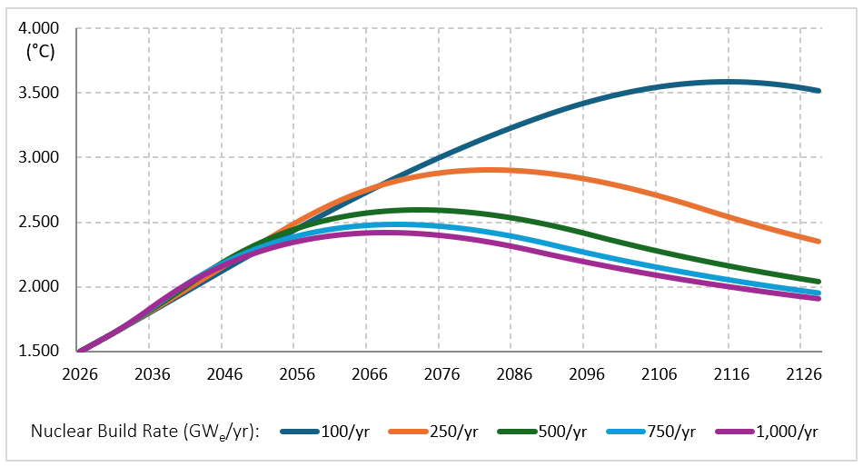
This graph shows the average global temperature for different nuclear reactor build rates. For example, if 9,000 GW_{e} were built over 9 years (1,000 GW_{e}/year), the average global temperature would peak at approximately 2.4°C relative to 150 years ago. If built over 30 years (300 GW_{e}/year), it would peak at approximately 2.8°C; and if built over 90 years (100 GW_{e}/year), it would peak at approximately 3.6°C. [4] [5]
Current global nuclear construction is roughly 10 GW_{e}/year; therefore, this would represent a major increase. Scientists have warned against exceeding 1.5°C. Therefore, even large-scale nuclear construction would exceed that by a wide margin if SRM was not used.
Cost is also a challenge: the first 3,000 reactors would probably be “economic,” meaning cheaper than the fossil-fuel alternative, while the final 3,000 would impose trillions of dollars per year in additional costs. For details, see the Nuclear Reactors chapter within the GCM Proposal.
Speed and Scale. As noted previously, an engineered approach refers to numerically looking at Speed and Scale needed to solve a problem. In the above example, Speed refers to the number of nuclear reactors built each year, and Scale refers to the total number of nuclear reactors.
Consumer Behavior. Consumers do not benefit by reducing their own CO₂ emissions — they are too small. Instead, they benefit when the other 8 billion people on the planet act collectively. In other words, a realistic climate plan is not predicated on consumers paying more money for green products at large scales. This is why R&D is needed to make the green option cost less than the fossil fuel-based option.
Reflecting Sunlight is not Easy. Engineers explore multiple options without prejudice. In other words, reflecting sunlight would be considered. This would require a roughly 15-year staged path from R&D, to limited experimental operations, to possible construction and deployment. Moving from today’s research level toward full-scale capability would require roughly a 100-fold increase in activity. Along the way, four major risks would need to be managed: (a) timing risk (large-scale SRM equipment is not ready when needed), (b) harm risk (experiments reveal unacceptable effects), (c) conflict risk (nations disagree over SRM), and (d) termination risk (excess warming after SRM termination). In short, reflecting sunlight is not easy, and developing a safe method quickly would require a substantial surge in R&D. [10]
Global Warming is not Easy. World GDP is roughly $120T/year; therefore, a 10% climate-related decrease would represent a $12T/year cost. This could be driven by things like: (a) an AMOC collapse that disrupts European agriculture,[11] (b) a West Antarctic Ice Sheet collapse that increases sea level by 3.3 meters,[12] or (c) a reduction in river flow that disrupts agriculture, transport, and energy production. [13] In summary, so-called ‘climate adaptation’ is not easy either. [5]
Three Bad Options. Our society faces roughly three options: (a) bend the global warming curve with decarbonization/CDR, (b) bend the global warming curve with SRM, or (c) don’t bend the global warming curve and suffer the consequences. Unfortunately, all three are difficult.
Climate Moonshot. A reasonable strategy over the next few years is an R&D surge to support decarbonization, CDR and SRM. One might refer to this as a “Climate Moonshot.” This would improve our situation by lowering costs, reducing uncertainty, and expanding the set of technically credible options. [5] [8] [9]
Large-Scale Energy Research Center. A new “Large-Scale Energy Research Center” could: (a) develop machines that automate nuclear power site construction (view proposal), (b) develop standards for driving industrial processes directly with nuclear reactor heat (view proposal), and (c) develop large factory-built processing platforms that produce hydrogen, ammonia, chemicals, and other energy-intensive products. The goal could be to drive down the cost of green energy, to below that of fossil fuel. An initial $25M phase could support rough design of machines, techno-economic analysis, and standards development. For details, see the Large-Scale Energy Research Center Concept Note. [6]
Reflecting Sunlight Research Center. A new “Sunlight Reflectivity Research Center” could determine whether sunlight can be reflected at reasonable cost and without harm. Both Stratospheric Aerosol Injection (SAI) and Marine Cloud Brightening (MCB) could be considered. Experimental work could measure particle formation, transport, optical effects, atmospheric chemistry, cloud response, and possible side effects. Equipment work could develop aerosol-generation systems, aircraft or marine-platform integration, monitoring, communications, and controls. For details, see the SAI Proposals and MCB Proposals. [7] [8] [9]
Climate Decision-Making Research Center. A new “Climate Decision-Making Research Center” could develop scientific and computational tools for evaluating large-scale climate strategies. These tools could assess what combinations of decarbonization, carbon dioxide removal from the atmosphere, and solar radiation management could achieve specified climate objectives. The work could include improving global climate models (GCMs), improving CDR models, and developing online climate decision-making tools. An initial $25M phase could recruit scientific leadership, build a decision-making website, develop experiments, and identify which research activities justify additional funding. For details, see the Climate Decision-Making Research Center Concept Note. [7]
Climate Solution Website. The above research center could develop a Climate Solution Website that lets users specify climate Objectives and Constraints and then calculate which combinations of decarbonization, CDR, and SRM meet those objectives. Objectives might include bending the global warming curve or reducing the risk of Atlantic Ocean current collapse. Constraints might include prohibiting SRM or limiting maximum CDR cost. If the specified Objectives cannot be achieved under the selected Constraints, the website would return a “cannot solve” result. Otherwise, it would show the scale and cost of decarbonization, CDR, and SRM over time. For details, see the Climate Website chapter within the GCM Proposal. [7]
Two Problems. A Climate Solution Website would focus primarily on two problems. One is the carbon dioxide emissions problem (approximately 40 G_{t}CO₂/year), while the other is the global warming problem (approximately 0.3°C/decade). These problems are only slightly related. [2] [3]
Causes of Warming. Global warming is driven by excess carbon dioxide in atmosphere from over 150 years of past emissions, together with excess methane in atmosphere, declining sea ice, and thawing permafrost. [4]
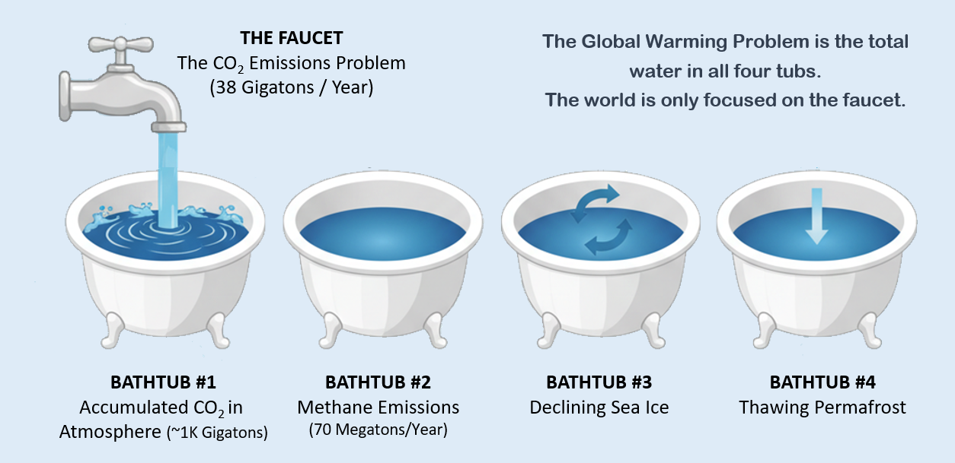
The Bathtubs. The climate problem is like a faucet with several bathtubs. The faucet represents annual carbon dioxide emissions, while the water in the tubs represents global warming. More specifically, the water at the faucet is proportional to the amount of carbon dioxide that is emitted into the atmosphere each year. While the combined water in all the tubs is very roughly proportional to the increase in Earth’s temperature each year. [4]
Policy Ignores Warming. The water in the first tub is due to 150 years of past carbon dioxide emissions — not one year’s emissions. Policy mostly focuses on emissions (the faucet), while ignoring global warming (the tubs). [4]
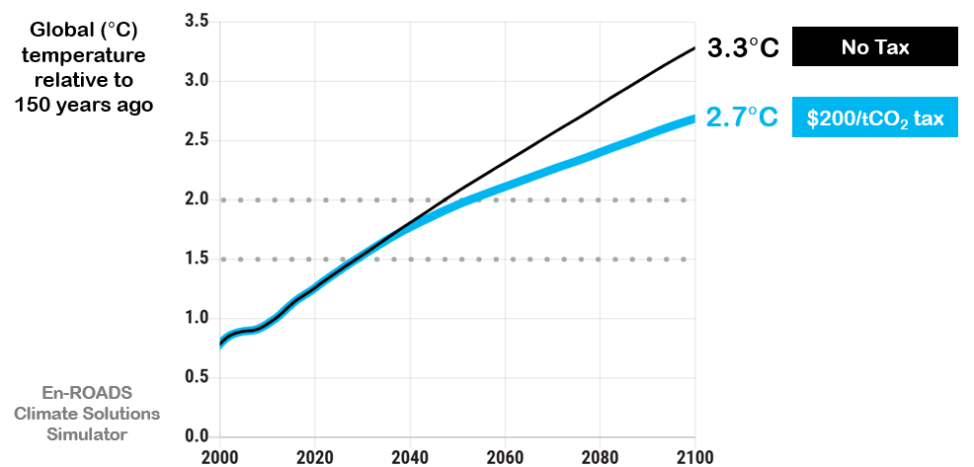
Decarbonization Policy Will Not Fix This. This graph shows the impact of a $200-per-ton global tax on carbon dioxide emissions. This is prohibitively expensive and not politically feasible, yet let’s ignore that for a moment and assess the impact this would have on the planet. According to the MIT En-ROADS simulator, the average global temperature keeps going up, both with and without this tax.
This tells us decarbonization policy will not solve the global warming problem. Also, this illustrates how the carbon dioxide emissions problem and the global warming problem are only slightly related, as discussed previously. [1]
Existing Proposals. Open-source billion-dollar-scale R&D proposals already exist (LINK) and can be used or modified at no charge. This includes proposals to automate nuclear power construction (PDF), drive chemical processes with nuclear heat (PDF), develop economic fusion (PDF), improve GCM and CDR models (PDF), conduct SAI experiments (PDF), develop SAI equipment (PDF), conduct MCB experiments (PDF), and develop MCB equipment (PDF).
Author: Glenn Weinreb — Contact | Biography | Website
References
[1] Climate Interactive & MIT Sloan, En-ROADS Climate Solutions Simulator and documentation. | Link
[2] Global Carbon Project, Global Carbon Budget 2025. | Link
[3] Hansen et al., “Global Warming Acceleration: Hope vs Hopium,” 2025; discusses recent warming rates near 0.3°C per decade. | Link
[4] IPCC, Climate Change 2023: AR6 Synthesis Report. | Link
[5] Global Climate Model Experimental Research Initiative (open-source proposal). | Link
[6] Large-Scale Energy Research Center | Concept Note. | Link
[7] Climate Decision-Making Research Center | Concept Note. | Link
[8] Climate Moonshot Portfolio: Stratospheric Aerosol Injection (SAI) proposals. | Link
[9] Climate Moonshot Portfolio: Marine Cloud Brightening (MCB) proposals. | Link
[10] Climate Emergency Forum, “An Engineered Approach to Climate,” Oct. 2026. | Link
[11] Ritchie et al., Nature Food 1, 76–83 (2020), doi:10.1038/s43016-019-0011-3. | Link
[12] Bamber et al., Science 324, 901–903 (2009), doi:10.1126/science.1169335. | Link
[13] Bevacqua, E., Rakovec, O., Schumacher, D. L., et al. “Direct and lagged climate change effects intensified the 2022 European drought.” Nature Geoscience 17, 1100–1107 (2024). | Link

