Climate Decision-Making
Research Center
Concept Note
━━━━━━━  CLIMATE  MOONSHOT  PORTFOLIO  Billions to  save trillions | ━━━━━━━━━━━━━━━━━━━━━━━━━━━━━━━━━━━━━━━━━━━━━━━━━━━  IMPROVE CLIMATE MODELS • BUILD DECISION TOOLS  OPEN-SOURCE SCIENCE FOR CLIMATE STRATEGY  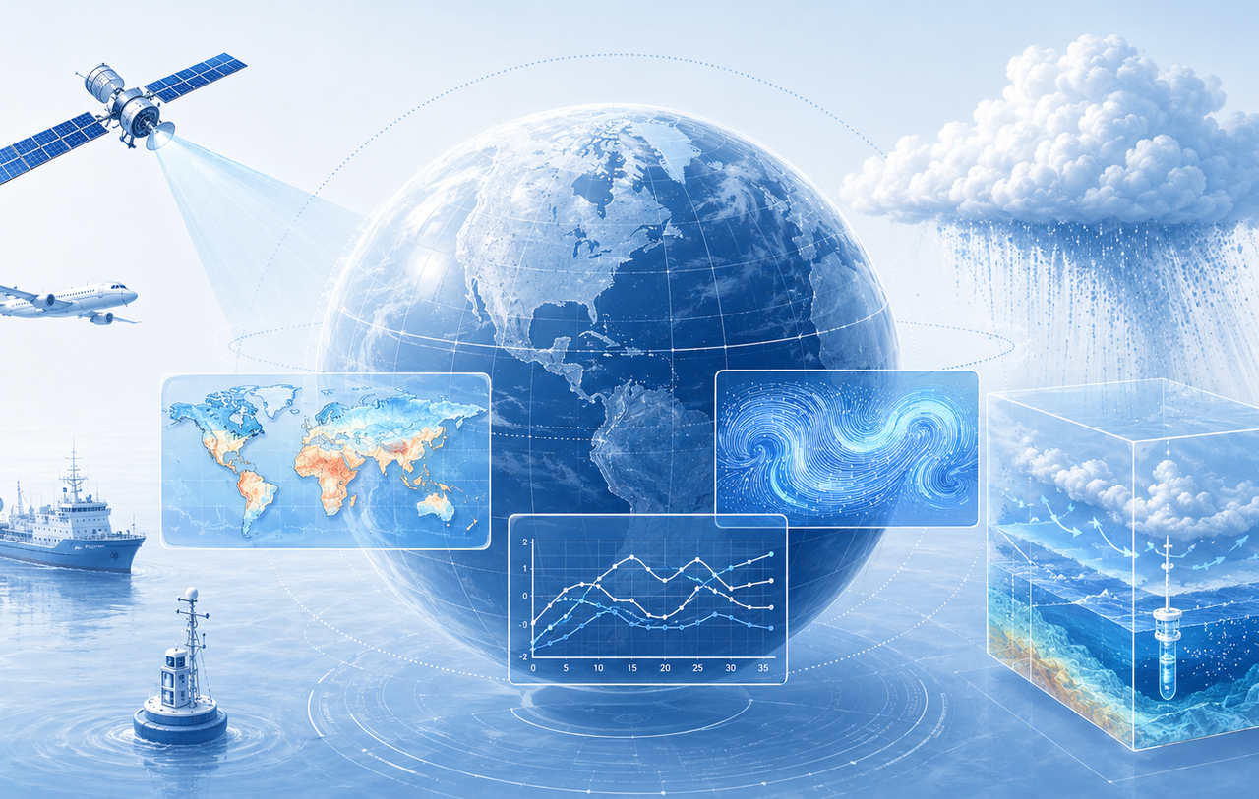  By Glenn Weinreb
━━━━━━━  OPEN  SOURCE | ━━━━━━━━━━━━━━━━━━━━━━━━━━━━━━━━━━━━━━━━━━━━━━━━━━━  Original files are free to copy and modify under the CC BY 4.0 open-source license.  September 27, 2026 | v1e | Copyright © 2026 by Glenn Weinreb | www.APlanToSaveThePlanet.org

Executive Summary
Purpose. We propose establishment of a Climate Decision-Making Research Center that develops the scientific and computational tools needed to evaluate large-scale climate strategies. These tools would determine what combinations of decarbonization, carbon dioxide removal from atmosphere (CDR), and solar radiation management (SRM) could achieve specified climate objectives. This work includes improving global climate models (GCM), improving CDR models, and developing on-line climate decision making tools.
Climate Solution Website. The initiative builds a Climate Solution Website that lets users specify climate Objectives and Constraints; and then calculates decarbonization, CDR and SRM that meets those objectives. Objectives include things like bend the global warming curve and prevent the collapse of Atlantic Ocean currents; while Constraints include things like solar radiation management is prohibited, and maximum CDR cost. If the specified Objectives and Constraints cannot be achieved, the website returns a “cannot solve” message. Otherwise, it shows the cost and size of decarbonization, CDR, and SRM for each year going forward.
Improve Climate Models. A Climate Solution Website would use a GCM as the underlying calculation engine; however, current GCMs are not accurate. We know this since they do not accurately predict observations, such as the global warming rate. Therefore, they need to be improved. To do this, we need to conduct experiments. This includes measuring how much sunlight reflects off air pollution and cloud studies.
Improve CDR Models. A Climate Solution Website would use CDR cost models to calculate how much CDR can be deployed and at what cost; however, these models are not accurate. For example, models for growing trees do not adequately account for impacts on land and food costs. This initiative would develop a global database covering approximately 10 major CDR techniques and hundreds to thousands of candidate regions or sites for each technique where appropriate. For each candidate region or site, the program would estimate marginal cost as deployment increases ($/_{t}CO₂ versus G_{t}CO₂/year), including land, energy, water, transportation, storage, permanence and other constraints. These results would be combined into regional and global CDR supply curves.
Organizational Model. The Center could be based at a major research university and collaborate with other universities, national laboratories, government research organizations, modeling centers, and international partners. The existing open-source Global Climate Model Experimental Research Initiative would be a starting point for independent review—not a predetermined research agenda.
Initial Funding. An illustrative $25M initial phase could recruit scientific leadership, review and redesign the research architecture, build a prototype Climate Solution Website, establish model-validation benchmarks, develop detailed experimental designs, and identify which research activities justify more funding.
Open-Source Public Good. Research products, software, datasets, model benchmarks, assumptions, cost models, and decision tools would be published openly wherever practical so governments, researchers, foundations, and other organizations can reproduce, challenge, improve, and reuse the work.
Boundary. The Center would provide research and decision support. It would not authorize deployment of solar-radiation-management technologies, select political policy, or hide scientific disagreement behind a single answer.
Continued on next page…

Climate Solution Website
A central product would be an open-source Climate Solution Website that turns research results into an accessible decision system. A user would specify climate objectives, constraints, assumptions, and time horizons; the system would search precomputed model ensembles and validated emulators, then return feasible strategy families—or report that the requested objectives cannot be met under the selected constraints.
Illustrative questions the website could explore include:
- What would it take to bend the global warming curve by a specified year?
- How much CDR is required under alternative emissions pathways?
- What happens if sunlight reflection is prohibited?
- How do strategies differ in regional precipitation, ocean circulation, sea ice, and other risks?
- Which combinations minimize estimated cost while meeting selected climate constraints?
- Which requested objectives are infeasible or highly uncertain?
The website would display model versions, observations, forcing datasets, cost assumptions, uncertainty, provenance, failure conditions, and model disagreement. A website result would be decision support—not authorization to deploy a climate intervention.
Continued on next page…

We Need to Measure Sunlight Reflecting Off Pollution
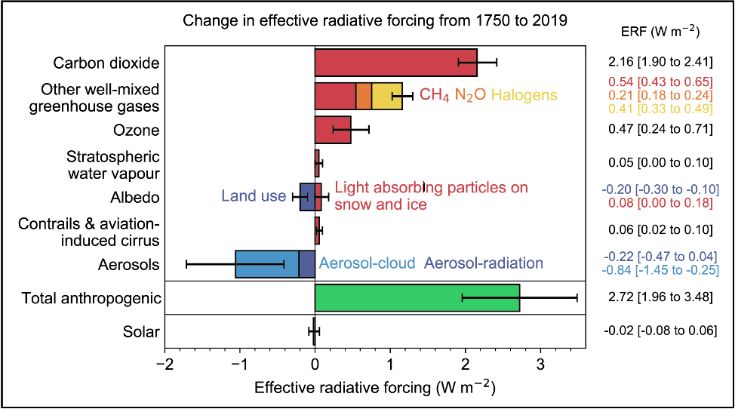
Figure G1. Change in effective radiative forcing from 1750 to 2019 (IPCC Ar6 Wg1 Fig 7.6)
Global warming is made up of multiple components (“radiative forcings”) that add together, as illustrated above. As one can see, some components increase global warming (red), whereas others decrease global warming (blue). These combine to produce total warming (green). The blue “Aerosol” cooling bar is caused by sunlight reflecting off particles and droplets in the atmosphere. These substances, known as aerosols, often originate from human-made air pollution.
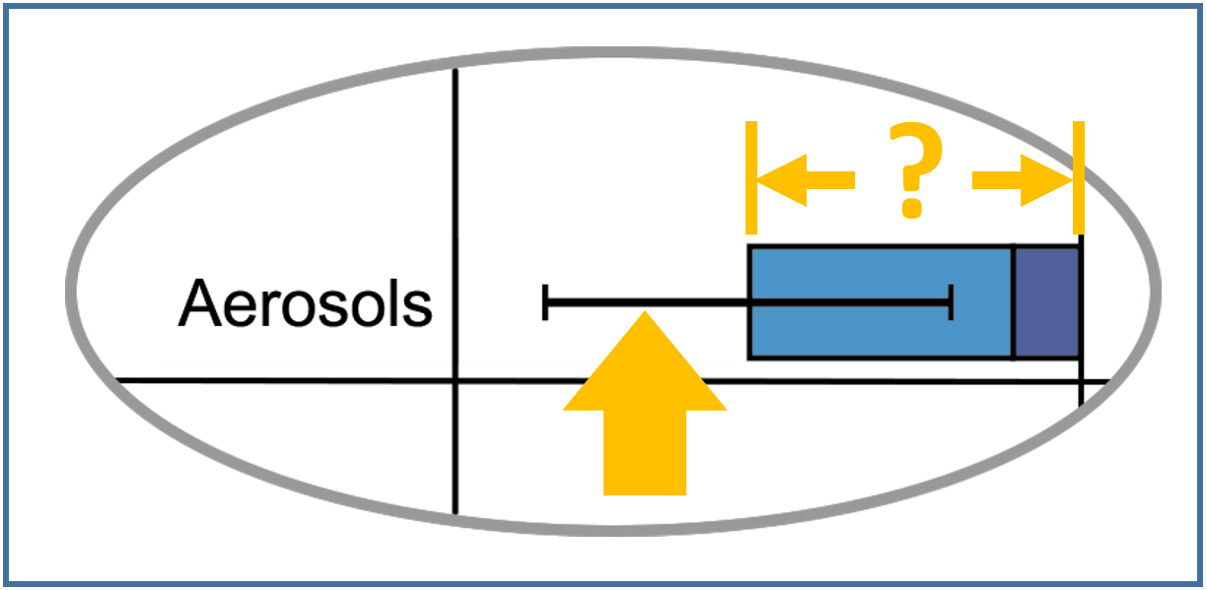
Notice the size of the Aerosol error bar relative to the amount of warming from 150 years' worth of carbon dioxide (i.e., top red bar). It is about 80% of that level. In other words, the degree to which scientists do not understand global warming, based on cooling error bars, is large.
This makes it difficult to calculate when, where and how much sunlight needs to be reflected, to avoid runaway global warming. In other words, the Aerosol parameter needs to be measured, instead of being estimated (with a large degree of uncertainty). More specifically, we need to conduct experiments that measure how much sunlight reflects off anthropogenic aerosols (i.e. air pollution).

We Need to Better Understand Clouds
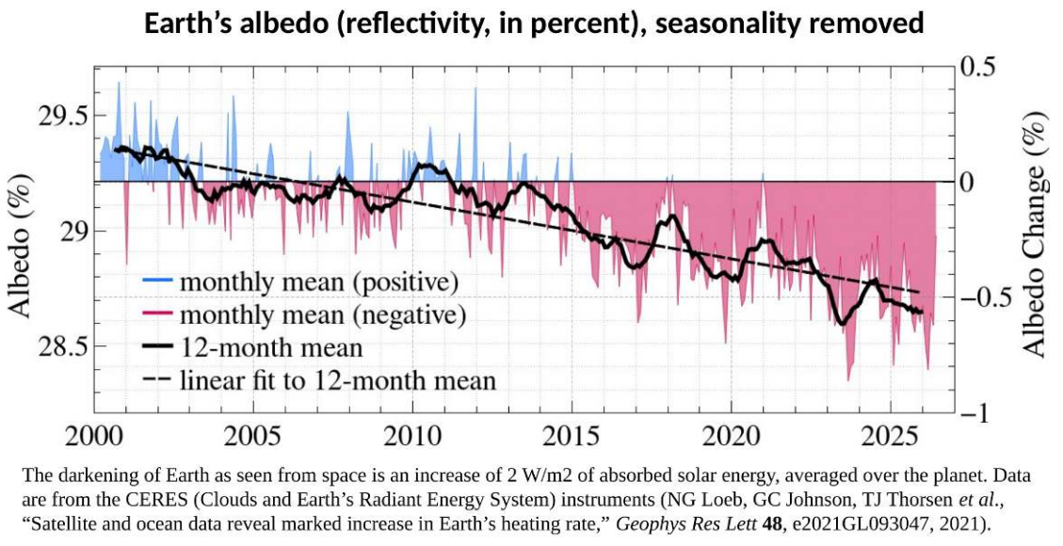
Figure G2. Earth's albedo (reflectivity, in percent), seasonally adjusted.
Albedo refers to how much sunlight reflects off the top of the atmosphere. This is measured with satellites, and it has changed significantly over the last 25 years (in the wrong direction) as shown above. These changes are mostly due to changes in clouds. However, climate models (i.e. AR5 and AR6) only expect them to change 0.43W/m² per 1°C of global temperature change. This is referred to as the global cloud feedback coefficient, and clouds seem to be changing roughly 4-times more than that predicted by this coefficient (i.e. ~1W/m² change over ~0.6°C = 1.6W/m²/°C which is roughly 4-times more than 0.43W/m²/°C). The observed changes in albedo suggest the cloud feedback coefficient is low and/or not-well-understood processes are changing clouds. Put more simply, we need to conduct experiments that improve our understanding of clouds.
Continued on next page…

Illustrative Research Program
The existing open-source GCM proposal provides one possible $1B / five-year research architecture. The Center would review, modify, combine, remove, or replace these areas based on independent scientific assessment and value-of-information analysis.
Program | Five-year $ | Main purpose
Area 1. Earth radiation budget and planetary-albedo benchmark | $88M | Measure and reconcile incoming and outgoing radiation, albedo trends and cloud radiative effects.
Area 2. Anthropogenic aerosol radiative-forcing closure | $154M | Measure direct and cloud-mediated reflection and absorption from pollution and its removal.
Area 3. Marine low-cloud and cloud-feedback experiments | $127M | Constrain subtropical low-cloud feedbacks and cloud susceptibility relevant to MCB.
Area 4. Mixed-phase, high-latitude cloud and surface-albedo experiments | $88M | Improve Arctic and Southern Ocean cloud, sea-ice and snow feedbacks.
Area 5. Deep convection, precipitation and tropical-organization experiments | $79M | Constrain convective aggregation, anvil clouds, humidity and rainfall response.
Area 6. AMOC, ocean heat uptake, freshwater and sea-ice observations | $105M | Measure circulation, mixing and thresholds that control heat uptake and AMOC risk.
Area 7. Rapid-response natural-perturbation program | $48M | Observe volcanic eruptions, wildfire smoke, shipping-fuel changes and major pollution shifts.
Area 8. Storm-resolving, large-eddy and process-model experiments | $61M | Translate observations into improved parameterizations and scale-aware physics.
Area 9. Model Evaluation and Uncertainty Quantification | $35M | Run held-out tests, causal attribution, model weighting, and decision-focused uncertainty analysis.
Area 10. Climate Solution Website and Decision System | $20M | Integrate climate, mitigation, CDR and sunlight-reflection models into a decision-support system.
Area 11. Carbon Dioxide Removal Resource, Cost, and Deployment Models | $125M | Build a global site- and region-resolved CDR database and marginal-cost supply curves across approximately ten major pathways.
Area 12. Observing backbone, calibration and autonomous platforms | $40M | Maintain common radiometry, aircraft, ship, buoy, balloon and satellite-calibration systems.
Area 13. International participation, governance and open-data infrastructure | $20M | Support Global South leadership, independent review, engagement and permanent archives.
Area 14. Contingency and rapid-response reserve | $10M | Respond to rare events, failed instruments, ship or aircraft delays and unexpected findings.
Total | $1.000B

Illustrative $25M Initial Phase
The first phase should not attempt to perform $1B of research for $25M. Its purpose would be to establish leadership, independently evaluate the architecture, build working prototypes, define high-value experiments, and prepare credible follow-on programs.
Illustrative work | Funding
Scientific leadership, fellows and program management | $4M
Independent review and redesign of research architecture | $3M
Climate Solution Website prototype | $4M
Model-evaluation and benchmark development | $4M
Experimental-design and measurement studies | $3M
Climate / energy / CDR cost-model integration | $2M
Workshops, visiting scientists and international collaboration | $2M
Open data, software and publication infrastructure | $1M
Independent review and contingency | $2M
Possible first-phase deliverables include:
- An independently reviewed Version 2.0 research architecture with revised priorities and budgets.
- A working prototype Climate Solution Website linked to existing model ensembles and transparent assumptions.
- A benchmark and validation framework for evaluating whether models improve for decision-relevant quantities.
- Detailed designs and cost estimates for the highest-value field, laboratory, observing, and modeling programs.
- A prioritized roadmap identifying which research should scale, which should be redesigned, and which should stop.
- Open-source software, datasets, documentation, and reproducible calculation records.
All numbers on this page are illustrative planning values for discussion, not a funding commitment or final budget.

Center Structure and Development Path
Potential Host. A major research university with substantial capabilities in climate science, atmospheric science, oceanography, computing, engineering, economics, and public policy could provide the administrative and scientific core. The Center could then subcontract or partner with specialized institutions around the world.
Scientific Independence. An independent scientific director and advisory panel should have authority to revise the existing proposal, reject assumptions, add alternatives, and change priorities. The objective is not to validate a preselected plan; it is to develop a better decision-making system.
Program Management. The Center would use stage gates, open data, independent review, shared-asset planning, reproducible model evaluation, and explicit stop/redesign criteria. Funding would increase only when preceding evidence justifies the next increment.
Collaboration. Potential collaborators could include universities, national laboratories, government research organizations, climate-modeling centers, satellite and observing programs, research-aircraft facilities, foundations, and international partners. The Center should use existing infrastructure where practical rather than duplicate it.
Success. A successful initial phase would not need to “solve climate change.” Its job would be to create credible scientific infrastructure, decision tools, and a prioritized roadmap that make much larger climate R&D investments easier to evaluate and execute.

Related Material

Open-Source Proposals
The following proposals are intended as starting points for researchers. A host university, scientific team, or funding source can independently review the assumptions, develop alternatives, revise budgets, and publish improved versions via the CC BY 4.0 open-source license.
Global Climate Model Experimental Research Initiative
https://www.ma2life.org/g/cm/cmp_gcm_experimental_research.pdf
https://www.ma2life.org/g/cm/cmp_gcm_experimental_research.docx

Climate Decision-Making Research Center | Concept Note
https://www.ma2life.org/g/cm/climate_decision_making_research_center.pdf
https://www.ma2life.org/g/cm/climate_decision_making_research_center.docx

Large-Scale Energy Research Center | Concept Note
https://www.ma2life.org/g/cm/large_scale_energy_research_center.pdf
https://www.ma2life.org/g/cm/large_scale_energy_research_center.docx

Automate Nuclear Power Site Construction
https://www.ma2life.org/g/cm/cmp_fission_automate_site_construction.pdf
https://www.ma2life.org/g/cm/cmp_fission_automate_site_construction.docx

Co-locate Chemical Processing with Nuclear Power
https://www.ma2life.org/g/cm/cmp_fission_chemical_processing.pdf
https://www.ma2life.org/g/cm/cmp_fission_chemical_processing.docx

Climate Moonshot Portfolio
https://www.aplantosavetheplanet.org/cmp

Videos
The Science of Global Warming [#7]
https://www.youtube.com/watch?v=Por9aWKLdc4

The Uncertainty of Climate Change [#8]
https://www.youtube.com/watch?v=HoqX7uBaeKU

Paul Beckwith: Engineering review of the Climate Solution Website
https://www.youtube.com/watch?v=jt59fYZuXIA

Full Video Series
https://www.aplantosavetheplanet.org/video

Ceppi (2021), “Observational evidence that cloud feedback amplifies global warming”, PNAS. (link)

