 | Nuclear Power Automated Site-Construction Initiative
━━━━━━━  CLIMATE  MOONSHOT  PORTFOLIO  Billions to  save trillions | ━━━━━━━━━━━━━━━━━━━━━━━━━━━━━━━━━━━━━━━━━━━━━━━━━━━  Proposed $1 Billion / Five-Year R&D Program  HTR / PWR DEVELOPMENT TRACKS  SPECIAL-PURPOSE MACHINE DEVELOPMENT  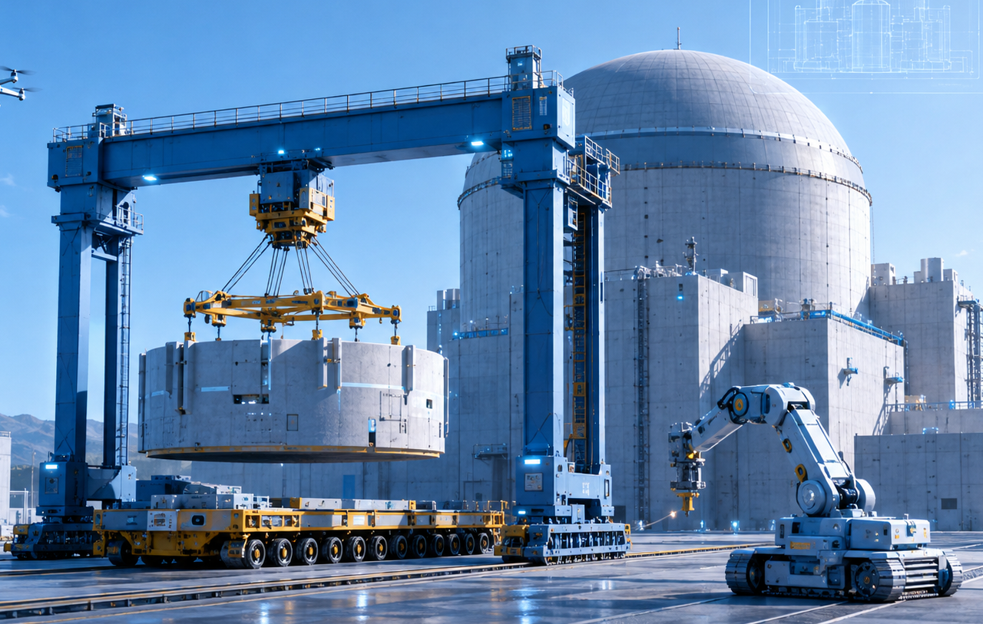  By Glenn Weinreb  Developed with assistance from ChatGPT
━━━━━━━  OPEN  SOURCE | ━━━━━━━━━━━━━━━━━━━━━━━━━━━━━━━━━━━━━━━━━━━━━━━━━━━  Original files are free to copy and modify under the CC BY 4.0 open-source license.  August 21, 2026 | v2k | Copyright © 2026 by Glenn Weinreb | www.APlanToSaveThePlanet.org

Executive Summary
Purpose. This proposed $1 billion, five-year R&D initiative develops and demonstrates machines, tooling, controls, logistics, and digital systems that could automate repetitive site-construction work for two standardized Chinese reference plants: a high-temperature gas-cooled reactor (HTR), using China's HTR-PM/HTR-PM600 family as the initial reference design, and a Hualong One-class Pressurized Water Reactor (PWR). It is a design-and-demonstration program, not a budget to build or license a commercial nuclear plant.
Economic hypothesis. A reusable construction-machine platform, combined with standardized interfaces, modularization, heavy handling, human-supervised automation, metrology, and auditable digital quality records, may reduce site labor, rework, construction time, and financing exposure. Common machinery is preferred where it lowers lifecycle cost; reactor-specific tooling is used where geometry, sequence, or nuclear requirements make commonality impractical.
Five-year work. The program develops full-scale or near-full-scale prototypes for excavation and earthworks; material flow; heavy lift and precision positioning; concrete, rebar, formwork, steel-liner, and structural automation; module transport and installation; digital twins, autonomy, metrology, and nuclear QA; and a shared non-nuclear pilot site. The baseline technical program is $800 million with a centrally controlled $200 million risk reserve and explicit decision gates before the largest fabrication and pilot commitments.
Success criterion. The objective is independently measured evidence: machine performance, construction quality, safety, labor, cycle time, availability, rework, site-construction cost, schedule, and implications for total plant CAPEX and LCOE. The program does not guarantee a specific reactor cost, construction duration, siting outcome, electricity price, or commercial deployment.
Climate Moonshot Portfolio. We define “Climate Moonshot” as conducting R&D to the extent required to solve the climate problem. This would require a portfolio of R&D initiatives, an example of which is at www.APlanToSaveThePlanet.org. The document you are reading is one initiative within that portfolio. It uses a Common Framework that establishes shared rules for governance, procurement, data rights, independent review, and oversight. All documents within this portfolio are open-source and may be freely viewed, used, and modified.

Program at a Glance
The program is designed to determine whether a reusable family of machines, controls, interfaces, and quality systems can materially lower the cost and duration of nuclear site construction in China while preserving nuclear construction quality, safety, and regulator credibility.
Item | Program design
Total funding and duration | $1.0 billion over five years.
Mission | Develop and demonstrate reusable systems that reduce site-construction labor, rework, schedule, and financing exposure for standardized nuclear plants in China.
Reference tracks | HTR-PM/HTR-PM600 high-temperature gas-cooled reactor track plus Hualong One/HPR1000-class PWR track.
Technical strategy | Use common machinery, controls, metrology, interfaces, and digital QA where lifecycle economics support commonality; use reactor-specific tooling where geometry, sequence, or nuclear requirements require divergence.
Baseline technical program | $800M across ten work packages; $200M centrally controlled risk reserve.
Principal development | Excavation and earthworks; material flow; heavy lift and positioning; rebar/concrete/liners; module transport and installation; autonomy, metrology, and nuclear QA data systems.
Demonstration | Shared non-nuclear dual-track pilot site with representative HTR and PWR civil test articles and repeated end-to-end machine campaigns.
Evidence standard | Independent measurement of machine cycle time, labor, availability, quality, rework, safety, site $/W, construction schedule, and implications for total CAPEX and LCOE versus conventional Chinese construction.
End product | An evidence-based recommendation to proceed with HTR, PWR, both, or neither for first licensed deployment work; completion does not authorize a commercial nuclear plant.

Summary Videos
Low-Cost Nuclear Power [#11]
https://www.youtube.com/watch?v=AIlbovU67wI
Automated Nuclear Power Construction [#12]
https://www.youtube.com/watch?v=afO0cy1l7Qo
How to Make $10 Trillion Dollars [#13]
https://www.youtube.com/watch?v=4gqmKGV1h5Y

Table of Contents
Executive Summary 2
Program at a Glance 3
Table of Contents 4
What is Nuclear Power Automated Site-Construction? 5
Program Architecture and $1 Billion Budget 8
Program Crosswalk 11
What Is New Beyond Current Chinese Nuclear Construction? 12
Stage Gates and Go/No-Go Criteria 14
Development Phases 16
Safety, QA, and Qualification 31
Automated Construction Costs 33
Cost Comparison: Electricity Generation Only 35
Cost Comparison: Electricity Generation + Transmission 39
Purchase Orders 41
Purchase Order Recipients 48
Project Management 51
Funding Source Requirements 53
Top Nuclear Construction and Automation References 55
Top Researchers and Organizations 64
Scientific and Engineering Advisory Panel 66
Management Advisory Panel 68
Agreements 69

What is Nuclear Power Automated Site-Construction?
The proposed program would develop custom machines, standardized interfaces, and digital systems that automate repetitive site-construction work for two Chinese nuclear reference plants. The HTR track would use a modular pebble-bed high-temperature gas-cooled reactor architecture derived from the commercially operating Shidao Bay HTR-PM and the larger multi-module HTR-PM600 concept. The PWR rack would use a Hualong One / HPR1000-class plant representative of the standardized Generation III pressurized-water reactors that China is now building in series. The program would not redesign reactor physics, fuel, or the nuclear steam-supply system. It would redesign how approved plant structures and components are constructed, moved, positioned, inspected, and documented at the site.
The economic hypothesis is that a common construction platform can attack costs shared by both reactor types: excavation and earthworks, rock finishing, reinforced concrete, steel liners and structural modules, material movement, heavy lifting, fit-up, welding assistance, inspection, cable and pipe support installation, metrology, rework, and schedule delay. The same core machines should be designed to accept reactor-specific tools and fixtures. A machine fleet that moves from project to project can improve through repetition, reduce craft variability, support 24/7 bounded operation, and generate comparable cost, schedule, safety, and quality data across many plants.
The two reactor tracks require different civil architectures. The HTR concept in the Climate Moonshot Business Plan uses repeated deep, lined cylindrical excavations, rail-mounted gantries, and factory-built support modules. A Hualong One-class PWR instead requires a large nuclear island, basemat, containment structure, steel liner, equipment compartments, major embedded items, and heavy installation of the reactor pressure vessel, steam generators, pressurizer, pumps, piping, and structural modules. The program therefore should maximize common machinery while allowing different end-effectors, work envelopes, lifting systems, formwork, and sequencing for each reference plant. Figures in this document primarily illustrate the HTR track; the PWR track requires its own full-scale mockups and test articles.
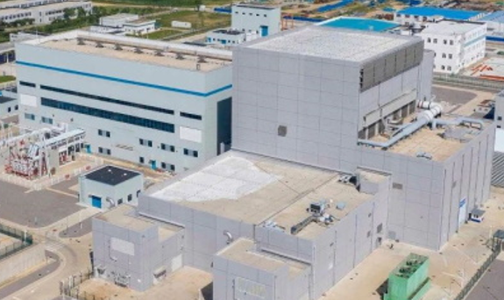
Figure 1: The HTR-PM demonstration plant, one of the two China reference tracks.
The five-year effort would be a construction-equipment and construction-process development program. It would design, prototype, test, and debug machines at a shared non-nuclear pilot site in China or elsewhere. Human-supervised automation is the appropriate initial objective: machines execute bounded tasks automatically while qualified operators authorize starts, pause work, intervene, and recover from faults. The PWR track is particularly valuable because China already has a large Hualong One supply chain and is deploying modularization, mechanization, automation, digitalization, intelligent construction systems, automatic welding, and construction robots. The program should build on those practices rather than pretend it is starting from zero.
A successful program would deliver two frozen reference construction models, a common machine architecture, reactor-specific tooling packages, full-scale or near-full-scale prototypes, representative HTR and PWR civil test articles, heavy transport and component-placement demonstrations, and an auditable digital quality record. It would independently measure the site-construction cost and schedule effects for both designs, including first-of-a-kind and repeated-build cases. It would also quantify a potential HTR siting/transmission advantage without assuming that Chinese regulators will automatically allow closer siting. The output is evidence for a first licensed deployment decision, not a promise of a particular electricity price.
Key boundary of the program
- Included: China-specific construction-system design; HTR and PWR reference construction models; non-nuclear prototypes; civil and structural test articles; heavy equipment; site logistics; digital engineering; metrology; quality records; pilot demonstrations; cost/schedule models; and licensing-support studies.
- Excluded: nuclear fuel qualification; reactor physics R&D; redesign of safety functions merely to simplify construction; commercial plant construction; electricity generation; and ownership or operation of an HTR or PWR plant.
- Conditional: controlled access to HTR-PM and Hualong One/HPR1000 design data, Chinese codes and standards, supplier information, and regulator engagement. If proprietary design access is incomplete, use functionally representative non-nuclear mockups while preserving the dual-reference construction mission.

Program Architecture and $1 Billion Budget
Prompt to AI: A five-year program has $1 billion to develop custom machines and systems that automate site construction in China for both an HTR track, initially using HTR-PM/HTR-PM600 as the reference design, and a Hualong One/HPR1000-class PWR. How should the money be allocated, what should the program deliver, and what should it explicitly not promise?
Response From AI:
The recommended interpretation is a dual-reference design-and-demonstration program, not the construction budget for nuclear plants. All amounts are preliminary planning estimates in constant 2026 dollars. The baseline technical program is $800 million, with a centrally controlled $200 million reserve. The program deliberately avoids splitting the money into two independent $500 million efforts. Instead, it develops a common machine platform first, then funds HTR-specific and PWR-specific tooling and test articles only where plant geometry or nuclear construction sequence truly differs. This creates a direct competition: for each task, measure whether one common machine, two variants, or conventional Chinese construction is cheapest and most reliable.
Work package | Budget | Share | Principal five-year deliverable
Area 1. Dual-reference plant, site, and construction-system design | $90M | 9.0% | Controlled HTR and Hualong One construction reference models, common interfaces, reactor-specific tooling envelopes, quantities, sequences, and machine procurement packages.
Area 2. Excavation, earthworks, and precision rock-cutting machines | $95M | 9.5% | Full-scale or near-full-scale prototypes for HTR deep excavation and PWR bulk excavation/foundation preparation, using common controls and interchangeable tools where practical.
Area 3. Material handling, spoil removal, and machine exchange | $55M | 5.5% | Integrated material-flow and machine-exchange systems that keep both HTR and PWR construction fronts supplied without waiting on haulage, staging, or maintenance.
Area 4. Heavy lift, gantry, crane, rail, and positioning systems | $95M | 9.5% | Prototype heavy-handling systems with standardized lifting interfaces and reactor-specific fixtures for repeated HTR cells and large PWR nuclear-island components/modules.
Area 5. Concrete, rebar, formwork, steel-liner, and structural automation | $150M | 15.0% | Automated structural construction for HTR lined excavations and PWR basemat/containment work, including rebar, embedments, concrete, steel liners, inspection, and digital records.
Area 6. Heavy-module transport and site-logistics system | $80M | 8.0% | Reusable transport and staging systems for factory-to-site movement of HTR modules and PWR structural/mechanical modules, with standardized site handoff interfaces.
Area 7. Reactor-island and support-module installation automation | $85M | 8.5% | Mockups and tools to transport, position, align, connect, inspect, and repeatedly install major HTR and PWR components without nuclear material.
Area 8. Digital twin, autonomy, metrology, and nuclear QA data thread | $65M | 6.5% | One integrated planning, control, metrology, configuration, quality, and auditable as-built data thread supporting both reactor construction tracks.
Area 9. Integrated dual-track pilot site and end-to-end demonstration | $55M | 5.5% | Shared non-nuclear pilot with distinct HTR and PWR test zones where the common machine fleet and reactor-specific tooling operate end to end and produce independent evidence.
Area 10. Program management, nuclear QA, China licensing support, and independent review | $30M | 3.0% | Owner-side program office controlling the common platform, two reference designs, contracts, interfaces, cost, schedule, safety, quality, data rights, independent review, and transition.
Area 11. Central contingency and risk reserve | $200M | 20.0% | Funds released only for documented technical, integration, supplier, site, China-regulatory, or schedule risks across either reactor track.
Suggested five-year funding profile
Year | Technical work | Reserve | Total | Primary emphasis
Year 1 | $110M | $20M | $130M | Freeze the two China reference construction models; map common versus reactor-specific tasks; design-data strategy; economics; safety/licensing basis.
Year 2 | $160M | $30M | $190M | Preliminary machine design, competing concepts, HTR and PWR civil mockup design, component tests, pilot-site design.
Year 3 | $210M | $40M | $250M | Detailed design, prototype fabrication, common controls/digital thread, pilot civil work, reactor-specific tooling.
Year 4 | $210M | $60M | $270M | Peak fabrication and full-scale demonstrations: HTR excavation/lining; PWR basemat/containment/liner; heavy transport and installation.
Year 5 | $110M | $50M | $160M | Repeated dual-track campaigns, reliability growth, independent cost/schedule audit, China deployment and Phase II packages.
Total | $800M | $200M | $1.000B | Reserve remains under sponsor control and may remain unspent.
Program-level success criteria
- Two controlled China reference construction models - one HTR track initially based on HTR-PM/HTR-PM600 and one Hualong One/HPR1000-class PWR - with interfaces, quantities, tolerances, sequences, and licensing assumptions.
- Full-scale or near-full-scale non-nuclear civil test articles representing the hardest HTR underground work and the hardest PWR basemat/containment/steel-liner work.
- A common prototype fleet for excavation, material flow, heavy handling, rebar, concrete, structural installation, transport, metrology, autonomy, and digital QA, with reactor-specific tooling where required.
- Repeated HTR and PWR end-to-end demonstrations with measured labor, machine cycle time, availability, quality, rework, safety, cost, and schedule.
- Auditable as-built data threads for both reference plants linking design to materials, machine logs, surveys, inspections, NDE, nonconformances, and acceptance.
- Independent bottom-up estimates of site-construction $/W, total plant CAPEX impact, build time, plant-gate LCOE impact, and delivered-electricity impact under multiple transmission-distance scenarios.
What the program would not accomplish
- It would not build or license an operating nuclear power plant.
- It would not demonstrate nuclear fuel, reactor operation, helium-system operation, PWR primary-system operation, or electricity generation.
- It would not assume the HTR underground concept or the current Hualong One construction sequence is optimal; competing civil and modularization concepts must be tested.
- It would not guarantee a specific overnight capital cost, construction duration, siting distance, transmission cost, or electricity price.
- It would not relax nuclear safety classification, QA, inspection, or regulatory requirements to make automation easier; the target is high automation under qualified human supervision.

Program Crosswalk
This program crosswalk links the $1 billion budget to the development, procurement, and decision architecture. References to subphases, purchase orders, and gates are mappings rather than additional budget lines; the same work must not be counted twice.
Work package | Track | Principal five-year deliverable | Budget | Relevant development / procurement
Area 1. Dual-reference construction-system design | Common + HTR + PWR | Frozen HTR/PWR construction models, common interfaces, quantities, sequences, and procurement packages. | $90M | 1A-1F; Gates G1-G3
Area 2. Excavation and precision rock cutting | Common + variants | HTR deep-excavation and PWR bulk/foundation-preparation prototypes. | $95M | 2A-2F; Gates G2-G5
Area 3. Material handling and machine exchange | Common + variants | Integrated spoil, material-flow, docking, utility, and recovery systems. | $55M | 3A-3F; Gates G2-G5
Area 4. Heavy lift, gantry, crane, rail, positioning | Common + variants | Standardized heavy-handling platform with HTR/PWR fixtures and proof-tested precision placement. | $95M | 4A-4F; Gates G2-G5
Area 5. Concrete, rebar, formwork, liners, structures | HTR + PWR + common tools | Automated HTR lining and PWR basemat/containment/steel-liner construction with digital inspection. | $150M | 5A-5F; Gates G2-G5
Area 6. Heavy-module transport and site logistics | Common + variants | Reusable rail/SPMT/transfer/staging systems and open handoff interfaces. | $80M | 6A-6F; Gates G2-G5
Area 7. Reactor-island and support-module installation | HTR + PWR + common tools | Mockups and tools for transport, positioning, fit-up, connection, NDE, and repeatable installation. | $85M | 7A-7F; Gates G2-G5
Area 8. Digital twin, autonomy, metrology, QA data thread | Common | Integrated planning, control, configuration, metrology, traceability, and auditable as-built record. | $65M | 8A-8F; Gates G1-G5
Area 9. Integrated dual-track pilot | Common site + two test zones | Repeated end-to-end HTR and PWR construction campaigns with independent evidence. | $55M | 9A-9F; Gates G3-G6
Area 10. Program management, QA, licensing support, review | Program-wide | Owner-side integration, nuclear QA oversight, China licensing support, independent review, and final economics. | $30M | 10A-10E; Gates G1-G6
Area 11. Central contingency and risk reserve | Program-wide reserve | FS-controlled reserve released only for documented risk, redesign, recovery, or added verification. | $200M | Reserve task orders; written change control

What Is New Beyond Current Chinese Nuclear Construction?
This initiative should treat current Chinese nuclear-construction capability as the baseline, not as the research target. The proposal’s existing CNNC and CGN references describe smart construction systems, modularization, automatic welding, integrated hoisting, digital handover, and field robots. The Moonshot therefore funds the next layer: full-scale development and measurement of construction systems that remain labor-, schedule-, rework-, or quality-intensive, and proof of whether a reusable machine fleet can materially reduce site-executed $/W and construction time.
Capability | China baseline represented in this proposal | Moonshot extension to test
Digital construction | BIM/smart-site systems and digital handover are already used. | Link design, work packages, machine logs, metrology, inspection, nonconformance, and as-built records into one auditable HTR/PWR data thread.
Automatic welding | Automatic welding is already used on selected nuclear-construction tasks. | Extend automation to fit-up, weld-assist, inspection/NDE, repair, and repeatable connection work where qualification and lifecycle economics justify it.
Heavy lift and modularization | Chinese projects already use large modules, integrated lifts, and sophisticated crane planning. | Standardize reusable lifting/positioning interfaces, machine controls, precision metrology, and reactor-specific fixtures; measure cycle time, availability, and rework.
Construction robots | Field robots already perform selected finishing and support tasks. | Move into higher-value repetitive work such as rebar, embedments, concrete support, inspection, logistics, and bounded assembly under human supervision.
Excavation and foundation preparation | Highly mechanized conventional excavation is available. | Develop HTR deep-excavation/lining systems and PWR bulk-excavation/basemat precision-finishing systems with common controls and interchangeable tooling where practical.
Rebar, concrete, liners, and embeds | Advanced but still labor- and sequence-intensive nuclear civil work. | Test prefabrication, robotic placement/verification, modular formwork, sensing, curing, steel-liner automation, and machine-readable QA records.
Machine commonality | Equipment is generally selected around each project and task. | Create a reusable common machine architecture, then deliberately split into HTR- or PWR-specific tooling only when geometry, sequence, safety, or lifecycle cost requires it.
Economics validation | Project reporting exists, but it does not provide the controlled counterfactual this program needs. | Instrument conventional and automated work using identical accounting boundaries so independent reviewers can reconstruct labor, machine time, rework, schedule, site $/W, and total-plant effects.

Dual-track automation map
The table below is a compact visual map of where common machinery is most valuable and where the two reactor references require different tooling. It also makes the PWR track explicit rather than treating Hualong One as an add-on to the original HTR concept.
HTR-specific construction | Common machine / digital platform | PWR-specific construction
Repeated deep lined cylindrical excavations; vertical spoil and shaft logistics; repeated-cell gantry fixtures; HTR vessel/steam-generator simulators. Optimize repetition across many smaller reactor modules. | Machine controls and supervisory autonomy; metrology; QA/data thread; rebar/concrete systems; heavy handling controls; transport interfaces; maintenance and diagnostics. Use the same acceptance logic: measured productivity, quality, safety, rework, availability, maintainability, and independently reconstructed economics. | Large basemat and nuclear island; containment and steel liner; dense embedments; very large reactor-vessel/steam-generator/pressurizer lifts; PWR structural and mechanical modules. Optimize serial construction of a mature ~1.1 GWe-class unit while extending existing Chinese modularization and smart-construction practice.

Stage Gates and Go/No-Go Criteria
Passing a gate authorizes only the next R&D stage. It does not authorize an operating reactor or commercial deployment. Gate criteria should be fixed before the associated major commitment, independently reviewed, and tied to the measured construction baseline. Failure should trigger redesign, repetition, scale reduction, competitive substitution, or termination rather than automatic progression.
Gate | Required evidence | Decision enabled | If not met
G1. Reference baseline ready (Month 9) | Controlled HTR and PWR reference construction models; site envelopes; quantities; interfaces; design-data strategy; Chinese code/licensing assumptions; conventional cost/schedule baselines; measurement plan. | Authorize competing machine/process concepts and risk-reduction work. | Close data gaps, revise assumptions, or use functionally representative non-nuclear mockups; do not claim savings against an uncontrolled baseline.
G2. Concept down-selection (Month 18) | Competing concepts and early tests show which tasks should use common machines, HTR-specific tooling, PWR-specific tooling, or conventional Chinese construction; lifecycle economics and major hazards are updated. | Authorize preliminary design of selected concepts while retaining alternatives where uncertainty remains material. | Continue limited competition, redesign, or stop concepts that do not show credible cost, quality, safety, or schedule value.
G3. Preliminary design ready (Month 24) | Preliminary designs, interfaces, safety/QA approach, pilot configuration, suppliers, cost/schedule estimate, test plan, and independent review are credible. | Authorize detailed design, long-lead procurement, and major prototype fabrication. | Do not commit major fabrication; resolve deficiencies, narrow scope, or select a different concept.
G4. Pilot construction authorization (Month 32) | Detailed designs and configurations are controlled; representative HTR/PWR test articles, instrumentation, acceptance criteria, site safety, quality, and supplier readiness are complete. | Authorize full-scale pilot civil work and prototype installation. | Delay or reduce the pilot, replace suppliers or articles, and repeat readiness review.
G5. Integrated test readiness (Month 42) | Prototype qualification, proof loads, metrology, autonomy safe-stop behavior, QA/data thread, open deficiencies, test procedures, and independent witness plans demonstrate readiness. | Authorize repeated dual-track end-to-end construction campaigns. | Correct deficiencies before integrated testing; do not waive material safety, quality, or measurement requirements to preserve schedule.
G6. Phase II decision (Month 60) | Repeated HTR and PWR performance; reliability growth; independent cost/schedule reconstruction; quality and failure record; licensing/qualification gap analysis; accepted open handoff package. | Recommend HTR, PWR, both, or neither for separately authorized first-site / Phase II work. | Stop, redirect, or continue only narrowly justified R&D; completion of Phase I creates no entitlement to deployment.
Program-level stop rule
The program should stop or redirect a workstream when repeated tests do not show credible reductions in lifecycle construction cost or schedule, when quality or safety requirements cannot be met reliably, when reactor-specific divergence eliminates the expected common-platform advantage, when required design/licensing access cannot be obtained, or when the expected value of additional information is lower than competing uses of the remaining funds.

Development Phases
Prompt to AI: For each dual-reference budget item, identify the development phases, approximate cost, deliverable, and major decision gates. Distinguish common machinery from HTR-specific and PWR-specific tooling.
Response From AI:
The phases below overlap across the five-year program. The key discipline is to freeze two reference construction models early enough that machinery is designed against real quantities, loads, tolerances, Chinese codes, and work sequences. Common machinery should be favored when it reduces lifecycle cost; reactor-specific tooling should be funded only when geometry, safety classification, or sequence makes commonality uneconomic or unsafe.
Common stage | Timing | Purpose
A. Requirements and feasibility | Months 0-12 | Freeze the HTR and PWR construction reference models, compare alternatives, secure design data, and test physical/economic assumptions.
B. Preliminary design and risk reduction | Months 6-24 | Down-select common versus reactor-specific concepts; test critical civil, structural, controls, logistics, and China-code risks.
C. Detailed design and procurement | Months 18-36 | Produce controlled drawings, software baselines, supplier packages, mockups, long-lead procurements, and dual-track pilot plans.
D. Fabrication and qualification | Months 24-44 | Build prototypes and prove loads, precision, endurance, compatibility, safe failure behavior, and repeatability on representative HTR/PWR tasks.
E. Integrated pilot demonstration | Months 36-56 | Operate systems in both test zones and collect independent performance, safety, quality, cost, and schedule evidence.
F. Reliability growth and handoff | Months 48-60 | Correct deficiencies, freeze replicable designs, and prepare separate first-site packages for HTR and PWR deployment in China.

Area 1. Dual-reference plant, site, and construction-system design - $90 million
Controlled HTR and Hualong One construction reference models, common interfaces, reactor-specific tooling envelopes, quantities, sequences, and machine procurement packages.
Subphase | Principal activity and deliverable | Cost
1A | China reference requirements, design-data access, and licensing strategy | $15M
1B | Site envelopes, civil quantities, geotechnical assumptions, and temporary works for both reference plants | $15M
1C | Design-for-automation, modularization, common interfaces, and construction sequence | $20M
1D | HTR-specific underground construction cell and machine-interface design | $15M
1E | PWR-specific basemat, containment, steel-liner, embedment, and nuclear-island construction design | $15M
1F | Comparative cost/schedule/siting model and final machine procurement package | $10M
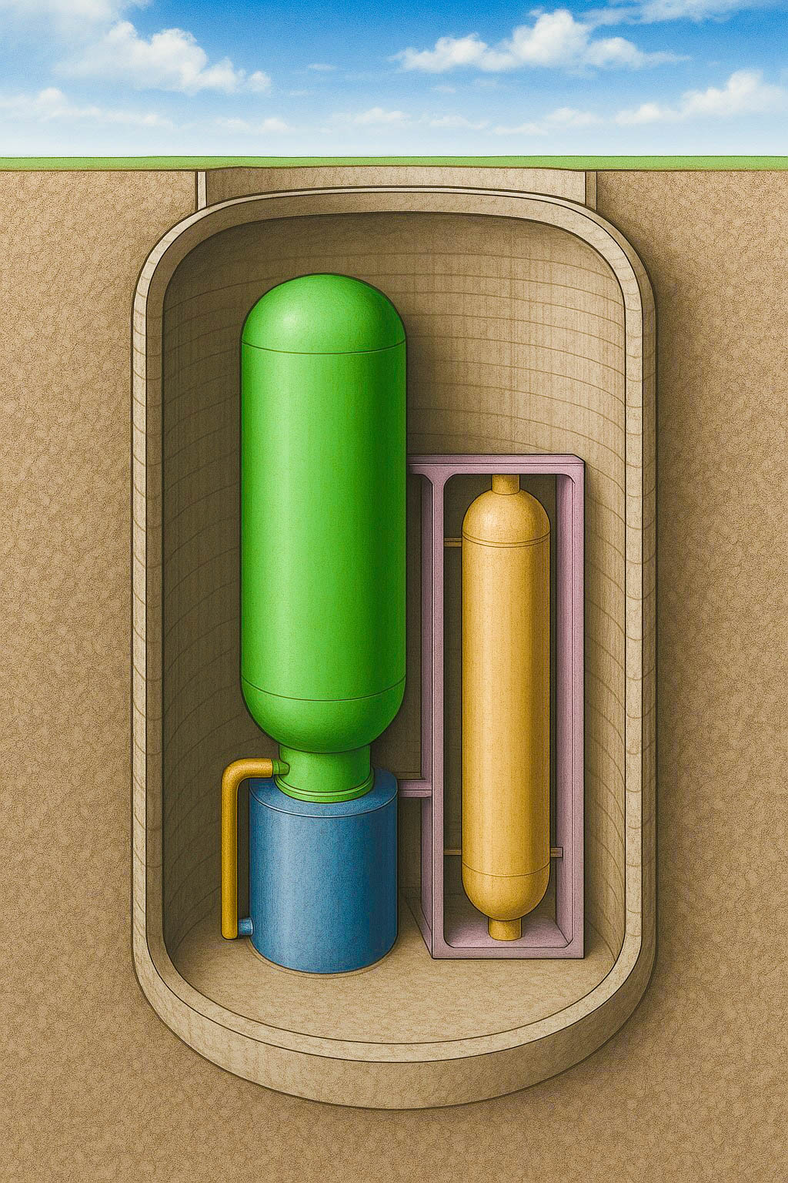
Figure 2. HTR-track conceptual underground placement of a reactor vessel and heat exchanger.
Source: Climate Moonshot Business Plan; concept by Glenn Weinreb.
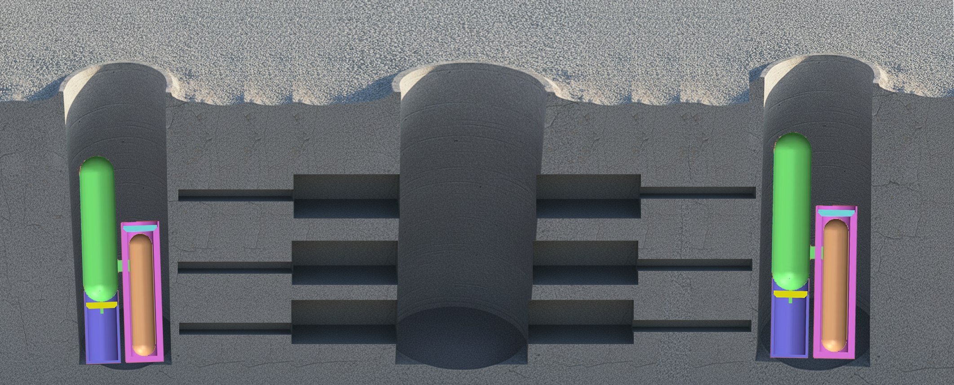
Figure 3. HTR-track repeated excavations for reactor vessels and support equipment.
Source: Climate Moonshot Business Plan; concept by Glenn Weinreb.
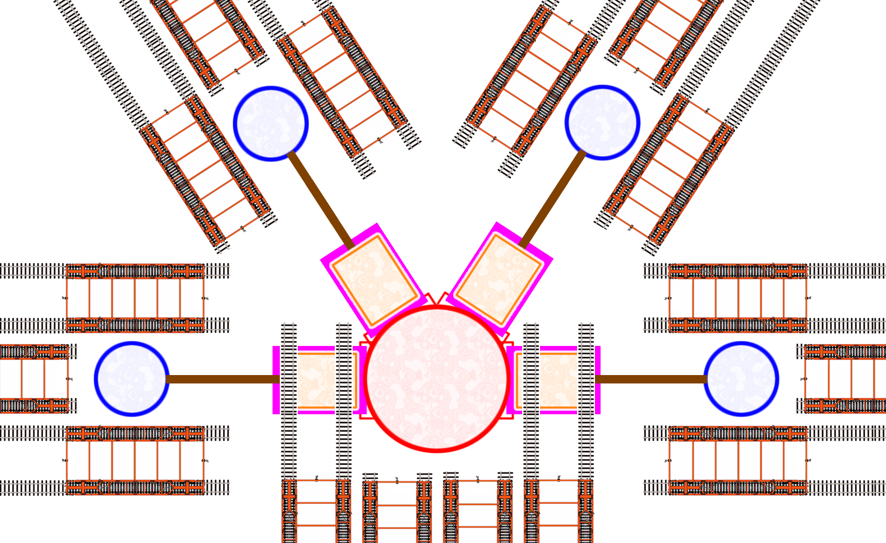
Figure 4. HTR-track example layout with four reactor vessels supported by one equipment excavation.
Source: Climate Moonshot Business Plan; concept by Glenn Weinreb.

Area 2. Excavation, earthworks, and precision rock-cutting machines - $95 million
Full-scale or near-full-scale prototypes for HTR deep excavation and PWR bulk excavation/foundation preparation, using common controls and interchangeable tools where practical.
Subphase | Principal activity and deliverable | Cost
2A | Geology, tool, and excavation-method competition for both site architectures | $10M
2B | HTR shaft/deep-excavation machine preliminary design | $20M
2C | PWR bulk excavation, basemat preparation, and precision rock-finishing machine design | $20M
2D | Common machine prototype fabrication and subsystem qualification | $20M
2E | Dual-track non-nuclear excavation and foundation-preparation demonstrations | $15M
2F | Reliability growth and replicable manufacturing package | $10M
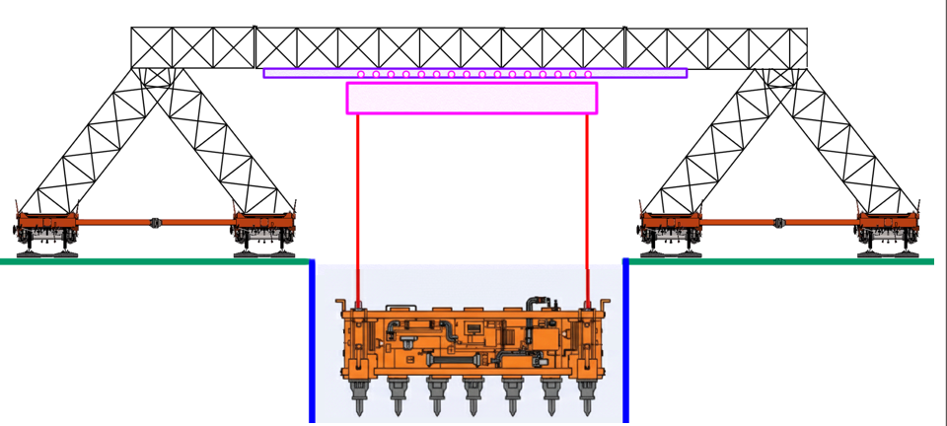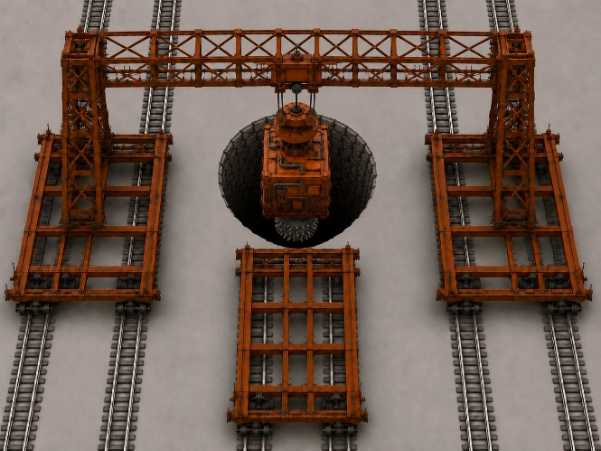
Figure 5. Gantry-like crane concept supporting excavation; adaptable tooling is a common-platform objective. Source: Climate Moonshot Business Plan; concept by Glenn Weinreb.
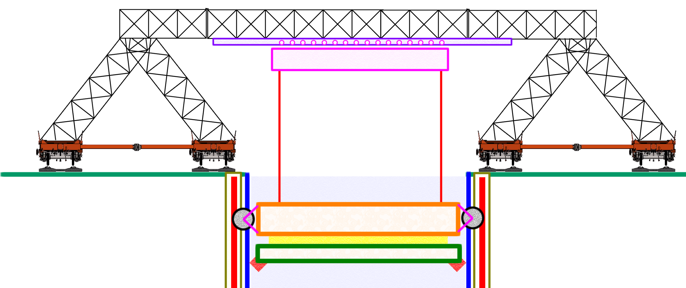
Figure 6. Conceptual precision rock-finishing machine for the HTR track; PWR tooling would address basemat and nuclear-island geometry. Source: Climate Moonshot Business Plan; concept by Glenn Weinreb.

Area 3. Material handling, spoil removal, and machine exchange - $55 million
Integrated material-flow and machine-exchange systems that keep both HTR and PWR construction fronts supplied without waiting on haulage, staging, or maintenance.
Subphase | Principal activity and deliverable | Cost
3A | Material-flow requirements and concepts for both reference plants | $5M
3B | HTR vertical spoil, hoist, and shaft-logistics design | $10M
3C | PWR horizontal excavation, laydown, and high-volume material-logistics design | $10M
3D | Common conveyors, crushers, hoists, docking, utilities, and controls | $15M
3E | Dual-track throughput, jam, maintenance, and recovery demonstration | $10M
3F | Final scale-up design and operating package | $5M

Area 4. Heavy lift, gantry, crane, rail, and positioning systems - $95 million
Prototype heavy-handling systems with standardized lifting interfaces and reactor-specific fixtures for repeated HTR cells and large PWR nuclear-island components/modules.
Subphase | Principal activity and deliverable | Cost
4A | Loads, geometry, rail, crane, and nuclear-lifting requirements for both reference plants | $10M
4B | HTR rail-mounted gantry, trolley, and repeated-cell handling design | $15M
4C | PWR heavy-lift, temporary gantry, crane, and large-module installation design | $15M
4D | Common lifting tools, controls, prototype fabrication, and factory proof testing | $30M
4E | Dual-track pilot installation, proof-load testing, and repeated precision moves | $18M
4F | Reliability growth and Chinese code-compliance package | $7M
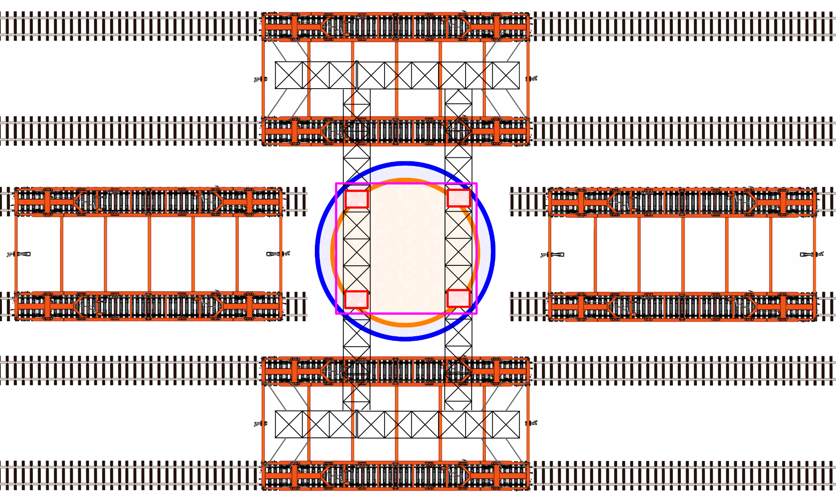
Figure 7. Conceptual rail-mounted gantry with a three-axis trolley; one candidate common heavy-handling platform. Source: Climate Moonshot Business Plan; concept by Glenn Weinreb.
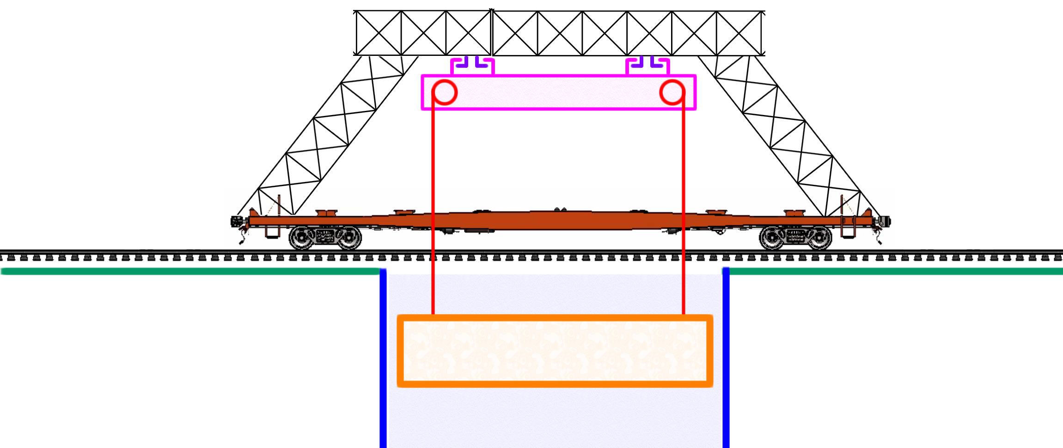
Figure 8. Gantry crane, side view.
Source: Climate Moonshot Business Plan; concept by Glenn Weinreb.

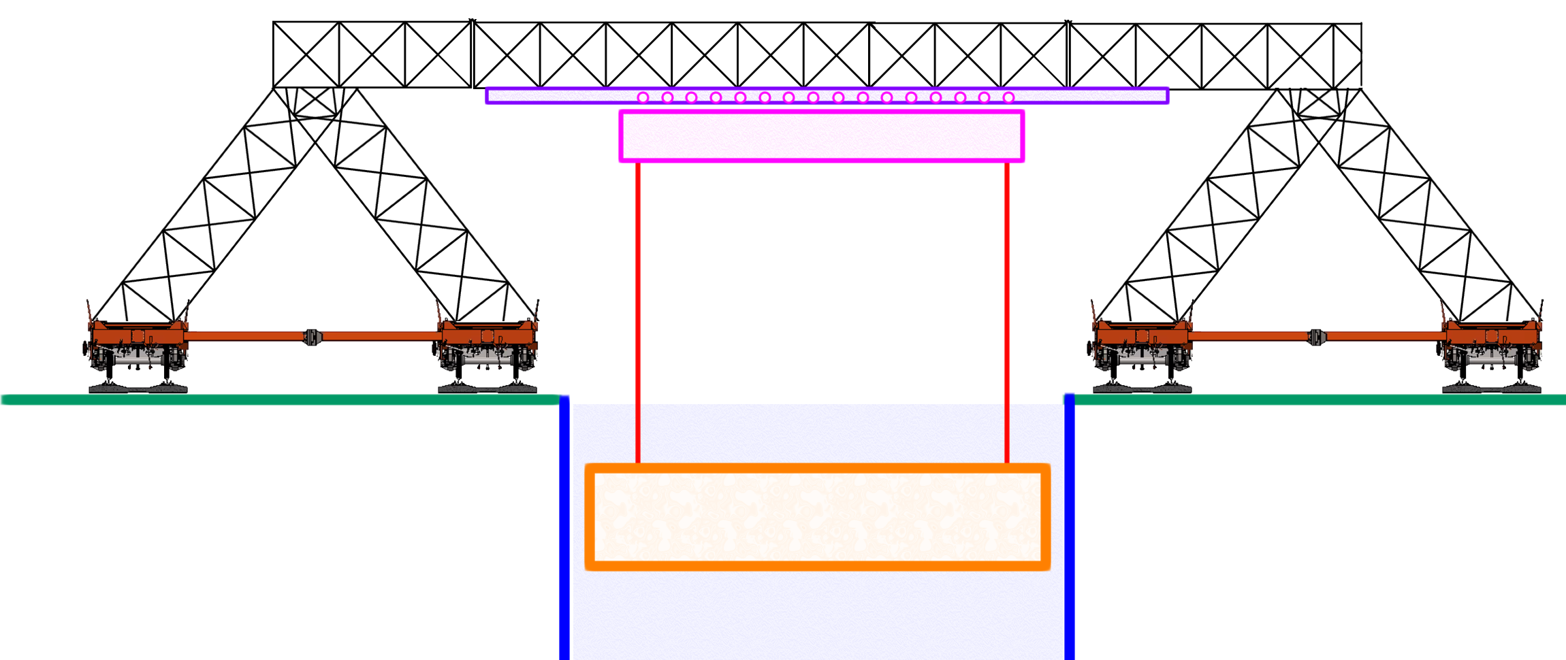
Figure 9. Gantry crane, front view.
Source: Climate Moonshot Business Plan; concept by Glenn Weinreb.

Area 5. Concrete, rebar, formwork, steel-liner, and structural automation - $150 million
Automated structural construction for HTR lined excavations and PWR basemat/containment work, including rebar, embedments, concrete, steel liners, inspection, and digital records.
Subphase | Principal activity and deliverable | Cost
5A | Structural-system comparison, materials, and qualification plan | $15M
5B | Automated rebar, embedments, anchors, and as-built verification | $30M
5C | Modular formwork, batching, placement, curing, sensing, and concrete inspection | $25M
5D | PWR steel-liner and structural-module fabrication/installation automation | $25M
5E | Full-scale HTR lining and PWR basemat/containment representative demonstrations | $40M
5F | Reliability, code support, and final construction package | $15M
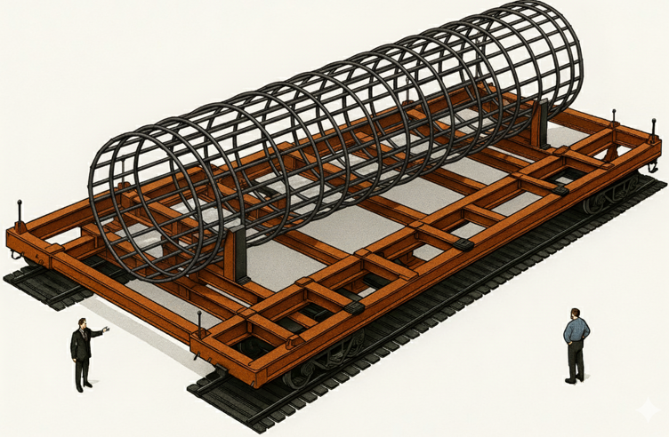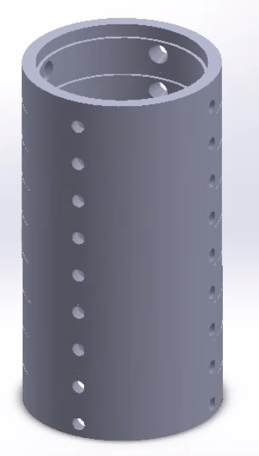
Figure 10. Conceptual rebar cage transported on a large rail platform; similar off-site fabrication principles can be tested for PWR reinforcement assemblies.
Source: Climate Moonshot Business Plan; concept by Glenn Weinreb.

Area 6. Heavy-module transport and site-logistics system - $80 million
Reusable transport and staging systems for factory-to-site movement of HTR modules and PWR structural/mechanical modules, with standardized site handoff interfaces.
Subphase | Principal activity and deliverable | Cost
6A | Cargo, route, bridge, port, factory, and site-interface requirements | $8M
6B | Standardized rail/SPMT/heavy-transport platform design competition | $14M
6C | Loading, transfer, temporary track/road, staging, and route equipment | $10M
6D | Prototype transport-platform and transfer-equipment fabrication | $22M
6E | Loaded route, curve, grade, transfer, and crane/gantry-handoff demonstrations | $18M
6F | Open interface standard and deployment package | $8M
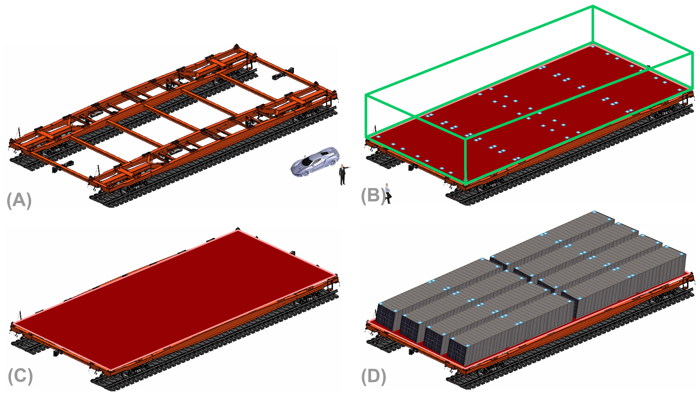
Figure 11. Double-width railcars or multi-rail platforms support large and heavy loads; the program would compare rail, SPMT, and site-specific alternatives.
Source: Climate Moonshot Business Plan; concept by Glenn Weinreb.
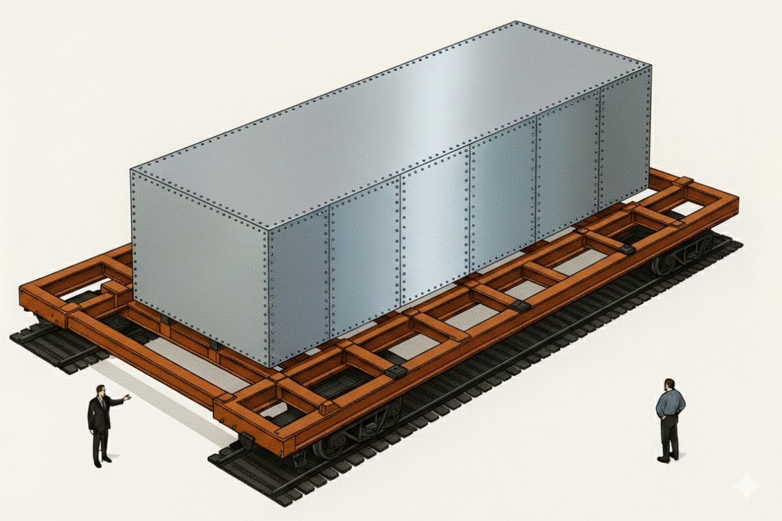
Figure 12. Equipment bins or modules are transported from factory or shipyard to the nuclear site; module envelopes differ between HTR and PWR tracks.
Source: Climate Moonshot Business Plan; concept by Glenn Weinreb.
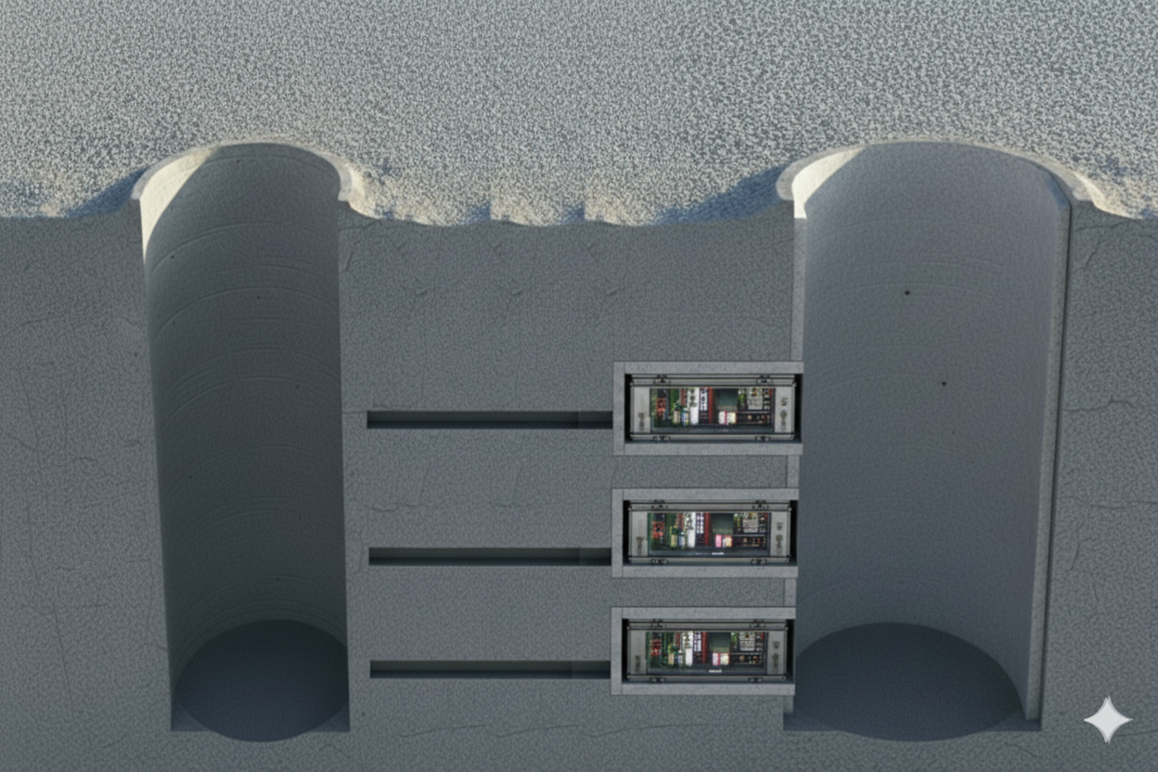
Figure 13. HTR-track equipment modules mounted in concrete-lined cavities.
Source: Climate Moonshot Business Plan; concept by Glenn Weinreb.

Area 7. Reactor-island and support-module installation automation - $85 million
Mockups and tools to transport, position, align, connect, inspect, and repeatedly install major HTR and PWR components without nuclear material.
Subphase | Principal activity and deliverable | Cost
7A | Module, datum, connection, tolerance, and inspection architecture | $8M
7B | HTR reactor-vessel, steam-generator, and support-module simulators | $12M
7C | PWR reactor-vessel, steam-generator, pressurizer, pump, and structural-module simulators | $15M
7D | Placement, alignment, bolting, fit-up, welding-assist, NDE, and connection tools | $20M
7E | Dual-track end-to-end installation and repeatability demonstrations | $22M
7F | Final interface standard and nuclear-qualification gap plan | $8M
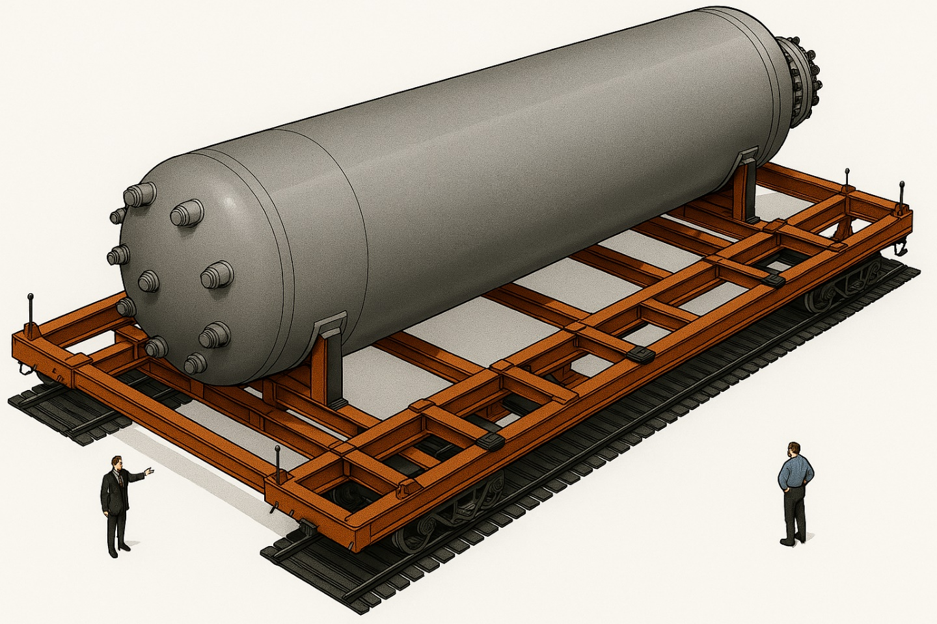
Figure 14. Reactor vessel transported from factory to site; the PWR track requires separate transport and lifting fixtures for much larger primary-system components.
Source: Climate Moonshot Business Plan; concept by Glenn Weinreb.

Area 8. Digital twin, autonomy, metrology, and nuclear QA data thread - $65 million
One integrated planning, control, metrology, configuration, quality, and auditable as-built data thread supporting both reactor construction tracks.
Subphase | Principal activity and deliverable | Cost
8A | China data architecture, identifiers, records, access, and cybersecurity | $8M
8B | HTR and PWR plant/site/machine/logistics 4-D digital twins | $12M
8C | Supervisory autonomy, geofencing, safe stop, intervention, and fault recovery | $15M
8D | Metrology, material traceability, inspection, NDE, and nonconformance integration | $12M
8E | Pilot operating center and cyber/safety exercises | $10M
8F | Open software/data release and regulated handoff package | $8M

Area 9. Integrated dual-track pilot site and end-to-end demonstration - $55 million
Shared non-nuclear pilot with distinct HTR and PWR test zones where the common machine fleet and reactor-specific tooling operate end to end and produce independent evidence.
Subphase | Principal activity and deliverable | Cost
9A | China pilot-site selection, environmental review, and dual-track design | $7M
9B | Civil works, test zones, tracks/roads, utilities, workshops, control room, and safety systems | $13M
9C | Subsystem installation and integration | $10M
9D | Progressive commissioning and test-readiness review | $8M
9E | Repeated HTR and PWR construction campaigns and independent audit | $12M
9F | Phase II readiness review and first-site handoff | $5M

Area 10. Program management, nuclear QA, China licensing support, and independent review - $30 million
Owner-side program office controlling the common platform, two reference designs, contracts, interfaces, cost, schedule, safety, quality, data rights, independent review, and transition.
Subphase | Principal activity and deliverable | Cost
10A | Program formation, governance, China implementation plan, and financial controls | $5M
10B | Requirements, procurement, baseline, and dual-reference interface control | $5M
10C | Design, supplier, manufacturing, and nuclear QA oversight | $6M
10D | Pilot safety, testing, environmental, security, and regulator engagement | $7M
10E | Final audit, lifecycle economics, comparative technology assessment, and Phase II decision package | $7M

Area 11. Central contingency and risk reserve - $200 million
Reserve is held by the funding source and released only after a written problem statement, alternatives analysis, independent review, updated cost/schedule estimate, and conflict check.
Reserve stage | Max. | Examples
Requirements and reference design | $25M | Unexpected limits on HTR or PWR design data; China licensing/code studies; alternative site or structural concepts; added baseline measurements.
Prototype design | $35M | Second-source concepts, failed tool tests, structural redesign, controls or functional-safety changes, HTR/PWR interface divergence.
Fabrication and pilot site | $55M | Supplier failure, long-lead material, rework, pilot-site changes, inflation, extraordinary heavy logistics, replacement mockups.
Integration and test | $65M | Damaged prototypes, failed dual-track tests, additional pilot cycles, hardware/software/interface redesign, failure investigation.
Final readiness | $20M | Additional reliability runs, final deficiencies, China licensing/QA documents, cost-model verification, schedule recovery.

Safety, QA, and Qualification
The five-year program is deliberately a non-nuclear construction R&D and demonstration effort. Its safety case therefore focuses on full-scale construction hazards, nuclear-quality evidence, controlled reactor interfaces, automation behavior, and the qualification gap between a successful pilot and work allowed on a licensed nuclear site. Portfolio-wide safety, audit, conflict, procurement, open-data, and stop-work rules remain governed by the Common Framework.
Area | Initiative-specific requirement | Five-year evidence / boundary
Non-nuclear pilot boundary | Use representative structures, loads, simulators, tools, and data without nuclear fuel or reactor operation. | No fuel qualification, primary-system operation, reactor operation, or electricity generation is authorized by this program.
Reference design authority | Control HTR and PWR geometry, loads, tolerances, safety classifications, interfaces, and permitted design data. | A machine or construction-process change may not silently alter a licensed/safety-significant reactor interface.
Nuclear QA and traceability | Apply applicable Chinese nuclear-construction QA requirements to representative work, including configuration, material identity, records, nonconformance, and corrective action. | Acceptance packages must permit an independent reviewer to reconstruct what was built, with what material/configuration, by which process, and against which requirement.
Human-supervised automation | Define operating domains, authorization, geofencing, safe stop, intervention, fault recovery, logging, and maintenance states. | Unattended operation is not assumed as a five-year objective; automation advances only when failure behavior is understood and independently reviewed.
Heavy lift and machine safety | Use engineered load cases, proof tests, exclusion zones, redundant monitoring where appropriate, safe-failure logic, and independent witnessing. | Repeated precision moves must demonstrate load control, positioning accuracy, recovery from faults, and no unacceptable degradation of lifted components or fixtures.
Civil structures and temporary works | Qualify representative concrete, rebar, liners, embeds, anchors, temporary works, curing, inspection, and dimensional control against applicable requirements. | Full-scale or near-full-scale HTR and PWR test articles must show quality at least comparable to the conventional Chinese baseline.
Metrology and NDE | Use calibrated, traceable measurement and independent V&V for critical dimensions, weld/connection quality, material traceability, and as-built verification. | Machine productivity is not accepted if it creates hidden inspection debt, unresolved nonconformance, or less reliable records.
Cybersecurity and controlled information | Protect controlled reactor/vendor data while separating it from sponsor-funded machine foreground work and open test evidence. | Release restrictions must be narrow and documented; the public machine/test package should remain reusable to the maximum lawful extent.
Qualification gap to first licensed site | Maintain a living list of tests, codes, procedures, vendor approvals, regulator interactions, and site-specific qualification still required after the pilot. | A successful pilot is evidence for a Phase II decision, not authorization to construct or license a commercial reactor.
Independent hold / stop authority | Provide independent QA, safety, and test authorities direct access and defined hold/stop rights. | Serious safety, quality, cyber, or configuration findings can halt the affected work until disposition is approved.

Automated Construction Costs
Prompt to AI: Compare Automated China HTR, Automated China PWR, and conventional China PWR construction, but treat the automated cases as planning scenarios rather than demonstrated costs. Make the assumed construction-cost and schedule changes explicit and identify what the R&D program must actually measure.
Response From AI:
Purpose of this chapter. The automated HTR and PWR numbers in this proposal are not observed costs and should not be read as predictions. They are central planning scenarios used to test whether construction automation is economically important enough to justify the R&D. The program should measure site-executed construction cost and schedule first, then independently reconstruct total plant CAPEX, financing exposure, LCOE, and useful-heat economics from those measurements.

Central planning comparison
China case | Status / interpretation | Build time | Overnight CAPEX ($/We) | Site-construction ($/We) | Electricity LCOE ($/MWh) | Heat LCOE ($/MWhth)
Hualong One-class PWR | Current planning baseline represented in this proposal | 5–7 yr;  ~6 yr typ. | $2.00–$2.50 | $0.75–$1.00 | $34–$45 | $11–$14
Automated Hualong One-class PWR | Modeled central scenario; not demonstrated | 3.5–4.5 yr | $1.45–$1.75 | $0.35–$0.50 | $27–$34 | $9–$11
Automated HTR-PM/HTR-PM600-type plant | Modeled mature multi-module scenario; not demonstrated | 3–4 yr | $1.70–$2.10 | $0.30–$0.45 | $32–$41 | $13–$17
Important qualification. The automated rows are hypotheses to be tested, not program promises or acceptance criteria. The HTR and PWR heat figures also measure energy quantity rather than heat quality: HTR-PM offers much higher-temperature steam than a PWR, so one MWhth is not economically interchangeable across the two reactor types.

Economic sensitivity the program should actually test
The most direct economic variable controlled by this initiative is site-executed construction cost. Using the proposal’s conventional-PWR site baseline of $0.75–$1.00/We, the following sensitivity shows what different measured automation outcomes would mean before making any claim about total plant CAPEX or LCOE.
PWR site-construction outcome | Reduction versus conventional site | Resulting site-executed target
Conventional baseline | 0% | $0.75–$1.00/We
Conservative automation case | 25% | $0.56–$0.75/We
Central automation case | 50% | $0.38–$0.50/We
Stretch automation case | 65% | $0.26–$0.35/We
These are mechanical sensitivity calculations applied to the supplied baseline. They do not establish total plant CAPEX or LCOE because factory equipment, engineering, owner cost, commissioning, financing, and schedule effects must be modeled separately and consistently.

Required economic evidence
At every major pilot campaign, report both conventional and automated values for labor hours, machine hours, cycle time, availability, material usage, rework, quality holds, schedule-critical-path effect, site-executed $/W, and uncertainty. Then report the independently reconstructed consequence for total overnight CAPEX, months to fuel load, financing exposure, plant-gate LCOE, delivered-electricity scenarios, and useful process heat.
A strong result may be a NO. If a machine shifts cost from field labor into expensive fabrication, maintenance, inspection, or schedule risk without lowering lifecycle cost, the program should document that result and stop or redirect the concept rather than preserve a preselected cost target.

HTR / PWR strategic tradeoff
The PWR track remains the stronger candidate for lowest-cost electricity because China already has a large standardized Hualong One supply chain and roughly 1.1 GWe from one reactor unit. The HTR track remains attractive where repetitive modular construction, passive/inherent safety characteristics, potential siting differences, or high-temperature industrial heat create system value that electricity-only LCOE misses. The program should therefore preserve both tracks through the early discriminating tests and allow the measured evidence to favor one, both, or neither.

Cost Comparison: Electricity Generation Only
Prompt to AI: In China, what are costs for: (a) new coal fired power plant, (b) marginal cost for existing coal fired power plant, (c) solar farm, and (d) wind farm. In summary table, include: (a) electricity LCOE ($/MWh electricity), (b) heat LCOE ($/MWh heat), (c) construction capex ($/watt). Also, in summarize table, include: (a) new Automated China HTR, (b) new Automated China PWR, and (c) new conventional China PWR. In summary table, show values as a range (e.g. $24 to 32/MWh). After you produce that table, produce another table that is similar yet do not show the range and instead show average value within range rounded off to nearest dollar.

We focus on China because it operates both PWR and HTR-PM reactors commercially and has a large nuclear manufacturing, supply-chain, and construction base capable of supporting rapid scale-up and repeated standardized builds.
Response From AI:
Links to References
https://chatgpt.com/share/6a778d0b-5ee8-83ea-8792-db8fa4903a37
For a China-only comparison, I would use the following as reasonable planning numbers. These are plant-gate costs in roughly 2025–2026 USD, with no 1,000-km transmission, battery storage, renewable firming, CCS, or explicit incremental carbon charge. For CAPEX, I am using total installed/overnight construction CAPEX per watt of electric nameplate capacity, because that is the most comparable measure across technologies.
For renewables, IRENA's newest data put China's 2025 average LCOE at $36/MWh for solar PV and $27/MWh for onshore wind. Recent Chinese government project data show substantial project-to-project CAPEX variation for both solar and wind.

Table 1 — Recommended ranges
China generation technology | Cost Type | Fuel Type | Electricity Cost ($/MWhₑ) | Heat Cost ($/MWhₜₕ) | Construction CAPEX ($/Wₑ)
New coal plant — ultra-supercritical | LCOE | Fossil fuel | $43 to $58 | $18 to $24 | $0.50 to $0.70
Existing coal plant — marginal cost | Marginal | Fossil Fuel | $35 to $45 | $16 to $20 | N/A — already sunk
New solar farm | LCOE | Renewable | $25 to $45 | $26 to $47 * | $0.40 to $0.60
New onshore wind farm | LCOE | Renewable | $22 to $32 | $23 to $34 * | $0.65 to $1.00
New Automated China HTR | LCOE | Nuclear | $32 to $41 | $13 to $17 † | $1.70 to $2.10
New Automated China PWR | LCOE | Nuclear | $27 to $34 | $9 to $11 † | $1.45 to $1.75
New conventional China PWR | LCOE | Nuclear | $34 to $45 | $11 to $14 | $2.00 to $2.50
† Modeled; not yet demonstrated.
* Solar/wind heat requires an important qualification. I assumed the electricity is converted to heat with approximately 98% efficient electric resistance heating, with a small allowance for heater equipment. It does not include thermal storage, batteries, backup generation, or the cost imposed by intermittent operation. Thus $29/MWh of wind-derived heat is not equivalent operationally to $15/MWh of continuously available HTR-PM steam.
The coal figures deserve a little explanation. A recent Chinese study estimated 2025 coal-fired LCOE in Gansu at about $43/MWh. Meanwhile, China's National Energy Administration reported March 2026 Qinhuangdao 5,500-kcal coal at RMB 682/tonne under long-term contracts and RMB 753/tonne spot. Modern new Chinese coal units are targeted below 270 grams of standard coal/kWh, while the fleet average target was below 300 g/kWh. Recent 2-GW ultra-supercritical projects also show extremely low Chinese construction costs—for example, a government project list gives RMB 8 billion for a 2,000-MW project, roughly RMB 4,000/kW. Taken together, those support roughly $43–58/MWh for a new plant and $35–45/MWh for the marginal operating cost of an existing plant, with mine-mouth plants toward the low end and coastal coal purchasers toward the high end (reference).
For the three nuclear cases, I retained the assumptions from our previous comparison. They should be treated differently from the coal/wind/solar figures: the two automated reactor designs do not exist yet at those costs, so these are engineering target/scenario estimates. Your $1 billion proposal itself explicitly says that the program develops and demonstrates construction automation and does not guarantee a specific overnight capital cost or electricity price. As a reality check, published analysis has used about $2,500/kW for a Chinese Hualong One, while CNNC reports that the first Hualong One took 68.7 months to construct and that China now has a very large standardized supply chain behind it.

Table 2 — Midpoint of each range
This is simply the arithmetic midpoint of Table 1, not a claim that the midpoint is the actual national average. I rounded energy costs to the nearest $1/MWh and CAPEX to the nearest $0.01/W.
China generation technology | Cost Type | Fuel Type | Electricity Cost ($/MWhₑ) | Heat Cost ($/MWhₜₕ) | Construction CAPEX ($/Wₑ)
New coal plant — ultra-supercritical | LCOE | Fossil fuel | $51 | $21 | $0.60
Existing coal plant — marginal cost | Marginal | Fossil Fuel | $40 | $18 | N/A — sunk
New solar farm | LCOE | Renewable | $35 | $37 * | $0.50
New onshore wind farm | LCOE | Renewable | $27 | $29 * | $0.83
New Automated China HTR | LCOE | Nuclear | $37 | $15 † | $1.90
New Automated China PWR | LCOE | Nuclear | $31 | $10 † | $1.60
New conventional China PWR | LCOE | Nuclear | $40 | $13 | $2.25
There is also a major heat-quality difference hidden in the table. HTR-PM currently produces steam at approximately 520°C, whereas Hualong-One-class PWR steam is below 300°C. The HTR-PM researchers specifically identify industrial process heat as one of the architecture's advantages; they also report that today's demonstration HTR-PM electricity costs about 20% more than standard commercial PWR power.
So, for the particular climate/industrial strategy we have been examining, Table 2 highlights the central tradeoff very clearly:
Cheapest intermittent electricity: ≈ $27/MWh (Onshore Wind)
Cheapest hypothesized 24/7 power: ≈ $31/MWh (Automated PWR)
Solar Farm: ≈ $35/MWh
Automated HTR (valuable ~520°C heat): ≈ $37/MWh
Existing coal marginal generation: ≈ $40/MWh
Conventional new Chinese PWR: ≈ $40/MWh
New coal: ≈ $51/MWh
That last comparison is potentially quite important for your proposal: if the automated-PWR assumptions can actually be achieved, building a new automated PWR would cost less per MWh than merely burning coal in many existing Chinese coal plants. That is a much stronger economic claim than simply saying nuclear competes with new coal, although it is also the claim that most needs to be demonstrated experimentally.

Community Acceptance and Siting Scenario
HTR-PM passive/inherent safety characteristics justify testing whether siting, emergency-planning assumptions, industrial co-location, or community acceptance could differ from a conventional PWR. This proposal does not assume that local governments, regulators, or communities will prefer HTR, and it does not assume a regulatory minimum distance for either reactor type. The economic model should therefore run multiple siting and transmission scenarios for both tracks and treat any HTR advantage as contingent on regulator-credible evidence, site-specific analysis, and local acceptance.

Cost Comparison: Electricity Generation + Transmission
Prompt to AI: HTR-PM has passive/inherent safety characteristics that may create a potential siting advantage relative to a PWR and therefore potentially reduce transmission costs. Please evaluate this as a scenario rather than assume a regulatory minimum distance. Redo the previous table and only show 3 columns: (a) LCOE electricity cost at gate of power plant, (b) LCOE cost for transmission lines, and (c) total LCOE (i.e. sum of column ‘a’ and ‘b’). All numbers shown would be $/MWh for electricity.
Response From AI:
Yes. If we explicitly model a siting advantage for the HTR track, using HTR-PM's passive/inherent safety characteristics as the initial reference, the comparison changes.
I would use the following representative siting assumptions: HTR 50 km; PWR 300 km; new coal 300 km; remote wind/solar 1,000 km. These are scenario assumptions, not Chinese regulatory minimum distances. The initial HTR-PM reference is attractive partly because loss of active cooling does not lead to fuel melting.

Table 1 — Electricity delivered to metropolitan area
China generation technology | LCOE at power-plant gate ($/MWh_{e}) | Transmission ($/MWh_{e}) | Total delivered LCOE ($/MWh_{e})
New coal — ultra-supercritical | $51 | $3 | $54
Existing coal — marginal cost | $40 | $1 ‡ | $41
New solar farm — 1,000 km away | $35 | $9 | $44
New onshore wind — 1,000 km away | $27 | $9 | $36
New Automated China HTR — ~50 km away | $37 | $1 † | $38
New Automated China PWR — ~300 km away | $31 | $3 † | $34
New conventional China PWR — ~300 km away | $40 | $3 | $43
† Modeled; not yet demonstrated.
‡ For existing coal, I am treating the transmission infrastructure as largely sunk and assigning about $1/MWh for incremental transmission O&M/loss effects rather than constructing a new dedicated transmission system.
The $9/MWh assumption for ~1,000 km transmission is reasonable for China. As a useful real-world benchmark, the Gansu–Shandong ±800-kV UHVDC line spans about 915 km, cost about RMB 20.2 billion, and transmitted 28.8 TWh in its first year of operation. China's newer Gansu–Zhejiang line is 2,370 km, costs about RMB 35.3 billion and is designed to transmit more than 36 TWh/year. I therefore use roughly $9/MWh as an all-in planning estimate for a heavily utilized 1,000-km UHV transmission system, including an allowance for losses.

The important result
Once transmission is included, the ranking becomes:
Automated PWR: $34/MWh_{e}
Wind at 1,000 km: $36/MWh_{e}
Automated HTR near city: $38/MWh_{e}
Existing coal marginal: $41/MWh_{e}
Conventional PWR: $43/MWh_{e}
Solar at 1,000 km: $44/MWh_{e}
New coal: $54/MWh_{e}
There is an important implication for the HTR strategy: its electricity-generation disadvantage versus an automated PWR shrinks from about $6/MWh at the plant gate ($37 vs. $31) to about $4/MWh delivered ($38 vs. $34) under these siting assumptions.
And the HTR track still has something the PWR does not: high-temperature process heat. So, for a metropolitan/industrial complex that needs both electricity and steam, the HTR could potentially become the lower-total-system-cost option even though its electricity-only LCOE remains modestly higher.
One caution: 300 km is not a physical or regulatory requirement for a Chinese PWR. Some Chinese PWRs can and do sit much closer to population centers. So, the transmission advantage should be modeled as an HTR siting hypothesis to test, rather than assuming every PWR necessarily needs hundreds of kilometers of transmission.

Purchase Orders
Prompt to AI: For each phase of each dual-reference budget item, list illustrative purchase orders, amounts, recipients, and acceptance logic. Treat “purchase order” as a procurement package that may be a contract, grant, cooperative agreement, reimbursable agreement, or task order. Assume the primary implementation and pilot work occurs in China.
Response From AI:
To avoid repeating generic contracting boilerplate already governed by the Common Framework, each subphase below is one illustrative procurement package. The package may be split among lead engineering, specialty performers, fabrication/test organizations, and an owner-direct independent reviewer. The table therefore keeps only the initiative-specific deliverable, amount, recipient class, and concise technical acceptance logic.

Area 1. Dual-reference plant, site, and construction-system design - $90 million
Illustrative recipients: Dual-reference design authorities / China execution team; specialty engineering; owner-direct independent reviewer.
PO | Illustrative procurement / deliverable | Amount | Technical acceptance
1A | China reference requirements, design-data access, and licensing strategy | $15M | Controlled design/interfaces accepted; independent review findings dispositioned.
1B | Site envelopes, civil quantities, geotechnical assumptions, and temporary works for both reference plants | $15M | Controlled design/interfaces accepted; independent review findings dispositioned.
1C | Design-for-automation, modularization, common interfaces, and construction sequence | $20M | Controlled design/interfaces accepted; independent review findings dispositioned.
1D | HTR-specific underground construction cell and machine-interface design | $15M | Controlled design/interfaces accepted; independent review findings dispositioned.
1E | PWR-specific basemat, containment, steel-liner, embedment, and nuclear-island construction design | $15M | Controlled design/interfaces accepted; independent review findings dispositioned.
1F | Comparative cost/schedule/siting model and final machine procurement package | $10M | Repeated performance plus final source/manufacturing/transition package.

Area 2. Excavation, earthworks, and precision rock-cutting machines - $95 million
Illustrative recipients: Heavy-equipment / tunneling OEMs; nuclear civil and geotechnical teams; independent full-scale test witness.
PO | Illustrative procurement / deliverable | Amount | Technical acceptance
2A | Geology, tool, and excavation-method competition for both site architectures | $10M | Controlled design/interfaces accepted; independent review findings dispositioned.
2B | HTR shaft/deep-excavation machine preliminary design | $20M | Controlled design/interfaces accepted; independent review findings dispositioned.
2C | PWR bulk excavation, basemat preparation, and precision rock-finishing machine design | $20M | Controlled design/interfaces accepted; independent review findings dispositioned.
2D | Common machine prototype fabrication and subsystem qualification | $20M | As-built/subsystem tests passed; source and QA records accepted.
2E | Dual-track non-nuclear excavation and foundation-preparation demonstrations | $15M | Independent witnessed metrics; failures/nonconformances dispositioned.
2F | Reliability growth and replicable manufacturing package | $10M | Repeated performance plus final source/manufacturing/transition package.

Area 3. Material handling, spoil removal, and machine exchange - $55 million
Illustrative recipients: Material-flow / mining / hoist / conveyor suppliers; controls integrator; independent throughput/recovery reviewer.
PO | Illustrative procurement / deliverable | Amount | Technical acceptance
3A | Material-flow requirements and concepts for both reference plants | $5M | Controlled design/interfaces accepted; independent review findings dispositioned.
3B | HTR vertical spoil, hoist, and shaft-logistics design | $10M | Controlled design/interfaces accepted; independent review findings dispositioned.
3C | PWR horizontal excavation, laydown, and high-volume material-logistics design | $10M | Controlled design/interfaces accepted; independent review findings dispositioned.
3D | Common conveyors, crushers, hoists, docking, utilities, and controls | $15M | As-built/subsystem tests passed; source and QA records accepted.
3E | Dual-track throughput, jam, maintenance, and recovery demonstration | $10M | Independent witnessed metrics; failures/nonconformances dispositioned.
3F | Final scale-up design and operating package | $5M | Repeated performance plus final source/manufacturing/transition package.

Area 4. Heavy lift, gantry, crane, rail, and positioning systems - $95 million
Illustrative recipients: Crane / heavy-lift / rail / SPMT OEMs and nuclear EPCs; independent structural/lifting-code reviewer and proof-load witness.
PO | Illustrative procurement / deliverable | Amount | Technical acceptance
4A | Loads, geometry, rail, crane, and nuclear-lifting requirements for both reference plants | $10M | Controlled design/interfaces accepted; independent review findings dispositioned.
4B | HTR rail-mounted gantry, trolley, and repeated-cell handling design | $15M | Controlled design/interfaces accepted; independent review findings dispositioned.
4C | PWR heavy-lift, temporary gantry, crane, and large-module installation design | $15M | Controlled design/interfaces accepted; independent review findings dispositioned.
4D | Common lifting tools, controls, prototype fabrication, and factory proof testing | $30M | As-built/subsystem tests passed; source and QA records accepted.
4E | Dual-track pilot installation, proof-load testing, and repeated precision moves | $18M | Independent witnessed metrics; failures/nonconformances dispositioned.
4F | Reliability growth and Chinese code-compliance package | $7M | Repeated performance plus final source/manufacturing/transition package.

Area 5. Concrete, rebar, formwork, steel-liner, and structural automation - $150 million
Illustrative recipients: Qualified nuclear civil contractors; concrete/rebar/steel fabricators; structural universities; independent materials/NDE/QA laboratories.
PO | Illustrative procurement / deliverable | Amount | Technical acceptance
5A | Structural-system comparison, materials, and qualification plan | $15M | Controlled design/interfaces accepted; independent review findings dispositioned.
5B | Automated rebar, embedments, anchors, and as-built verification | $30M | Controlled design/interfaces accepted; independent review findings dispositioned.
5C | Modular formwork, batching, placement, curing, sensing, and concrete inspection | $25M | Controlled design/interfaces accepted; independent review findings dispositioned.
5D | PWR steel-liner and structural-module fabrication/installation automation | $25M | As-built/subsystem tests passed; source and QA records accepted.
5E | Full-scale HTR lining and PWR basemat/containment representative demonstrations | $40M | Independent witnessed metrics; failures/nonconformances dispositioned.
5F | Reliability, code support, and final construction package | $15M | Repeated performance plus final source/manufacturing/transition package.

Area 6. Heavy-module transport and site-logistics system - $80 million
Illustrative recipients: Heavy-transport / CRRC / SPMT / port and route engineering teams; independent transport-safety and route audit.
PO | Illustrative procurement / deliverable | Amount | Technical acceptance
6A | Cargo, route, bridge, port, factory, and site-interface requirements | $8M | Controlled design/interfaces accepted; independent review findings dispositioned.
6B | Standardized rail/SPMT/heavy-transport platform design competition | $14M | Controlled design/interfaces accepted; independent review findings dispositioned.
6C | Loading, transfer, temporary track/road, staging, and route equipment | $10M | As-built/subsystem tests passed; source and QA records accepted.
6D | Prototype transport-platform and transfer-equipment fabrication | $22M | As-built/subsystem tests passed; source and QA records accepted.
6E | Loaded route, curve, grade, transfer, and crane/gantry-handoff demonstrations | $18M | Independent witnessed metrics; failures/nonconformances dispositioned.
6F | Open interface standard and deployment package | $8M | Repeated performance plus final source/manufacturing/transition package.

Area 7. Reactor-island and support-module installation automation - $85 million
Illustrative recipients: HTR/PWR vendor and EPC installation teams; heavy fabrication / robotics / welding / NDE / metrology suppliers; owner-direct installation reviewer.
PO | Illustrative procurement / deliverable | Amount | Technical acceptance
7A | Module, datum, connection, tolerance, and inspection architecture | $8M | Controlled design/interfaces accepted; independent review findings dispositioned.
7B | HTR reactor-vessel, steam-generator, and support-module simulators | $12M | As-built/subsystem tests passed; source and QA records accepted.
7C | PWR reactor-vessel, steam-generator, pressurizer, pump, and structural-module simulators | $15M | As-built/subsystem tests passed; source and QA records accepted.
7D | Placement, alignment, bolting, fit-up, welding-assist, NDE, and connection tools | $20M | As-built/subsystem tests passed; source and QA records accepted.
7E | Dual-track end-to-end installation and repeatability demonstrations | $22M | Independent witnessed metrics; failures/nonconformances dispositioned.
7F | Final interface standard and nuclear-qualification gap plan | $8M | Repeated performance plus final source/manufacturing/transition package.

Area 8. Digital twin, autonomy, metrology, and nuclear QA data thread - $65 million
Illustrative recipients: Industrial digital/controls providers; universities; metrology and nuclear-QA specialists; independent software V&V and cyber teams.
PO | Illustrative procurement / deliverable | Amount | Technical acceptance
8A | China data architecture, identifiers, records, access, and cybersecurity | $8M | Controlled design/interfaces accepted; independent review findings dispositioned.
8B | HTR and PWR plant/site/machine/logistics 4-D digital twins | $12M | Controlled design/interfaces accepted; independent review findings dispositioned.
8C | Supervisory autonomy, geofencing, safe stop, intervention, and fault recovery | $15M | Controlled design/interfaces accepted; independent review findings dispositioned.
8D | Metrology, material traceability, inspection, NDE, and nonconformance integration | $12M | Controlled design/interfaces accepted; independent review findings dispositioned.
8E | Pilot operating center and cyber/safety exercises | $10M | Independent witnessed metrics; failures/nonconformances dispositioned.
8F | Open software/data release and regulated handoff package | $8M | Repeated performance plus final source/manufacturing/transition package.

Area 9. Integrated dual-track pilot site and end-to-end demonstration - $55 million
Illustrative recipients: Neutral China-based system integrator / pilot contractor with HTR and PWR test-zone leads; owner-direct safety, quality, cost, and schedule witnesses.
PO | Illustrative procurement / deliverable | Amount | Technical acceptance
9A | China pilot-site selection, environmental review, and dual-track design | $7M | Controlled design/interfaces accepted; independent review findings dispositioned.
9B | Civil works, test zones, tracks/roads, utilities, workshops, control room, and safety systems | $13M | As-built/subsystem tests passed; source and QA records accepted.
9C | Subsystem installation and integration | $10M | Controlled design/interfaces accepted; independent review findings dispositioned.
9D | Progressive commissioning and test-readiness review | $8M | Independent witnessed metrics; failures/nonconformances dispositioned.
9E | Repeated HTR and PWR construction campaigns and independent audit | $12M | Independent witnessed metrics; failures/nonconformances dispositioned.
9F | Phase II readiness review and first-site handoff | $5M | Repeated performance plus final source/manufacturing/transition package.

Area 10. Program management, nuclear QA, China licensing support, and independent review - $30 million
Illustrative recipients: Managing Organization PMO; China nuclear QA/licensing advisers; independent estimator/auditor and review bodies.
PO | Illustrative procurement / deliverable | Amount | Technical acceptance
10A | Program formation, governance, China implementation plan, and financial controls | $5M | Controlled design/interfaces accepted; independent review findings dispositioned.
10B | Requirements, procurement, baseline, and dual-reference interface control | $5M | Controlled design/interfaces accepted; independent review findings dispositioned.
10C | Design, supplier, manufacturing, and nuclear QA oversight | $6M | Controlled design/interfaces accepted; independent review findings dispositioned.
10D | Pilot safety, testing, environmental, security, and regulator engagement | $7M | Controlled design/interfaces accepted; independent review findings dispositioned.
10E | Final audit, lifecycle economics, comparative technology assessment, and Phase II decision package | $7M | Repeated performance plus final source/manufacturing/transition package.
Across Work Packages 1–10, the procurement ledger must reconcile to the $800 million baseline technical program and identify HTR-only, PWR-only, and common-platform spending. Independent reviewers remain institutionally separate from the performer whose claim is being accepted.

Area 11. Contingent reserve task orders - up to $200 million
Reserve stage | Contingent task orders | Max.
Requirements/design | Additional HTR/PWR design-data access, alternative reference configurations, China-code/licensing analysis, added geology, baseline cost/schedule measurement, or early recovery. | $25M
Prototype design | Second-source concept, failed tool redesign, added structural/controls tests, common-platform split into reactor-specific variants, safety changes, red team. | $35M
Fabrication/site | Replacement supplier, long-lead parts, manufacturing rework, pilot-site change, replacement HTR/PWR mockups, extraordinary logistics. | $55M
Integration/test | Replacement articles, extra dual-track pilot cycles, hardware/software/interface redesign, failure investigation, reliability growth. | $65M
Final readiness | Additional reliability runs, deficiencies, licensing/QA documents, independent economics verification, schedule recovery. | $20M
Reserve is controlled by the Funding Source. Each release requires a written problem statement, alternatives analysis, independent review, revised cost/schedule baseline, accountable owner, and acceptance criteria; unused reserve may remain unspent.

Initiative-specific contracting additions
Classify every procurement package and major cost as HTR-only, PWR-only, or common-platform so shared-machine economics can be audited without double counting.
Separate the HTR and PWR reference design authorities, technical performers, and independent acceptance functions; a reactor vendor or machine builder does not solely certify its own savings, safety, quality, or readiness.
Flow down applicable Chinese nuclear QA, controlled-design-data, cybersecurity, physical-security, site-permit, and regulator-interface requirements in addition to the common portfolio terms.
Acceptance packages must compare measured performance against the applicable conventional Chinese construction baseline and deliver the final machine configuration, test evidence, maintenance data, source files, and reproducibility package.

Purchase Order Recipients
Prompt to AI: Who might receive the purchase orders in a China-based HTR + PWR construction-automation program? Identify illustrative Chinese organizations and, where useful, international specialty suppliers; explain competition and teaming; and separate performers from independent reviewers.
Response From AI:
The organizations below are illustrative candidates, not endorsements, availability commitments, or prequalified bidders. The China implementation strategy should make maximum use of the existing HTR-PM and Hualong One industrial base while competing construction machinery and digital systems on measurable performance. Reactor vendors and EPCs may supply controlled interface data and execute work, but they should not independently certify their own cost, schedule, safety, quality, or machine-performance claims.
Capability | Illustrative organizations | Potential contribution
HTR-PM/HTGR reference | Tsinghua INET; China Huaneng; Chinergy; CNNC; Shanghai Electric | HTR-PM construction reference, operating experience, component envelopes, safety boundaries, vendor interfaces, design-data access, and HTR-PM600 scale-up assumptions.
Hualong One / PWR reference | CNNC; China Nuclear Power Engineering (CNPE); China National Nuclear Power; CGN; CGN Engineering; major Chinese NSSS/equipment suppliers | Hualong One/HPR1000 reference geometry, construction sequence, modularization, component loads, QA requirements, supply-chain and serial-build experience.
Nuclear construction / civil EPC | China Nuclear Industry Huaxing Construction; other qualified CNNC construction subsidiaries; CGN Engineering; POWERCHINA Nuclear Engineering; major Chinese civil contractors | Nuclear civil work, basemat/containment, rebar/concrete, steel liners, modularization, constructability, Chinese QA, site logistics, commissioning interfaces.
Excavation and heavy equipment | China Railway Engineering Equipment Group; XCMG; SANY; LiuGong; Zoomlion; qualified tunneling/mining suppliers | Shaft/tunnel boring, bulk excavation, cutting, loading, conveyors, cranes, concrete machinery, wear tools, automation, maintenance, and scale manufacturing.
Automation and field robotics | Tsinghua; Tongji; Zhejiang University; Shanghai Jiao Tong; Harbin Institute of Technology; Chinese construction-equipment OEM automation teams | Perception, machine control, remote supervision, functional safety, path planning, force control, robotized rebar/concrete/finishing, bounded field trials.
Heavy lift, rail, SPMT, and port handling | XCMG; SANY; Zoomlion; CRRC; ZPMC; Chinese heavy-transport and port engineering firms; international specialists where justified | Heavy cranes, gantries, synchronized transport, rail vehicles, SPMTs, engineered rigging, route analysis, proof testing, precision module placement.
Concrete, rebar, liners, and structures | China Nuclear Industry Huaxing Construction; CSCEC; MCC; Tongji/Tsinghua structural teams; SANY/Zoomlion concrete systems; qualified steel fabricators | Nuclear structures, full-scale tests, rebar prefabrication/placement, formwork, concrete, PWR liners/structural modules, inspection and qualification.
Digital engineering and metrology | Huawei and other qualified Chinese industrial ICT providers; SUPCON/HollySys; Hexagon/Siemens/Bentley China where permitted; Tsinghua/Tongji | BIM/4-D planning, digital twins, industrial networks, configuration, machine guidance, reality capture, metrology, product lifecycle and as-built verification.
Independent integration and review | Independent Chinese universities/labs, qualified test institutes, China Academy of Building Research capabilities, independent cost/schedule specialists, international peer reviewers where permitted | System integration audit, structural/test witnessing, cyber review, cost/schedule assessment, QA audit, acceptance verification, public-interest program review.
Assignments by work package
Work package | Illustrative execution and independent review approach
1. Dual-reference plant, site, and construction-system design | Parallel HTR and Hualong One design-authority teams plus an owner systems integrator; independent constructability/economics review.
2. Excavation, earthworks, and precision rock-cutting machines | Chinese tunnel/shaft and heavy-equipment OEMs; nuclear civil contractor; geotechnical universities; independent full-scale test witnesses.
3. Material handling, spoil removal, and machine exchange | Mining/material-flow suppliers, hoist/conveyor firms, site-logistics contractors, controls integrator; independent throughput/recovery test team.
4. Heavy lift, gantry, crane, rail, and positioning systems | Chinese crane/heavy-lift/rail/SPMT OEMs and nuclear EPCs; separate structural/lifting-code reviewer and proof-load witness.
5. Concrete, rebar, formwork, steel-liner, and structural automation | Huaxing/qualified nuclear civil teams, concrete/rebar OEMs, steel-liner fabricators, structural universities; independent materials/NDE/QA laboratories.
6. Heavy-module transport and site-logistics system | Heavy-transport, CRRC/rail, SPMT, port/route/bridge engineers, factory module teams; independent transport safety and route audit.
7. Reactor-island and support-module installation automation | HTR and PWR vendor/EPC installation teams, heavy fabrication, industrial robotics, welding/NDE/metrology suppliers; owner-direct installation reviewers.
8. Digital twin, autonomy, metrology, and nuclear QA data thread | Chinese industrial digital/controls providers, universities, metrology vendors and nuclear QA specialists; independent software V&V and cyber teams.
9. Integrated dual-track pilot site and end-to-end demonstration | Neutral China-based system integrator with separate HTR and PWR test-zone leads; owner-direct safety, cost, schedule, quality and test witnesses.
10. Program management, nuclear QA, China licensing support, and independent review | China-based public-interest program office, independent estimator/auditor, nuclear QA/licensing advisers, legal/data-rights support, and advisory panels.
Managing organization versus Recipient
Managing Organization self-award, related-party, competition, pricing, conflict, audit, and recipient-transition rules are governed by the common framework. For this China dual-reference initiative, ownership and affiliation among CNNC-, CGN-, HTR-vendor, university, EPC, equipment-OEM, and Managing Organization entities must be visible so that HTR, PWR, common-platform, and conventional-construction comparisons remain credible.

Project Management
Prompt to AI: What project-management provisions are specific to this China-based HTR + PWR site-construction-automation initiative after incorporating the Climate Moonshot Portfolio Common Framework?
Response From AI:
Portfolio-wide governance, Managing Organization selection, fiduciary controls, procurement, financial controls, reserve governance, independent review, audit, conflicts, open-source/data rights, and transition rules are specified in the Moonshot Common Framework. This chapter states only the additional technical-management structure required by the dual-reference nuclear program.
Entity | Initiative-specific responsibility | Program-specific limit / interface
Program Manager / PMO | Own one integrated China execution baseline across both reactor tracks, the dual-track pilot site, and the ten baseline work packages. | Uses the common-framework fiduciary and procurement controls; may not waive licensed reactor interfaces, nuclear QA, independent review, or reserved Funding Source decisions.
Chief Engineer / Common Platform Design Authority | Own the construction-machine architecture, common mechanical/data interfaces, verification strategy, configuration control, and common-versus-reactor-specific decisions. | Cannot alter controlled HTR or PWR nuclear interfaces without the applicable Reference Design Authority.
HTR Reference Design Authority | Own HTR-PM/HTR-PM600 construction assumptions, loads, tolerances, sequence, safety-related boundaries, and approved interfaces used by the automation program. | Does not independently certify common-platform economics, machine performance, or PWR work.
PWR Reference Design Authority | Own Hualong One/HPR1000 construction assumptions, containment/nuclear-island interfaces, loads, tolerances, sequence, and safety classifications. | Does not independently certify common-platform economics, machine performance, or HTR work.
Independent Nuclear QA / Safety / Economics Authorities | Witness or independently reconstruct quality, pilot safety, software/metrology performance, cost, schedule, and acceptance evidence. | Must remain institutionally separate from the performer whose claim is being accepted and retain hold/withhold/stop authority within charter.
China Pilot / Transition Leads | Run the HTR and PWR test zones and prepare separate Year-4 first-site transition packages for the two reactor tracks. | Phase II or first licensed deployment is separately authorized; evidence may justify proceeding with one track, both tracks, or neither.
Initiative-specific management requirements
- The Managing Organization must be capable of China-based nuclear procurement and project execution, including coordination with qualified Chinese design authorities, nuclear civil contractors, equipment OEMs, test institutes, and applicable regulator interfaces.
- Maintain two controlled reactor-reference baselines and one common-machine/interface baseline. Changes affecting reactor geometry, loads, tolerances, nuclear QA, or safety classification require concurrence from the applicable reference design authority.
- Independent acceptance is required for nuclear lifting, representative civil test articles, autonomy/functional-safety behavior, metrology/NDE, digital QA records, and the bottom-up HTR/PWR cost-and-schedule comparison.
- By Year 4, maintain separate HTR and PWR first-site transition packages. Follow-on funding need not be split evenly; it should follow measured savings, quality, safety, licensing feasibility, and deployment value.

Funding Source Requirements
We assume the Funding Source aims to maximize climate benefit per dollar spent, as opposed to maximize financial return on an investment. This is sometimes referred to as “climate money”, and it differs from the traditional investment portfolio. Sources of climate money include high-net-worth individuals, foundations, and governments.
The portfolio-wide Funding Source requirements are specified in the Moonshot Common Framework. The additions below address the dual reactor reference, Chinese nuclear context, controlled reactor-vendor information, and the need for a fair measured comparison between HTR, PWR, common-platform, and conventional construction.
Requirement | Initiative-specific addition to the common framework
China dual-reference mission | Spend only on the five-year site-construction-automation mission for HTR-PM/HTR-PM600 and Hualong One/HPR1000-class reference plants, plus the non-nuclear pilot and required China-specific engineering/support.
Two controlled construction baselines | Freeze auditable HTR and PWR quantities, sequences, loads, tolerances, safety classifications, site assumptions, conventional labor/equipment baselines, and cost/schedule models before claiming automation savings.
Fair HTR/PWR/common-platform comparison | Do not preselect a reactor-track winner. Every major machine and process change reports HTR, PWR, common-platform, and conventional-baseline impacts using consistent accounting boundaries.
Chinese nuclear QA, licensing, and security | Apply the relevant Chinese nuclear construction QA, licensing/support, cybersecurity, physical-security, controlled-design-data, site-permit, and record requirements to the work actually performed.
Reactor-vendor background data / machine foreground rights | Protect narrowly identified reactor-vendor background data and lawful controlled information while preserving broad sponsor rights in funded construction machines, software, interfaces, test evidence, maintenance data, and manufacturing packages.
Human-supervised autonomy | Define operating domains, authorization, geofencing, safe stop, intervention, fault recovery, logging, and cyber controls; unattended operation is not assumed by the five-year program.
Independent HTR/PWR verification | No HTR vendor, PWR vendor, EPC, machine builder, or Managing Organization affiliate solely certifies its own safety, quality, productivity, site $/W, schedule, LCOE effect, or readiness claim.
Common interfaces / deliberate divergence | Prefer common lifting, transport, mechanical, electrical, data, metrology, and records interfaces; document when reactor-specific geometry, sequence, or nuclear requirements make separate tooling superior.
China supply-chain diligence | Screen major suppliers and critical parts for qualification, counterfeit risk, corruption, sanctions/export constraints, cybersecurity, forced-labor concerns, single-source dependency, and transition/second-source risk as applicable.
Separate Phase II / first-site authorization | Completion of this R&D program does not authorize a licensed plant, commercial construction, or equal follow-on funding for both reactor tracks. The Phase II decision is evidence-based and separately approved.
Program-specific record additions
- Controlled HTR and PWR construction quantities, sequences, assumptions, conventional baselines, and change history.
- Machine and pilot configurations, proof-load/precision/throughput/reliability evidence, failures, nonconformances, and corrective actions.
- An indexed record of China-specific code, licensing-support, nuclear-QA, cybersecurity, physical-security, and controlled-data assumptions or restrictions that affect reuse.
- Side-by-side HTR/PWR/conventional estimates for site-executed $/W, total plant CAPEX effect, build time, plant-gate LCOE, delivered-electricity scenarios, and useful process heat.
Climate-benefit metric
Do not claim climate benefit from prototype completion alone. Report the independently estimated reduction in cost and delivery time of standardized 24/7 low-carbon electricity and useful heat, multiplied by plausible Chinese deployment scale and adjusted for technical, licensing, financing, siting, transmission, and adoption risk. Publish HTR and PWR results side by side. A potential HTR siting/transmission advantage should remain a regulator-credible scenario to test rather than an assumed regulatory distance.

Top Nuclear Construction and Automation References
Prompt to AI: Identify and summarize the top papers, reports, and major references most relevant to a China-based program that automates site construction for both HTR-PM and Hualong One-class PWR plants. Explain why each matters and what it does not establish.
Response From AI:
The list combines HTR-PM safety and construction references, current Hualong One serial-construction and automation evidence, China nuclear-program context, nuclear cost/construction studies, modularization, digital engineering, and heavy-equipment robotics. It is not a systematic review. Before procurement, commission a formal Chinese-language search of NNSA requirements, GB/NB/T standards, CNNC/CGN construction procedures, patents, supplier data, lessons learned, and current project records.

HTR / HTR-PM Design, Safety, and Operations

Zhang (2006), “Design Aspects of the Chinese Modular High-Temperature Gas-Cooled Reactor HTR-PM.”
HTR-PM design lineage and safety concepts; useful for separating reactor-specific systems from construction tasks and defining the passive-safety basis behind the HTR-PM track.
Limitation: Orientation only; not a controlled as-built construction package or evidence that a proposed automated civil layout is licensable.
https://inis.iaea.org/

Zhang (2009), “Current Status and Technical Description of Chinese 2 x 250 MWth HTR-PM Demonstration Plant.”
Defines representative HTR-PM component sizes, module count, systems, and arrangement needed to bound lifting, excavation, transport, and installation machinery.
Limitation: Predates completion and commercial operation; current controlled design and as-built data should supersede it.
https://doi.org/10.1016/j.nucengdes.2009.02.023

Zhang (2016), “The Shidao Bay 200 MWe HTR-PM Demonstration Power Plant: An Engineering and Technological Innovation.”
Provides the HTR-PM engineering basis, 250 MWth modules, 567 C steam design, construction history, and multi-module economics discussion relevant to the HTR-PM reference track.
Limitation: Does not validate the Climate Moonshot underground arrangement or a construction-automation cost target.
https://www.engineering.org.cn/engi/EN/10.1016/J.ENG.2016.01.020

Zhang (2024), “Loss-of-Cooling Tests Validate the Inherent Safety of the World’s First Commercial Small Modular Reactor,” Joule.
Full-scale safety tests support the passive/inherent-safety rationale that motivates evaluating different HTR-PM siting and emergency-planning scenarios.
Limitation: Thermal safety behavior does not itself prove closer siting, lower transmission cost, or lower construction cost; regulators decide site requirements.
https://www.sciencedirect.com/science/article/pii/S2542435124002903

Dong (2025), “Testing the Multi-Modular Design and Inherent Safety Features of a Commercial Nuclear Power Plant,” Nature Communications.
Peer-reviewed evidence on multi-module HTR-PM operation and safety behavior; relevant to repeated-module construction and the case for industrial heat.
Limitation: Does not establish automated construction economics or the licensing of new civil arrangements.
https://www.nature.com/articles/s41467-025-58194-7

Hualong One and the Chinese Nuclear Program

CNNC (2025), “The Hualong One: China’s Solution for the Global Clean Energy Transition.”
Primary industry reference for the Hualong One serial-build program, supply chain, standardized deployment, and unit scale; useful for selecting the PWR reference plant.
Limitation: Promotional/owner material; independent cost and schedule verification remains necessary.
https://en.cnnc.com.cn/2025-05/12/c_1091926.htm

CNNC (2026), “Fuqing Nuclear Power Surpasses 400 Billion kWh.”
Documents the first Hualong One construction duration of 68.7 months and the continuing emphasis on standardization and digital intelligence; useful as a real Chinese schedule baseline.
Limitation: A first-of-a-kind record does not by itself establish the schedule of later units or the savings from the proposed automation program.
https://en.cnnc.com.cn/2026-06/01/c_1187358.htm

CGN (2026), “Taipingling Unit 2 Achieves First Grid Connection and Power Generation.”
Shows current Hualong One construction already using smart construction systems, modularization, automatic welding, integrated hoisting, digital handover, and robots; the program should extend rather than duplicate this work.
Limitation: Company reporting does not quantify the counterfactual cost or schedule without each technology; the program must instrument and independently audit those effects.
https://en.cgnpc.com.cn/encgn/pressReleases/2026-07/21/content_44c301fbe6d744c3b880896edc8c5442.shtml

IAEA (2026), China Country Nuclear Power Profile / PRIS.
Provides authoritative context on the scale of China’s operating and under-construction nuclear fleet, supporting the premise that a reusable machine fleet could have many deployment opportunities.
Limitation: Fleet counts and program context do not prove any particular reactor design or construction machine is economic.
https://cnpp.iaea.org/public/countries/CN/profile/highlights

Nuclear Cost and Project Delivery

MIT (2018), “The Future of Nuclear Energy in a Carbon-Constrained World.”
Identifies construction cost, design maturity, owner capability, standardization, and project delivery as central barriers to lower nuclear cost.
Limitation: Broad recommendations do not validate this dual-reference machine portfolio or its budget.
https://energy.mit.edu/wp-content/uploads/2018/09/The-Future-of-Nuclear-Energy-in-a-Carbon-Constrained-World.pdf

OECD Nuclear Energy Agency (2020), “Reducing the Costs of Nuclear Power.”
Framework for cost drivers across design, regulation, financing, supply chain, repeat build, project governance, and construction.
Limitation: Automation is one lever; financing, design changes, weak owner capability, or poor regulation can erase construction savings.
https://www.oecd-nea.org/jcms/pl_37787/

Energy Technologies Institute (2018), “The ETI Nuclear Cost Drivers Project.”
Evidence on repeat build, mature design, owner capability, contracting, productivity, and supply-chain conditions associated with lower cost.
Limitation: UK-focused evidence must be translated carefully to Chinese labor, supply chain, regulation, and serial construction.
https://es.catapult.org.uk/report/nuclear-cost-drivers/

EPRI (2019), “Economics-Based R&D Roadmap for Nuclear Power Plant Construction.”
A useful model for prioritizing construction R&D by measurable economic leverage and stage-gating rather than technological novelty alone.
Limitation: Does not prescribe the HTR-PM/PWR allocation or prove a specific machine will save money.
https://gain.inl.gov/gain-epri-neis-workshop-about-economics-based-rd-for-nuclear-power-construction/

IAEA (2020), “Management of Nuclear Power Plant Projects,” Nuclear Energy Series No. NG-T-1.6.
Provides a harmonized owner/operator framework for managing nuclear projects from initiation through closeout, including roles, interfaces, scope, schedule, cost, quality, procurement, risk, configuration, construction, commissioning, and lessons learned. It is directly relevant to the proposed owner-led program office and stage-gate structure.
Limitation: General international project-management guidance does not determine the Chinese contracting model, HTR/PWR machine portfolio, construction baseline, or measured savings from automation; those require China-specific execution data and independent cost/schedule evidence.
https://www.iaea.org/publications/13499/management-of-nuclear-power-plant-projects

Nuclear Construction, Modularization, and Digital Engineering

IAEA (2011), “Construction Technologies for Nuclear Power Plants.”
Established practices in modularization, heavy lifting, prefabrication, concrete, planning, inspection, commissioning interfaces, and quality control.
Limitation: Current Chinese codes, Hualong One practices, autonomy, digital twins, and modern equipment must supplement it.
https://www-pub.iaea.org/MTCD/Publications/PDF/P1526_Web.pdf

U.S. NRC (2004), “Application of Advanced Construction Technologies to New Nuclear Power Plants.”
Useful regulatory reasoning on inspectability, traceability, design control, modular construction, advanced concrete, and acceptance evidence.
Limitation: U.S. regulatory guidance is not Chinese licensing law and predates modern field robotics and digital construction.
https://www.nrc.gov/docs/ml0931/ml093160836.pdf

Wrigley (2021), “Off-Site Modular Construction and Design in Nuclear Power.”
Explains benefits and limits of factory fabrication, transport, lifting, tolerance, inspection, rework, and module interfaces.
Limitation: Larger or more factory-complete modules are not automatically cheaper; transport and connection complexity can offset gains.
https://www.sciencedirect.com/science/article/abs/pii/S0149197021000354

Lloyd (2020), “Modular Manufacture and Construction of Nuclear Power Plants,” Cambridge.
Detailed treatment of modularization strategy, organizational interfaces, manufacturing, transport, installation, and learning.
Limitation: A thesis is not a Chinese code, vendor commitment, or qualification record.
https://www.repository.cam.ac.uk/items/9b1eacd3-a74e-46fd-ba3c-e4f96df7bafb

NRIC (2024), “Advanced Construction Technology Initiative Final Design Review Report.”
Modern precedent for full-scale non-nuclear nuclear-construction demonstrations, factory/site integration, and digitally documented test articles.
Limitation: Uses different structural systems and regulatory context; results cannot simply be copied to HTR-PM or Hualong One.
https://nric.inl.gov/content/uploads/34/2024/11/RPT-24-79427-Rev-0-ACTI-Final-Design-Review-Report-1.pdf

Kropaczek (2023), “Digital Twins for Nuclear Power Plants and Facilities.”
Connects engineering models, data, uncertainty, configuration, and decision support; relevant to an auditable construction digital thread.
Limitation: A digital twin creates false confidence if inputs, calibration, configuration control, and verification are weak.
https://impact.ornl.gov/en/publications/digital-twins-for-nuclear-power-plants-and-facilities/

Bhardwaj (2017), AISC Design Guide 32.
Modular steel-plate composite structural methods provide a competing path to reduce formwork and rebar labor in nuclear structures and should be compared with conventional reinforced concrete.
Limitation: A structural method must satisfy the applicable Chinese design, seismic, fire, durability, fabrication, inspection, and licensing requirements.
https://www.aisc.org/

Tomer (2024), “Perspectives on Potential Advanced Construction Technologies for Nuclear Energy,” INL.
Reviews advanced nuclear-construction opportunities through NRIC’s Advanced Construction Technology Initiative, including vertical-shaft construction, factory-fabricated steel/concrete modular wall systems, monitoring, and digital twins. It is unusually close to this initiative’s premise that construction technology should be developed and demonstrated as an explicit nuclear R&D program.
Limitation: The report is oriented toward U.S. advanced-reactor demonstrations and does not establish Chinese HTR-PM or Hualong One costs, codes, site conditions, or the economics of this proposed common machine fleet.
https://inldigitallibrary.inl.gov/sites/sti/sti/Sort_89852.pdf

Wrigley (2024), “Modular Reactors: What Can We Learn from Modular Industrial Plants and Off Site Construction Research,” Nuclear Engineering and Technology.
Extends the nuclear modularization literature by drawing lessons from industrial plants and off-site construction, including module-design tools, logistics, supply chain, site planning, standardization, parallel work, factory quality, and commissioning before shipment. These lessons are relevant to deciding what work should move from the nuclear site into factories.
Limitation: The paper synthesizes modular-construction research rather than demonstrating a HTR-PM or Hualong One project; estimated benefits depend on module size, transport, interfaces, factory capability, site congestion, and the amount of work that can actually be shifted off site.
https://doi.org/10.1016/j.net.2023.09.029

NRIC / EPRI / GE Vernova (2025), “Advanced Construction Technology Initiative (ACTI)” Project Update.
Reports updated prototype testing and demonstration planning for diaphragm-plate steel-plate composite structures, automated welding, nondestructive examination, and digital twins. The work provides a current precedent for combining structural qualification, fabrication automation, inspection, and full-scale demonstration before deployment.
Limitation: This is a project presentation rather than a complete peer-reviewed cost study, and the demonstrated structural system is tied to a different reactor and regulatory context; it should inform test methods rather than be copied directly into either Chinese reference track.
https://nric.inl.gov/content/uploads/34/2025/08/11-Advanced-Construction-Technology-Initiative-ACTI.pdf

Construction Robotics and Automation

Zhang (2021), “An Autonomous Excavator System for Material Loading Tasks,” Science Robotics.
Shows sustained autonomous operation of full-size heavy equipment using perception, planning, and control, directly relevant to bounded site automation.
Limitation: Open-pit material loading is less constrained than nuclear excavation, precision finishing, lifting, and QA-controlled work.
https://www.science.org/doi/10.1126/scirobotics.abc3164

Sotiropoulos (2020), “Autonomous Excavation of Rocks.”
Addresses uncertain rock contact, estimation, planning, and force-aware control relevant to excavation and precision finishing.
Limitation: Requires scale-up to maintainable, high-throughput, dust/water-tolerant industrial machinery with nuclear construction records.
https://dspace.mit.edu/bitstream/handle/1721.1/128005/ICRA_2020___Automated_rock_scooping.pdf?isAllowed=y&sequence=2

Tan (2024), “Development and Field Evaluation of a Rebar-Tying Robot.”
Demonstrates progress automating repetitive reinforcing-steel work, a major labor target in both HTR-PM linings and PWR basemats/containments.
Limitation: Dense nuclear reinforcement, embedments, congestion, weld/tie rules, access, tolerances, and inspection require separate qualification.
https://www.sciencedirect.com/science/article/abs/pii/S0921889024002100

Zhao (2022), “Autonomous Robots in Concrete Construction: A Review.”
Catalogs robotic placement, printing, finishing, inspection, and sensing methods that can inform the concrete work packages.
Limitation: Most examples are not nuclear-grade, heavily reinforced, seismically qualified, or operated under Chinese nuclear QA.
https://www.mdpi.com/2504-446X/6/12/424

Yasutomi (2024), “Dual-Arm Construction Robot for Large-Scale Assembly.”
Relevant to remote manipulation, fit-up, bolting, tool use, and assembly in constrained construction spaces.
Limitation: The program should use conventional mechanization whenever it is more reliable, maintainable, inspectable, and economic than general-purpose robotics.
https://arxiv.org/abs/2403.19948

CNNC (2026), “New Robots Debut in Nuclear Power Construction.”
Documents deployment by China Nuclear Industry Huaxing Construction of self-developed concrete-surface grinding and paint-putty robots at the Ningde nuclear project, including automatic operation, visual recognition, obstacle avoidance, measured productivity, dust collection, and acceptance testing. It is direct evidence that Chinese nuclear construction is already moving from laboratory robotics into field use.
Limitation: The robots address finishing work rather than nuclear-island excavation, rebar, concrete placement, heavy lift, or component installation, and company-reported productivity does not by itself establish lifecycle cost savings or qualification for safety-related construction tasks.
https://en.cnnc.com.cn/2026-06/01/c_1187366.htm

Top Researchers and Organizations
Prompt to AI: Which organizations and external experts are especially useful to understand, consult, or recruit for a China-based HTR + Hualong One site-construction automation program, without duplicating the performer list in Purchase Order Recipients or the role-based Scientific and Engineering Advisory Panel?
Response From AI:
Potential performers and vendors are listed in Purchase Order Recipients. This chapter instead highlights reference-design authorities and outside experts who could help challenge the technical case, economics, constructability, robotics, and digital verification. Names are illustrative; availability, conflicts, employer approval, Chinese data/security restrictions, and independence must be checked before appointment.
Person / organization | Primary relevance | Potential use
Zuoyi Zhang / Tsinghua INET | HTR-PM technical authority | HTR-PM design, multi-module safety, operating experience, industrialization, and authoritative construction interfaces.
CNNC / CNPE Hualong One design authority | PWR design and standardization | Controlled Hualong One nuclear-island interfaces, safety classifications, component loads, design changes, and serial-build lessons.
CGN Engineering or equivalent Hualong One construction authority | PWR construction delivery | Current Chinese modularization, smart-site practice, automatic welding, integrated lifting, commissioning interfaces, and field productivity.
Jacopo Buongiorno | Nuclear systems and economics | Independent challenge on nuclear economics, project delivery, safety, and comparison of reactor/construction pathways.
Koroush Shirvan | Reactor economics and licensing | Cost, licensing, deployment, and bottom-up challenge to modeled automation savings.
Amit Varma | Nuclear structural systems | Large-scale nuclear structures, modular composite construction, concrete/steel systems, testing, and constructability.
Martin Fischer | Digital construction / project delivery | 4-D modeling, virtual design and construction, work packaging, schedule integration, and project-performance measurement.
Vineet Kamat | Construction robotics | Autonomy, simulation, machine safety, human-supervised field deployment, and construction robotics.
Carl Haas | Construction automation / productivity | Automation, modularization, work packaging, productivity measurement, and lifecycle economics.
Mani Golparvar-Fard | Reality capture / digital verification | Computer vision, progress measurement, as-built comparison, and digital-twin verification.
Independent Chinese nuclear QA / regulation expert | Chinese nuclear QA and licensing | Regulator expectations, hold points, records, nonconformance, construction qualification, and separation of vendor claims from acceptance.
Senior Chinese tunneling / heavy-equipment automation expert | Excavation and machinery | High-throughput excavation, machine reliability, maintainability, manufacturing scale, and automation under Chinese site conditions.
Selection principle. Use these names and organizations as a starting map, not as a preselected team. Early technical work should be competed where practical, and independent reviewers should remain separate from organizations whose cost, safety, quality, or performance claims they are asked to accept.

Scientific and Engineering Advisory Panel
Prompt to AI: What expertise and role-based seats should a scientific and engineering panel include for the China HTR + PWR construction-automation program, and how should it operate without duplicating the list of researchers and organizations?
Response From AI:
The panel should be role-based rather than a repeated roster of named experts. Candidates may be drawn from the preceding chapter, but final selection should follow conflict, data-access, independence, nationality/security, and availability review. The panel advises and challenges; it does not replace the licensed design authority, Chinese regulator, construction QA authority, owner, or site safety authority.
Panel seat | Required expertise | Primary review responsibility
HTR reference seat | HTR-PM/HTR-PM600 design, safety, operating and construction interfaces | HTR reference assumptions, repeated-cell construction, component envelopes, safety boundaries, and HTR-specific tooling.
PWR design seat | Hualong One/HPR1000 nuclear-island design and safety classifications | Controlled PWR interfaces, loads, tolerances, containment/liner/embedments, and design-change boundaries.
PWR construction seat | Current Chinese Hualong One serial construction and commissioning | Baseline productivity, modularization, smart-site systems, automatic welding, heavy lifts, and what the Moonshot must improve rather than duplicate.
Nuclear economics / licensing seat | Cost engineering, licensing, project delivery, financing | Baseline fairness, site $/W, total CAPEX/LCOE reconstruction, schedule/financing effects, siting assumptions, and Phase II evidence.
Civil / structural / geotechnical seat | Nuclear concrete, steel structures, shafts, basemats, containment, seismic and temporary works | Full-scale HTR/PWR civil test articles, structural qualification, tolerances, durability, rework, and constructability.
Machines / heavy handling seat | Construction/mining equipment, cranes, rail/SPMT, reliability and maintenance | Machine architecture, proof loads, throughput, maintainability, commonality, failure recovery, and factory-to-site logistics.
Robotics / functional safety seat | Autonomy, perception, controls, human-machine interaction | Operating domains, safe stop, intervention, fault recovery, bounded autonomy, and field qualification.
Digital / metrology / QA seat | Digital twins, software V&V, reality capture, NDE, configuration and nuclear QA | Data thread, calibration, traceability, cybersecurity, as-built evidence, nonconformance, and independent acceptance.
Independent Chinese QA / regulation seat | Chinese nuclear construction QA and regulator practice | Reality check on code, qualification, regulator engagement, controlled data, hold points, and first-site transition gaps.

Panel charter
Review the two controlled reactor references, alternatives, common-versus-specific machine architecture, pilot design, safety/quality evidence, cost/schedule methods, failures, and major stage gates. Require written management responses to material findings and preserve dissent. Meet quarterly plus major design/test reviews, with direct access to permissible contractor data, pilot facilities, cost models, failures, and independent test evidence.
Maintain a conflict register and require recusal when members are affiliated with a bidder, reactor vendor, EPC, machine supplier, Managing Organization affiliate, or organization under review. No panel member or subcommittee should become the sole acceptance authority for work performed by that member’s institution.

Standing subcommittees
Subcommittee | Expertise | Key reviews
Reactor references and nuclear safety | HTR/HTGR; Hualong One/PWR; plant systems; China licensing | Reference boundaries, safety classifications, controlled data, machine interfaces, siting assumptions, and first-site gaps.
Civil, structural, and underground | Geotechnical, shafts/tunnels, basemats, containments, seismic, concrete, liners, temporary works | HTR excavations/linings; PWR basemat/containment/liner; materials, tolerances, durability, constructability, and qualification.
Machines, logistics, and heavy handling | Construction/mining equipment, cranes, rail/SPMT, autonomy, functional safety, maintenance | Machine concepts, operating domains, proof loads, throughput, recovery, commonality, maintainability, and logistics.
Digital, metrology, and quality | Digital twins, software V&V, reality capture, configuration, NDE, nuclear QA | Data architecture, calibration, cybersecurity, traceability, as-built evidence, nonconformance, and acceptance.
Economics, schedule, siting, and deployment | Cost engineering, Chinese project delivery, financing, supply chain, transmission | Baseline fairness, site $/W, build time, total CAPEX/LCOE, delivered cost, learning, replication, and Phase II decisions.

Management Advisory Panel
Prompt to AI: What management-oversight expertise is uniquely needed for this China-based dual-reference nuclear construction program beyond the common Management Advisory Panel charter?
Response From AI:
The Moonshot Common Framework governs the panel charter, independence, audit access, conflicts, escalation rights, reserve review, corrective action, and Managing Organization oversight. This initiative adds several seats or equivalent capabilities because it combines Chinese nuclear construction, large state-owned supply chains, controlled design information, and a head-to-head HTR/PWR comparison.
Initiative-specific seat | Contribution | Why this program needs it
Retired Chinese nuclear megaproject or regulatory leader | China nuclear governance | Challenges the MO on nuclear safety culture, construction QA, regulator interfaces, licensing-support assumptions, and realistic first-site transition.
Independent China nuclear-construction / commissioning executive | Project delivery | Reviews civil/structural automation, heavy lift, commissioning interfaces, owner capability, productivity evidence, and whether savings survive real site constraints.
China public-procurement / related-party controls expert | Competition and integrity | Reviews affiliation among state-owned groups, universities, EPCs, vendors, and MO-related entities so awards and HTR/PWR comparisons remain transparent.
China/international IP, cyber, export, and controlled-data counsel | Data rights and transition | Reviews foreground machine rights, reactor-vendor background data, cybersecurity, controlled nuclear information, cross-border collaboration, second sourcing, and successor access.
All other management-panel seats and responsibilities are supplied by the common framework. Technology-specific scientific and engineering review remains with the Scientific and Engineering Advisory Panel in this proposal.

Agreements
Prompt to AI: Which agreement provisions should remain inside this proposal after the portfolio-wide Funding Source-to-Managing Organization and Managing Organization-to-Recipient master terms are moved to the common framework?
Response From AI:
The generic master agreement terms are specified in the Moonshot Common Framework and are not repeated here. Final contracts would use those common terms plus the program-specific schedules below, adapted by counsel to the parties, Chinese law, nuclear requirements, and the actual procurement instrument.

Program-Specific Schedules to the Common Agreements
Schedule | Initiative-specific contents
A - Program / Statement of Work | Dual HTR-PM/HTR-PM600 and Hualong One/HPR1000 reference baselines; common-machine mission; ten baseline work packages; non-nuclear dual-track pilot; exclusions; China locations/interfaces.
B - Budget / Payment | $800M baseline technical program plus $200M centrally controlled reserve; annual profile; HTR-only, PWR-only, and common-platform cost tags; initiative-specific acceptance holdbacks.
C - Milestones / Stage Gates | Month 9 mission/requirements; Month 18 concept down-selection; Month 24 preliminary design; Month 32 pilot construction authorization; Month 42 integrated test readiness; Month 60 Phase II decision; applicable nuclear-QA hold points.
D - Data / IP / Open Release | Broad reusable rights in sponsor-funded construction machines, software, interfaces, test data, manufacturing/maintenance packages, and economics; explicit schedules for controlled reactor-vendor background data and lawful China-specific restrictions.
E - Safety / Quality / Environment / Security | Graded nuclear QA, heavy-lift and machine safety, pilot EHS, human-supervised autonomy, cybersecurity/physical security, controlled-design-data handling, site permits, incident reporting, stop/hold authority, and regulator engagement.
F - Testing / Validation / Acceptance | Proof loads, precision, throughput, availability/reliability, failure recovery, metrology/NDE, as-built records, HTR/PWR test configuration, conventional baseline comparison, and independent witnesses/reviewers.
G - Transition / Closeout | Separate HTR and PWR first-site packages, final machine configurations, source code/data, tooling/spares/maintenance, supplier continuity, controlled-data disposition, asset transfer, and Phase II recommendations.

